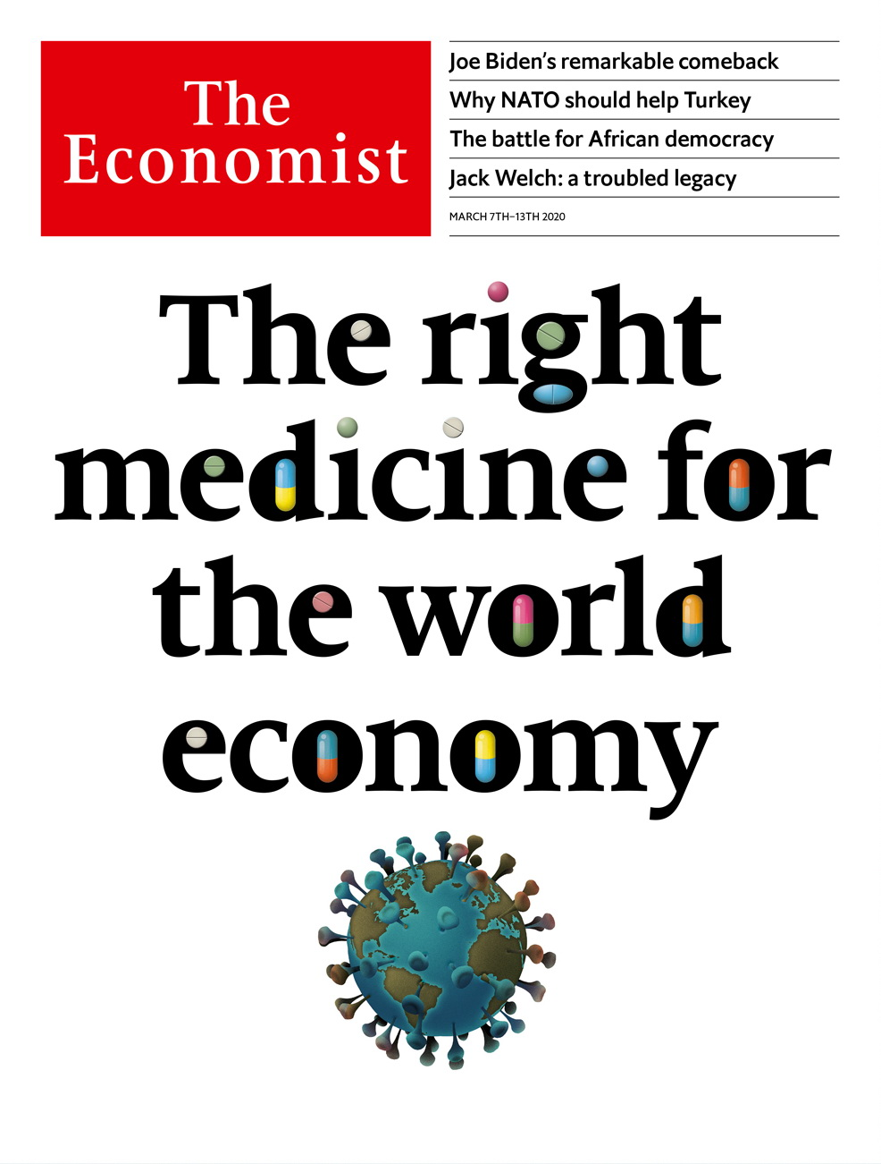

# Table of Contents

The world this week

Politics this week

Business this week

KAL’s cartoon

Leaders

The pandemic: The right medicine for the world economy

American politics: Joe Biden redux

Britain’s budget: Be bold, Boris

The war in Syria: An ally in need

African democracy: How to beat the Big Men

Letters

Letters to the editor: On telecoms, Ireland, Singapore, America, bananas, Brazil, oil

Briefing

Covid-19: New world curriculum

United States

After Super Tuesday: Look at Joe go

News from China: Quid pro quo

Lori Lightfoot: Policing poverty

Donald Trump’s record: The toolkit

Household budgets: The price is wrong

Lexington: Legends of the slaughter

The Americas

Feminism in Mexico: The violet tide

Crime in Latin America: Special victims

Surfing in Brazil: The big break

Bello: Happily after Evo?

Asia

Malaysia’s new government: Beset at its birth

Regulation in Bangladesh: Rules are made to be broken

Elections in Tajikistan: United in unity

The war in Afghanistan: Peace with Afghan characteristics

Politics in Sri Lanka: Brotherly shove

Banyan: Flu jabs

China

Women and covid-19: The mask slips

Uighurs: From slammer to serfdom

Chaguan: Total incredulity

Middle East and Africa

Syria’s war: The battle for Idlib

Israeli politics: In limbo

Democracy in Africa: Generation game

Europe

Refugees: You shall not pass

The euro area: A series of unfortunate events

Ireland: Shape-shifters

Slovakia’s election: A different kind of populism

France: Aux powerpoints, citoyens!

Charlemagne: Minority Report: Brussels edition

Britain

The budget and the bond markets: Neither shaken nor stirred

Coronavirus preppers: Apocalypse soon

Brexit negotiations: Seconds away, round two

Politicians and civil servants: Priti difficult

Hydrology: Putting the wiggles back in rivers

Retail: The high street’s escape route

Bagehot: A man of the world

International

Abortion: From backstreet to mail-order

Business

Jack Welch: Captain of industry

Technology mergers: Xeroxing HP

Bartleby: A woman’s work

Private equity: Locusts of attention

Go north, young woman: The glass-ceiling index

Telemedicine in China: The smartphone will see you now

Schumpeter: Plan V

Finance and economics

The world economy: Sneezy money

Asset prices: Motion sickness

Buttonwood: Penthouse to pavement

Liquidity in bond markets: Match point

American banks: When the bucks stop

Catastrophe finance: A pussyfooting cat bond

Free exchange: Material losses

Science and technology

Military technology: The rise of the ray gun

Wildfires: Animal heat

Satellite communications: A call from the heavens

Evolution: Which is really the weaker sex?

Books and arts

Inequality, revisited: A modern Marx

New American theatre: Notes from the underground

Baltic literature: The farmer’s tale

Irish fiction: A life in parts

Economic and financial indicators

Economic data, commodities and markets

Graphic detail

Coronavirus statistics: Tracking the stealthy killer

Obituary

Ernesto Cardenal: Building Utopia



### Friday, March 6, 2020

|  |  |
| --- | --- |
| The world this week | 3 |
| Leaders | 5 |
| Letters | 1 |
| Briefing | 1 |
| United States | 6 |
| The Americas | 4 |
| Asia | 6 |
| China | 3 |
| Middle East and Africa | 3 |
| Europe | 6 |
| Britain | 7 |
| International | 1 |
| Business | 7 |
| Finance and economics | 7 |
| Science and technology | 4 |
| Books and arts | 4 |
| Economic and financial indicators | 1 |
| Graphic detail | 1 |
| Obituary | 1 |

|  |  |  |
| --- | --- | --- |
|  | Sections | Leaders |

The world this week

Politics this week

.

Business this week

.

KAL’s cartoon

.

|  |  |  |
| --- | --- | --- |
|  | Sections | Leaders |

|  |  |  |  |
| --- | --- | --- | --- |
|  | Articles | Sections | Next |

# Politics this week

Mar 7th 2020 |



Joe Biden’s campaign bounced back after he won most of the 14 states that voted on Super Tuesday. Barack Obama’s vice-president racked up big victories in southern states, where black voters are a large part of the Democratic electorate. Mr Biden earlier scored a huge win in the South Carolina primary. The race for the party’s presidential nomination is now between him and Bernie Sanders, who won California, the biggest prize on Super Tuesday. Despite a costly media blitz, Mike Bloomberg did poorly and ended his campaign; he endorsed Mr Biden. Elizabeth Warren came in a miserable third in her home state of Massachusetts. See [article](https://www.economist.com/node/21781076).

In a boost to the power of the presidency, a federal appeals court sided with the White House when it ruled that Congress had no powers to sue a witness to force him to testify at hearings. The case centred on Donald McGahn, a former White House counsel who refused to appear before a committee investigating Russian influence in elections.

## The genie’s out of the bottle

The IMF announced a $50bn financing package to help emerging markets cope with the outbreak of covid-19, after warning that the disease posed a “serious threat” to global growth. The World Bank pledged $12bn. Meanwhile, the novel coronavirus continued its advance outside China. Italy closed all schools until mid-March following a spike in fatal cases. The number of infections soared in South Korea, which overtook China in reporting new cases. South Korea is testing extensively for the virus, unlike other countries, where its spread may be underreported. See article.

America carried out an air raid against Taliban fighters in Afghanistan who were attacking a security checkpoint. This came just days after both sides signed a peace deal, which Mike Pompeo, America’s secretary of state, had hailed as “a momentous day”. The Taliban has carried out dozens of attacks since signing the deal. America urged it to stick to its commitments. See article.

After a week of uncertainty, Malaysia has a new government. The incoming coalition, Perikatan Nasional, is composed of politicians from the United Malays National Organisation, which was booted out at an election in 2018 after 61 years in power, and various allies. The new prime minister is Muhyiddin Yassin, a former UMNO leader who later founded a different party. See article.

North Korea fired what are thought to be two short-range ballistic missiles into the Sea of Japan. It was its first weapons test this year.

A parliamentary election was called in Sri Lanka for April 25th. The strongman president, Gotabaya Rajapaksa, hopes his party will win enough seats to overturn recent constitutional amendments that have reduced the power of his office. See article.

## Rules v pills

Colombia’s Constitutional Court decided not to legalise abortions during the first 16 weeks of pregnancy. Its ruling leaves in place a decision from 2006, which restricts abortions to cases where the mother has been raped, her life is in danger or the fetus has health problems. Globally, mail-order abortion pills are rendering bans increasingly ineffective. See article.

Spain agreed to an extradition request from the United States for Hugo Carvajal, a former head of Venezuelan intelligence, whom the Americans suspect of drug-trafficking. Mr Carvajal fled Venezuela and was arrested in Madrid last year. In Venezuela, Nicolás Maduro, the dictator, urged women to have six children “for the good of the country”. Food shortages under the socialist regime have led to widespread malnutrition among children.

## Divide and rule

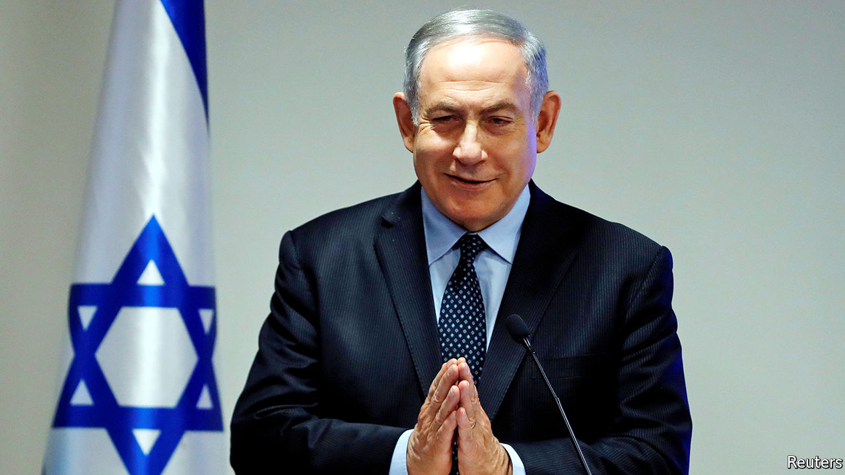

Binyamin Netanyahu, the prime minister of Israel, claimed victory in the country’s third parliamentary election in a year. His party, Likud, won 36 seats, compared with 33 for its main rival, Blue and White. But Mr Netanyahu’s alliance of nationalist and religious parties did not win a majority of seats, so he will struggle to form a government. See article.

Iran has stockpiled enough enriched uranium to build an atomic bomb and has blocked inspectors from visiting three nuclear sites, said the International Atomic Energy Agency. It would still take Iran months or years to manufacture a nuclear warhead.

The Democratic Republic of Congo discharged the last patient confirmed to have Ebola, raising hopes that it has contained an outbreak that has killed 2,264 people (two-thirds of those infected).

The constitutional court in Togo rejected claims that a presidential election won by the incumbent, Faure Gnassingbé, had been rigged. The vote and count were marred by irregularities and only a small number of observers were allowed to monitor them.

An attack by Syrian (and perhaps Russian) forces killed at least 36 Turkish troops in Idlib province, the last big pocket of rebel-held territory in Syria. Turkey responded with drone strikes and artillery attacks that dealt the regime of Bashar al-Assad a terrible blow. Turkish troops are in Syria to stop Mr Assad’s offensive on Idlib and prevent a new wave of refugees. See article.

## A new migrant crisis?

Meanwhile, Turkey declared that it would end a deal under which it stopped migrants from moving to the EU. Thousands of would-be asylum-seekers immediately headed to the border with Greece. Turkish officials said a number of people were killed in incidents involving Greek security forces opening fire on some of the migrants, but Greece has strongly denied this. See article.

The European Commission in Brussels published plans to halve carbon emissions within a decade, and backed it by proposing to “mobilise” €1trn ($1.1trn) in spending. Critics said little of this money was new. Greta Thunberg, a young climate-change activist, denounced the exercise as insufficiently ambitious.

Priti Patel, Britain’s home secretary, came under fire following the resignation of the most senior civil servant in her department. Sir Philip Rutnam left while issuing a claim for constructive dismissal against the Home Office, an unprecedented move. He claims she was involved in a briefing against him because she wanted to replace him. Allegations emerged that Ms Patel bullied officials in other departments. She denies any wrongdoing. See article.

In Slovakia, a new party created by an anti-corruption campaigner was the unexpected winner in a parliamentary election. The ruling party was ousted by a group called the Ordinary People and Independent Personalities party. See article.

This article was downloaded by calibre from <https://www.economist.com/the-world-this-week/2020/03/07/politics-this-week>

|  |  |  |  |
| --- | --- | --- | --- |
|  | Articles | Sections | Next |

|  |  |  |  |
| --- | --- | --- | --- |
| Previous | Articles | Sections | Next |

# Business this week

Mar 7th 2020 |

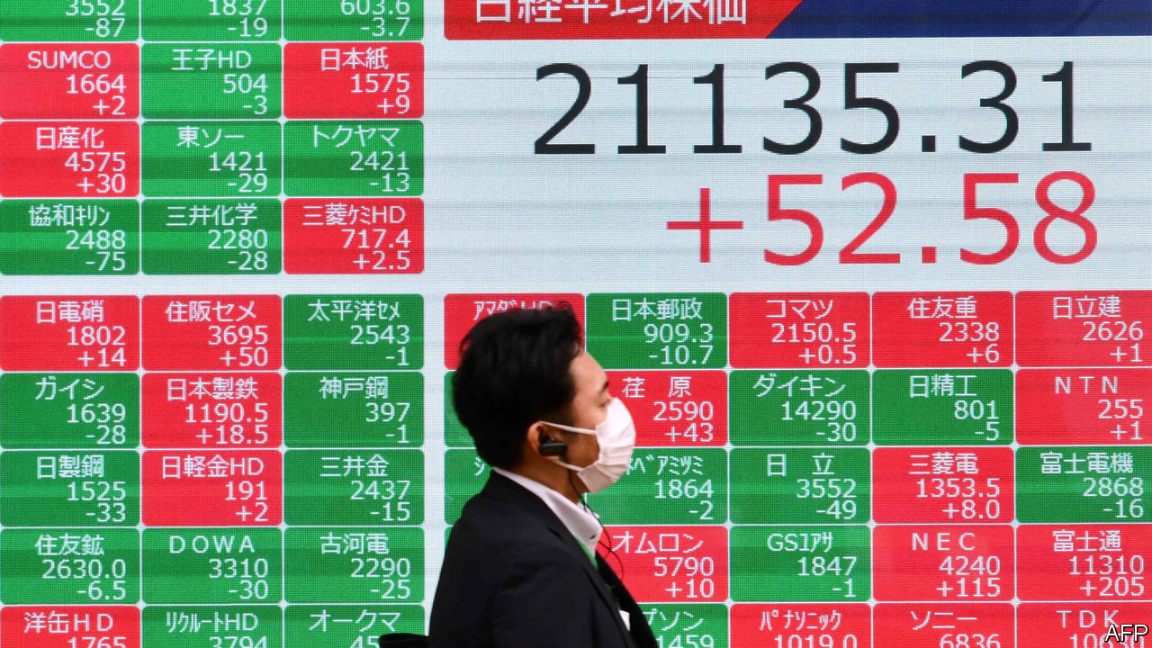

Stockmarkets swung wildly following the worst sell-off over a week for more than a decade. The Federal Reserve made an emergency half-a-percentage-point cut to its benchmark interest rate, to a range of 1-1.25%. The Fed last cut rates by half a point in October 2008, the maelstrom of the financial crisis. This time investors fear the potential impact of the spreading coronavirus, covid-19. The yield on ten-year us Treasury bonds fell below 1% for the first time. The central banks of Australia, Canada and Malaysia also cut rates while the Bank of Japan pumped liquidity into the financial system. The European Central Bank said it was ready to take “appropriate” action; the Bank of England said it would also act. See [article](https://www.economist.com/node/21781122).

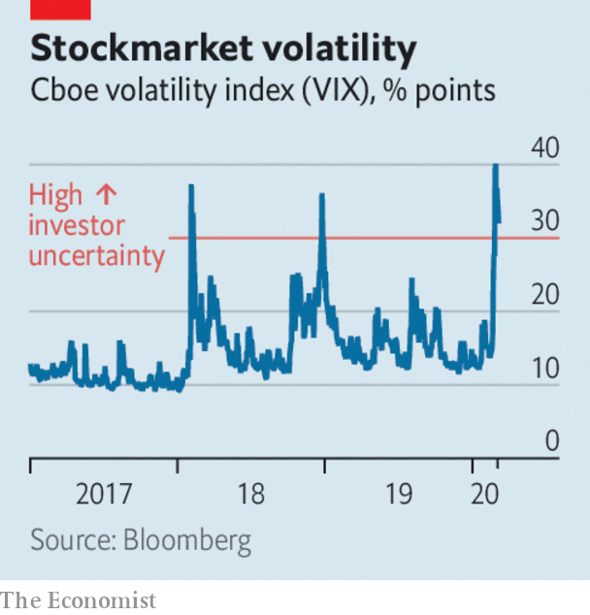

The International Air Transport Association reported that the covid-19 outbreak caused airline passenger demand in January to grow at the slowest pace since April 2010, when a volcanic ash cloud curtailed global travel. It warned that January was “just the tip of the iceberg”, given that flight restrictions did not begin until January 23rd. Airlines could lose up to $113bn in revenue.

The impact of the coronavirus lockdown on the Chinese economy was laid bare in new data. An index of activity in services plummeted to 26.5 in February from 51.8 in January (a reading below 50 indicates a contraction in activity). In Hong Kong a measure of general business activity plunged to 33.1, the lowest since the survey started in 1998. In some good news, Foxconn, which assembles products for Apple, Samsung and others in China, said it expected to return to normal production capacity by the end of March.

A Dutch diagnostics company at the forefront of developing tests to detect covid-19 agreed to a takeover from an American rival. Thermo Fisher struck a deal worth $11.5bn for Qiagen, which recently sent test kits for evaluation to four Chinese hospitals. Qiagen worked on disease detection during the SARS and swine-flu outbreaks.

## Cyril Ramaphosa’s headache

South Africa fell into recession again at the end of last year. The economy contracted by 1.4% in the fourth quarter compared with the previous three months, after shrinking by 0.8% in the third quarter. The country has been blighted by rolling power blackouts, which disrupted industry and retail in December. The central bank has warned that growth will stay low if creaking state-owned utilities are not reformed. GDP grew by just 0.2% in the whole of 2019, the slowest pace in a decade.

Revised figures showed that India’s economy grew by 4.7% in the last three months of 2019 compared with the same quarter a year earlier, the weakest showing in seven years. Turkey’s GDP expanded by 5.9% in the fourth quarter; a strong rebound was fuelled by consumer spending. But the economy grew by only 0.9% in the whole year, as Turkey grappled with the fallout from a currency crisis.

A jury took just six hours to find three former executives at Barclays not guilty of fraud in relation to the bank’s bail-out by Qatar’s wealth fund during the 2008 financial crisis. John Varley, the bank’s chief executive at the time, was acquitted last year. The case has raised questions about Britain’s Serious Fraud Office, which spent more than seven years investigating the matter.

Sergio Ermotti, who is stepping down as chief executive of UBS, is to become chairman of Swiss Re, ending speculation that he would be named chairman of the Swiss bank.

Jack Dorsey may have a tougher time running Twitter, after it emerged that Elliott, an activist hedge fund, has accumulated a 4% stake in the social-media platform and wants him to give up one of his two roles as chief executive of Twitter and Square, a mobile-payments provider. Mr Dorsey founded both companies. Elliott reportedly thinks that Twitter’s shares are undervalued because Mr Dorsey is not focusing on the company.

Xerox formalised its $35bn hostile bid for HP by sending a letter to shareholders at the computer-and-printer company explaining why it thinks its offer is a good deal. If HP does not agree to the bid Xerox will try to replace the board. See article.

## A lift to its bottom-line

Following a lengthy bidding process, Thyssenkrupp decided to sell its elevator business to a private-equity consortium for €17.2bn ($19.2bn), one of the largest-ever buy-out deals in Europe. The consortium is led by Cinven, an activist investor that has been pushing the German engineering group to break up its business. See article.

A ban on plastic bags came into force across New York state. Officials reckon that New York’s 19.5m residents use 23bn plastic bags a year, which clog landfills and get entangled in trees. The ban took many disgruntled shoppers by surprise. Disgruntled retailers will be able to flout the law until April 1st; after that they face a fine.

This article was downloaded by calibre from <https://www.economist.com/the-world-this-week/2020/03/07/business-this-week>

|  |  |  |  |
| --- | --- | --- | --- |
| Previous | Articles | Sections | Next |

|  |  |  |  |
| --- | --- | --- | --- |
| Previous | Articles | Sections | Next |

# KAL’s cartoon

Mar 7th 2020 |

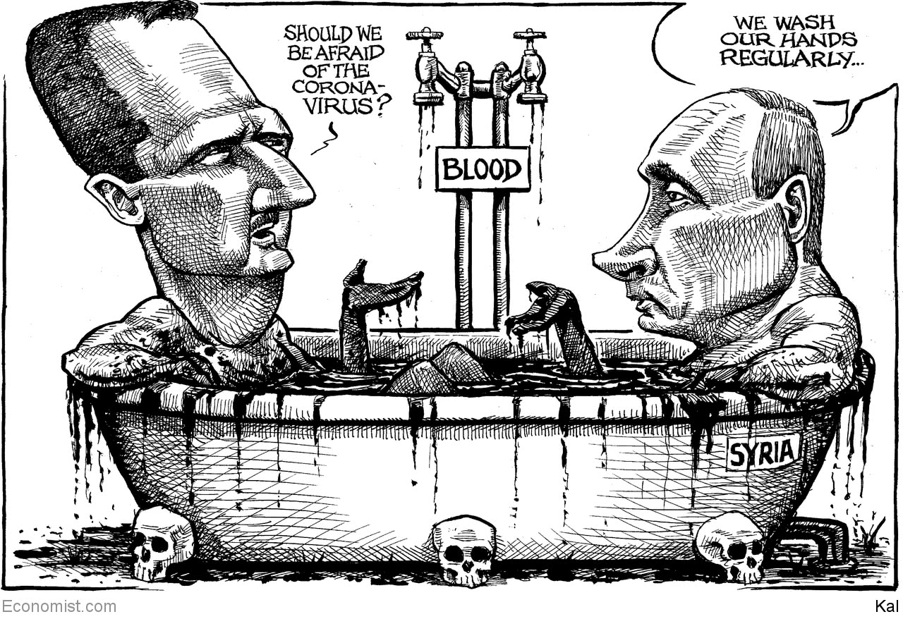

This article was downloaded by calibre from <https://www.economist.com/the-world-this-week/2020/03/07/kals-cartoon>

|  |  |  |  |
| --- | --- | --- | --- |
| Previous | Articles | Sections | Next |

|  |  |  |
| --- | --- | --- |
| The world this week | Sections | Letters |

Leaders

The pandemic: The right medicine for the world economy

.

American politics: Joe Biden redux

.

Britain’s budget: Be bold, Boris

.

The war in Syria: An ally in need

.

African democracy: How to beat the Big Men

.

|  |  |  |
| --- | --- | --- |
| The world this week | Sections | Letters |

|  |  |  |  |
| --- | --- | --- | --- |
|  | Articles | Sections | Next |

#### Covid-19

# The right medicine for the world economy

Coping with the pandemic involves all of government, not just the health system

Mar 5th 2020 |

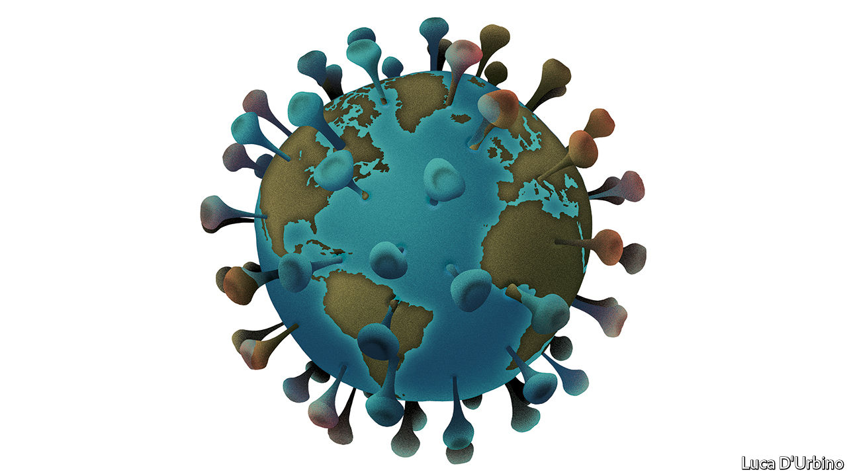

IT IS NOT a fair fight, but it is a fight that many countries will face all the same. Left to itself, the covid-19 pandemic doubles every five to six days. When you get your next issue of The Economist the outbreak could in theory have infected twice as many people as today. Governments can slow that ferocious pace, but bureaucratic time is not the same as virus time. And at the moment governments across the world are being left flat-footed.

The disease is in 85 countries and territories, up from 50 a week earlier. Over 95,000 cases and 3,200 deaths have been recorded. Yet our analysis, based on patterns of travel to and from China, suggests that many countries which have spotted tens of cases have hundreds more circulating undetected (see Graphic detail). Iran, South Korea and Italy are exporting the virus. America has registered 159 cases in 14 states but as of March 1st it had, indefensibly, tested just 472 people when South Korea was testing 10,000 a day. Now that America is looking, it is sure to find scores of infections—and possibly unearth a runaway epidemic.

Wherever the virus takes hold, containing it and mitigating its effects will involve more than doctors and paramedics. The World Health Organisation has distilled lessons from China for how health-care systems should cope (see Briefing). The same thinking is needed across the government, especially over how to protect people and companies as supply chains fracture and the worried and the ill shut themselves away.

The first task is to get manpower and money to hospitals. China drafted in 40,000 health workers to Hubei province. Britain may bring medics out of retirement. This week the World Bank made $12bn and the IMF $50bn available for covid-19. The Global Fund, which fights diseases like malaria and TB, said countries can switch grants. In America Congress is allocating $8.3bn of funding. The country has some of the world’s most advanced hospitals, but its fragmented health system has little spare capacity. Much more money will be needed.

Just as important is to slow the spread of the disease by getting patients to come forward for testing when outbreaks are small and possible to contain. They may be deterred in many countries, including much of America, where 28m people are without health coverage and many more have to pay for a large slug of their own treatment. People also need to isolate themselves if they have mild symptoms, as about 80% of them will. Here sick pay matters, because many people cannot afford to miss work. In America a quarter of employees have no access to paid sick leave and only scattered states and cities offer sickness benefits. Often the self-employed, a fifth of Italy’s workforce, do not qualify. One study found that, in epidemics, guaranteed sick pay cuts the spread of flu in America by 40%.

Sick pay also helps soften the blow to demand which, along with a supply shock and a general panic, is hitting economies. These three factors, as China shows, can have a dramatic effect on output. Manufacturing activity there sank in February to its lowest level since managers were first surveyed in 2004. In the quarter to March the economy as a whole could shrink for the first time since the death of Mao Zedong. The OECD expects global growth this year to be its slowest since 2009. Modelling by academics at the Australian National University suggests that GDP in America and Europe would be 2% lower than it would have been in the absence of a pandemic and perhaps as much as 8% lower if the rate of deaths is many times higher than expected. Financial markets are pricing in fear. The S&P 500 has fallen by 8% from its peak on February 19th. Issuance of corporate debt on Wall Street has more or less stopped. The yield on ten-year Treasuries dipped below 1% for the first time ever.

In rich countries, most of the economic effort has been directed towards calming financial markets. On March 3rd America’s Federal Reserve cut rates a fortnight before its monetary-policy meeting, and by an unusually large half-a-percentage point (see article). The central banks of Australia, Canada and Indonesia have also acted. The Bank of England and the European Central Bank are both expected to loosen policy, too.

Yet this slowdown is not a textbook downturn. Lower rates will ease borrowing costs and shore up sentiment, but no amount of cheap credit can stop people falling ill. Monetary policy cannot repair broken supply chains or tempt anxious people into venturing out. These obvious limitations help explain why stockmarkets failed to revive after the Fed’s cut.

Better to support the economy directly, by helping affected people and firms pay bills and borrow money if they need it. For individuals, the priority should be paying for health care and providing paid sick leave. The Trump administration is considering paying some hospital bills for those with the virus. Japan’s government will cover the wages of parents who stay at home to care for children or sick relatives; Singapore’s will help cab drivers and bosses whose employees are struck down. More such ideas will be needed.

For companies the big challenge will be liquidity. And although this shock is unlike the financial crisis, when the poison spread from within, that period did show how to cope with a liquidity crunch. Firms that lose revenues will still face tax, wage and interest bills. Easing that burden, for as long as the epidemic lasts, can avoid needless bankruptcies and lay-offs. Temporary relief on tax and wage costs can help. Employers can be encouraged to choose shorter hours for all their staff over lay-offs for some of them. Authorities could fund banks to lend to firms that are suffering, as they did during the financial crisis and as China is doing today. China is also ordering banks to go easy on delinquent borrowers. Western governments cannot do that, but it is in the interest of lenders everywhere to show forbearance towards borrowers facing a cash squeeze, much as banks did to public-sector employees during America’s government shutdown in 2018-19.

There is a tension. Health policy aims to spare hospitals by lowering the epidemic’s peak so that it is less intense, if longer-lasting. Economic policy, by contrast, aims to minimise how long factories are shut and staff absent. Eventually governments will have to strike a balance. Today, however, they are so far behind the epidemic that the priority must be to slow its spread. ■

This article was downloaded by calibre from <https://www.economist.com/leaders/2020/03/05/the-right-medicine-for-the-world-economy>

|  |  |  |  |
| --- | --- | --- | --- |
|  | Articles | Sections | Next |

|  |  |  |  |
| --- | --- | --- | --- |
| Previous | Articles | Sections | Next |

#### After Super Tuesday

# Joe Biden redux

His victories suggest that the Democratic Party has not yet wandered off to the wilderness

Mar 5th 2020 |

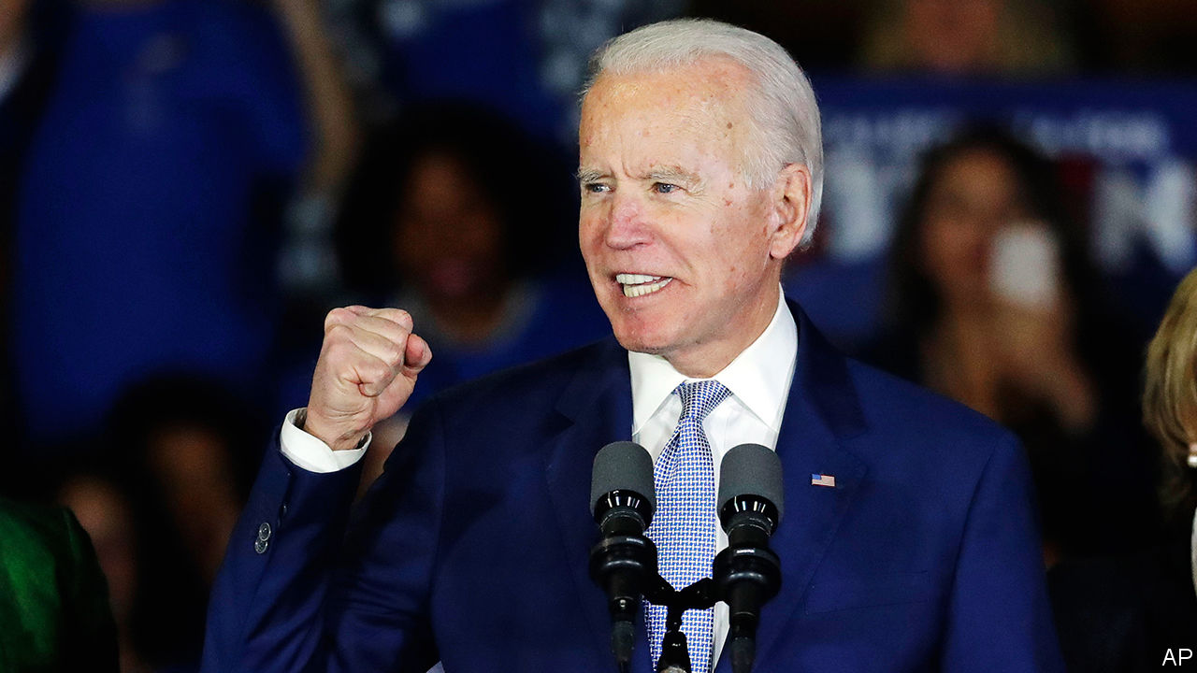

ELECTIONS HAVE a knack of making pundits look foolish. Ever since the Brexit referendum, electoral upsets around the world have involved underdogs and insurgents pulling off unexpected victories. The Democratic Party seems to be bucking that trend. On March 3rd Super Tuesday produced an upset of a different sort, one that makes Joseph Robinette Biden Jr—a moderate 77-year-old former vice-president making his third bid for the top job—the favourite to win the party’s nomination, and hence to take on President Donald Trump in November.

Democrats seem to have learned the lesson in game theory provided by the Republican Party in 2016. When the primary field is divided between a large number of similar candidates bent on attacking one another, it is possible for a factional candidate who attracts 30% of the electorate to win the nomination even if he terrifies the majority. This set-up landed the Republicans with a nominee who, at the outset of their primaries, much of the party saw as a threat to its very existence. Pete Buttigieg and Amy Klobuchar therefore deserve praise for bowing out before it was too late to prevent Bernie Sanders, America’s lone democratic-socialist senator, from securing the nomination of a party that he joined only to stand in this election. After Tuesday’s vote Mike Bloomberg followed them. The hope is that he will energetically put his formidable electoral machine and even more formidable wallet behind Mr Biden.

That is because Mr Sanders may still win. Both he and Mr Biden have about 600 delegates from the states that have voted so far. They each need 1,400 more to win outright. This race has not been kind to front-runners. Ask Elizabeth Warren who, having briefly dazzled, came third in her home state of Massachusetts. And Mr Biden is not an ideal candidate. He can seem incapable of answering any question in fewer than 1,000 words. His candidacy has long been more reassuring in theory than in practice.

Moreover, at a moment when Washington experience seemingly counts for little with voters, Mr Biden has an awful lot of it. He first arrived as a senator in 1973 and never left. His long record contains several embarrassing moments that voters will be grimly familiar with by November, should he become the nominee. Expect to hear more about plagiarism, about his opposition to busing, his support for the Iraq war, and his votes to deregulate the financial industry. That would give the Trump campaign plenty of material to work with. Ask Obama campaign alumni about Mr Biden as a candidate and they look at their shoes.

Yet Mr Biden also has strengths, which are easy to discount because he is so familiar. He is that rare thing in politics: a decent man. His Washington experience may seem more appealing now America is facing a pandemic. His policy platform is to the left of where Barack Obama ran in 2008 or 2012, and even where Hillary Clinton was in 2016 (see article). But much of it is sensible and, more important, some policies might even pass the Senate. For example, Mr Biden has an ambitious scheme to reduce carbon emissions. It would require $1.7trn over ten years in additional federal spending, but that is less than what Mr Sanders proposes to spend just on replacing petrol and diesel vehicles with electric ones.

This contrast between Mr Biden and Mr Sanders is not just a matter of ideology. It also reflects a different approach to politics. Mr Sanders requires a political revolution to accomplish his ends. Mr Biden, by contrast, refuses to write off the other side as beyond redemption. Many younger Democrats think that the former vice-president’s faith in his power to persuade Republicans to cross the aisle and support him is touching at best, and dangerously naive at worst. Yet the only way to bring about long-lasting change in Washington is for a president to find a coalition in Congress that is broad enough to pass laws. After Super Tuesday, it looks as if only one candidate on the Democratic side may be capable of doing that.■

Dig deeper:

* Sign up and listen to Checks and Balance, our new [newsletter](https://www.economist.com/checksandbalance/) and [podcast](https://www.economist.com/podcasts/2020/02/21/checks-and-balance-our-new-weekly-podcast-on-american-politics) on American politics
* Explore [our guide](https://www.economist.com/united-states/2020/02/26/the-economists-guide-to-the-us-2020-elections) to the US 2020 elections

This article was downloaded by calibre from <https://www.economist.com/leaders/2020/03/05/joe-biden-redux>

|  |  |  |  |
| --- | --- | --- | --- |
| Previous | Articles | Sections | Next |

|  |  |  |  |
| --- | --- | --- | --- |
| Previous | Articles | Sections | Next |

#### Fiscal policy

# Why Britain needs a bold budget

Covid-19 is not the only reason that the government should increase spending

Mar 7th 2020 |

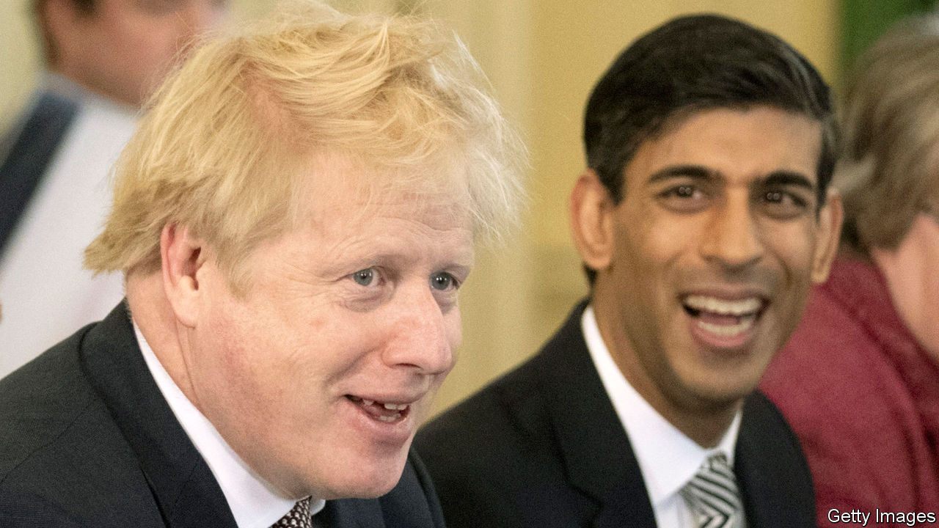

THE SMOKE signals rising from Downing Street suggest that the budget due on March 11th will be dull. The covid-19 virus has clouded the outlook; the new chancellor, Rishi Sunak, needs to get his feet under the desk; there will be more fiscal announcements later in the year. It sounds as though the government plans to treat the budget as a holding operation. That would be a mistake. A new government’s first budget is a big moment, and this government has a lot to do. It is time to be bold, not boring.

For over a decade economic policy has been about managing a series of blows. First there was the financial crisis, which landed the government with the cost of rescuing the banks. Then there was Brexit, which has delayed firms’ investment decisions. Now there is covid-19, which is bound to slow the economy further.

These last two factors would argue for an expansionary budget. But there is a further reason: while the government managed immediate perils, long-term problems—notably poor productivity and public services, particularly outside the south-east—have gone unattended.

To deal with these issues, Mr Sunak will have to spend more in two areas. The first is investment. The government looks set to double the R&D budget and boost infrastructure spending, particularly for greener transport. That is all to the good, but other sorts of investment also need a boost. To enhance workers’ skills, Britain should spend more on technical education for school leavers and those already in work. And to raise private investment, which has been weak since 2016 and is growing more slowly than in any other G7 economy, the chancellor should increase capital allowances, which let investment spending be deducted from tax bills, and thus encourage firms to invest.

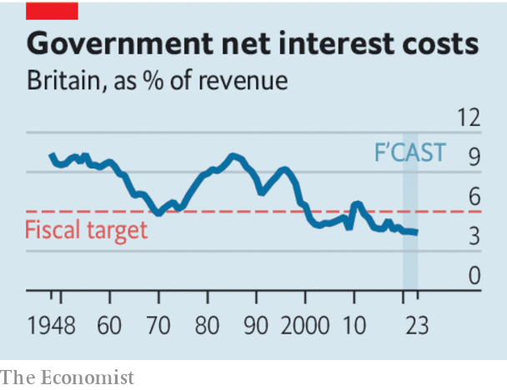

The second area that deserves more cash is public services. Local authorities, which provide many of them, have about a third less to spend, in real terms, than they did in 2010, and the government’s current plans imply further cuts. That is poor politics and poor economics. A shiny new railway station, paid for out of the capital budget, will be scant consolation to many voters, nor will it boost poorer regions’ prospects if local services, funded out of current spending, continue to deteriorate.

How to pay for all this? In the long run, modestly higher public spending will require higher taxes. And some taxes should rise now, not least to show voters the direction of reform. Raising fuel duty, which has been frozen for almost a decade, will bring in revenue and help wean Britain off fossil fuels. Council tax, the main charge on residential property, needs an overhaul both to raise money and to remove its regional distortions. The property valuations on which it is set date back to 1991, since when real house prices have quadrupled in the capital and doubled in Yorkshire. People sitting on multi-million-pound London piles pay less property tax than those in cheaper homes in other bits of Britain.

Most of the extra spending, however, should be funded by borrowing. That alarms many sensible Britons, who worry that the government is getting too far into debt and will lose credibility by, yet again, breaking the fiscal rules it has set itself. Those fiscal rules have been revised five times over the past decade.

These are valid concerns, but they are outweighed by Britain’s situation. The amount of debt matters less than the cost of servicing it, and, with interest rates historically low, that has fallen steadily from 6.5% of tax revenues in 2010 to 4.6% now. Britain is also insulated against shocks because the government’s bonds, at a 15-year average maturity, are longer-dated than those of any other major economy. Of Britain’s three fiscal rules—to balance the current budget in three years, to keep capital spending below 3% of GDP and to keep an eye on government borrowing costs—the one that really matters, therefore, is a pledge to keep the government’s interest bill below 6% of tax revenues. Time to junk the other rules, stick to that one, and start spending. ■

This article was downloaded by calibre from <https://www.economist.com/leaders/2020/03/07/why-britain-needs-a-bold-budget>

|  |  |  |  |
| --- | --- | --- | --- |
| Previous | Articles | Sections | Next |

|  |  |  |  |
| --- | --- | --- | --- |
| Previous | Articles | Sections | Next |

#### An ally in need

# Why NATO should grit its teeth and help Turkey in Idlib

The crisis is an opportunity for the alliance to reinvigorate itself, while alleviating the suffering

Mar 7th 2020 |

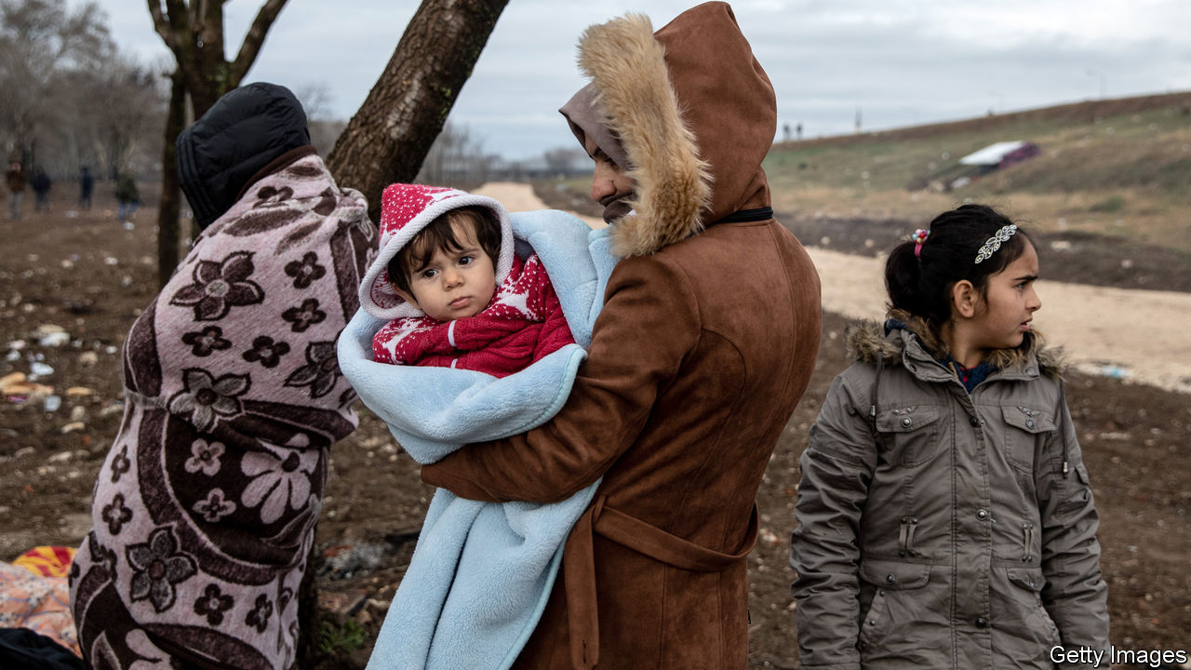

FEW PLACES on Earth are more miserable than Idlib province, the last big pocket of rebel-held territory in war-torn Syria. It is home to some 3m people, roughly half of whom are there only because they have fled fighting elsewhere. Along with the poor, huddled masses came jihadists, who now largely control the territory. Syria’s dictator, Bashar al-Assad, wants it back, even if that means reducing it to rubble. His months-long bombing campaign has destroyed schools, houses and hospitals, and pushed a million people towards Turkey’s sealed border. Many are trapped there, cold, hungry and exposed.

The world is at last waking up to this humanitarian crisis—and to the fact that Turkey is the only country trying to stave it off. Fearing another flood of migrants, its president, Recep Tayyip Erdogan, has sent thousands of troops to Idlib in recent weeks to stop Mr Assad’s offensive. Dozens were killed in an attack by Syrian (and perhaps Russian) forces on February 27th, prompting retaliatory strikes from Turkey (see article). But what got the attention of European countries was Mr Erdogan’s decision to open Turkey’s borders and send refugees streaming their way (see article).

Turkey is crying out for help in Idlib. Its NATO partners should provide it, not only to stop the suffering of desperate Syrians, but also to reinvigorate their faltering alliance.

Some NATO members are reluctant to work with Mr Erdogan. This is understandable. He locks up dissidents, cosies up to Russia, uses refugees as bargaining chips, and is often at odds with NATO. Look no further than Syria, where Turkey has pounded Kurdish fighters, whom it calls terrorists, but whom America regards as allies in the fight against Islamic State. Mr Erdogan sees Vladimir Putin, Russia’s president, as the man to deal with in Syria—and elsewhere. Mr Putin, in turn, uses Mr Erdogan to divide and weaken NATO. Russia’s sale to Turkey of an S-400 anti-aircraft system, which is incompatible with NATO systems, has deepened the rift between Turkey and its allies.

But Turkey is too important for NATO to abandon. It has the alliance’s second-biggest army and sits at the crossroads between west and east. The situation in Idlib, dire as it is, provides an opportunity to reset relations. Turkey has renewed its call for NATO to patrol a no-fly zone over the province and asked America for Patriot missiles to defend itself against attack. Western leaders are understandably reluctant to put troops on the ground or planes in the air around Idlib. NATO, though, can do more than merely express solidarity. Promises of more ammunition, humanitarian aid and radar surveillance over Syria are a start. Spain already stations Patriot missiles in Turkey and other European allies should step in. NATO should put its weight behind talks to reach a political settlement over Idlib. And Turkey should insist that some of its allies should be present at such talks, something Russia rejects.

These moves will not completely heal the rift between Turkey and the West, nor will they solve the problem of Idlib, which has been festering for years. But they might restore some of Turkey’s faith in its allies and send a message to Mr Putin. The fact that such strategic considerations—and a fear of Syrian refugees—might motivate Western policymakers more than their concern over struggling Syrians is disheartening. Yet NATO attention would look the same to the people of Idlib whatever its motive. Helping Turkey there would alleviate some of their suffering. ■

This article was downloaded by calibre from <https://www.economist.com/leaders/2020/03/07/why-nato-should-grit-its-teeth-and-help-turkey-in-idlib>

|  |  |  |  |
| --- | --- | --- | --- |
| Previous | Articles | Sections | Next |

|  |  |  |  |
| --- | --- | --- | --- |
| Previous | Articles | Sections | Next |

#### The battle for liberty in Africa

# How African democrats can fight back

And how outsiders can help them

Mar 7th 2020 |

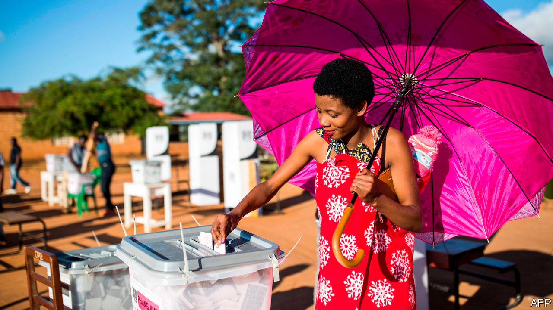

THREE-QUARTERS of Africans favour multiparty democracy. Whereas in rich countries the fashion is to lament democracy’s shortcomings, Africans want more of it. Their passion is born of experience. Many have endured one-party or military rule, and know that unaccountable rulers abuse. Hence the bravery of the hundreds of thousands of Sudanese who protested against the dictatorship of Omar al-Bashir last year. After three decades of tyranny, plunder and economic mismanagement, they had had enough. What started as a rally against higher bread prices turned into a popular wave that forced the army to ditch the despot and agree to a transition to democracy.

A struggle is raging in sub-Saharan Africa. Most Africans, like people anywhere, want to choose their own rulers. A smaller but powerful group—autocrats and their supporters—is determined to thwart them. Over the past 30 years democracy has gained ground in Africa. During the cold war, peaceful changes of government at the ballot box were almost unheard of, because of Soviet and American support for friendly tyrants. After 1990 nearly every African country held elections. But in the past decade democrats have been pushed back again (see [article](https://www.economist.com/node/21781113)). Political freedom has shrunk in Africa since 2008, according to Freedom House, a watchdog. Crooked ruling parties have found myriad ways to nobble opponents and make elections unfair. The share of Africans who report that they are free to say what they think fell from 79% to 70% in 2008-18. Of the 21 countries that switched off the internet last year, 12 were African. The same number have passed laws making it harder for NGOs to operate.

Several trends favour the autocrats. China offers cash for roads and bridges with no pesky questions about governance. The current White House has no interest in promoting democracy. And new surveillance technologies let autocrats snoop inside dissidents’ phones, making it easier to harass them.

However, Africa’s democratic backsliding should be seen in context. It is smaller in scale than the advances of the 1990s and early 2000s—a case of three steps forward and one step back. And the forces that favour democracy remain strong.

One is urbanisation. The share of sub-Saharan Africans who live in cities has doubled since 1975, to 40%, and continues to rise. City folk are younger, better educated and harder to intimidate than their rural cousins. In the countryside ruling-party thugs can chivvy whole villages to the polls and threaten to take away their food aid if they back the opposition. In cities, by contrast, dissidents can more easily organise. Autocrats try to suppress urban turnout at elections, but this often causes anger to spill onto the streets. African political protests are more than three times as common as they were in 2012, by one estimate, and last much longer. Soldiers can disperse any crowd, but sometimes refuse to shoot. Some even switch sides and join the protesters, as at a crucial point in Sudan’s uprising last year.

Another force is Africans’ desire to build institutions to hold the mighty to account. These include a probing press and vigorous NGOs: think of the tireless reporters who exposed Angola’s kleptocracy, or Catholics who proved Congo’s election was stolen. They include assertive courts: think of the judges who overturned rigged elections in Kenya in 2017 and Malawi in February. They include legislatures, which are not as toothless as is often supposed. Most African presidents are now subject to term limits, which are more than twice as likely to be honoured as broken. And they include reformers within ruling parties. The big struggle in South Africa is between the pro- and anti-corruption factions of the ruling African National Congress; the anti-theft wing narrowly regained the upper hand in 2017.

Some say that an obsession with democracy is misguided, that China proves smart autocracy is better at promoting economic growth. Yet studies show an association between democracy and higher growth in sub-Saharan Africa. Other research suggests that the more democratic a country is, the more likely it is to invest in education and health. Strongmen with spreadsheets can foster development for a time. But democracy does it better. And the moral argument for it is even stronger.

Africa’s battle for democracy will be won or lost by Africans themselves. Still, the rest of the world can and should choose a side. The West has been hopelessly inconsistent, one minute lambasting Zimbabwe for ballot-rigging, the next minute endorsing the same crime in Congo. Better to offer steadier and more united support for democracy. Outsiders should not only reject sham elections but also be more outspoken in the period between votes. Diplomacy is often about timing. Outside help is most useful when a political stand-off could go either way (as when Gambia’s president tried to hang on despite losing an election, but was ejected by the threat of force from neighbouring countries) or when a new, reformist regime is finding its feet (as in Ethiopia today). To know when to intervene, countries need diplomats on the ground, and governments back home that listen to them. President Donald Trump’s gutting of the State Department has not helped.

Support for elections should be more creative. Rather than merely watching what happens on polling day, donors should back local NGOs that can spot intimidation months in advance; digital analysts who can detect disinformation; and parallel voter tabulations against which official results can be checked.

Most important, outsiders should support institution-building. This is slow and thankless. The results are less visible than China’s railways and dams. Yet it is essential. Prosecutors, legislators and journalists all need training; some also need cash to keep the lights on. African whistle-blowers are harder to ignore when outsiders trumpet their findings. It would be wrong for outsiders to fund opposition parties. But championing financial liberalisation can make for more competitive politics, especially in countries where state-run banks deprive opposition parties of credit, thus making it hard to fund campaigns.

Africa matters. By 2060 it will have twice as many people as China. Outsiders should care whether such a giant neighbour is prosperous and peaceful. Democracy cannot guarantee that, but its absence makes poverty and disorder more likely. ■

This article was downloaded by calibre from <https://www.economist.com/leaders/2020/03/07/how-african-democrats-can-fight-back>

|  |  |  |  |
| --- | --- | --- | --- |
| Previous | Articles | Sections | Next |

|  |  |  |
| --- | --- | --- |
| Leaders | Sections | Briefing |

Letters

Letters to the editor: On telecoms, Ireland, Singapore, America, bananas, Brazil, oil

.

|  |  |  |
| --- | --- | --- |
| Leaders | Sections | Briefing |

|  |  |  |  |
| --- | --- | --- | --- |
|  | Articles | Sections | Next |

#### On telecoms, Ireland, Singapore, America, bananas, Brazil, oil

# Letters to the editor

A selection of correspondence

Mar 7th 2020 |



## Tricky telecoms

“[How to handle Huawei](https://www.economist.com/leaders/2019/01/31/how-to-handle-huawei)” (January 25th) called for the adoption of encryption as a way to mitigate the threat of snooping by Chinese tech firms. Although end-to-end encryption can secure communications, it also hinders lawful interception, such as the ability of a country’s police and intelligence agencies to monitor calls. This is a power that even democratic governments are reluctant to lose. Once lawful interception is part of a phone network, it is difficult to secure confidentiality in communications. For example, in 2004 Ericsson’s mobile-phone exchanges in Greece were hacked to reroute calls made by government officials to an array of shadow phones linked to another country, using lawful intercepts.

Furthermore, end-to-end encryption does not secure metadata, such as a phone’s location or the caller’s identity. Both can be valuable to a foreign power. Finally, all arguments regarding voice-call security will become irrelevant, as ever more communications take place over internet platforms, such as Skype, WhatsApp or Viber. We live in a complex world.

DIOMIDIS SPINELLIS  
Professor of software engineering  
Athens University of Economics and Business

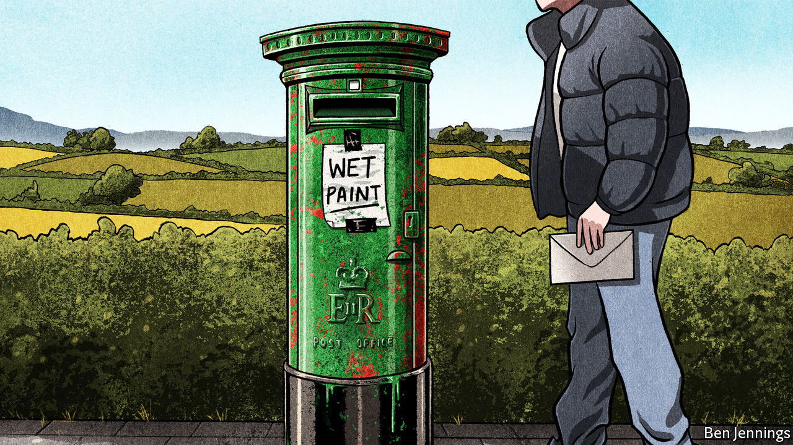

## North and south

You wondered whether a united Ireland would need a new flag (“[Is some revelation at hand?](https://www.economist.com/briefing/2020/02/13/brexit-and-sinn-feins-success-boost-talk-of-irish-unification)”, February 15th). Given that the flag of the republic of Ireland is already a tricolour of the green of the Catholics, the orange of the Protestants and white representing the hope for peace between them, it is not clear what more a new flag could symbolise.

One change that may help would be if a united Ireland rejoined the Commonwealth. Ireland left in 1949 because it could not be a republic and remain a member, though the rules were changed soon after to accommodate India. The queen is not head of state in that country. British-Irish hostility is largely a thing of the past, so this easy concession may make Protestants more comfortable with the prospect of a unified Ireland.

MICHAEL TICKTIN  
Roosevelt, New Jersey

A united Ireland and an independent Scotland would help England, with Wales, find that role in the world which Dean Acheson observed we have been seeking since the loss of empire. Shocked and reduced in size we would (hopefully) accept that we were no longer able to punch above our weight. A smaller country but still with lots of economic heft, we could focus on domestic needs. Being a Holland is rather attractive.

ROGER STAPLETON  
Poole, Dorset

It now looks more likely that the goal of a united Ireland pursued by Irish republicans for the past century could at last be achieved, not as the result of civil protest, IRA violence or Sinn Fein politicking, but rather as the unintended consequence of a single vote supported by mostly conservative Britons: Brexit. Irish republicans will identify with Napoleon’s advice to never interrupt your enemy when he is making a mistake.

ANDREW LINDGREN  
San Francisco

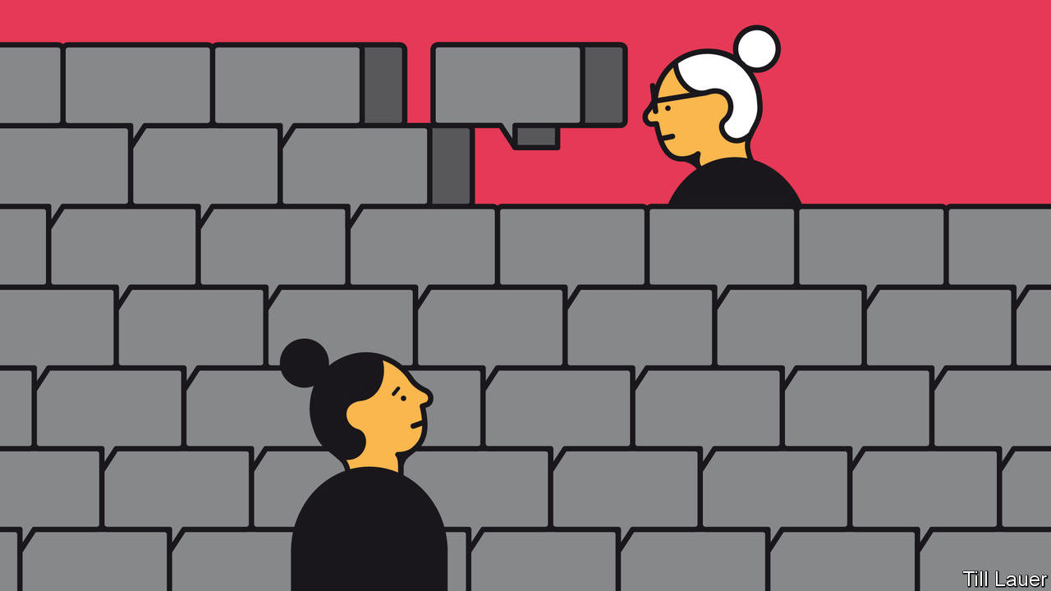

## Language in Singapore

Chinese Singaporeans used to speak varied dialects, but Mandarin was not alien to them ([Banyan](https://www.economist.com/asia/2020/02/22/singapore-has-almost-wiped-out-its-mother-tongues), February 22nd). Already by the 1950s, Mandarin was the dialect taught in Chinese-medium schools in Singapore, and the standard dialect in China. However, over the years, parents increasingly sent their children to English-medium schools in the hope of securing better jobs for them. Had the government done nothing, the decline of Mandarin and all other dialects would have been rapid and drastic. Instead, Singapore adopted a bilingual education policy and required all Chinese students to study Mandarin as a second language.

Dialect-speaking families made a sacrifice, to keep their language and culture alive for future generations. But most families got by, with older members learning enough Mandarin to engage with their grandchildren. Decades later, interest in dialects has revived among young Singaporeans. Quite a few are taking up conversational courses, seeking to connect with their roots.

But it is not realistic to expect Chinese Singaporeans to learn English, Mandarin, plus their own dialect, without weakening their competence in each. Despite Banyan’s optimism, the average human’s capacity for learning languages is finite. This is the experience not just of Singapore, but other multilingual societies such as Mauritius and Hong Kong.

I join Banyan, though, in lamenting the lack of adequate Mandarin equivalents for many colourful dialect expressions, and regret that English is an even poorer substitute for swearing.

FOO CHI HSIA  
High commissioner for Singapore  
London

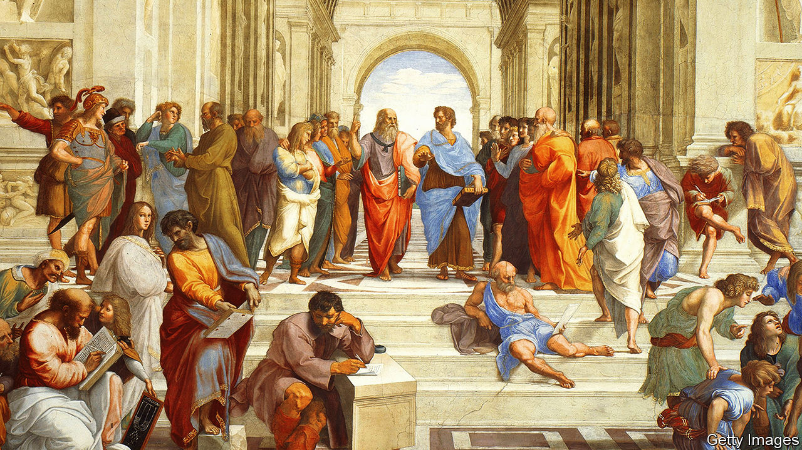

## Abolish the electoral college

In America we are certainly feeling the sting of “less democracy” (“[Too much of a good thing](https://www.economist.com/books-and-arts/2020/02/13/why-an-excess-of-democracy-can-lead-to-poor-decisions)”, February 15th). The electoral college was designed by the Founding Fathers to step in and elect the president if voters got too deranged. It has yet to serve that purpose, but it has upended democracy twice in the past five elections by electing a president who has not attained the most votes.

FRED LAKNER  
San Diego

Democratic governments could indeed do with a little less democracy. If only the United States would abolish presidential primaries and return to the old days of closed-door party committees choosing the candidates who are most likely to win. We would then be spared the likes of Donald Trump and Bernie Sanders, who attract support at the extreme ends of their parties at the primaries. Choosing behind closed doors would result in moderate candidates for both parties.

ROGER SAVITT  
Bedford, New York

## The banana man

The school of tropical medicine at Baylor College is not America’s first (“[Anger in a time of autism](https://www.economist.com/united-states/2020/02/22/anger-in-a-time-of-autism)”, February 22nd). The School of Hygiene and Tropical Medicine at Tulane University was founded in New Orleans in 1912, thanks to funding from Samuel Zemurray, known as Sam the Banana Man. Zemurray’s banana empire in Honduras inspired the term “banana republic”, of which New Orleans is considered by some, myself included, to be the northern-most point.

GARY FLEMING  
New Orleans

## Look out for Belgium also

The world this week ([February 22nd](https://www.economist.com/the-world-this-week/2020/02/22/politics-this-week)) mentioned that the best military minds in Brazil are trained on what they believe to be the biggest threat to their country over the next 20 years: France. Are you sure they are not thinking about football?

PASCAL LECCIA  
Singapore

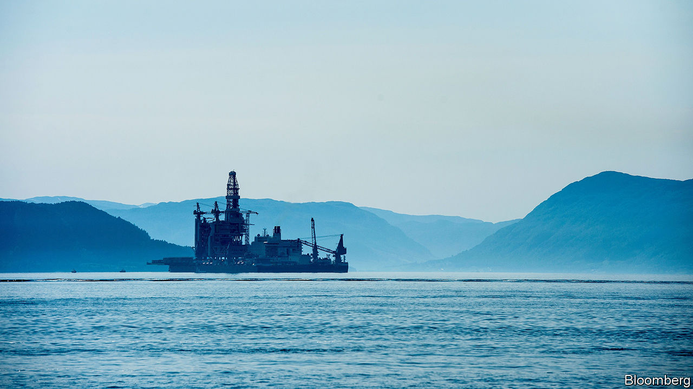

## Addicted to oil

Norwegians yearning to be green while continuing to owe their wealth to fossil fuels (“[Ecowarriors bankrolled by oil](https://www.economist.com/europe/2020/02/08/why-every-norwegian-ecowarrior-has-200000-petrodollars)”, February 8th) reminded me of the infamous adage among drug-dealers: don’t get high on your own supply.

MICHAEL URBICH  
Zug, Switzerland

This article was downloaded by calibre from <https://www.economist.com/letters/2020/03/07/letters-to-the-editor>

|  |  |  |  |
| --- | --- | --- | --- |
|  | Articles | Sections | Next |

|  |  |  |
| --- | --- | --- |
| Letters | Sections | United States |

Briefing

Covid-19: New world curriculum

.

|  |  |  |
| --- | --- | --- |
| Letters | Sections | United States |

|  |  |  |  |
| --- | --- | --- | --- |
|  | Articles | Sections | Next |

#### Firstest with the mostest

# What the world has learned about facing covid-19

Many countries are ill prepared

Mar 5th 2020 | BEIJING, MILAN, SEOUL, SINGAPORE AND WASHINGTON

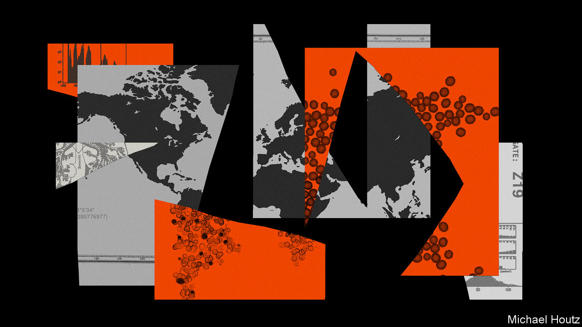

SPEAKING FROM his home in Abuja, Chikwe Ihekweazu, the director general of the Nigerian Centre for Disease Control, says China has one big lesson to teach the world about covid-19: “It can be contained.” Mr Ihekweazu was in voluntary self-isolation following a visit to Wuhan, the city at the centre of the Chinese outbreak, as part of a group of experts dispatched by the World Health Organisation (WHO) to examine the country’s measures to stop the spread of covid-19.

These measures seem to have had significant success. On February 4th China recorded 3,887 new cases. On March 4th the number was 139. The report that the WHO group published on February 28th put the good results down to the way that the state had used manpower and technology to implement quarantine meticulously on an unprecedented scale. It did not go into the disturbing mechanisms of state power employed to that end.

All over the country cities closed down schools, public transport and almost all social and economic activity to stop people from moving around. In Wuhan, a city of 11m people, have been restricted to their homes for five weeks. The lockdown was enforced not just by the network of officials which covers every block of flats, street and alley but also, under the influence of those officials, by the property managers at residential compounds. In some villages life is now relatively unconstrained; there are reports that in others every visitor has to be cleared by a local party boss. The top-down set-up lends itself to excessive alacrity among the lower echelons. Missing a target is less dangerous than overstepping the mark. Hence the (swiftly censored) online videos showing police smashing Mahjong tables, people being paraded or tied to trees for failing to wear face-masks, or a screaming woman barricaded in her home with iron bars.

How less thuggish states can achieve similar results remains to be seen. In South Korea, the country with the most cases outside China, stringent measures widely supported by the public may be slowing the rate of spread. A drop has definitely been seen in Singapore, where pandemic preparedness became a priority after the SARS outbreak of 2003. The city-state knows where all but 12 of the 112 cases it has seen got infected.

But whether the isolation of whole towns in northern Italy has done much to curb the outbreak there remains to be seen. In Iran there is no evidence as yet of any overarching control at all. And in America the response to date has been a shambolic missed opportunity. Shockingly, the worst American bungling has more in common with the catastrophic early stages of the Chinese epidemic—when officials minimised risks and punished truth-tellers, thus letting the disease spread much further and faster than it might have—than with the country’s later co-ordinated control efforts.

## The wrong controls

In the week from February 26th to March 4th the number of countries and territories reporting cases of covid-19 rose from 50 to 85 (see map). Most, so far, have fewer than a dozen cases, mostly imported from or directly linked to cases in China, Iran, Italy and South Korea, which between them accounted for 91,903 of the 95,124 confirmed cases as of March 4th (see chart). Low case numbers, though, should not be taken to signify successful containment; they are often a measure of ignorance.

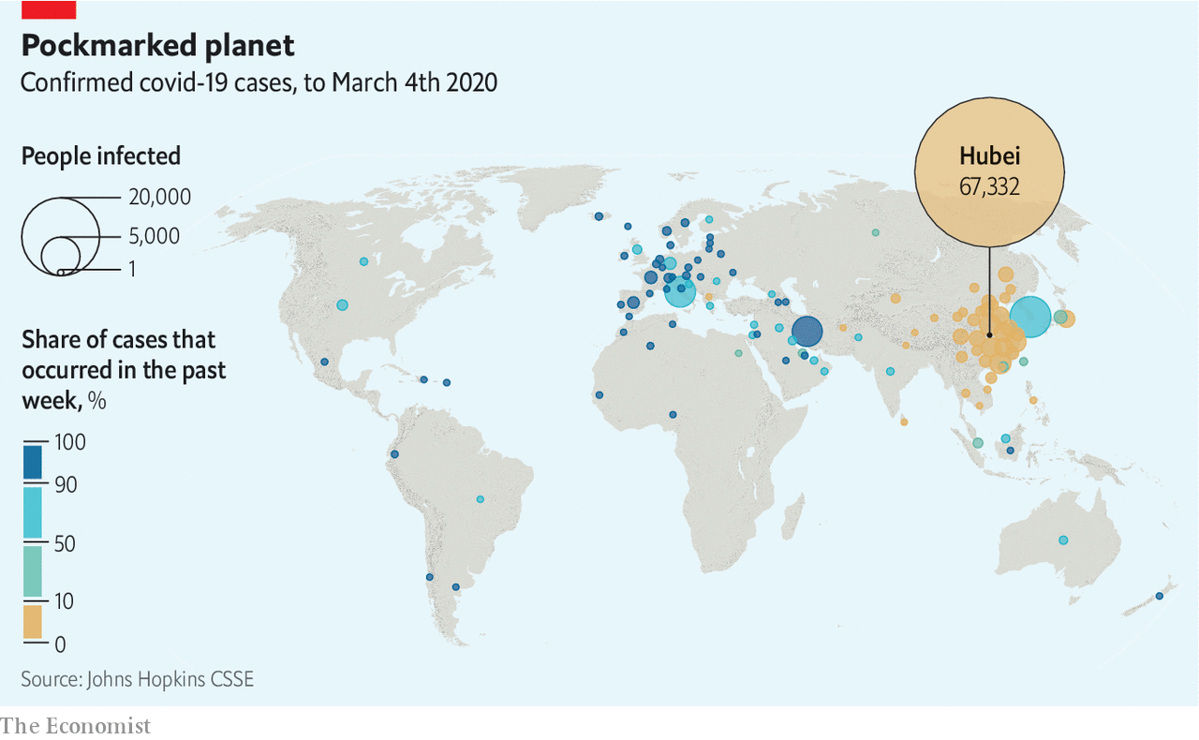

Take America. On February 25th Larry Kudlow, chief economic adviser to President Donald Trump, told reporters that “We have contained this. I won’t say airtight, but it’s pretty close to airtight.” As he spoke a cluster of cases at a care facility in Washington state was showing that America’s public-health agencies had been caught flat footed. Test kits made available by the Centres for Disease Control and Prevention (CDC) were faulty; restrictions were limiting tests in other settings. By March 1st, when South Korea had run 100,000 tests for the virus, America—which saw its first case on January 23rd—had run fewer than 500.

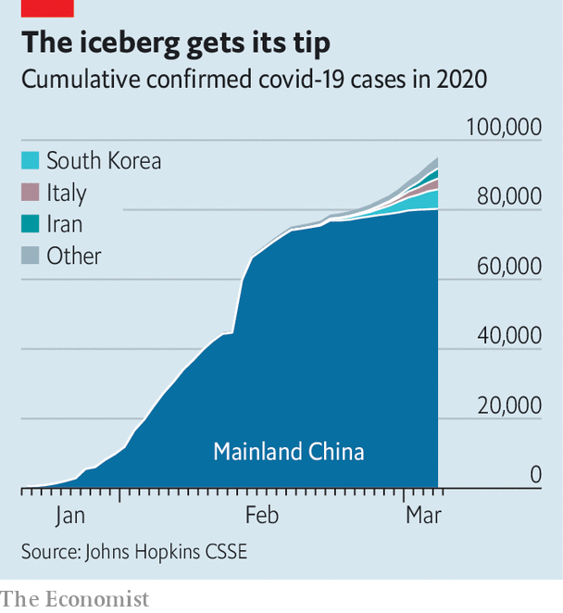

The WHO team urged all countries which have seen any cases to follow China in carrying out as much testing as they could, especially of unexplained pneumonia cases and flu-like symptoms in patients who seem not to be infected with the flu virus. “Test and you shall find,” says Gabriel Leung of the University of Hong Kong, who was also on the WHO team. “You either test and find it early, and do something about it, or the body bags are going to pile up,” he adds.

That dire warning has not yet born bitter fruit in under-tested America, but it could. As of March 4th, there were cases in 14 American states. Some of them, such as that of a New York lawyer and his family, have no obvious connection to any of the four high-incidence countries, strongly suggesting that there are what epidemiologists call silent chains of transmission in the country. In a population without measures in place to control such chains, a single undiagnosed case can, in principle, give rise to more than 3,000 cases six weeks later. On March 4th, while Mr Trump blamed his predecessor, Barack Obama, for the CDC’s problems, Andrew Cuomo, the governor of New York, revealed he had asked 1,000 people in Westchester, where the infected lawyer lives, to isolate themselves.

In South Korea, by contrast, the government is being forthright and formidably transparent, allowing Koreans to trace their possible brushes with the disease. As well as briefing the press thoroughly twice a day, and texting reporters details of every death, the government puts online a detailed record of each new patient’s movements over previous days and weeks, allowing people to choose to shun the places they visited. The risk of illicit activity being thus uncovered—at least one extramarital affair may have been—gives people an extra incentive to avoid exposure to a disease which, in most of the infected, results in only mild symptoms.

## No Roman candles

Across the country, schools are closed and public gatherings cancelled. Though neither Daegu nor Cheongdo, the cities which saw the first clustered outbreaks, were ever completely locked down, more than 9,000 people in Daegu were quarantined. As in China, where personal data from electronic payment and social media apps have been used by the authorities to track people’s movements and estimate their chances of infection, phones play a role in South Korea, too. The government has produced an app which reports on quarantined people’s movements and can alert authorities if they abscond. Officials call regularly to check in on people.

South Korea has powers that put very little weight on its citizens’ privacy; some aspects of its response might be hard to mount in other democracies. But in countries where there is a high level of trust in government, some strong measures will be supported. When SARS hit Toronto in 2003 only 23 of almost 30,000 people placed under quarantine refused to comply. Asked in a survey how serious a crime or misdemeanour they thought breaking quarantine was, half of Canadians ranked it as similar to manslaughter. In all the countries questioned about their attitudes to quarantine in an Ipsos MORI poll at the end of February, a majority said that they would back quarantines if the government called for them. In Canada, the majority was 78%, one of the largest seen. In Italy it was only 60%, the smallest.

That seems to reflect national levels of trust. Last June polling by the Wellcome Trust, a charity, found that 78% of Canadians said they trusted government health advice. In Germany and Britain the number was over 80% and in South Korea a remarkable 86%. In Italy it was just 63%; in America, worryingly, lower still at 59%. Italians will need to wait a bit to discover if their government’s response has deserved what trust they have accorded it. According to Walter Ricciardi, a leading public-health expert in Rome, it will take until the middle of March to know whether sealing towns with outbreaks off into two “red zones” has worked to slow the virus’s spread. It cannot be good news that over 400 cases have now been diagnosed in an area around the city of Bergamo, north of Milan. On March 4th the government announced it was closing schools and universities until March 15th.

If a quarantine is to enjoy public support, the people it shuts away need to be well looked after. Economically, those in Italy may be: the government has put aside €3.6bn ($4bn) to cover the epidemic’s costs. Some of it is earmarked to help exporters such as the doubly unlucky Erik Granzon. Not only is his fireworks company suffering the inconvenience of life in one of the two red zones; it also lost €300,000 last week when big displays were cancelled in Qatar and Milan so as to limit opportunities for further infection.

Some in the other red zone have more pressing problems. In a video posted to YouTube on March 3rd, Costantino Pesatori, the mayor of Castiglione d’Adda, a village of 4,650 inhabitants, said: “We feel truly alone. People are ill and are not receiving the necessary assistance. Help us please.” There are around 100 infections among the villagers; there have been 15 deaths. Mr Pesatori told The Economist that all three doctors in the village were in quarantine and a locum had “no gloves, no mask, no overalls—nothing to protect him.” He is begging the authorities to open consulting rooms at two local hospitals or send in army doctors.

A lack of supplies is being reported elsewhere in the red zones, too. In nearby Casalpusterlengo, Anna Rossi, a pharmacist, says she has no disinfectant gel to sell her customers, nor any masks capable of stopping contagion. On March 2nd a group of general practitioners wrote to the health minister in Rome that they too lacked protective equipment. “We want to stay at our patients’ sides,” they wrote. “But how can we do so effectively if we are not given the minimal means with which to defend them and defend ourselves?”

This looks like being a problem more widely. The WHO says the world’s health-care workers will need 89m medical masks a month to deal with covid-19. Because production is currently only about 70% of that there are shortages, and prices have gone up six-fold. Germany, Russia, Taiwan and Thailand have restricted exports of masks to protect their domestic supplies. China, which last year made half the world’s face masks, has not banned exports. But in practice they have, understandably, ground to a halt.

## Masks of sorrows

Production, though, has rocketed—as it could elsewhere, if politicians forced it to. According to the government, China is now making 116m face masks a day, 12 times the production a month ago, with 1.7m of them the high-performance sort that health-care workers need when faced with patients coughing and sneezing. A General Motors joint venture in south-western China is making both its own disposable face masks and face-mask-making machinery for the many other companies doing the same. There are no precise figures for the production of tests, but the number carried out suggests that it, too, has soared.

Some populations will not be able to afford to test at the necessary rates—or to hospitalise large numbers of patients. In Africa, which currently has very few cases, a big emphasis on tracking cases at this early stage in the epidemic could serve to limit the absolute number of infections, avoiding wherever possible the extensive community transmission that seems to have taken off in Iran. Bitter experience of other epidemics means that some African countries are well set up for this. Mr Ihekweazu’s teams go out to investigate a new disease outbreak of some sort almost every week with the help of SORMAS, an open-source data-logging app used by health workers.

That said, although covid-19 has become a major priority, it is not the overriding concern it could be. Mr Ihekweazu notes that Nigeria is currently experiencing the largest spike in Lassa fever cases it has ever seen; Africa also has a high burden of the world’s most deadly respiratory disease, tuberculosis. Most of Mr Ihekweazu’s team is focused on the new virus, but some remain ring-fenced for other areas “so that we don’t drop the ball.”

In places where the covid-19 ball is being dropped, or has been dropped already, the sort of self-isolation being urged in Westchester will be crucial to slowing the spread of the disease. In Britain statutory sick pay, normally not applicable until the fourth day of absence, will now be paid from the first to encourage people to stay at home if they think they need to. That said, the pay is not generous and does not cover the lowest paid.

In America both the health-care system and paid-leave laws are poorly configured for epidemics. Public-health authority is mostly devolved to state and city health agencies, creating a patchwork system of control. Preparedness, funding and sophistication all vary by county and hospitals, meaning that response and care could become uneven.

The patchwork system could be especially problematic if it leads to sick people showing up to work when they should not. Few lower-income workers in service-sector jobs have the option of paid sick leave available to them. The prospect of lost wages—and potentially a lost job—could be enough to persuade them to attend work rather than stay at home feeling a bit ill but increasingly poor. A study of paid sick-leave mandates in America by Stefan Pichler and Nicholas Ziebarth, two economists, found that the policy reduced the spread of influenza by 5% in normal times and 40% during a wave. Assuming that covid-19 is comparable, that calculation suggests that the 39 states that do not require paid sick leave risk a worsened crisis.

The second big problem is that, because pandemic preparedness is not generally billable, American hospitals do not keep spare infectious-disease capacity. “We’re already running our health-care systems razor-thin in terms of capacity. There’s very little excess capacity in people, beds...or protective equipment,” says Michael Osterholm, an infectious-disease specialist at the University of Minnesota. A lack of preparedness has already forced the quarantine of 124 staff because of a single patient in California.

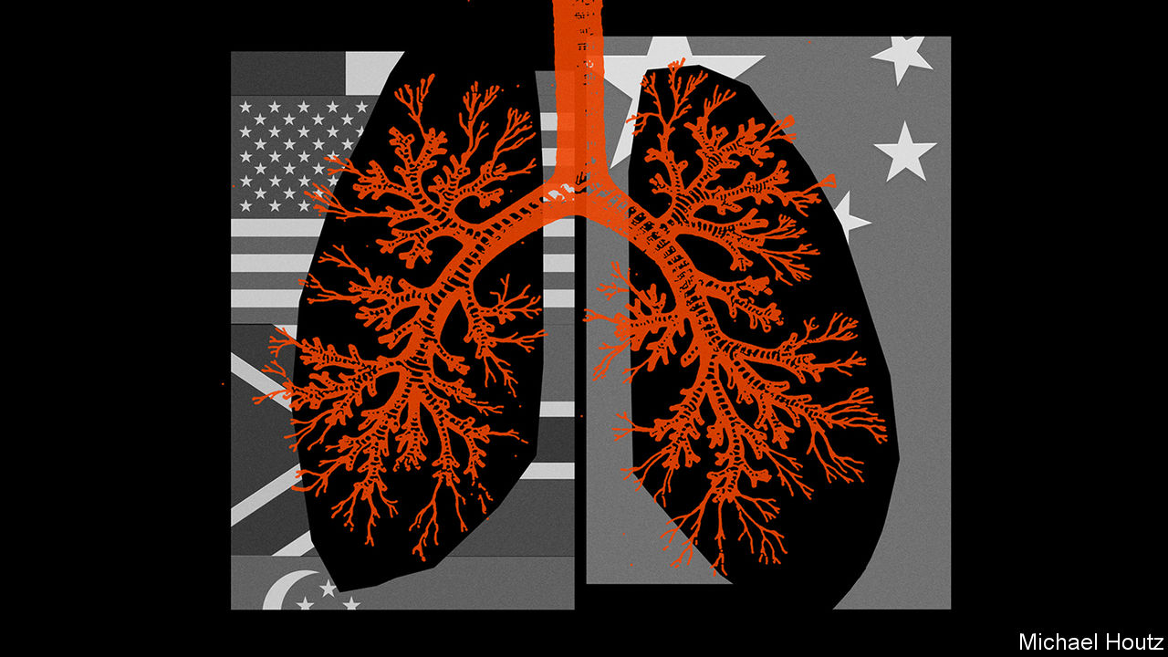

At the patient level, the costs of medical testing and treatment could act as a hindrance to effective containment. There are already widely circulating reports of worried patients showing up to emergency rooms for testing who are leaving with medical bills for thousands of dollars. More than a quarter of the 28m uninsured Americans say they have put off medical care they cannot afford. The Trump administration is said to be considering routing disaster-relief funds towards reimbursing the uninsured, which would ease things. The implications for the un- and under-insured of the $8.3bn “supplemental appropriation” passed by the House on March 4th are not clear.

## Pay attention

Not all countries can be as well prepared as Singapore: rich enough to pledge S$5.6bn ($4bn)—as much as Italy—to blunt the disease’s economic impacts, well organised enough to enforce pretty strict measures and shaken by SARS into taking such things seriously. Yet Lee Hsien Loong, the prime minister, still worried in February that the costs would eclipse those of SARS. Lawrence Wong, co-chair of the ministerial task force on covid-19, warns that “all it takes is one incident, one event, and there is a sharp spike in cases and sustained transmission.” Everyone has things to learn. Some have more than others. ■

This article was downloaded by calibre from <https://www.economist.com/briefing/2020/03/05/what-the-world-has-learned-about-facing-covid-19>

|  |  |  |  |
| --- | --- | --- | --- |
|  | Articles | Sections | Next |

|  |  |  |
| --- | --- | --- |
| Briefing | Sections | The Americas |

United States

After Super Tuesday: Look at Joe go

.

News from China: Quid pro quo

.

Lori Lightfoot: Policing poverty

.

Donald Trump’s record: The toolkit

.

Household budgets: The price is wrong

.

Lexington: Legends of the slaughter

.

|  |  |  |
| --- | --- | --- |
| Briefing | Sections | The Americas |

|  |  |  |  |
| --- | --- | --- | --- |
|  | Articles | Sections | Next |

#### After Super Tuesday

# Joe Biden has pulled off one of the great political comebacks

The former vice-president has run a lousy campaign. He will likely be the Democratic nominee anyway

Mar 5th 2020 | BOSTON AND HOUSTON

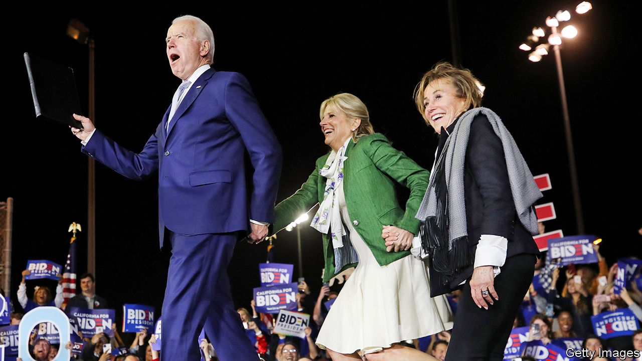

Editor’s note (March 5th 2020): This article has been updated to note that Elizabeth Warren has ended her candidacy.

ONLY A FEW days ago the Democratic primary looked like a re-run of the 2016 Republican contest that launched Donald Trump. The field was crowded and had no clear establishment favourite. The chief contenders for that role—Joe Biden, Mike Bloomberg, Pete Buttigieg and Amy Klobuchar—were ripping into one another while cannibalising the moderate vote. This had created an opportunity for Bernie Sanders, a left-winger with a small but loyal base, to follow the Trump tactics: by turning a series of modest pluralities into an insurmountable delegate lead. Mr Sanders had won or tied the first three states and was predicted to win many more on Super Tuesday, March 3rd. The primary has instead been turned on its head.

A thumping win for Mr Biden in South Carolina on February 29th persuaded Mr Buttigieg and Ms Klobuchar to bow out and endorse him. Three days after bagging his first ever state—during his third presidential campaign—the 77-year-old former vice-president then went on a stunning tear through the Super Tuesday states. He won ten in all, from Maine in the north to mighty Texas in the south. He won states where he had not campaigned or even advertised: including Massachusetts, where he had spent a mere $11,000, assuming it would pick Mr Sanders or another leftist, Elizabeth Warren, the local senator. Mr Sanders won only three states, including his own tiny Vermont. And though as The Economist went to press, he was also leading in California, the biggest prize of all, Mr Biden was running him close enough to be assured of a big chunk of its 415 delegates.

Neither Ms Warren nor Mr Bloomberg, the only other serious candidates remaining, won a state. The contest no longer resembles the Republican primary in 2016 but rather the Democratic one of that year. Mr Biden and Mr Sanders are locked in a two-man race, to bag states and collect delegates, that the left-winger’s smaller faction means he may struggle to win.

The obvious reason for Mr Biden’s unpredicted success is that a huge number of late deciders broke for him. Exit polls from ten states suggest he won more than 40% of them everywhere apart from Vermont; Mr Sanders won far fewer. But why did this happen? Mr Sanders and his supporters detect an establishment plot. They always do. Though, to be fair to them, the sudden way Mr Buttigieg, Ms Klobuchar and other elected Democrats folded behind Mr Biden, despite justified doubts about his age, speed of thought and ability to enthuse voters, does suggest a degree of co-ordination. Yet that would be only a partial explanation for Mr Biden’s amazing turnaround.

The main reason was black voters: the biggest, most moderate and active part of the Democratic coalition. Hardly present in the early states, they predominate in South Carolina, where they took a deep breath and backed Mr Biden by a huge margin. Exit polls suggest that 56% of black voters followed suit on Super Tuesday. Asked why she had voted for Mr Biden, a black woman emerging from a polling station in Houston, offered a familiar explanation: “He was vice-president with Barack Obama and they did a good job.” Whether in reward for his loyalty to the first black president, or by simple process of elimination, black voters thus swept away the taint of failure that had hitherto clung to Mr Biden.

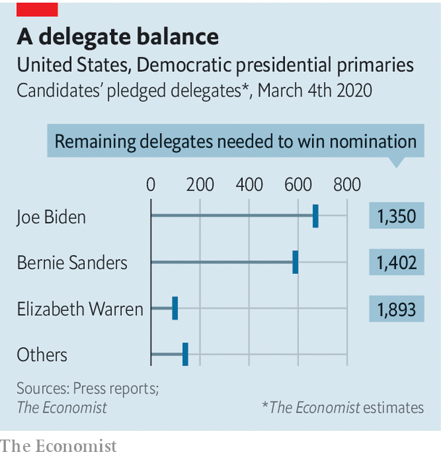

His endorsement by Mr Buttigieg and Ms Klobuchar, who have seen him up close, also helped—especially in Ms Klobuchar’s state of Minnesota, where he thereby pulled off another surprise victory. And Mr Biden also enjoyed a few breaks, including the woeful recent debate performances of his main rival, Mr Bloomberg, who entered the primary on Super Tuesday and quit it the following day. Mr Sanders entered the multi-state contest rather tarnished, too—his brief spell as the front-runner having drawn unprecedented attention to his history of praising some of the achievements of Fidel Castro’s Cuba. The Democratic establishment had no say in most of that. It was merely one among the several factors that made Mr Biden, a widely discounted former front-runner, seem suddenly more plausible as a third of Democratic voters were about to have their say.

According to our analysis of states that have reported, as well as estimates for California, Mr Biden now has roughly 671 of the 1,991 delegates he would need for the nomination. Mr Sanders has 589. (Ms Warren, with only 89, dropped out of the race on Thursday). That leaves plenty of room for doubt about which septuagenarian will prevail. Yet Mr Biden has demonstrated his advantage. While Mr Sanders mainly won votes from his usual fanbase—made up of white lefties, young voters and Hispanics—the former veep drew support from across the party. For example, he also did well in the sorts of affluent, mostly white suburbs that gave Democrats their House majority in 2018 and where they would need to win again to defeat Mr Trump in November. In Virginia, for example, where he beat Mr Sanders by 30 points, he ran up sizeable margins in both the heavily black Tidewater region and in the diverse, highly educated suburbs of Washington, DC.

Even more tantalising for hopeful Democrats, the former vice-president also notched up some unexpected wins in places that used to back them but have recently shifted towards the Republicans. Maine and Minnesota provided examples of that; there were even reports of Republican voters in Alabama requesting Democratic ballots in order to back Mr Biden. Exit polls showed him doing best with older and more moderate voters. Mr Sanders did far better with younger voters, which looks like a long-term problem for Mr Biden, if not necessarily a crippling one, given how few of them vote.

That the diverse Democratic starting-field has been winnowed down to two white-haired white men is depressing to some Democrats. Yet politically, at least, Mr Biden and Mr Sanders are miles apart. The former vice-president, who is also a veteran of 36 years in the Senate, is a devoted institutionalist. Mr Sanders is calling for a political revolution that would up-end many aspects of American life.

The senator from Vermont wants to ban private health insurance and create a single-payer system free at the point of service. Mr Biden would prefer to preserve the Affordable Care Act, better known as Obamacare, and augment it by creating a public option for health insurance.

Mr Sanders would spend an incredible $16trn on his Green New Deal, including, among other things, a federal jobs-guarantee. Mr Biden also has a bold climate plan, requiring $1.7trn in new federal spending. But its entire size is less than what Mr Sanders would spend replacing petrol- and diesel-powered cars with electric vehicles.



Rather than decriminalise illegal border crossings, as Mr Sanders wants to, Mr Biden would try to create a pathway to citizenship for undocumented immigrants already in America. Both agree on the necessity of undoing much of President Donald Trump’s legacy, particularly his immigration restrictions and deconstruction of health care and environmental provisions. Both would resubscribe to the Paris agreement and the nuclear deal with Iran.

Mr Biden’s critics on the left have dismissed his platform as Hillary Clinton’s warmed up. In fact, he is running to the left of her and Mr Obama. He supports a $15-an-hour minimum wage, and, channelling Mr Sanders a bit, talks of launching a “clean-energy revolution”. He has pledged to “impose carbon-adjustment fees or quotas on carbon-intensive goods from countries that are failing to meet their climate and environmental obligations”, and is more comfortable with renewable-energy standards than with carbon pricing, to help achieve emissions reductions. On foreign policy, he is less of a liberal interventionist abroad than Ms Clinton was—though he is not quite as inclined to isolationism as is Mr Sanders.

How much of either candidate’s platform could be enacted is doubtful, given how hard it will be for the Democrats to take back the Senate in November. Yet Mr Biden’s proposals appear at least to have achieved their political aim of being broadly acceptable. The same could be said of his candidacy in general.

He could yet stumble. Despite a couple of good victory speeches, by his rambling standards, Mr Biden’s weakness as a campaigner is manifest. To observe his look of mounting puzzlement, as his own sentences meander uncontrollably, can be a disconcerting experience. Yet, in the absence of a standout performer to rally their party’s divergent quarters, Democrats appear to have settled on Mr Biden as their likeliest unifier. That largely reflects his personal qualities, including his reputed kindliness, loyalty to Mr Obama and well-known forbearance in the face of personal tragedies—including the death of a wife and two children. This has marked him as a person of quality. “He’s been there,” said a weary-looking voter wearing hospital scrubs in Houston. “I trust him.”

He may not stage huge rallies like Mr Sanders, and may be less thrilling to his supporters, but Mr Biden’s reputation for steadiness and decency in public life may be enough. They are attributes Americans miss. It is also notable that he did especially well on Super Tuesday with voters whose main priority is to get rid of Mr Trump.■

Dig deeper:

* Sign up and listen to Checks and Balance, our new [newsletter](https://www.economist.com/checksandbalance/) and [podcast](https://www.economist.com/podcasts/2020/02/21/checks-and-balance-our-new-weekly-podcast-on-american-politics) on American politics
* [Explore our guide](https://www.economist.com/united-states/2020/02/26/the-economists-guide-to-the-us-2020-elections) to the US 2020 elections

This article was downloaded by calibre from <https://www.economist.com/united-states/2020/03/05/joe-biden-has-pulled-off-one-of-the-great-political-comebacks>

|  |  |  |  |
| --- | --- | --- | --- |
|  | Articles | Sections | Next |

|  |  |  |  |
| --- | --- | --- | --- |
| Previous | Articles | Sections | Next |

#### Quid pro quo

# The White House kicks out journalists working for China’s state media

But is a retaliation against a country that does not value a free press a good idea?

Mar 7th 2020 | NEW YORK



FIFTY YEARS ago a New York correspondent for Pravda, the mouthpiece of the Soviet Communist Party, was expelled. This was in retaliation for the expulsion from Moscow of a correspondent for Time magazine, after a cover story that had displeased the Politburo. Months later a Newsweek reporter was expelled from Moscow. America retaliated by kicking out a correspondent for Tass, the Soviet news agency. The American government has not played this game since the cold war, but it is resuming now, with a different adversary.

On March 2nd, less than two weeks after China expelled three journalists for the Wall Street Journal, the State Department announced that it was placing a cap of 100 on the number of Chinese citizens who could be employed in America for five state- and Communist Party-owned media organisations—a reduction from their current total of 160. The cap, effective from March 13th, means that up to 60 Chinese nationals will be forced to leave, a diplomatic swipe that adds a new tension to the relationship.

China’s ejection of the reporters came a day after the Trump administration designated the five state- and party-owned media outlets as foreign missions of the Chinese government, to reflect their function as propaganda instruments, officials said, as opposed to independent news organisations. The five are: Xinhua, CGTN, China Daily, China Radio International and the distribution arm of People’s Daily, the party’s mouthpiece.

Administration officials said the visa caps were meant to establish “more reciprocity” with China in how the countries treat journalists. (American news organisations in mainland China employ about 75 non-Chinese citizens, including Americans.) They argued that Chinese state media employees in the United States still operate unencumbered, working and publishing as they (or their employers) please, while American journalists in China face harassment, intimidation and the threat of expulsion.

The expulsion of the Wall Street Journal reporters putatively came as punishment for a headline in the newspaper’s opinion pages that described China as the “sick man of Asia”. But the reporters had also displeased authorities in Beijing by working on stories related to Xi Jinping, China’s president, and the internment in Xinjiang of more than 1m people, mostly Uighur Muslims. The Foreign Correspondents’ Club of China, in a survey published on March 2nd, said that since 2013 the Chinese government has expelled or declined to renew visas for nine reporters and imposed tighter leashes on foreign journalists in the form of short-term visas that must be renewed frequently. More than 80% of foreign correspondents surveyed said they had encountered “interference, harassment or violence” while working.

China hawks have long advocated retaliation against state media operating in America. Some have suggested the administration’s actions do not go far enough in sending a message to Beijing. President Donald Trump could threaten to blunt China’s propaganda drive in America more directly, by taking aim at the broadcasts of CGTN, or at the practice of paying for China Daily’s reports to be published as inserts into American newspapers. That would accord with the Trump administration’s argument that the Chinese employees affected are not “journalists” but propaganda workers, like those for Pravda and Tass.

Press-freedom advocates have argued that instead America should set an example, as an open society. Raising the cost to China, albeit marginally, of treating foreign journalists poorly, may seem like a good idea. The problem for America is that, when playing this game, the side that cares about press freedom is at a disadvantage to the one that does not. On March 3rd Hua Chunying, spokeswoman for the foreign ministry, intimated in a tweet that “reciprocity” would mean tougher visa restrictions for America’s media, perhaps including single-entry visas that force journalists to reapply for entry every time they leave the country. “Now the US kicked off the game,” she wrote, “let’s play.”■

This article was downloaded by calibre from <https://www.economist.com/united-states/2020/03/07/the-white-house-kicks-out-journalists-working-for-chinas-state-media>

|  |  |  |  |
| --- | --- | --- | --- |
| Previous | Articles | Sections | Next |

|  |  |  |  |
| --- | --- | --- | --- |
| Previous | Articles | Sections | Next |

#### Policing poverty

# Chicago’s mayor thinks she has a plan to end poverty in a generation

The city’s changing demographics make Lori Lightfoot’s job harder

Mar 7th 2020 | CHICAGO

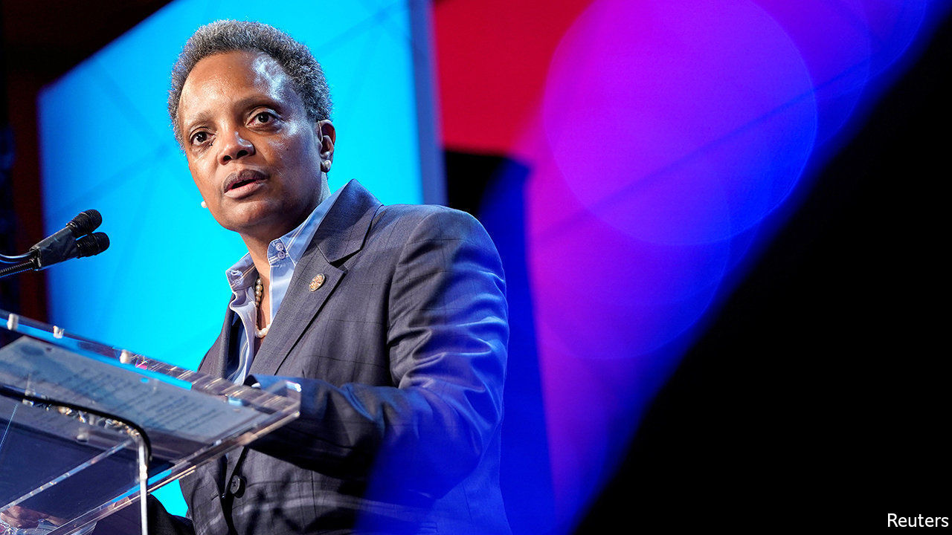

BLACK FAMILIES on Chicago’s South and West Sides have long endured joblessness, decrepit housing and violence. Lori Lightfoot, the city’s mayor for the past nine months, has made cutting poverty her main goal. Like the rest of the country, the city is doing well on this score: the poverty rate for Afrian-Americans and Hispanics has been creeping down, though that has more to do with low unemployment and decent wage growth than with City Hall.

Ms Lightfoot, who grew up poor in Ohio, speaks personally about privation. Her childhood taught her “what hardship and financial struggle was all about”. Though her father had three jobs, the family saw cars repossessed and services cut off for unpaid bills. She put herself through college and studied law. Her first summer job paid more than her father had ever earned. She was too embarrassed to tell him.

This sort of story is still common in Chicago. In its public schools 76% of students qualify for free meals because of low incomes. When classes end, many do without nutritious food. Life-expectancy can vary by as much as 15 years between neighbouring areas on the South Side. Ms Lightfoot points out that Cook County, which includes the Windy City, has the highest rate of personal bankruptcies in Illinois—often because people owe debts to the city.

Ms Lightfoot traces inequality’s roots in America to the “original sin of slavery”, and blames government for keeping black families down. She cites redlining, a practice of city governments and mortgage-lenders to determine which neighbourhoods African-Americans were allowed to live in, and the de facto segregation of black children at school. A mayor cannot do much about that history, and in any case many of her plans are small-bore. She will start by scrapping city fines and fees that burden the poor especially—as a small example, libraries no longer charge for overdue books. She wants more rights for tenants and the end of regulations that take away drivers’ licences for petty infractions, because losing a car often means losing a job.

She promises an extra $750m over the next three years to spruce up roads, parks and public transport in ten corridors running through needy districts. Philanthropists and foundations will be tapped for help. She will also expand a financial model that diverts some capital from firms building offices and skyscrapers downtown to boost small businesses in poor areas. Rahm Emanuel, her predecessor, launched that scheme in 2017 and says it will soon be worth $170m.

One of Ms Lightfoot’s plans is genuinely radical, however. Citing the “outrageous amounts of money that we spend on a criminal-justice infrastructure that is mostly punitive”—over $1.7bn a year for policing—she wants to switch spending to social and economic needs. Broken families, poor care for children and overall deprivation are the deepest causes of violent crime, she argues. Spending on mental-health care, she says, could do more to curb crime than paying for lots of arrests.

None of that will be easy. The wealthy voters who swept Ms Lightfoot to office last year could grow jittery if cuts to police are followed by a spike in violent crime. More important, the Chicagoans most affected by violence are the city’s poorest residents, whom Ms Lightfoot wants to help. She risks a sour relationship with the police after sacking their superintendent for ethical lapses in December. Her separate plans to tackle corruption leave some long-serving city aldermen uneasy. And her record as a negotiator has yet to be proved after Chicago’s teachers won big payouts from her last year, after a lengthy strike.

Ms Lightfoot’s aspiration to “end poverty in a generation” has a further glitch. The poverty statistics are skewed by a decades-long collapse in the black population. Since 2010 the city has seen a net loss of 70,000 black residents, who fled to the suburbs, next-door Indiana or southern cities like Atlanta. Part of the decline in poverty simply reflects the fact that there are just fewer poor African-Americans in Chicago now. Yet some of those left behind are too poor to move, making the poverty that remains even more intractable.■

This article was downloaded by calibre from <https://www.economist.com/united-states/2020/03/07/chicagos-mayor-thinks-she-has-a-plan-to-end-poverty-in-a-generation>

|  |  |  |  |
| --- | --- | --- | --- |
| Previous | Articles | Sections | Next |

|  |  |  |  |
| --- | --- | --- | --- |
| Previous | Articles | Sections | Next |

#### Assessing the president

# Donald Trump’s toolkit

How the president has used OMB, an obscure but important federal agency

Mar 7th 2020 | WASHINGTON, DC

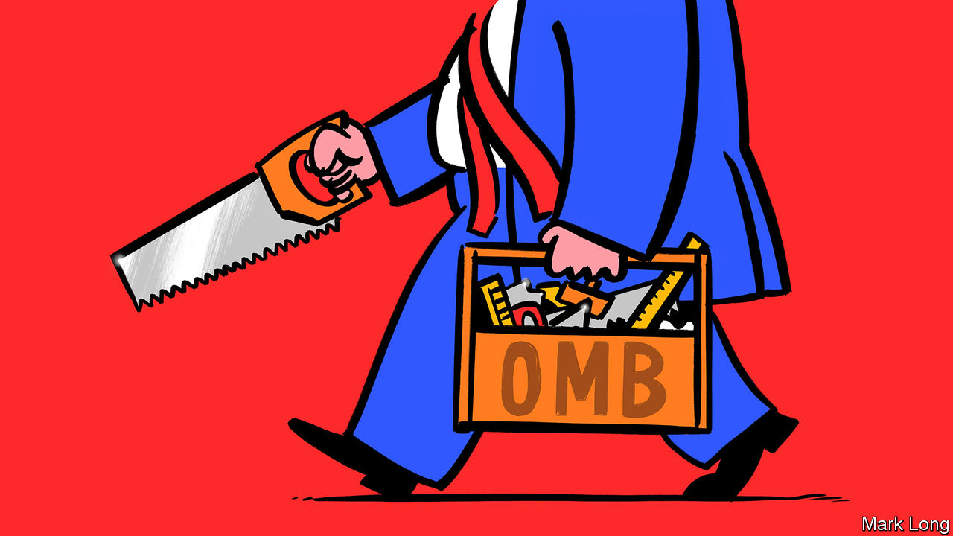

AMERICA’S GOVERNMENT, as all its citizens learn at school, comprises three branches: executive, legislative and judicial. At the top of the executive branch sits the actual executive—the president. But the branch also includes an array of agencies, both the departments represented in the cabinet, and others—including the National Security Council and the Council of Economic Advisers—that make up the Executive Office of the President (EOP). These agencies advise on and implement presidential policy. Most of the EOP gets repopulated with a change in administration, as it should: new presidents have new policy agendas, which require new personnel.

The exception to that rule is the EOP’s biggest office: the Office of Management and Budget (OMB). Most of its 500-odd employees are career civil servants who take pride in providing nonpartisan advice to presidents of both parties. In 1921 Charles Dawes, the first head of the OMB’s predecessor agency, the Bureau of the Budget, explained that if Congress “passed a law that garbage should be put on the White House steps, it would be our regrettable duty, as a bureau, in an impartial, nonpolitical and nonpartisan way, to advise the executive and Congress as to how the largest amount of garbage could be spread in the most expeditious and economical manner.” Russell Vought, the OMB’s acting director, calls his office “the president’s Swiss army knife”. It has been central to Donald Trump’s efforts to loosen environmental regulations and to cut budgets. It also played a role in the Ukraine scandal.

When Congress refused to appropriate adequate funds for Mr Trump’s border wall, OMB found it. When the government shut down in 2018-19, the OMB found ways for the Internal Revenue Service to send out tax refunds, and for the Department of Agriculture to provide food stamps. The OMB’s job is to understand the mechanics of federal-government operations, and explain to the president and his staff how to get things done. Its titular head is Mick Mulvaney, who is also the president’s chief of staff, but Mr Vought, a former Hill staffer and vice-president of Heritage Action, a conservative policy-advocacy group, has operational control.

The OMB staff often have backgrounds in law or public policy, and tend to like their work: for the past five years, the OMB has ranked in the top quartile of small federal agencies in the Partnership for Public Service’s “Best Places to Work in the Federal Government” survey. (It had dipped early in the Obama administration; Peter Orszag, Mr Obama’s first OMB director, was widely disliked.) One senior official in a previous administration praised the office’s civil servants: “I thought they were just so good, so knowledgeable. They were stubbornish about making clear what they thought, but they also did a lot of, ‘Well, if you want to do that stupid thing, here’s how you do it’.”

As the B in the office’s name suggests, one of OMB’s chief duties is to write the president’s annual budget, in consultation with agencies from across the federal government. Because Congress, not the executive, appropriates funds, the president’s budget is an expression of wishes, not an allocation of funds. To translate the president’s policy priorities into budgetary terms, the OMB’s Resource Management Offices (RMOs), organised by broad oversight areas, weigh competing interests from different parts of government. For the Trump administration, that meant proposing a 27% cut in the funding of the Environmental Protection Agency and a 21% cut in the State Department this year.

Another duty, as the M suggests, is managerial. Once a budget passes—or, as has grown increasingly common, there is a continuing resolution, that merely keeps current funding levels constant—the OMB advises and evaluates agency performance. The OMB also oversees a range of federal functions, including procurement, IT, personnel and financial management.

Within the OMB sits the Office of Information and Regulatory Affairs (OIRA). OIRA reviews agencies’ proposed regulatory changes, ensuring that benefits outweigh costs, and, for new regulations, that agencies have fully considered non-regulatory alternatives to achieve their stated goals.

OIRA has been central to Mr Trump’s deregulatory effort. Just days after his inauguration, the president issued an executive order requiring two regulations to be repealed for every new one introduced. In October his administration estimated that it had actually cut eight and a half regulations for every new one. Some take issue with how Mr Trump’s OIRA conducts cost-benefit analysis of these regulations. Richard Revesz of NYU Law School argues that in its deregulatory zeal, the Trump administration has “made a mockery of cost-benefit analysis [by] weighing broader indirect costs [of regulation], and insisting on ignoring any indirect benefits”. In delaying Obama-era environmental regulations, for instance, he argues that the administration has ignored or downplayed unquantified benefits, such as long-term improvements to air and water quality, while overstating the costs of compliance to industry.

In its keenness to deregulate, OIRA has sometimes got in its own way. According to the Institute for Policy Integrity, a think-tank, the administration has won just five of the 71 court challenges it has faced over deregulation and other agency policy.

Although Mr Vought says morale at the OMB remains healthy, one recently retired veteran demurs. “Career staff were asked […] give us options to do X. They would lay out a range of options,” including ones they thought would be extreme enough to be “a non-starter”, and “usually they chose the non-starter”. The department has also become unusually high-profile for the wrong reasons: it was the OMB’s associate director for national security programmes, Michael Duffey, who told the Pentagon that there was “clear direction from POTUS to continue to hold” military aid to Ukraine.

In January the Government Accountability Office (GAO), a non-partisan auditor, found that this action violated federal law. Mr Vought disputes that: he believes that the OMB had the right to delay funding, and that the GAO’s analysis stems partly from partisan animus (the GAO answers to Congress rather than the president). He also notes that the White House has delayed other tranches of foreign aid, such as to Pakistan and Gaza, over policy concerns.

When not getting rid of regulations and holding up military aid to allies, the OMB has been doing the sort of good-government things it might have done under any administration, streamlining the federal grantmaking process or implementing a law which encourages government to use data better when drafting policy. Another ex-employee says he is “impressed with people’s ability to continue to do their job even when the interest in a fair process isn’t being respected by the leadership of the administration.” Which is about as pejorative as a retired civil servant can be. ■

Dig deeper:

* Sign up and listen to Checks and Balance, our new [newsletter](https://www.economist.com/checksandbalance/) and [podcast](https://www.economist.com/podcasts/2020/02/21/checks-and-balance-our-new-weekly-podcast-on-american-politics) on American politics
* [Explore our guide](https://www.economist.com/united-states/2020/02/26/the-economists-guide-to-the-us-2020-elections) to the US 2020 elections

This article was downloaded by calibre from <https://www.economist.com/united-states/2020/03/07/donald-trumps-toolkit>

|  |  |  |  |
| --- | --- | --- | --- |
| Previous | Articles | Sections | Next |

|  |  |  |  |
| --- | --- | --- | --- |
| Previous | Articles | Sections | Next |

#### The price is wrong

# What one game show reveals about the American economy

Why have contestants on “The Price is Right” become so much worse at guessing?

Mar 7th 2020 | SAN FRANCISCO

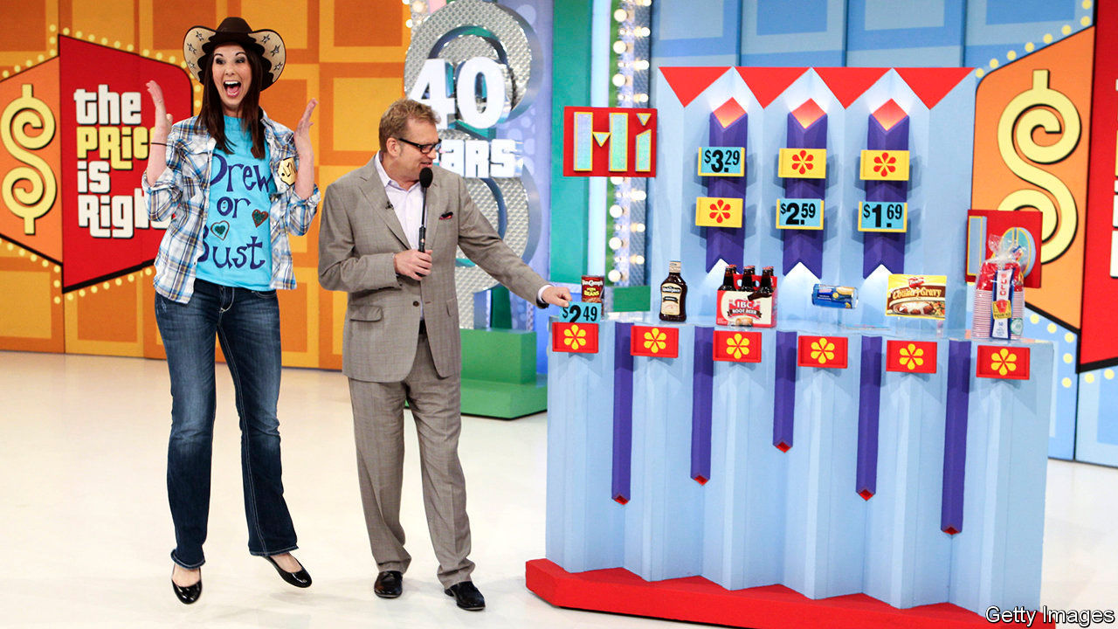

SINCE 1972 Americans have sat through more than 9,000 episodes of “The Price is Right”, a game show with an economic twist. After being summoned from the audience by the famous catchphrase—“come on down”—contestants must guess the exact price of prizes, ranging from guitars to garden furniture. If they bid too high, they are disqualified. In a recent paper Jonathan Hartley of Harvard’s Kennedy School points out an interesting trend. Contestants have got a lot worse at guessing prices (see chart).

Technology may play a role. Reaching for a smartphone is easier than recalling a fact from memory. Who remembers phone numbers anymore? People may just fall out of the habit of recalling prices. Still, the rise of the smartphone is a recent phenomenon—it cannot explain why contestants became worse guessers during the 1970s, 1980s and 1990s.

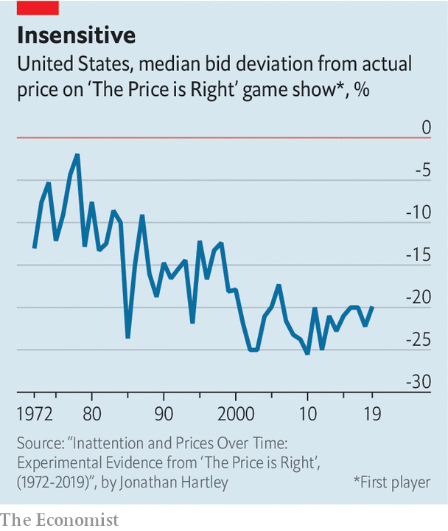

Economic changes may be a better explanation. A paper published in 2001 suggested that higher GDP growth raised “price-recall error”. Like the proverbial politician who thinks a gallon of milk costs $15, as people get richer they worry less about budgeting. (Contestants guessed a bit better after 2010, when GDP growth was weak and budgets tight.) A related trend is that Americans devote a shrinking share of their household spending to goods—which tend to appear on “The Price is Right”—and a rising share to services, such as dining and child care, which do not. Contestants might be pretty good at guessing the price of a spin class or a babysitter.

Perhaps the most intriguing explanation, however, relates to globalisation. In the early 1970s consumers had a relatively limited selection of products to choose from. Around the time that “The Price is Right” first aired, Sears catalogues were hundreds of pages long. But a search on Amazon brings up nearly 1,000 results just for the word “toaster”. Firms offer a huge range of differentiated products at wildly different prices, allowing consumers to satisfy their peculiar wants. The upshot is that guessing prices is trickier. What is the price of a shovel, for which there were more than 10,000 results on Amazon?

The rise of online shopping adds further confusion. Online retailers use algorithms to respond instantly to fluctuations in supply and demand. Alberto Cavallo of Harvard Business School finds that some large retailers now change their prices, both upwards and downwards, twice as frequently as they did a decade ago. All of which suggests that contestants’ guesses may yet get worse.

This article was downloaded by calibre from <https://www.economist.com/united-states/2020/03/07/what-one-game-show-reveals-about-the-american-economy>

|  |  |  |  |
| --- | --- | --- | --- |
| Previous | Articles | Sections | Next |

|  |  |  |  |
| --- | --- | --- | --- |
| Previous | Articles | Sections | Next |

#### Lexington

# Talking about a revolution

The Boston massacre, which took place 250 years ago this week, is heroically misrepresented

Mar 7th 2020 |

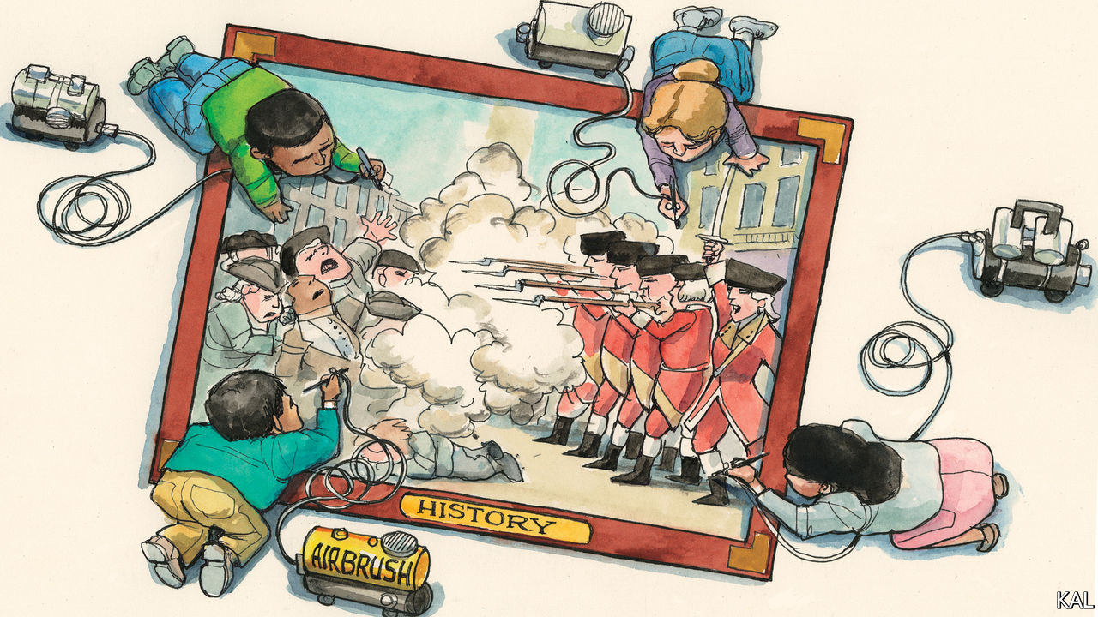

ON AN ICY late evening in Boston, on March 5th 1770, an angry mob advanced on a dozen redcoats standing outside the city’s customs building. Ignoring the pleas of the British officer present, Captain Thomas Preston, the Bostonians hurled razor-edged oyster shells and blocks of wood and ice in the darkness, knocking one soldier off his feet. He fired back, prompting several others to do likewise before Preston, despite having been clubbed in the mêlée, ordered them to stop. The soldiers retired, leaving three men dead in the snow and several wounded, two of whom died shortly after.

To ascertain what had gone wrong and who was to blame for the “bloody massacre”, there followed the most forensic series of investigations of the colonial period. It led to and included the trials of Preston and eight of his men for murder, at which scores of eye witnesses were cross-examined by the sharpest legal minds. The defence team for the soldiers included John Adams, a future president, and called 52 witnesses. The testimonies were contradictory. Some claimed Preston had ordered the soldiers to shoot. Most described the British retaliating under severe provocation; given the noise, darkness and confusion it was hard to be sure of anything.

Two of the redcoats were convicted of manslaughter and had the letter M seared into their thumbs. The rest were acquitted. “Facts are stubborn things…whatever may be our wishes, our inclinations, or the dictates of our passions,” said Adams in his defence of the soldiers.” In a later diary entry, displayed in a fine anniversary exhibition at the Massachusetts Historical Society, he determined that “the verdict of the jury was exactly right”.

That is not a view with which many of those who gather to watch Boston’s annual re-enactment of the riot this week would concur. An idea of the massacre as an act of imperialist terror which provoked the crisis, five years later, after which this column is named is one of America’s most popular historical myths. This reflects a disinformation campaign that began directly after the violence and has continued, one way or another, ever since. At a time when the political use of history is proving especially contentious—following the impeachment row and another over the New York Times’s 1619 Project, which aims to reframe the American story around racism—the Boston Massacre is an instructive example.

Bostonians’ antipathy towards the 2,000 British troops sent to the city in 1768 has also been exaggerated. A new book by Serena Zabin documents many family ties between the armed forces and civilian population (it helped that Boston had a surfeit of women). Nonetheless, the garrison offended the libertarian zeal of the Bostonian elite, whose members duly seized on the riot for propaganda value. A cartoon engraved by Paul Revere depicted the redcoats as sneering killers, Preston as their apish cheerleader and the customs office as “Butcher’s Hall”. An annual Massacre oration—the precursor of this week’s re-enactment—was launched a few months after the redcoats’ acquittal. Adams declined to give the third oration on the spurious ground of old age (he was 37). Yet he had in a way facilitated this burgeoning distortion through his own economy with the truth. He had taken pains to absolve regular Bostonians of any blame for the violence, instead attributing it to “a motley rabble of saucy boys, negroes and molattoes, Irish teagues”. Based on sketchy evidence, he blamed one of the victims, a black sailor called Crispus Attucks, in particular.

This had unforeseen consequences. Eighty years later Attucks was embraced by black abolitionists in Boston as the “first martyr of the American revolution”. When it was put to them that the riot was not the revolution and there was scant evidence for Attucks’s lead role, they had only to cite Boston’s orations and Adams’s defence. A Bostonian paramilitary group, precursor to black units in the Union army, was called the Attucks Guards. A grand monument to Attucks was raised in Boston Common in 1888. Dedicating it, the Irish nationalist poet John Boyle O’Reilly tied Attucks to freedom struggles everywhere: “We honour a shrine unfinished, a column uncapped with pride…when Crispus Attucks died.”

Attucks remains popular with black activists. In the civil-rights era, schools were named after him. Recent victims of police brutality and the group they inspired, Black Lives Matter, have been compared to him. White activists also recall the massacre. During its re-enactment in 1975, protesters against Massachusetts’s then policy of busing black children to affluent schools collapsed in the street—to assert that they were also victims of tyranny.

This saga holds several lessons. Libertarian ideals were the intellectual basis for the revolutionary struggle, yet a distorting lens through which to understand almost any isolated episode of it. Their epic force (illustrated in the massacre’s early commemorations: the 1775 oration was delivered by Joseph Warren, months before his death at Bunker Hill, in a toga) proved irresistible from the start, however. This politicising of events has in turn fuelled a rich American tradition of mobilising history to score points.

## All I want for Crispus

The Times’s 1619 Project (named after the year Africans were first brought to North America) is not only a corrective to that tradition, but part of it. It has been criticised for being partial and containing inaccuracies. It also downplays the contribution of African-Americans to America’s struggle to live up to the founders’ vision; and the inspiration many of them have found in it. African-Americans were participants in the Boston Massacre and, in one of the first states to restrict and then abolish slavery, beneficiaries of the events it helped set in train. In the figure of Attucks, they also found an unlikely inspiration in massacre propaganda.

Sticklers for historical accuracy have much to complain of here. Yet the incontestable fact of the massacre offers consolation. In 18th-century Boston, justice and the rule of law prevailed over politics and the mob. Perhaps even more than ideas of freedom, they are America’s foundation. May Adams’s successors remember it.■

This article was downloaded by calibre from <https://www.economist.com/united-states/2020/03/07/talking-about-a-revolution>

|  |  |  |  |
| --- | --- | --- | --- |
| Previous | Articles | Sections | Next |

|  |  |  |
| --- | --- | --- |
| United States | Sections | Asia |

The Americas

Feminism in Mexico: The violet tide

.

Crime in Latin America: Special victims

.

Surfing in Brazil: The big break

.

Bello: Happily after Evo?

.

|  |  |  |
| --- | --- | --- |
| United States | Sections | Asia |

|  |  |  |  |
| --- | --- | --- | --- |
|  | Articles | Sections | Next |

#### The violet tide

# Mexico’s new feminist wave

Outrage at the killing of women starts a mass movement

Mar 7th 2020 | MEXICO CITY

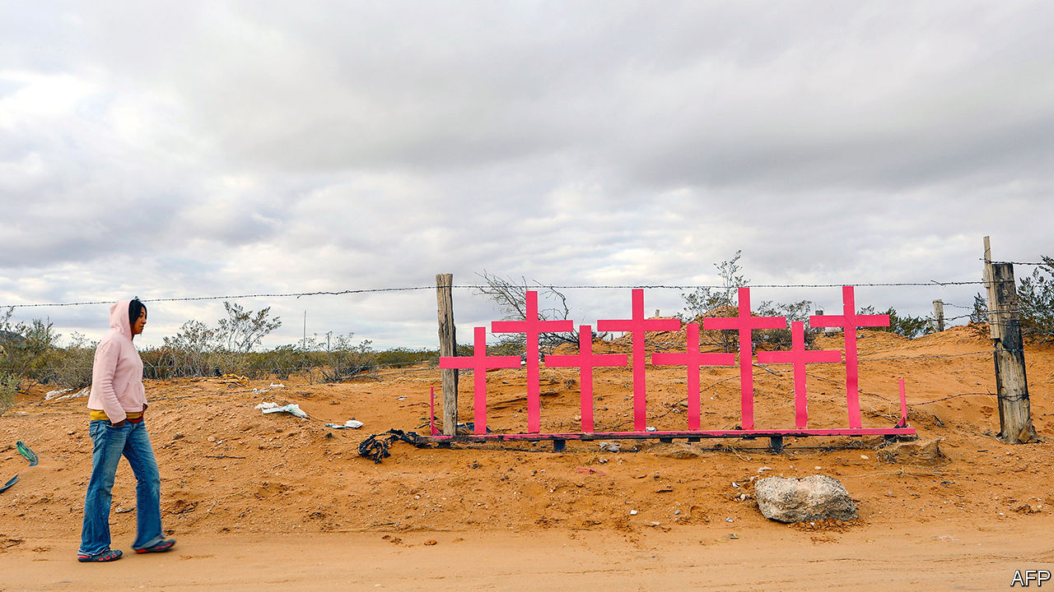

FROM THE rooftop of an office block in Mexico City, Sonia Barroeta tells of a lifetime of small abuses. If she wears a skirt, men “won’t leave me in peace”, she says. She has been wearing black trousers for 30 years. She counts six occasions on which she used pepper spray on aggressive men. Now nearing 60, she plans to take part in a demonstration for the first time, a protest to be held on March 8th, International Women’s Day.

On the next day she will join a “national women’s strike”. In her case that will mean staying home from work, along with the other 40 female staff and students of the Asteca Aviation School, which trains (mostly male) pilots and (mainly female) flight attendants. Women suffer not just on the street, but also the office, the home and everywhere in between, says Ms Barroeta. “As a woman, you are worth less from the day you are born.”

Feminist groups called the march and the strike after two brutal murders in February. Ingrid Escamilla, 25, was killed and skinned by her husband. Fátima, a seven-year-old, was abducted, sexually abused and murdered. The Women’s Day march is expected to be the biggest feminist mobilisation in Mexico’s history. This fight against violence is the first big social movement to form during the presidency of Andrés Manuel López Obrador, a left-wing populist who took office in December 2018.

It is part of a Latin American wave. Last year, after police abused women who took part in demonstrations against inequality, price rises and election-rigging in several countries, women held protests against sexism. A Chilean anthem called “A Rapist in Your Path” has been sung from Paraguay to Honduras. (Sample lyric: “The oppressive state is a macho rapist”.)

Although violence is the spur to protest, women are a smaller proportion of murder victims than in countries where they are generally better treated. In Switzerland, in 2018 the best of the 189 countries ranked in the UN Development Programme’s genderinequality index, half of murder victims are female. In 74th-placed Mexico, which has many more murders, the proportion has been steady at 10-15% since the 1990s. That is because a typical murder involves one male gangster shooting another. In 2018, when 36,700 people were killed in Mexico, 3,700 were women.

Feminists argue that murders of women are especially vicious. “They kill us with a distinct cruelty,” says Citlalli Hernández, a senator. Mexico recognises “femicide”, the murder of a woman or girl because she is female, as a separate crime (see article). The country classified 980 killings as femicides last year, up from 411 in 2015. Many are the culmination of domestic violence that was reported to police, and are thus preventable. In surveys about whether people feel safe, a gap appeared in 2014: the share of women who feel at risk is ten percentage points higher than that of men.

That has inspired a movement characterised by the youth of its adherents, their militancy and their use of social media to organise. After a teenager accused four policemen of rape last August, women rallied under the hashtag “They don’t take care of us, they rape us”. They smashed the glass doors of the prosecutor’s office in Mexico City, vandalised the Angel of Independence, the city’s best known monument, and clashed with all-women riot squads.

Although murder is the focus of these protests, it is not the only target. “What we want is to change the culture, the social relations, the place we have been put historically,” says Sayuri Herrera, a lawyer.

Most Mexicans want less violence against women. Universities and business groups are backing the Women’s Day march. There is less enthusiasm for other feminist goals, such as access to abortion. The capital legalised abortion in the first trimester in 2007 and the southern state of Oaxaca did so later. Other jurisdictions have not followed.

The protests are aimed more at changing social attitudes than government policy. Their leaders do not expect much help from Mr López Obrador. Though a former agitator himself, he dislikes forces he cannot control. He claims that the feminist movement has been “infiltrated” by conservatives, who exploit its anger to criticise him. In February, while promoting a lottery to pay for medical supplies, he responded to questions from reporters about murdered women by saying, “I do not want femicides to overshadow the raffle.” Some activists defend Mr López Obrador by saying that his administration includes more feminists than did earlier governments.

Being a feminist in Mexico has never been easy. “We were 20 locas [crazy women] in the streets with pro-abortion signs,” says Marta Lamas, a professor at the National Autonomous University, recalling protests she took part in 45 years ago. A spate of horrific murders has captured Mexicans’ attention. That may not bring about the broader changes that feminists seek. ■

This article was downloaded by calibre from <https://www.economist.com/the-americas/2020/03/07/mexicos-new-feminist-wave>

|  |  |  |  |
| --- | --- | --- | --- |
|  | Articles | Sections | Next |

|  |  |  |  |
| --- | --- | --- | --- |
| Previous | Articles | Sections | Next |

#### Special victims

# Why Latin America treats “femicides” differently from other murders

Does treating some murders of women as a separate crime help bring perpetrators to justice?

Mar 7th 2020 | MONTERREY



LIDIA FLORENCIO GUERRERO keeps a candlelit shrine to her daughter, Diana, who in 2017 was raped and murdered in Chimalhuacán, a Mexican town. She has a file documenting how police bungled the investigation. They failed to cordon off the crime scene or wear gloves while handling Diana’s body. Her clothes went missing. Photos of the corpse were sloppily taken, says Diana’s sister, Laura. Ms Guerrero cannot look. She uses the word “femicide” to describe her daughter’s death.

The word is centuries old but has recently taken on a particular meaning: the murder of a female because of her sex. In Latin America femicide has a legal meaning, too. Since 2007 15 countries have recognised it as a distinct category of killing. The proportion of murders of women that are recognised as femicide varies widely. In Mexico, where the criteria include “degrading” injuries or sexual violence inflicted on the victim and a “sentimental relationship” between her and the killer, the share is about a quarter. Countries in other regions, such as France, are debating whether to adopt femicide laws.

The concept of femicide raises public awareness of violence against women, says Martha Cecilia Reyes, head of the women’s institute of Nuevo León, a state in northern Mexico. It is supposed to help bring perpetrators to justice. In many countries jail sentences are stiffer than for murder. The maximum for femicide in Nuevo León is 70 years, 30 years longer than for other murders. Mexican courts do not require prosecutors to show that a femicide defendant intended to kill his victim. That makes it harder for men who beat their wives to death to get away with a manslaughter conviction, says Estefania Medina, a lawyer.

Femicide-specific institutions build expertise. Guatemala has, in effect, a parallel justice system, with specialist judges and prosecutors. Investigators in Mexico’s state-level femicide units are trained to think differently about murder scenes, says Griselda Núñez Espinosa, Nuevo León’s femicide prosecutor. That includes learning to search rubbish for tissues with traces of semen. Femicide cases are more likely than other homicides to end in a jail sentence, since many have an “obvious suspect” in the form of a lover or relative, says Ms Núñez.

But femicide laws have critics. Some lawyers find it absurd that a jealous husband who kills his wife will get decades more jail time than one who kills her male lover. Investigators of femicide cases have no more training and resources than do others, say some lawyers, and so are no more successful at winning convictions.

A survey of prosecutors in Peru found that many deemed it too hard to prove that a murderer had been motivated by misogyny. Some misclassified femicides as ordinary homicides because they thought that would make it easier to win convictions. Mexico’s attorney-general, Alejandro Gertz Manero, recently floated the idea of repealing the law that recognises femicide as a separate crime. It creates extra work for overtaxed investigators, he suggested.

Ms Guerrero did not learn of her daughter’s death for a week because police registered her as a man (deliberately, she believes). They refuse to classify her murder as a femicide. Changing that would not bring justice. But, says Ms Guerrero, it would acknowledge that “Diana was killed simply for being a woman.”■

This article was downloaded by calibre from <https://www.economist.com/the-americas/2020/03/07/why-latin-america-treats-femicides-differently-from-other-murders>

|  |  |  |  |
| --- | --- | --- | --- |
| Previous | Articles | Sections | Next |

|  |  |  |  |
| --- | --- | --- | --- |
| Previous | Articles | Sections | Next |

#### Weathering the storm

# Brazilians dominate surfing (for now)

But their success comes as the industry struggles

Mar 7th 2020 | MARESIAS, SÃO PAULO



GABRIEL MEDINA (pictured), arguably the best surfer in the world, grew up in Maresias, a coastal town in Brazil known for its white sand and rolling waves. As a child in the early 2000s, he watched his fellow Brazilians compete in the world surf championships in Hawaii. They were known as “small-wave surfers”: scrappy but second-rate. Australians and Americans took home all the trophies.

That changed in 2014, when Mr Medina’s daring aerials and cut-throat competitiveness led him to victory. His generation, called “the Brazilian storm”, professionalised the sport. “Fifteen years ago,” says his trainer, Allan Menache, “you got out of the water and drank a beer.” Adriano de Souza, a Brazilian surfer who went pro before Mr Medina, introduced unprecedented discipline. Cross-training (eg, swimming and yoga) gave him and his compatriots an edge. English lessons helped them secure sponsorships. Last year, Brazil clinched its fourth win in six years.

The World Surf League (WSL) recently opened an office in São Paulo. Globo, Brazil’s largest television network, expanded its coverage of the sport in 2015 and made Mr Medina’s rags-to-riches tale into an on-demand film. More man about town than beach bum, the 26-year-old arrived at its premiere in January wearing a sleek blue suit, trailed by an entourage.

Surfing will make its Olympic debut in Tokyo in July, and more amateurs are braving the waves than ever. The WSL is trying to attract new fans through sustainability and sexual equality: beach clean-ups follow tournaments and both sexes win equal prize money, though the pro tour has 34 spots for men and only 17 for women. In Brazil, “lots of parents are putting their kids in the water and hoping they’ll be the next Gabriel Medina,” says Alfio Lagnado, the owner of Hang Loose, a surfwear brand.

But the forces behind the Brazilian storm are weakening. The global surf industry is going through a slump. Quiksilver, a beachwear brand that once sponsored hundreds of athletes, filed for bankruptcy in 2015, after trying but failing to become a mainstream fashion giant just as the retail industry hit hard times. In 2019 Hurley, another surfwear maker, announced that it would dissolve its professional team. Big brands like Corona and Jeep are “more interested in profiting off superstars than building the talent base”, says Miguel Pupo, one of 12 Brazilian surfers on this year’s pro tour. The sport’s fate depends on sponsors’ farsightedness: using the fame of this generation to invest in the next.

Caio Costa, a 15-year-old from Maresias, understands the precariousness of his chosen career. He trained at the Gabriel Medina Institute, which provides free coaching to talented adolescents. He plans to ask businessmen who holiday in Maresias for money to buy surfboards ($500) and plane tickets for qualifiers that will put him on track for the professional circuit ($15,000). He gazes at the ocean as rain begins to pelt the waves. A dozen young surfers scamper out, boards in hand. “We Brazilians make a huge effort,” he says. He hopes they can weather the storm.■

This article was downloaded by calibre from <https://www.economist.com/the-americas/2020/03/07/brazilians-dominate-surfing-for-now>

|  |  |  |  |
| --- | --- | --- | --- |
| Previous | Articles | Sections | Next |

|  |  |  |  |
| --- | --- | --- | --- |
| Previous | Articles | Sections | Next |

#### Bello

# Bolivia after the ouster of Evo Morales, a leftist strongman

The interim president seeks an electoral mandate. Will that destabilise the country?

Mar 7th 2020 |



“THE BOLIVIAN people won’t accept seeing those who have the privilege of directing our collective destiny using their power and the resources of state institutions...to change the rules of democracy and benefit themselves.” So wrote Samuel Doria Medina, a businessman and politician, in a newspaper column on January 26th. He was referring to Jeanine Áñez, a previously obscure opposition senator who in November became Bolivia’s caretaker president. Evo Morales, a leftist strongman, was overthrown that month by protests over electoral fraud. To the dismay of many outsiders, Ms Áñez decided to stand herself in the re-run election, to be held on May 3rd. Her attempt “should be banned”, wrote Mr Doria.

A few days later Mr Doria became Ms Áñez’s running-mate. The priority, he said, was unity to prevent the return of Mr Morales’s Movement to Socialism (MAS) and Ms Áñez was the candidate best placed to achieve that. This shows that pragmatism is trumping principle among Mr Morales’s opponents. But if Ms Áñez triumphs, it may provide additional ammunition to those who claim that Mr Morales was the victim of a coup. And that may presage further instability in Bolivia.

Mr Morales, who was the first elected president of indigenous descent, used natural-gas revenues to build schools, roads and clinics in poor areas. He spoke up for the downtrodden. But he was also guilty of the abuses Mr Doria complains of. He was ruthless in dealing with opposition, and controlled the courts and the electoral authority. Elected three times, in 2016 he narrowly lost a referendum to relax term limits. He stood again in last October’s election anyway.

When this appeared to be heading for a run-off between Mr Morales and Carlos Mesa, a centrist, the president was declared the winner after a sudden interruption in the vote count. That prompted an uprising which ended when the army, as well as the Catholic church and the main union confederation, urged Mr Morales to resign. In all, 36 people died in clashes. The Organisation of American States (OAS), invited by Mr Morales to audit the vote, found widespread and deliberate manipulation, which included the use of hidden servers and falsified tally sheets.

Now Mr Morales, who is in exile in Buenos Aires, has launched a propaganda offensive in which he claims that there was no fraud and that Ms Áñez is ruling as a dictator. In a report last month, commissioned by the Centre for Economic and Policy Research, an think-tank in Washington that supports Venezuela’s dictatorship, two researchers claimed to find no statistical evidence of electoral fraud in Bolivia. That brought a robust response from the OAS, which dismissed the report as “neither honest, nor fact-based nor comprehensive”.

By pressing criminal charges against Mr Morales and some of his collaborators, critics say the interim government is exceeding its mandate. But it also struck an all-party agreement to name a new electoral authority, whose head commands widespread respect. The authority has barred Mr Morales’s attempt to run for the Senate, on the grounds that he is non-resident.

Mr Morales’s position inside Bolivia is weakening. He imposed Luis Arce, his former finance minister, as the MAS candidate, against the wishes of the party. Polls show that Mr Arce would win the first round of the election but with only around 30% of the vote. Unless he gains 40% and a ten-point lead he will face a run-off in June, which the polls suggest that either Mr Mesa or Ms Áñez would win.

Abroad, Ms Áñez is chiefly known for brandishing a large bible at the presidential palace and exclaiming “Glory to God” when she took over. She is a social conservative but in some other ways is less reactionary and more pragmatic than her image. A mestiza from a poor background, she is an experienced parliamentarian. She decided to stand after a poll gave her a 43% approval rating.

Whoever wins faces two big tasks. One is to fix the economy, which Mr Morales left with a big fiscal deficit, an overvalued exchange rate and declining gas revenues. The other is to unite the country. It may help that if Mr Arce loses, the MAS is likely to split between diehards and younger, more moderate leaders. After 14 years of Mr Morales, “we have to go back to recognising that politics involves disagreement, debate and deal-making,” says Roberto Laserna, a social scientist in Cochabamba. These tasks may fall to Ms Áñez.

This article was downloaded by calibre from <https://www.economist.com/the-americas/2020/03/07/bolivia-after-the-ouster-of-evo-morales-a-leftist-strongman>

|  |  |  |  |
| --- | --- | --- | --- |
| Previous | Articles | Sections | Next |

|  |  |  |
| --- | --- | --- |
| The Americas | Sections | China |

Asia

Malaysia’s new government: Beset at its birth

.

Regulation in Bangladesh: Rules are made to be broken

.

Elections in Tajikistan: United in unity

.

The war in Afghanistan: Peace with Afghan characteristics

.

Politics in Sri Lanka: Brotherly shove

.

Banyan: Flu jabs

.

|  |  |  |
| --- | --- | --- |
| The Americas | Sections | China |

|  |  |  |  |
| --- | --- | --- | --- |
|  | Articles | Sections | Next |

#### Beset at its birth

# Malaysia’s new government may be even more unstable than old one

It does not seem to have a policy agenda, even though problems are piling up

Mar 7th 2020 | KUALA LUMPUR

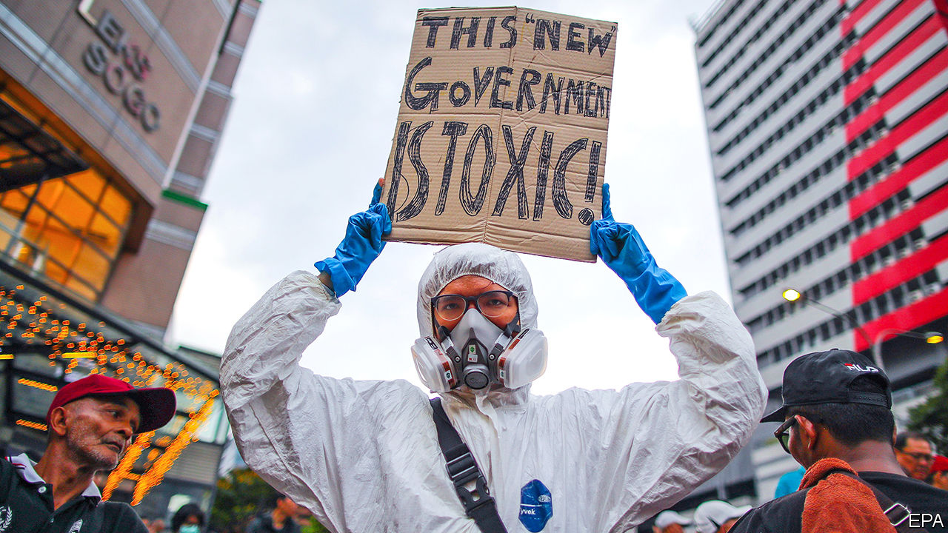

“I AM A brother to the Malays, the Chinese, the Indians, the Sikhs, the Ibans, the Kadazans, the Dusun, the Murut and those of various ethnicities,” declared Malaysia’s new prime minister in his first televised address on March 2nd. Muhyiddin Yassin’s conciliatory words played well in a country riven by turbulence among its largely race-based parties. The previous government, a coalition called Pakatan Harapan, collapsed on February 24th after one of its components split in two and another, Bersatu, broke away altogether. After a week of confusion, a new ruling coalition emerged: Perikatan Nasional, (“national alliance”), led by Mr Muhyiddin. He was sworn in on March 1st.

Perikatan Nasional contains some very familiar faces. Its biggest component is the United Malays National Organisation (UMNO), which ran Malaysia for 61 years, but took a 21-month sabbatical after Pakatan Harapan booted it from office in 2018. Other members include PAS, an Islamic outfit, and almost all of Bersatu. It is on friendly terms with parties from the state of Sarawak, in the Malaysian part of Borneo, whose support is needed to give Perikatan Nasional a majority in the lower house of parliament.

While each party has its own platform, advancing Malay interests is a common goal. Bumiputras—Malays and other indigenous groups, who make up 69% of the country’s population of 32m—have special privileges enshrined in the constitution. Pakatan Harapan talked about the need for a more meritocratic system, although it did little to introduce one. That endeared it to the 24% of Malaysians who are ethnically Chinese and the 7% with Indian roots, as well as to liberal Malays, but most bumiputras were alarmed.

Mr Muhyiddin presents himself as a unifier. He will have to start with parliament. He got the nod from the king to form a government only on the basis that he was “likely” to be able to command a majority. His decision on March 4th to delay parliament’s next sitting until May will buy him time to woo wavering or biddable parties and MPs. Although he has many grand jobs at his disposal, starting with seats in cabinet, he also has many jockeying factions to mollify. An attempt at racial diversity would bolster minorities’ confidence in the government.

Holding Perikatan Nasional together will be a challenge for Mr Muhyiddin. UMNO brings lots of baggage. Its president, Ahmad Zahid Hamidi, is among the candidates for deputy prime minister. But he is on trial for allegedly misappropriating funds meant for a charity. Support within UMNO for Najib Razak, the prime minister from 2009 to 2018, remains strong. But Mr Najib faces several trials on charges related to 1MDB, a state investment company from which some $4.5bn disappeared on his watch. Mr Najib denies all wrongdoing, and recently said that under the new government he “would expect that the atmosphere would be more conducive towards a fair trial”. Yet any indication that prosecutors are going soft on Mr Najib, who remains an UMNO MP, would presumably go down as badly with voters as the 1MDB scandal did in the first place.

That is just one item in the daunting in-tray that awaits new ministers, whenever they are named. There is also covid-19, cases of which are creeping up in Malaysia. The epidemic, in turn, is likely to harm the economy. In the last quarter of 2019 it grew at its slowest pace in a decade; the current quarter is expected to be even worse. The prime minister’s advisers urge action to help the poorest 40% of citizens, the vast majority of whom are bumiputras. Bringing down the cost of living “is essential”, believes Rais Hussin, Bersatu’s chief strategist. The recent political drama has made matters worse, he notes, since it has caused the ringgit to weaken, which will boost the cost of meat, dairy and other imported foods. Joblessness among young people is another concern. The overall unemployment rate is around 3%, but among those aged 15-24 it is over 10%. Many of those who do have jobs are overqualified for the positions they occupy.

Perikatan Nasional has existed for less than two weeks. It has no manifesto. If its constituent parties have agreed on any policies to tackle the country’s problems, they have not made them public. Then there is the question of how to handle the pet projects of each party in the government. For years PAS, for instance, has pushed for the adoption of an Islamic criminal code, including harsh punishments such as amputations and stoning. Under Mr Najib, UMNO toyed with such ideas, too. The parties from Sarawak, meanwhile, are likely to demand lavish spending in their state, even as the ailing economy crimps revenue. “It’s not going to be a bed of roses,” admits an adviser to the government. ■

This article was downloaded by calibre from <https://www.economist.com/asia/2020/03/07/malaysias-new-government-may-be-even-more-unstable-than-old-one>

|  |  |  |  |
| --- | --- | --- | --- |
|  | Articles | Sections | Next |

|  |  |  |  |
| --- | --- | --- | --- |
| Previous | Articles | Sections | Next |

#### Rules are made to be broken

# A new mobile-money firm in Bangladesh is benefiting from special treatment

Its connections to the government may help

Mar 7th 2020 | DHAKA

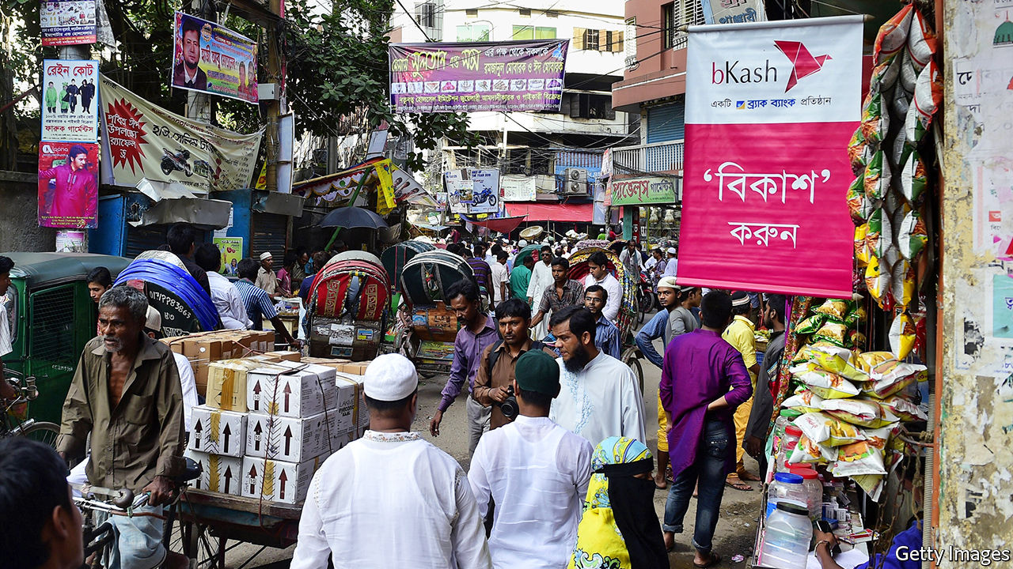

THE FABRIC shops are far more eye-catching, but the business that attracts the most customers in Islampur market, Bangladesh’s biggest textile bazaar, is a drab hole in the wall. A long queue of young men, all clutching mobile phones, wait patiently to hand the shopkeeper faded notes to top up their bKash accounts.

Since mobile money took off in Bangladesh nearly a decade ago, bKash has dominated the industry. It has done so well that the company’s name has become a verb, notes Biru Paksha Paul, a former chief economist of Bangladesh Bank, the central bank: “‘I’ll bKash you some money,’ the kids say, instead of transfer.” When Mr Paul first heard that a new firm, Nagad, was entering the business, he was pleased: “Some healthy competition at last.” Alas, Nagad’s success is a sign of just the opposite.

Mobile money is a big business in Bangladesh. Three-quarters of Bangladeshis have a mobile phone, but less than half have a bank account. Migrants from rural areas to the cities are eager to send remittances back to their villages, many of which lack banks, says Mamun Rashid of PWC, a consultancy. Even in the capital, Dhaka, he notes, “The traffic is so bad, sending money using a phone makes much more sense.”

In 2019 more than $51bn of transactions were made via mobiles, up from $27bn in 2016. Almost 60% goes through bKash, which is owned by BRAC bank, a local financial institution, and several grand foreign investors, including the World Bank’s private-sector arm; an affiliate of Alibaba, a giant Chinese e-commerce firm; and the Bill & Melinda Gates Foundation, an enormous American charity. It has more than 30m customers.

But Nagad is catching up fast. Since Sheikh Hasina Wajed, the prime minister, attended its launch a year ago, its turnover has risen rapidly, to 1bn taka ($11.8m) a day, about a seventh of bKash’s total. It has also amassed lots more customers than bKash on paper—60m—although many of these are signed up automatically, thanks to a deal with a mobile-network operator, Robi.

Tanvir Mishuk, Nagad’s managing director, cites three reasons for the firm’s success. First, it has simplified the cumbersome and expensive paper-based registration and anti-money-laundering checks used by other mobile-money firms. Second, it charges 1.45% of each transfer, compared with bKash’s 1.85%. Third, Nagad is a joint venture between Mr Mishuk’s company, Third Wave Technologies Limited (TWTL), and the post office. This arrangement is beneficial for both firms, he argues. Thanks to Nagad, he says, the post office’s “balance-sheet is looking better”. TWTL, meanwhile, can capitalise on the post office’s big network of branches and familiarity to rural Bangladeshis.

The rewards Nagad reaps from its close relationship with the government, however, go much further. Unlike other mobile-money services, Nagad is not regulated by the central bank and therefore ignores many of the regulations that bind its competitors. The limit on daily transactions for a Nagad account, for instance, is 250,000 taka. The central bank limits its rivals to 30,000 taka. This has helped Nagad attract higher-spending customers, especially business-owners, and thus bring in more revenue with fewer transactions.

Nagad’s deal with Robi also bypasses the central bank’s “know your customer” rules, intended to curb money-laundering. All of Robi’s customers are automatically registered with Nagad, without providing any paperwork beyond that needed to take out a mobile subscription. By the same token, Nagad does not have to provide daily settlement data to the central bank.

Mr Mishuk argues that the central bank does not need to oversee Nagad because the post office, which owns a 51% stake, already has a banking arm. The central bank disagrees. In a series of letters and inter-governmental meetings since the beginning of last year, it, along with the ministry of finance and the anti-corruption commission, have called for Nagad to be brought under central-bank control, arguing that neither the regulations on mobile money nor the laws governing the post office allow a service like Nagad to be run without normal supervision. Nagad’s current status, officials have argued, provides opportunities for money-laundering, corruption and unfair competition. So far, these protests have been ignored.

“Why should one private company enjoy different rules than the others?” asks Mr Paul. The answer may lie in its ownership. Mr Mishuk says his fellow shareholders are businessmen in engineering and telecoms. But in 2017, according to documents seen by The Economist, Kazi Monirul Kabir, a telecoms magnate, transferred his stake in TWTL to Razee Mohammad Fakhrul and Nahim Razzaq, both members of parliament, and Rezwana Nur, the wife of the prime minister’s deputy press secretary, Ashraful Alam Khokon. Five months later, the partnership with the post office was signed.

Mr Razzaq was the only one of the three to respond to The Economist’s questions about their ties to the company, saying he was no longer a shareholder. Neither he nor Mr Fakhrul declared any shares in TWTL when they took their seats in parliament last year. Mr Mishuk says they were all once shareholders, but are not any more, although he cannot remember when they sold their shares. He also says that he has some other partners in the business, via a company in Singapore, although he cannot disclose who they are.

The government of Bangladesh has a habit of doling out favours to the well-connected. State-owned banks are rotting because of out-of-control lending to favoured businessmen, who are seldom inclined or obliged to pay back loans, says Michael Puli, an analyst covering Bangladesh at Standard & Poor’s, a rating agency. Members of parliament from the ruling Awami League party have also recently urged the central bank to hand out licences for new banks to friends and relatives.

The Bangladesh Nationalist Party (BNP), in government from 2001 to 2006, was no more virtuous, Mr Paul says. Citycell, the country’s first mobile-phone company, whose largest stakeholder was a BNP lawmaker called Morshed Khan, thrived on the back of skewed government policies in the early 2000s. But his company’s fortunes waned with his party’s.

Nagad’s fortunes look set to rise. It does not face “the conventional impediments” of working with the public sector because it is fulfilling the government’s vision of “digital Bangladesh”, says Mr Mishuk. The key to making such a public-private partnership work, he explains, is “transparency”: “We make sure there is no shady request, there is no shady manipulation.” ■

This article was downloaded by calibre from <https://www.economist.com/asia/2020/03/07/a-new-mobile-money-firm-in-bangladesh-is-benefiting-from-special-treatment>

|  |  |  |  |
| --- | --- | --- | --- |
| Previous | Articles | Sections | Next |

|  |  |  |  |
| --- | --- | --- | --- |
| Previous | Articles | Sections | Next |

#### United in unity

# Tajikistan’s long-serving ruler dispenses with all political opposition

Emomali Rahmon has been in power since 1992

Mar 7th 2020 | DUSHANBE

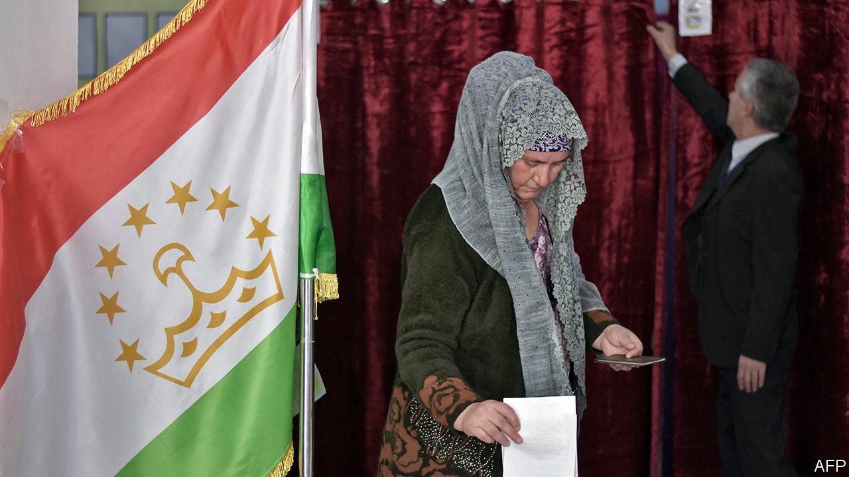

MAMMOTH PHOTOS of Emomali Rahmon, Tajikistan’s bushy-eyebrowed president, are everywhere in Dushanbe, the capital: striding in a suit, posing in a poppy field, waving regally. But as voters went to the polls to elect a new parliament on March 1st, advertising for political parties was all but invisible. The subliminal message was clear: however voters vote, the president—officially, the Founder of Peace and National Unity, Leader of the Nation—will still run the show.

Mr Rahmon’s People’s Democratic Party of Tajikistan scooped 75% of seats in parliament. Five other parties won seats, offering different manifestos but uniform devotion to the great man. Their role is to provide a semblance of opposition. The only outfit that was critical of Mr Rahmon, the Social Democratic Party of Tajikistan (SDPT), won 0.3% of the vote and no seats.

Rahmatullo Zoirov, the loquacious lawyer who leads the SDPT, says the president is an illegitimate leader who has rigged the political system to cling to power, most recently through a referendum allowing him to remain president for life. Mr Zoirov was under no illusions about his party’s chances, expressing doubt about “the fairness, freedom and transparency of this election” as he cast his ballot. He refused to accept the results after they were released. The Organisation for Security and Co-operation in Europe, which usually monitors elections in the region, deemed this one too far below its standards to be worth a full mission, citing limited political choices and a deterioration in respect for basic freedoms. In some polling stations, at least, one member was allowed to vote for an entire family. The election commission, however, says the vote was clean and fair.

Mr Rahmon and his lackeys are not without support. Many voters leaving polling stations had endorsed the ruling party out of a desire to preserve stability, a powerful motivator in a country that fought a brutal civil war after independence from the Soviet Union in 1991. They are getting what they wish for: Mr Rahmon came to power in 1992, and is now the longest-serving leader in the former Soviet Union.

Many others switched off. “To be honest, I’m more interested in Brexit than local politics,” said one man, complaining that no one had canvassed for his vote during the campaign, which featured no television debates or rallies. One woman, asked what she hoped for from the new parliament as she left a polling station, raised her eyebrows and replied: “Nothing.”

Tajikistan, the poorest country in the former Soviet Union, has plenty of problems: low wages, high prices and a shortage of work for the young, fast-growing population of 9.5m. Tajiks flock abroad to work, mostly to Russia: officially, the number of émigrés stands at 500,000, but some estimates put it as high as 2m. Mr Rahmon’s critics say his friends and relatives are doing well, but ordinary people are not. More than a quarter live in poverty, by the government’s own count. Tajikistan is deeply in hock to China, to which it has been granting land and mining concessions to pay off loans. It also depends on its former colonial master, Russia, which has a military base in Tajikistan.

The election was the first since a moderate Islamic party that was for years the main opposition to Mr Rahmon was banned, in 2015. The government labelled the Islamic Renaissance Party of Tajikistan a terrorist group, sending its leader, the mild-mannered Muhiddin Kabiri, fleeing abroad. Other senior members were jailed. From exile in Berlin, Mr Kabiri dismissed the talk of terrorism as a “trumped-up pretext” to ban the only party capable of posing a challenge to Mr Rahmon, who had already eliminated most secular opposition. A reformist movement called Group 24 was outlawed in 2014. Its leader, Umarali Quvvatov, was later shot in Istanbul.

Mr Rahmon will probably stand for re-election in November. But there is speculation that he may step aside and anoint as his successor his son, Rustam Emomali, the 32-year-old mayor of Dushanbe. That would make the Founder of Peace and National Unity the founder of Central Asia’s first modern-day dynasty, too. ■

This article was downloaded by calibre from <https://www.economist.com/asia/2020/03/07/tajikistans-long-serving-ruler-dispenses-with-all-political-opposition>

|  |  |  |  |
| --- | --- | --- | --- |
| Previous | Articles | Sections | Next |

|  |  |  |  |
| --- | --- | --- | --- |
| Previous | Articles | Sections | Next |

#### Peace with Afghan characteristics

# A peace deal signed. Then America and the Taliban resume fighting

In fact, it’s not clear that the peace deal called for peace

Mar 7th 2020 |

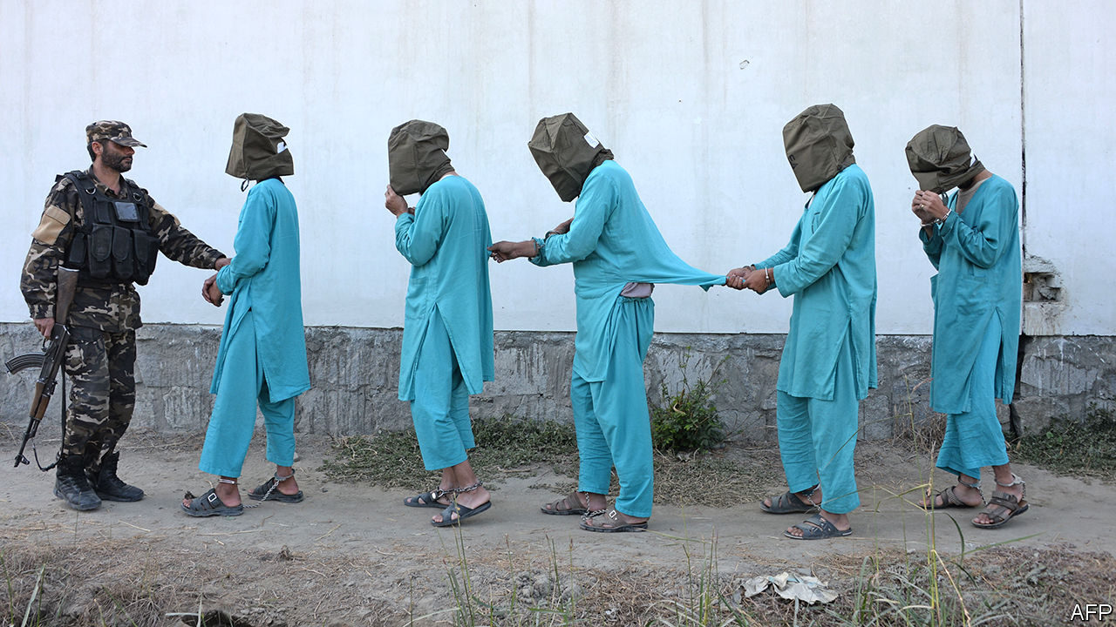

THE INK was barely dry on the peace agreement signed on February 29th by America and the Taliban before the disputes began. The deal states that “up to 5,000” Taliban prisoners will be released before March 10th, paving the way for talks between the Taliban and assorted Afghan grandees about the future of the country. But the deal glosses over who will do the releasing. Most Taliban prisoners are in the hands of the Afghan government, with whom the Taliban have refused thus far to negotiate, on the grounds that it is an illegitimate, American-imposed regime (although the government is supposed to participate in the talks on March 10th). Ashraf Ghani, the president, says he has not made any promises to release anyone.

Meanwhile, both sides have resumed shooting one another. They had observed a partial but successful seven-day ceasefire in the run-up to the signing. American and Afghan officials said this “significant reduction” in violence should continue, but the Taliban have called it off. On March 3rd they attacked no fewer than 43 government checkpoints in just one of Afghanistan’s 34 provinces, Helmand. On the same day in another province, Kunduz, at least 15 Afghan soldiers were killed. The following day, just hours after President Donald Trump said he’d had a “very good talk” with the Taliban’s chief negotiator, Abdul Ghani Baradar, American warplanes bombed a Taliban position in support of Afghan troops—the first air strike since the agreement was signed.

All this does not necessarily mean that the deal is dead. America, after all, says it is pressing on with its promise to reduce its garrison in Afghanistan from 12,000 to 8,600 troops and to close five bases by mid-July. But as Mark Esper, America’s defence secretary, says, implementing the agreement will be “a long, windy, bumpy road”.

Part of the problem is the ambiguity of the deal. The public parts of it make no mention of a ceasefire, beyond suggesting that the inter-Afghan talks may produce one. But there are two “implementing documents”—in effect, codicils that have not been published. Mike Pompeo, America’s secretary of state, says there was “a detailed set of commitments that the Taliban have made about the levels of violence that can occur”. The commander of American forces in Afghanistan, General Scott Miller, puts it more bluntly: “The United States has been very clear about our expectations—the violence must remain low.”

American officials seem to be trying to talk the Afghan government into going along with the release of prisoners, in order to get the inter-Afghan talks going. That may yet happen, keeping the agreement broadly on track. But the events of the past few days suggest that the deal will be even harder to stick to than it was to strike. ■

This article was downloaded by calibre from <https://www.economist.com/asia/2020/03/07/a-peace-deal-signed-then-america-and-the-taliban-resume-fighting>

|  |  |  |  |
| --- | --- | --- | --- |
| Previous | Articles | Sections | Next |

|  |  |  |  |
| --- | --- | --- | --- |
| Previous | Articles | Sections | Next |

#### Brotherly shove

# Sri Lanka’s ruling party calls an election, hoping for a landslide

But civil libertarians and economists quake at the prospect

Mar 7th 2020 | COLOMBO

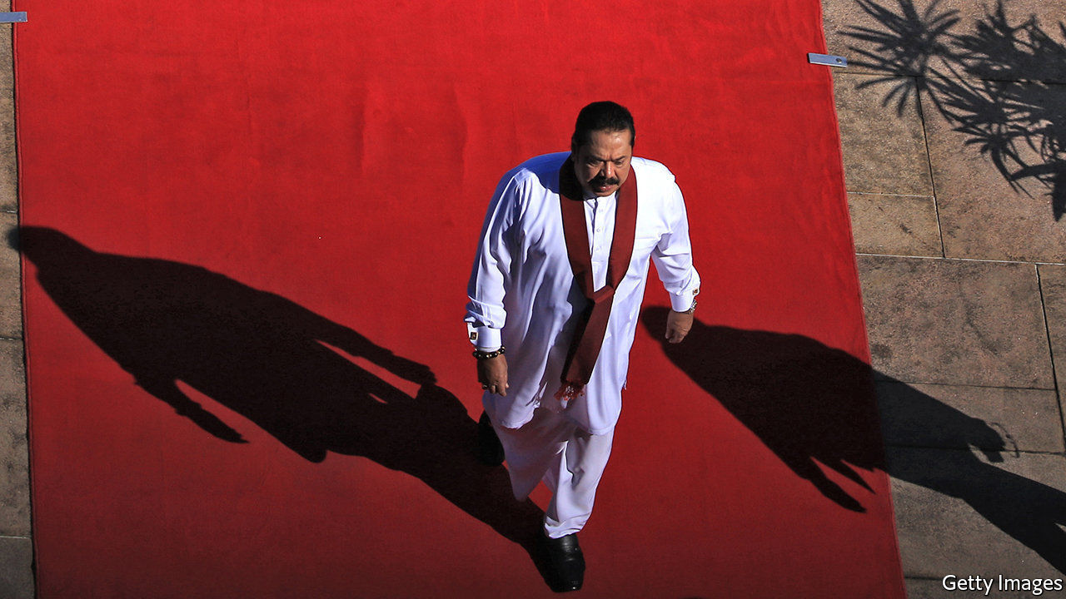

JUST FIVE years ago the Rajapaksa family seemed to have lost everything. Mahinda Rajapaksa was beaten in Sri Lanka’s presidential race in 2015, ending his ten-year tenure. His younger brother, Gotabaya, was no longer number two (to Mahinda) in the ministry of defence. Basil, the baby of the brood, had lost his job as minister of economic development, and their eldest sibling, Chamal, would soon be ousted as speaker of parliament. Worse, the incoming government was threatening to prosecute varied Rajapaksas and their allies for everything from corruption to human-rights abuses.

But five years is an age in politics. Sahodara Samagama or Brothers Inc, as Sri Lankans jokingly call the resilient political clan that first entered parliament three generations ago, in 1936, is very much back in business. In November Gota, as he is widely known, captured the presidency in a landslide. He picked Mahinda, the former president, to be his prime minister. Chamal is still an MP and Basil, though out of government, runs the family’s political party, the Sri Lanka People’s Front (known by its Sinhala initials SLPP). Few Sri Lankans doubt that when polls open for a new parliament on April 25th, the nine-party coalition he has stitched will romp home.

Yet for the Rajapaksas, capture of the presidency, the cabinet and, in all probability, the legislature (in addition to considerable influence in the army, the police, the courts and much of the media) may not be enough. What they would really like is not merely a parliamentary majority but a two-thirds majority. That way they could roll back constitutional changes brought in by the previous government that trimmed the president’s powers. They could also, fear some among the 30% of the island’s 22m people who are not part of the Sinhalese Buddhist majority, scrap efforts to reconcile the country’s different ethnicities and religions after the murderous civil war of 1983-2009. Rival politicians and liberal types, meanwhile, worry that they will redouble the assault on civil liberties that took place when Mahinda was president.

Signs of such intentions are already showing. After Gota became president in November he placed the civilian police and the registration of NGOs under the control of the defence ministry. The ministry itself is run by a fierce general, with another hardliner in command of the army; both have been accused of war crimes. Human-rights activists and journalists say that while there have been no disappearances, as in the bad old days, forms of intimidation such as surveillance and repeated interrogations are becoming common again. Among signs that have worried Tamils, a minority concentrated in the north and east and in Colombo, the capital, whose armed uprising sparked the war, was a ministerial order in January that the national anthem may now only be sung in Sinhalese and no longer also in Tamil. Ominously, too, the government in February officially annulled its predecessor’s co-sponsorship of a resolution by the UN Human Rights Council, which had prescribed institutional steps for reconciliation between Tamils and Sinhalese.

Grisly terror attacks on churches and hotels last year by members of a local jihadist cult, which left 259 dead, drew attention to poor policing and intelligence and allowed the Rajapaksas to portray themselves as more reliably tough on security issues. “But in the guise of stability they want to arrogate all power to themselves and restrict public space,” warns Rauff Hakeem, an MP and former minister who happens to be Muslim. “It’s as if they are preparing for a police state.”

Few analysts believe the SLPP will gain its desired two-thirds. But this has more to do with an electoral system of proportional representation, which tends to reflect Sri Lanka’s demographic mix, than to the appeal or dynamism of the main opposition group, the United National Party (UNP). It is in disarray, split between a faction that backs Ranil Wickremesinghe, a seasoned but charmless politician, and one led by the more popular but less savvy Sajith Premadasa, the son of a former president. Mr Premadasa has forged an alliance of 12 groups to fight the SLPP. Mr Wickremesinghe is not only refusing to join, but also to allow Mr Premadasa to use the UNP’s symbol, an elephant. “What people are saying is, ‘How can they run a country if they can’t even run a party?’” says Malinda Seneviratne, a columnist and poet.

Given the opposition’s dysfunction, the Rajapaksas may be able poach some of its MPs even if they do not win the coveted two-thirds of seats outright. It is not just civil liberties that may suffer under a period of unchecked single-party rule. The economy, too, is at a worrying juncture.

The central government’s debt currently stands at around 82% of GDP. Interest payments eat up 42% of government revenue. For the next five years the International Monetary Fund expects that the government will have to borrow a further 2.7-5.2% of GDP annually. The already battered tourism industry is taking another hit from the coronavirus scare. So far the Rajapaksas’ answer has been a big tax cut, which in turn has generated scepticism about the government’s fiscal probity. Even a whopping parliamentary majority may struggle to sort out the government’s alarming finances. ■

This article was downloaded by calibre from <https://www.economist.com/asia/2020/03/07/sri-lankas-ruling-party-calls-an-election-hoping-for-a-landslide>

|  |  |  |  |
| --- | --- | --- | --- |
| Previous | Articles | Sections | Next |

|  |  |  |  |
| --- | --- | --- | --- |
| Previous | Articles | Sections | Next |

#### Banyan

# Japan may have to cancel the Olympics

Covid-19 could scupper Prime Minister Abe Shinzo’s pet project

Mar 7th 2020 |



IF BANYAN HAD to choose one country in which to ride out a pandemic, it would surely be Japan. Early 19th-century woodblock prints of bathing testify to Japan’s old and admirable cult of cleanliness. Modern Japanese have for years been quick to don a face mask at the first sniffle, out of consideration for others. And the population responds swiftly to public messaging.

Hygiene measures advocated against covid-19 since mid-January emphasise frequent washing of hands. This has surely helped slow the spread of the coronavirus, especially given that of Japan’s 1,035 covid-19 cases and 12 deaths, most are associated with a cruise ship held for weeks off Yokohoma. One striking and positive side-effect is already apparent: unlike in Europe or America, doctors report sharp falls in cases of ordinary flu, not only compared with previous years but also with the first part of the winter. Given that 3,300 deaths were attributed to flu in Japan in 2018, the good hygiene inculcated in recent months may well have saved far more lives than covid-19 has claimed.

For all that, social strains have shown in recent days. In Tokyo scuffles have broken out in queues for facemasks outside pharmacies. Panic-buying of toilet paper has left shelves bare. A photograph of toilet rolls in a public lavatory chained to their dispenser with a bicycle lock has done the rounds. While hardly “Lord of the Flies”, it is all highly unusual in such a well-behaved country.

Blame a squall of doubt over the government of the usually assertive prime minister, Abe Shinzo. His problems seem, precisely, to have begun with the cruise ship, the Diamond Princess. When cases of covid-19, contracted overseas, became clear among the 3,700 people aboard, measures to isolate them failed badly. The vessel was, as one passenger put it, a floating petri dish, as the number of infected soared to over 700, with seven deaths. Extraordinarily, crew were eventually let ashore from the infected vessel, and Japanese passengers allowed to return home on public transport, with no further quarantine measures.

When it comes to bumbling crisis management, Japan has form. After the Kobe earthquake in 1995, yakuza (gangsters) set up soup kitchens, so slow was government help to arrive. Bureaucratic disarray ruled in the Diamond Princess’s handling, too. European ambassadors with nationals aboard complained they did not know who in the government to call. Fans wondered whether Mr Abe, invisible during the crisis, had lost his touch. His hitherto unassailable poll ratings fell sharply.

To contain the damage to his reputation as well as the coronavirus, on February 27th Mr Abe took the initiative, telling all schools to close until April. Preparing for the worst, he rushed through legislation this week allowing a state of emergency to be declared. And he unveiled an emergency spending package.

The assertive Abe, then, is back. So much so that questions are growing about what expert advice, if any, he drew on for his schools decision. New social stresses will surely emerge, not least for working mothers (it never seems to be fathers) who must now drum up weeks of day-time childcare. “The government does not grasp what it’s like to raise children,” one mother complains.

The government claims that Japan will return to normal in April. That seems implausible. A state visit by China’s president, Xi Jinping, which was supposed to put the two countries’ listing relationship on an even keel, has already been postponed. There is little political cost to Mr Abe—after all, nationalists who backed his rise to power had been grumbling about his hosting the Chinese dictator.

Much more rides on the Olympic Games in Tokyo this summer. Mr Abe intends them to foster the patriotism whose absence among ordinary Japanese he laments. He wants the games to make Japan seem open, global and even multicultural. And, though vastly over budget, they are to crown the prime minister’s seven-year rule.

To cancel the games would generate not only disappointment among ordinary Japanese but anger at the wasted expense they have already had to bear. But a pandemic would take the decision out of his hands—not least, says Nakano Koichi of Sophia University, because the Olympic village would be “a cruise ship on land”. Bet on a postponement of the games at the very least, and on a long delay before the prime minister’s popularity shines again.

This article was downloaded by calibre from <https://www.economist.com/asia/2020/03/07/japan-may-have-to-cancel-the-olympics>

|  |  |  |  |
| --- | --- | --- | --- |
| Previous | Articles | Sections | Next |

|  |  |  |
| --- | --- | --- |
| Asia | Sections | Middle East and ... |

China

Women and covid-19: The mask slips

.

Uighurs: From slammer to serfdom

.

Chaguan: Total incredulity

.

|  |  |  |
| --- | --- | --- |
| Asia | Sections | Middle East and ... |

|  |  |  |  |
| --- | --- | --- | --- |
|  | Articles | Sections | Next |

#### Going viral

# Covid-19 has revealed widespread sexism in China

But women are resisting furiously online

Mar 7th 2020 | SHANGHAI

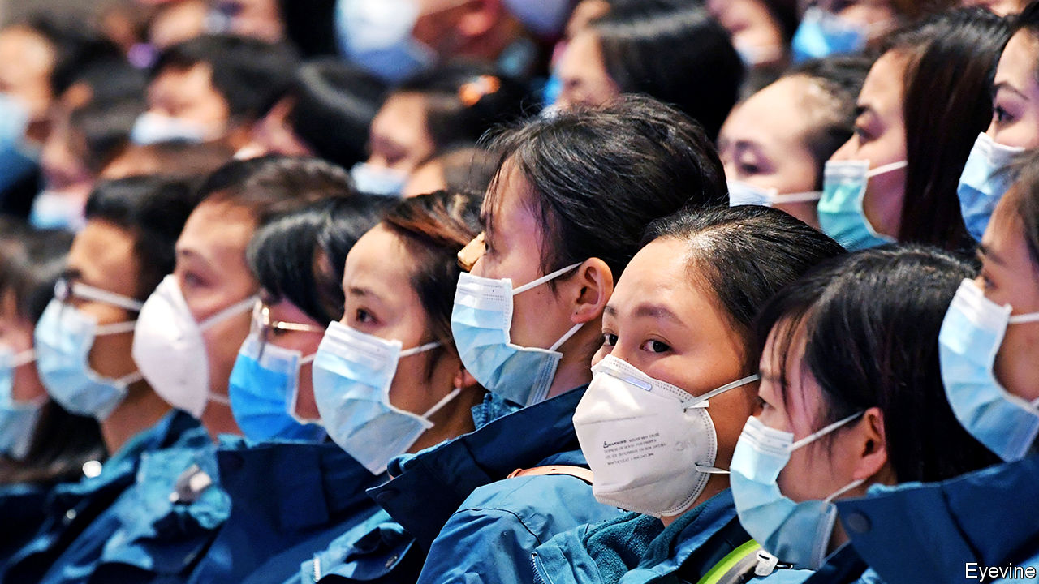

THE ADORABLE animated cartoon mascots were sure to inspire national solidarity—or so the Communist Youth League thought. But for most of its 13m followers on Weibo, a popular microblog, the pair inspired only ridicule and irritation. “Lovely land” and “Abundant red flags” (the names allude to poems by Mao Zedong) were pulled within hours. But female netizens continued to revile “Lovely land”, or Jiangshanjiao by her Chinese name, as a symbol of all that is decidedly unlovely about women’s lives in their land.

“Jiangshanjiao, are you still a virgin?” they asked, mimicking the sort of sexism they encounter. “Jiangshanjiao, if your husband hits you, do the police respond?” “Why are you wearing a short skirt?” “Did your parents want another child because you were a girl?” “Our company only recruits men.” One uploaded a song about Jiangshanjiao: “You can get a Master’s and a PhD and still not be proud / Because it won’t be easy to find a husband.” It was viewed more than 5m times before it was removed by censors.

As anger has grown over the Communist Party’s handling of covid-19, state-run news outlets have pumped out reports of patriotic donors and heroic workers. Featured prominently in their propaganda are female doctors and nurses in Wuhan, the centre of the disease. Last month CCTV, the state broadcaster, ran a segment on a nine-months-pregnant medical worker whom it hailed as “a great mother and an angel in a white gown” for continuing to work in an emergency ward in the city.

A day later the city’s newspaper cheered another who had returned to her post ten days after a miscarriage. Another publication, in the province of Zhejiang, praised a hospital in Wuhan for “avoiding waste” by serving different meals to male and female medical workers. An accompanying photograph appeared to show that male workers got an extra dish, and more soup, yoghurt and fruit than their female colleagues.

Readers heaped scorn on such reports, some of which were swiftly deleted (along with many indignant comments). Most galling, perhaps, was a video posted by a local news outlet in Gansu province showing about a dozen female medics, bound for Wuhan, having their heads shaved. The hospital said they had done so voluntarily, but some were weeping. Moreover, in a group shot, the newly bald female workers surrounded a male doctor who not only wore a higher-grade face mask but still had all his hair. An article on WeChat, “Please stop using women’s bodies as a propaganda tool”, was viewed over 100,000 times before it was censored.

In recent years, says Zoe, a blogger in Beijing, feminist activists have been detained and silenced, and their social-media accounts taken down. The advocacy group she helped run, Feminist Voices, was obliged to close in 2018. So it is increasingly falling to ordinary women to push back. They seem readier than ever to do so. Evelyn Lin (not her real name), a 30-year-old feminist in Shanghai, says that she was taken aback by how many friends who would not dream of calling themselves feminists took to social media to vent about Jiangshanjiao. The trend, she says, was “an outlet to express anger, whether about the government or censorship or discrimination”.

The number of women fulminating online is “larger than you might think”, says Cara Wallis of Texas A&M University. After the head-shaving episode, #SeeingFemaleWorkers went viral on Weibo, urging people to recognise the professional contribution of female medics. The hashtag has been used almost 700,000 times. In Hubei province, where the outbreak began, most doctors and more than 90% of nurses are women, according to the Shanghai Women’s Federation, a government body.

There is no shortage of chauvinism to decry. The government of Jinan, in Shandong province, has told companies to encourage female staff—but not men—to stay at home to care for children, as schools nationwide remain shut. Since people have been confined to their homes, NGOs have reported an increase in domestic violence. Ms Cao, a woman beaten by her boyfriend in the southern city of Shenzhen, uploaded to Weibo her conversation with a police mediator after he urged her to drop the case: “He has a good job,” he is heard saying. “Do you really want to ruin him?”

Ms Lin, who volunteers to help victims of domestic violence, has been helping Ms Cao since her ordeal. She has also helped a woman whose mother was beaten by her father after she insisted he wear a mask outdoors, and a victim of marital rape, for whom leaving the house has become much harder since virus-related restrictions were placed on her district. Others have set up networks to help women during the epidemic, such as “Vaccines Against Domestic Violence”: because “the door can block covid-19, but it cannot block another virus: domestic violence”. Over 2,500 volunteers have signed up since March 1st to be “vaccines” who listen out for abuse and encourage neighbours to resolve conflicts peacefully. Yuanzhong, an NGO based in Beijing that focuses on women’s rights, recently published a new guide to domestic abuse, including such tips as how to file for divorce under quarantine.

Volunteers are also sending sanitary pads to hospital workers in Hubei and nearby. Among them is Alex Li, who runs Biede Girls, a platform about women’s issues. Periods, says Ms Li, are “very much getting overlooked”. Many female workers feel embarrassed to speak to superiors, she finds. The problem was brought to public attention last month when male bosses at hospitals in Hubei reportedly turned away donations of sanitary products on the grounds that they were not essential. Ms Li says that, although her donations are now accepted by hospitals, she must still spend big sums to get them delivered.

The propagandists’ portrayals of women during the epidemic—as self-sacrificing, brave or beautiful—“basically all follow the playbook”, says Zoe, the blogger. But she was surprised to see a state-run charity follow the volunteers’ lead and donate sanitary pads. People’s Daily has condemned “feudal” attitudes to menstruation and eulogies to “extreme behaviour” such as returning to work right after a miscarriage. Only fierce and widespread anger, she reasons, could have spurred the party’s mouthpiece to say such things. ■

This article was downloaded by calibre from <https://www.economist.com/china/2020/03/07/covid-19-has-revealed-widespread-sexism-in-china>

|  |  |  |  |
| --- | --- | --- | --- |
|  | Articles | Sections | Next |

|  |  |  |  |
| --- | --- | --- | --- |
| Previous | Articles | Sections | Next |

#### From slammer to serfdom

# What happens when China’s Uighurs are released from re-education camps

Many are forced to work in factories, a new report claims

Mar 7th 2020 | BEIJING

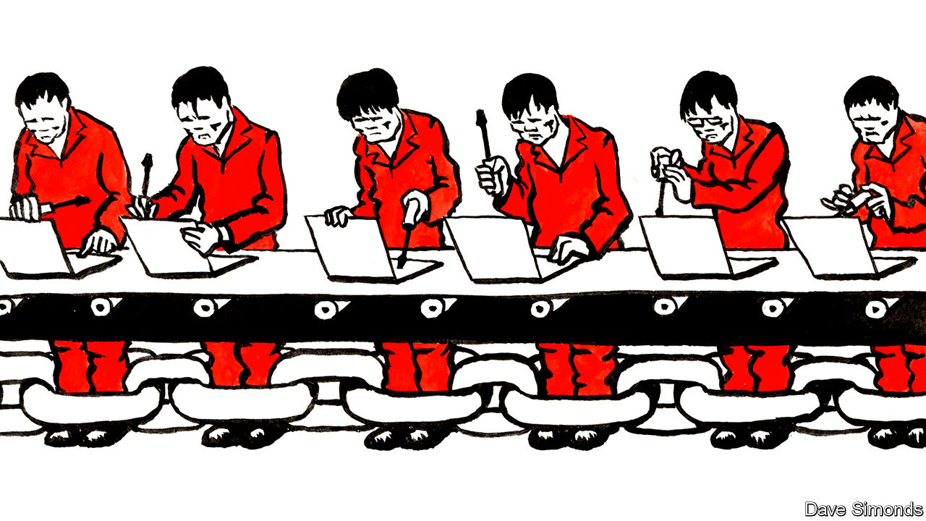

AT THE END of last year the Communist Party decided to deflect some of the international opprobrium it was earning because of its vast network of detention facilities in the western region of Xinjiang. Since 2017 perhaps 1m Uighurs, a predominantly Muslim group indigenous to the area, have been thrown into the prison camps, which are officially referred to as vocational-training centres. Offences include even the most innocuous forms of piety, such as sporting long beards. The party had claimed the centres were necessary to “deradicalise” potential terrorists. Few outsiders accepted this implausible argument. So in December Xinjiang’s government declared that “all trainees” in the camps had “graduated”.

Where are they now? A report published on March 1st by the Australian Strategic Policy Institute (ASPI), a think-tank in Canberra, reveals that some former detainees in Xinjiang have swapped one form of coercion for another, and have been obliged to go work in other provinces. In 2017-19, the study found, more than 80,000 Uighurs were shipped out of Xinjiang to take jobs in factories across China under conditions that “strongly suggest forced labour”. An analysis of government documents suggests that many prisoners were transferred directly from the detention centres to their new workplaces.

Vicky Xu, the study’s lead author, found that at least 27 factories in nine provinces benefit from this labour-transfer scheme. Many are links in supply chains of prominent Western brands like Apple, Dell, Mercedes-Benz and Nike. Not all such companies may be aware of this, since big multinationals are unlikely to deal directly with every subcontractor.

China’s government openly admits that it arranges for the transfer of “surplus” Uighur workers in Xinjiang to the rest of China. The scheme, meant to reduce poverty, is known as “Xinjiang Aid”. Factories in wealthy coastal provinces, which tend to be short of labour, offer higher wages than most forms of manual work in Xinjiang, a poorer region. The government insists that participation in the programme is entirely voluntary. The foreign ministry impugns the integrity of ASPI, accusing it, without evidence, of ties with the “US government and arms dealers”.

Ms Xu acknowledges that there may be a “genuinely” voluntary component. Even so, her research indicates that once Uighur workers arrive on factory sites, their freedoms are severely curbed. Satellite imagery and first-hand accounts compiled by Ms Xu and her co-authors paint a disturbing picture. Uighur workers live in segregated quarters and eat in separate canteens from their ethnic-Han comrades. In some factories Uighurs are paid less for the same work. Relatives back in Xinjiang are said to face threats lest Uighur workers think of resigning before their contracts end.

A recent online ad for “government-sponsored” Uighur labour posted by an agent affiliated to Xinjiang’s government extols the benefits of hiring Uighurs. One such benefit is the “semi-military style of management”, says the posting. That is because a “government-appointed companion” is required to live on-site for every 50-100 Uighurs, the agent explains. The function of this “companion”, whose salary must be borne by the prospective employer, is ostensibly to prevent cultural misunderstanding between Uighurs and Han Chinese. In all likelihood, however, they are really there to snoop and to enforce discipline. “If one Uighur misbehaves, they all get sent back.” It may be a while yet before criticism of the party’s conduct in Xinjiang dries up. ■

This article was downloaded by calibre from <https://www.economist.com/china/2020/03/07/what-happens-when-chinas-uighurs-are-released-from-re-education-camps>

|  |  |  |  |
| --- | --- | --- | --- |
| Previous | Articles | Sections | Next |

|  |  |  |  |
| --- | --- | --- | --- |
| Previous | Articles | Sections | Next |

#### Chaguan

# China’s propagandists are trapped by their own rhetoric

The total victory they have promised over the new coronavirus is impossible

Mar 7th 2020 |



THE REVIEWS are not yet in, but it is safe to say that “A Battle Against Epidemic: China Combating covid-19 in 2020” has the makings of a bestseller. A project overseen by the Central Propaganda Department of the Communist Party of China, the forthcoming hardback is billed as a tribute to President Xi Jinping’s “outstanding leadership” in the fight against the novel coronavirus. With Mr Xi already dubbed “Commander of the People’s War” against covid-19 by official media, it would be a bold party committee or government office that does not order a copy. Yet those eager to reserve one in advance will need patience, because the volume has suddenly vanished from the online catalogues of the People’s Publishing House. When the book returns in some guise, as it doubtless will, the contents may have changed quite a bit. For propaganda chiefs need to rethink their rhetoric about covid-19, since they cannot hope to live up to it.

Since January hundreds of millions of Chinese have spent weeks in locked-down villages and towns, forbidden to meet friends and family. Some have had to home-school children. Others are living on savings until their workplaces re-open. Scanning social media for news, many normally apolitical citizens have been angered by reports of official cover-ups and incompetence, or by viral smartphone videos of security forces thuggishly enforcing quarantines. The same citizens have then been shocked to see controversial reports deleted before their eyes by censors.

Anxious to rally a frightened public, Chinese leaders declared all-out war on the devil virus some weeks ago. It will end, they promise, with “a complete win”. State and party news outlets have cast doctors and nurses as “white-clad and fearless warriors”. Medics killed by the virus have been hailed as battlefield martyrs.

Though China has nothing resembling a free press, some more independent voices can be heard, whether bloggers or a few big-city, commercially driven news outlets that push the limits of what may be reported. The epidemic has seen notably brave work by Caixin, a business publication whose commercial backers include Tencent, a technology giant, and which is said to have high-ranking fans, among them (it is rumoured) Wang Qishan, China’s vice-president and a former anti-corruption chief. The publication has sent several teams to Wuhan, the city at the centre of the outbreak. They reported that officials hushed up news of tests conducted in December that first discovered the new virus and then suppressed evidence that it could jump from human to human. Editorials in Caixin have argued that transparency is the key to winning public trust, because suppressing the truth fuels panic.

Caixin’s reports have been repeatedly deleted by censors. For all that, and a bit unexpectedly, its calls to level with the public also earn praise from some in the party press. That may be because greater honesty is the only way out of the trap created by early, hubristic promises of total victory. Back on February 20th, when almost all confirmed cases of covid-19 were inside the country’s borders, the China Daily boasted, “Were it not for the unique institutional advantages of the Chinese system, the world might be battling a devastating pandemic.” Now the virus has been detected in more than 70 countries, and—in the past few days—travellers have been found returning to China with infections picked up abroad. This virus is going to be around for a long time, perhaps forever. Someone will have to break that to the Chinese public.

Hu Xijin is editor-in-chief of the Global Times, a bombastic tabloid under the People’s Daily, the party’s official mouthpiece. Mr Hu notes that his own paper’s reports exposed instances of bungling by Wuhan officials. But he concedes that Caixin’s “performance on the investigative front really stood out”. Caixin’s work gives state media cause for “self-reflection”, he adds: the government press “should have played a supervising role” when city, provincial and national health officials made mistakes at the start of the outbreak.

Asked how he thinks Caixin got away with its limit-testing reporting during this crisis, Mr Hu describes a mysterious process by which Chinese media outlets sense the political currents of the day and try to align their work with “what society needs” at that moment, as he puts it. Enter the current at the right time and success can follow, he explains. “If sometimes you miss, the results might be very different.”

A provocateur who relishes explaining to Western reporters how wrong they are, Mr Hu is serene about the challenge of admitting that virus outbreaks may continue long after China eases strict quarantine rules. “If we need to change strategy, we can change any time,” the editor says, venturing that the Chinese are practical, want to go back to work and live in a country with better virus controls than “high-risk” France, Germany, Italy or South Korea. “They want to be rid of the virus. But if it can’t be defeated, we need to accept that too.”

## When in doubt, lash out

True to nationalistic form, in recent days the Global Times has accused Western nations of failing to learn from China’s resolute policies, as the world prepares for a “protracted war” against the virus. Tut-tutting about the cost of health care in America, the tabloid asked, “If a superpower fails to control covid-19 simply because many people cannot afford treatment, then can that country really be great again?”

China’s top leaders are more subtle about their blame-sharing, but still at pains to note that virus-control is now a collective, global challenge. Meeting scientists on March 2nd Mr Xi talked of “humanity’s battle against diseases” and of the tasks facing all mankind. Such language is not as stirring as books about China single-handedly saving the world. But right now the task is selling something short of total victory to a frightened Chinese public, many of whom distrust official assurances about public health. Blaming the world is a good start. ■

This article was downloaded by calibre from <https://www.economist.com/china/2020/03/07/chinas-propagandists-are-trapped-by-their-own-rhetoric>

|  |  |  |  |
| --- | --- | --- | --- |
| Previous | Articles | Sections | Next |

|  |  |  |
| --- | --- | --- |
| China | Sections | Europe |

Middle East and Africa

Syria’s war: The battle for Idlib

.

Israeli politics: In limbo

.

Democracy in Africa: Generation game

.

|  |  |  |
| --- | --- | --- |
| China | Sections | Europe |

|  |  |  |  |
| --- | --- | --- | --- |
|  | Articles | Sections | Next |

#### The battle for Idlib

# As Turkey pounds the Syrian army, Russia wants to talk

Two tetchy autocrats, one propped-up tyrant and a big bloody mess

Mar 5th 2020 | BEIRUT AND ISTANBUL

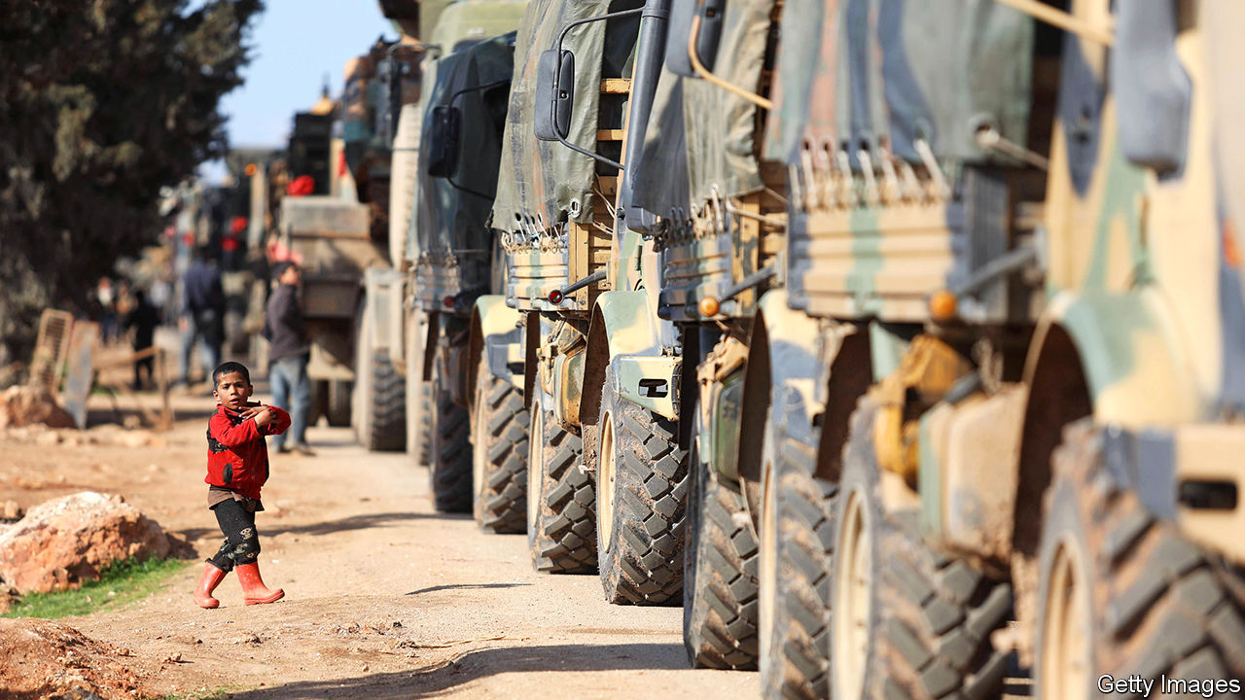

THE SYRIAN army is still better at stealing refrigerators than at fighting rebels. But after a decade of war it at last looked to be learning better tactics. Instead of sending lone tanks to bounce through the hills, some units fighting in Idlib, the last opposition-held province, have worked together, with columns of armour backed by infantry. In recent days, though, grainy black-and-white footage has shown those tanks being pulverised from overhead, their crews helpless to fight back.

Long accustomed to squaring off with ill-equipped rebels, Bashar al-Assad’s men are unexpectedly battling the second-largest army in NATO. The clash began on February 27th when an air strike on a Turkish convoy killed at least 36 soldiers, the deadliest attack on Turkish troops in more than two decades. It is still unclear whether Syrian or Russian jets dropped the bombs. But Turkey has chosen to respond to Syria with a barrage of drone strikes and artillery that have dealt Mr Assad’s regime its worst blow in years. It has also brought Turkey to the brink of conflict with Russia, Mr Assad’s biggest foreign backer.

As The Economist went to press, the leaders of Russia and Turkey were to hold a meeting in Moscow. President Recep Tayyip Erdogan entered with a stronger hand than he had just weeks ago. He wants to stop the Syrian regime from retaking Idlib and forcing millions more desperate refugees across the border. Caught between a furious Mr Erdogan and a recalcitrant Mr Assad, Vladimir Putin cannot offer much. He and Mr Erdogan might agree on a new demarcation line to separate Turkish and Syrian troops, an updated version of the deal they made in Sochi in 2018—which quickly fell apart. That may only delay the reckoning, but may be enough to stanch the current fighting. In the long run, Turkey’s intervention may also benefit Russia, by demonstrating to the Syrian regime that it cannot endure without Russian support.

That should now be painfully clear to Mr Assad. Although there are no precise statistics on his losses (both sides have an incentive to fudge them), even regime loyalists say hundreds of Syrian soldiers have been killed by Turkish strikes. The casualties also include members of Hizbullah, a Lebanese militia that backs Mr Assad, and other Iranian-trained militias stocked with Afghan and Pakistani fighters. A video posted on social media showed Syrian troops roaming Idlib in an ambulance (itself a war crime), desperately trying to hide from Turkish missiles. Scores of Syrian tanks have been destroyed or captured.

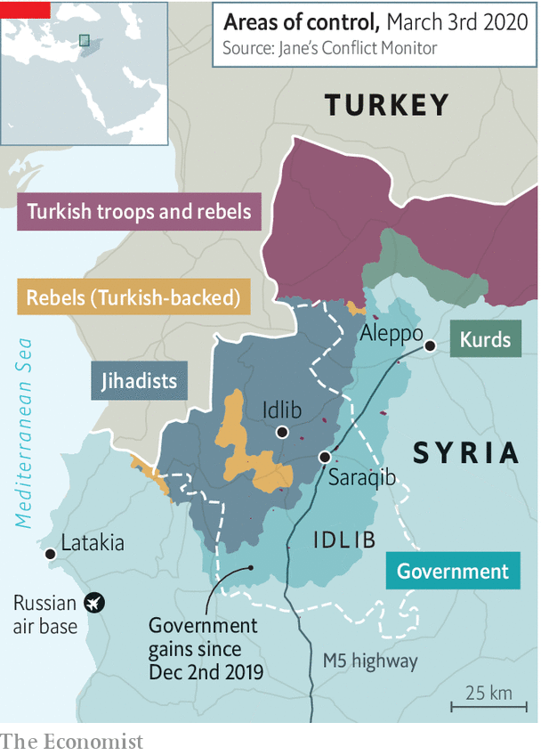

Turkey hit back mostly with unmanned drones. They fly low and slow, without the range or payload of America’s hulking Reapers. But they pack enough punch to wreck armoured units. Syria’s air defences, never very strong, were useless against swarms of drones orbiting overhead. After Syrian jets shot one down, a Turkish F-16 downed two of the Syrian planes.

The Turks could do this because Russia sat on the sidelines. On February 29th Mr Erdogan asked his Russian counterpart to “get out of the way” in Idlib. Mr Putin temporarily obliged, letting Turkey save face and claim retribution. Russian jets were grounded for much of the weekend and air-defence batteries kept quiet. Mr Putin probably cares more about economic and military ties with Turkey than about Syria. He would love to split Turkey from NATO and the European Union.

Still, he cannot indulge Turkey forever, because he cannot afford to see Mr Assad fall. Before the latest clash in Idlib the regime seemed on track to recapture all of the province, home to millions of Syrians displaced from elsewhere. Now Hizbullah and Iran have had to rush in reinforcements to help a Syrian army on the defensive. Letting Turkey slaughter Mr Assad’s forces would hurt Russian credibility and could force the Kremlin to send more of its own men to defend Mr Assad’s gains.

In recent weeks the focal point of fighting has been Saraqib, a town in eastern Idlib that sits on the M5, the main north-south highway. If rebels control it they can block transport between Damascus, the capital, and Aleppo, Syria’s one-time commercial hub. Saraqib, now under regime control, has changed hands three times since late February. On March 2nd the Russian defence ministry announced that it would deploy military police there.

They have little to police: Saraqib has few people left. But a Russian presence would limit Turkey’s freedom of action, unless Turkey were willing to engage Russian troops directly. That is unlikely, especially if Turkey’s NATO allies were against it. Neither America nor European states relish another intervention in the Middle East, least of all a direct clash with Russia.

Turkey has not helped its case in the West. Its dalliance with Moscow, last year’s offensive against Kurdish insurgents in Syria, the readiness to use refugees to put pressure on Europe, and a series of other rows have damaged its reputation. Another offence was its purchase of Russia’s S-400 air-defence system. America refuses to sell Mr Erdogan its own Patriot missiles unless it mothballs the Russian batteries.

Though Turkey inflicted painful damage on the Syrian regime, its own casualties put Mr Erdogan in a tight spot at home. He was already under fire for his Syria policy, even among friends. Most Turks want the 3.6m Syrians living in Turkey to go. His threat to grant them free passage to Europe has played well at home. But if he cannot prevent Idlib’s collapse he will face further criticism for leaving Turkish troops vulnerable on the battlefield, without a clear mandate. Mr Erdogan enjoys a reputation as a neighbourhood tough who helped turn Turkey from a Western client state into a regional power. “A major setback in Idlib would be a major setback to his image,” says Galip Dalay of Oxford University.

In the end, Messrs Erdogan and Putin face similar dilemmas. They want to contain the conflict, leaving Idlib as a buffer zone between Turkey and regime-held Syria. Vladimir Frolov, an expert on Russian foreign policy, points to the Donbas in eastern Ukraine as a model. Mr Assad, though, still wants to reclaim the last bits of his ravaged kingdom. Turkish ire and Russian insouciance may force him to back off, for now. But no one has a real solution for Idlib—and for the millions of exhausted, desperate civilians trapped inside. ■

This article was downloaded by calibre from <https://www.economist.com/middle-east-and-africa/2020/03/05/as-turkey-pounds-the-syrian-army-russia-wants-to-talk>

|  |  |  |  |
| --- | --- | --- | --- |
|  | Articles | Sections | Next |

|  |  |  |  |
| --- | --- | --- | --- |
| Previous | Articles | Sections | Next |

#### Limbo time

# Binyamin Netanyahu’s party has come out on top in Israel’s election

But he will still struggle to form a government

Mar 5th 2020 | JERUSALEM

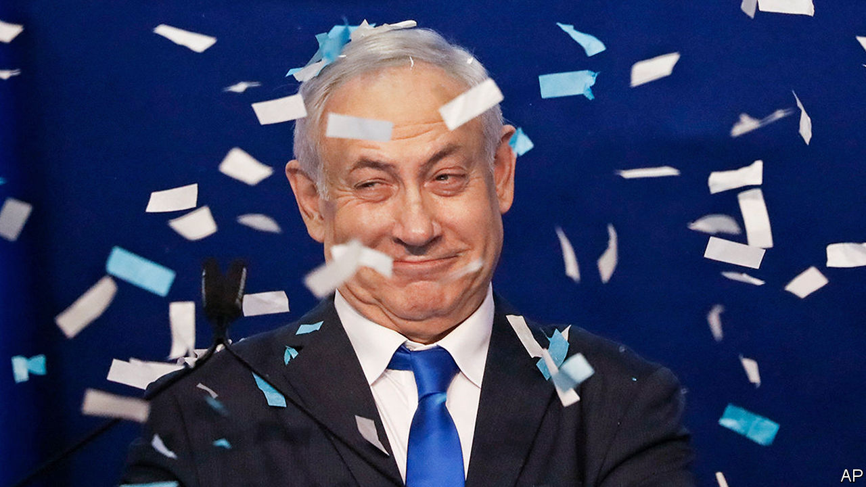

NEVER COUNT out Binyamin Netanyahu. For the past three decades that has been the cardinal rule of Israeli politics. And it was reinforced on March 2nd, when the 70-year-old prime minister pulled off another electoral feat. Mr Netanyahu’s party, Likud, has won the most seats (36) in Israel’s parliamentary election—the third in less than a year. But his coalition of nationalist and religious parties is three seats short of a majority in the 120-member Knesset (parliament).

The previous two ballots, in April and September last year, failed to produce a government. There is no guarantee that this one will either. But Mr Netanyahu has momentum. When Likud was overtaken by Blue and White, its main rival, as the largest party in September, some wrote Mr Netanyahu’s political obituary. More earth was shovelled into his grave when, in November, the attorney-general indicted him for bribery and fraud. Mr Netanyahu, though, hung on, denying any wrongdoing. In December he soundly defeated a challenge to his leadership of Likud. Then he launched a blistering re-election campaign.

Already Israel’s longest-serving prime minister, Mr Netanyahu had plenty to brag about on the stump. He has kept Israel secure, improved ties to Arab states and overseen a growing economy. What is more, President Donald Trump has given him a succession of political gifts: the recognition of Jerusalem as Israel’s capital, the isolation of the Palestinian Authority and, most recently, a peace plan that gives Mr Netanyahu almost everything he wants.

Yet the prime minister’s campaign was defined by its dirtiness. Mr Netanyahu questioned the mental health of Benny Gantz, Blue and White’s leader and a former military chief of staff (appointed by Mr Netanyahu). He even suggested that Mr Gantz had been blackmailed by the Iranians. Mr Netanyahu’s son, Yair, tweeted about alleged infidelity by Mr Gantz. As President Reuven Rivlin, a Likud member, cast his ballot, he lamented that the campaign had declined “to the point of filth”.

But Mr Netanyahu also relied on data to target micro-constituencies, such as immigrants, cab drivers and airline employees. He bombarded each with promises, such as telling cannabis-users that he would decriminalise the recreational use of the drug, and delaying a measure that would make taxi fares more transparent.

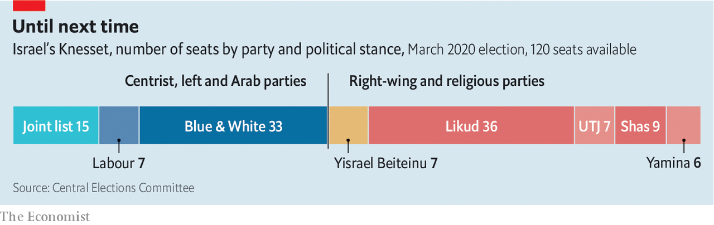

Mr Gantz’s strategy was to appeal to “soft-right” voters fed up with Mr Netanyahu’s alleged corruption. But this made the party almost indistinguishable from Likud, and many voters stuck to the original. Blue and White won 33 seats, as in September. Left-wing parties suffered. The coalition of Labour, Gesher and Meretz won just seven seats, down from 11 in September. Some of its former voters supported the Joint List, an alliance of predominately Arab parties, which got 15.

The parties that oppose Mr Netanyahu won a small majority, but are divided. Right-wing members of Blue and White and the nationalist Yisrael Beiteinu party refuse to work with the Joint List. So Mr Netanyahu will probably be given the first chance to form a government. If so, the Supreme Court might intervene. It will undoubtedly be asked to decide whether Mr Rivlin can legally invite someone under criminal indictment to assemble a coalition. Senior members of the opposition are also talking about changing the law in order to ban an indicted politician from forming a government. “Gantz is trying to steal the election,” says Mr Netanyahu.

Even if he is given the green light, Mr Netanyahu has work to do. His coalition won 58 seats, so he needs to peel off three opposition members to get a majority. Alternatively he could cut a deal with Blue and White. During the campaign Mr Gantz ruled out serving under an indicted prime minister. But his poor result might soften his stand. On election night he insisted only that the allegations against Mr Netanyahu be heard in court. The prime minister’s trial is due to begin on March 17th (though some in his coalition still hope to grant him retroactive immunity).

The outcome also raises the question of annexation. Mr Netanyahu has promised to proceed with Mr Trump’s peace plan, which allows Israel to apply sovereignty to large parts of the occupied West Bank, including the Jordan Valley. The prime minister has been working with the Americans on how to move forward. He may feel that action needs to be taken before Mr Trump might have to vacate the White House. And becoming the man who brought more of the promised land under full Israeli control would make for an excellent campaign slogan in case a fourth election is required to break the deadlock. ■

This article was downloaded by calibre from <https://www.economist.com/middle-east-and-africa/2020/03/05/binyamin-netanyahus-party-has-come-out-on-top-in-israels-election>

|  |  |  |  |
| --- | --- | --- | --- |
| Previous | Articles | Sections | Next |

|  |  |  |  |
| --- | --- | --- | --- |
| Previous | Articles | Sections | Next |

#### Generation game

# Young Africans want more democracy

Their ageing rulers are finding new ways to thwart them

Mar 7th 2020 | COTONOU, KHARTOUM AND LILONGWE

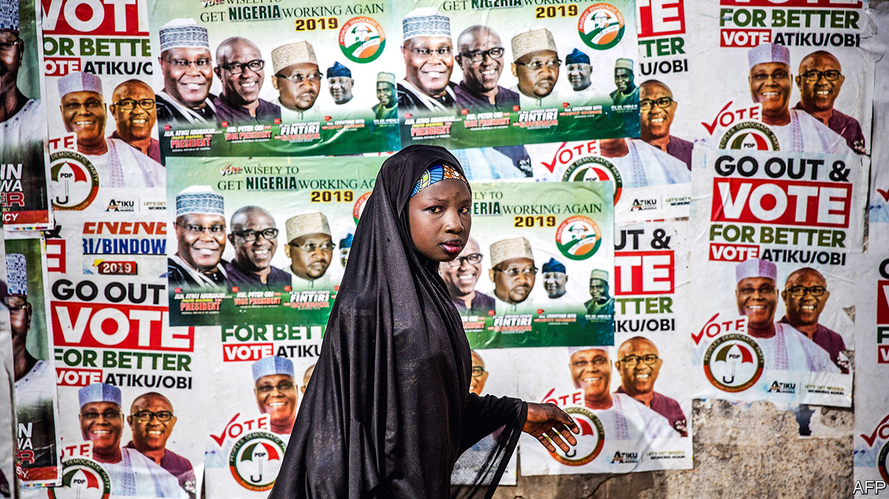

ONE DAY in January Comlan Hugues Sossoukpe awoke before dawn in Lomé, the capital of Togo, and slipped across the frontier to a safe house in Benin. It was only the second time he had been in his home country since May, when he fled after being charged with “breaching public order”. His apparent crime: writing about how troops loyal to Patrice Talon, Benin’s president, shot peaceful protesters.

The 33-year-old—eloquent, passionate, tired—explains that activism is a family trait. His father spent years on the run and three uncles were sent to labour camps for opposing the dictatorship of Mathieu Kérékou, one of dozens of autocrats who bestrode Africa in the 1970s and 1980s. His relatives fought for Benin’s trailblazing shift to multi-party elections in 1991, a move that was replicated by most African countries by the end of the decade. “I consider myself a child of democracy,” he says.

Like many such offspring he is frustrated with his inheritance. Until recently Benin was a bastion of liberty. But the government of Mr Talon, a tycoon elected president in 2016, has stuffed courts with cronies, excluded opposition parties from elections, shut down the internet and arrested journalists. Each year Freedom House, a watchdog in Washington, publishes a global assessment of democracy, giving each country a score out of 100. Benin’s decline in 2019, from 79 to 66, or from “free” to “partly free”, as per the report’s categories, is one of the largest drops ever for an African country. “Now that our freedoms are being lost we realise what we had,” reflects Mr Sossoukpe.

No one story can epitomise the hopes of a country, never mind a continent. But Mr Sossoukpe is far from alone in his aspirations. Across Africa the demand for democracy is outstripping supply. Young, urban populations want the right to express themselves, vote in fair elections and hold leaders to account—at the same time as already flawed democracies are becoming more so. It is a mismatch that will shape the continent. “Younger Africans do not want to go back to one-party states or military rule,” says Chris Fomunyoh of the National Democratic Institute, another American watchdog. “They want to improve on the baseline they’ve been given.”

That is not an easy starting-point given the history of post-colonial Africa. Departing European powers made only cursory efforts to leave behind democratic institutions. Their priority was to leave quickly, keeping business and diplomatic ties. By the end of the 1970s just three countries in sub-Saharan Africa were definitively multi-party democracies (Botswana, the Gambia and Mauritius). More than two-thirds had undergone military rule. There were at least 40 coups.

The colonial legacy is one reason why nearly every country became authoritarian. Africa has more than 2,000 languages and 6,000-10,000 political groupings. Europeans drew borders with callous disregard for facts on the ground. They ruled using coercion and co-option, devolving power to tribal leaders, some of whose chiefly credentials were invented, as was the case with the Igbo in Nigeria. When they took over weak and diverse states, new leaders often adopted tools of repression and patronage.

Following colonial ways was often the easiest path. But rejecting Western-style democracy was a choice that several African leaders consciously made. Tanzania’s Julius Nyerere argued that multi-party democracy was “unAfrican”. One-party states, he said, better reflected a culture where consensus was prized.

Other leaders were less erudite. The 20th century saw a rogue’s gallery of dictators: murderous despots like Jean-Bédel Bokassa (Central African Republic) and Idi Amin (Uganda); ostentatious kleptocrats such as Mobutu Sese Seko (Congo) and Sani Abacha (Nigeria); charismatic megalomaniacs such as Kwame Nkrumah (Ghana); paranoid rulers like Daniel arap Moi (Kenya) and Hastings Banda (Malawi). Banda ran seven different security services and banned the song “Cecilia” by Simon & Garfunkel because it offended his unofficial first lady, Cecilia Kadzamira.

By the time the Soviet Union collapsed many African economies were broke. That led to protests and the fall of some tyrants previously propped up by Moscow. It also made it easier for a self-confident West to insist on elections as a condition of aid or credit. By 1994 only 35 countries in sub-Saharan Africa had held elections; by 2010 just two had not (Eritrea and Eswatini, formerly Swaziland). Academics call this era the “second wave” of democratisation, three decades after independence.

Authoritarian rulers used patronage networks to woo pliant elites, especially those of their own ethnic group. They ran what Frederick Cooper, a historian, calls “gatekeeper states” that controlled access to foreign aid, receipts from natural-resource exports and taxes on trade. Since they relied on minerals and foreigners for cash, rather than income taxes, they had little incentive to nurture an urban middle class, and little accountability to their own people. They kept the rural poor in line with handouts and threats. They prized loyalty over competence.

## The ballot boxes are stuffed

Dictators and military coups are now rarer than they were during the cold war. But most African countries display what political scientists call “electoral authoritarianism”, where the pageantry of voting obscures a lack of genuine democracy. Elections are regular but regularly rigged.

The picture seems to have deteriorated. Freedom House classifies just seven countries as “free”—the lowest total since 1990.

Southern and west African countries are typically more free than those in the east and central regions. A few states have liberalised in the past two years. Under Abiy Ahmed, Ethiopia’s prime minister, political prisoners have been released, among other reforms. Last year Sudanese toppled Omar al-Bashir, a genocidal dictator. New governments in Angola and Mauritania have begun to loosen up. But the overall trend is disappointing.

This is especially true of countries once seen as bright spots, such as Benin and Zambia, the first two African countries (Mauritius apart) whose presidents were ejected at the ballot box, both in 1991. In Benin Mr Talon rejects what his communications minister, Alain Orounla, calls the “Nescafé democracy” of the 1990s—instant and bitter. In Zambia President Edward Lungu has, among other moves, leant on courts to allow him to run for a third time in 2021. Under John Magufuli, president since 2015, Tanzania has arrested opposition MPs and journalists, shut media outlets and passed laws to muzzle dissidents. The government urges neighbours to snitch on gay people so they can be punished. It expels pregnant girls from school.

The closing of the public space is apparent elsewhere. Polls by Afrobarometer, a pan-African research organisation, find that the share of Africans who say they are free to say what they think declined from 79% in 2008 to 70% in 2018. From 2004 to 2018 12 African countries passed laws making it harder for NGOs to operate. Another six are planning to do so. Reporters Without Borders said that 22 out of the 48 sub-Saharan African countries were “bad” or “very bad” places for journalists: they have recently been killed (in Somalia), banned (Burundi and Congo) and arrested (Cameroon, Liberia and Tanzania, among others).

Technology is boosting Big Brother. Huawei has reportedly helped Uganda and Zambia to spy on political opponents. Rwanda’s regime has allegedly hacked messages of perceived enemies. Of the 21 countries that shut down the internet last year, 12 were African.

The international environment is making it easier for authoritarian regimes, too. Africa’s democratic backsliding is not unique. Freedom House’s average global score has declined for 14 consecutive years. And anti-democratic powers are vying for the ears of African leaders.

China is the most influential. It lends more money and sells more arms to sub-Saharan Africa than any other country. The Communist Party also runs courses for ruling parties across the continent, including those from South Africa, Angola, Namibia, Tanzania and Ethiopia.

Russia is much less powerful but more brazen. It focuses on fragile resource-rich countries. Since 2018 Russian military advisers have served President Faustin-Archange Touadéra in the diamond-rich, horribly corrupt Central African Republic.

Chinese and Russian action goes alongside Western inaction. There was no mention of “democracy” in the speech outlining the Trump administration’s “Africa strategy” in December 2018—a change from previous presidencies. Though some members of repressive regimes, such as Zimbabwe’s, have been subject to American sanctions, Donald Trump’s priority is to woo states away from Chinese and Russian influence. So in Congo, for example, America, with reluctant European backing, welcomed the election of President Félix Tshisekedi, despite copious evidence that he lost by miles to another candidate.

International institutions have been similarly weak. The World Bank is reluctant to stop aid for odious regimes even when local activists, as in Tanzania, have asked it to do so. The Southern African Development Community, a regional group, is seemingly incapable of criticising rigged elections. West Africa’s equivalent, ECOWAS, has on occasions stuck up for democracy and against coups, but has been less critical of slides towards autocracy since the election of Muhammadu Buhari as Nigeria’s president in 2015.

Outsiders may care little about African democracy. But there is no such apathy on the continent itself. In an Afrobarometer poll of 34 countries published in 2019, 68% of Africans said that democracy was the best form of government, a share that was broadly stable over the previous decade. The figure is higher when respondents are presented with specific alternatives; 78%, for example, said they would not give up multi-party elections for strongman rule. It is possible that more Americans than Africans are tempted by authoritarianism. According to the World Values Survey, a research project, 24% of Americans, and 32% of those without a degree, say that a “strong leader” who does not have to bother with Congress or elections is a “fairly” or “very” good idea. (These shares were higher before Mr Trump became president.)

Though Africans remain keen on the idea of democracy, frustration with the reality has risen. In the late 1990s only about a quarter of respondents in a sample of 14 African countries tracked by the Centre for the Future of Democracy at the University of Cambridge expressed “dissatisfaction” with democracy. By the 2010s that had risen to about a half.

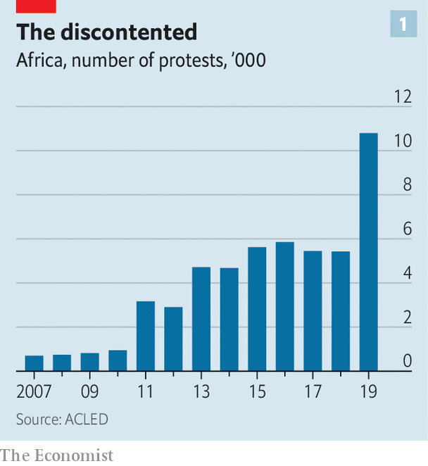

Dissatisfaction is reflected in the rising number of protests. In 2019 there were 10,793 demonstrations in Africa, according to the Armed Conflict Location & Event Data Project, compared with 819 in 2009 (see chart 1). And whereas demonstrations typically lasted for days or weeks, recent cases in, say, Malawi, Sudan, Togo and Guinea have gone on for many months.

The imbalance between how much democracy young Africans want and how much they have is altering political dynamics. “The game has changed,” argues Judd Devermont of the Centre for Strategic and International Studies, a think-tank in Washington. Politics is becoming more competitive and less predictable. Or as a report by America’s National Intelligence Council put it in 2018: “This tug-of-war between leaders and their publics will become more intense.”

The winners will vary, depending on the balance of forces in each country. On one side are the electoral authoritarians, operating in a conducive international environment. On the other are trends that will make their reigns more difficult.

One is demography. Africans are young. Most were born in the 21st century (most people in the EU were born before 1978). They are also rapidly urbanising: 21 of the world’s 30 fastest-growing cities are in Africa. Both trends are disruptive for old parties run by old men that depend on old rural voters. Young Africans, like young people almost everywhere, have weaker ties to traditional parties. African city-dwellers are more likely to oppose incumbents than their rural peers, who are less well educated, have fewer sources of information and are more easily intimidated.

Africa’s young populations have inspired breathless talk of a “demographic dividend”. But because birth-rates remain high, the share of working-age people in African countries remains generally lower than in Asian countries in the 20th century. African economies are also not producing enough opportunities for young people—another destabilising force. Economic growth for sub-Saharan Africa will be about 3.4% per year over the next five years, predicts Capital Economics, a consultancy in London. That is not much faster than population growth.

And it is bad news for the 1m or so Africans who enter the labour market every month. Fewer than one in four will get a formal job, reckons the Africa Growth Initiative based at the Brookings Institution, another Washington think-tank. The rest face a more precarious future in the informal sector—precisely the type of jobs done by those who swell political protests. Data from the World Bank suggest that social mobility is lower in Africa than in almost any other part of the world.

It is no coincidence that the wellsprings of protests are slums. Some politicians are already tapping discontented young voters. Bobi Wine, the self-styled “ghetto president” running against Yoweri Museveni in next year’s presidential election in Uganda, is only the most eye-catching.

Lisa Mueller, a political scientist, argues that demonstrations are inspired by a mix of middle-class (usually older) people’s demands for political freedoms and poorer (usually younger) people’s economic grievances. The mix was apparent in Sudan, as protests sparked by rising bread prices combined with opposition to dictatorship.

There was a similar breadth to protests in Malawi against the dubious re-election of Peter Mutharika, the 79-year-old president, in May 2019. (Dollops of Tipp-Ex were used to alter tally sheets.) The demonstrations led to the Constitutional Court in February ordering a rerun, only the second time judges have done so in African history, following Kenya’s example in 2017.

## A great day for freedom

For some it was mainly a victory for freedom. “We can perhaps say that our democracy has begun, 26 years after [the end of Banda’s dictatorship],” reflected Danwood Chirwa, a Malawian lawyer. Younger protesters, however, had more material things on their minds. “I hope for change of government and with that change I will start a small business because the opportunities under the current government are very limited,” said Pikilana Maliza, an unemployed 23-year-old from a township in the capital, Lilongwe.

Malawi’s doughty judges show the importance of institutions. Strong judiciaries, parliaments and the like are checks on arbitrary power. And while many are under political influence, some are willing to act as vehicles for those campaigning for greater democracy.

Take African legislatures. They are often dismissed as rubber-stamp institutions. But they have helped ensure that, since 1990, all but seven of the 47 countries in sub-Saharan Africa that have non-ceremonial heads of state have term limits. These limits are more than twice as likely to be kept as broken.

Institutions cannot always restrain a determined autocrat, but they can raise the costs of him repressing his people and clinging to power. This is one reason why there has been a rise in the number of peaceful, if not always democratic, changes of government (see chart 2). There have been 29 non-violent transfers of power since 2015, compared with just nine in the first half of the decade. Of the 49 sub-Saharan leaders in charge at the start of 2015, just 22 are in place today. Many of these changes reflect deals among elites, such as the one that brought Abiy to power in Ethiopia. But they show that political systems do respond to pressure.

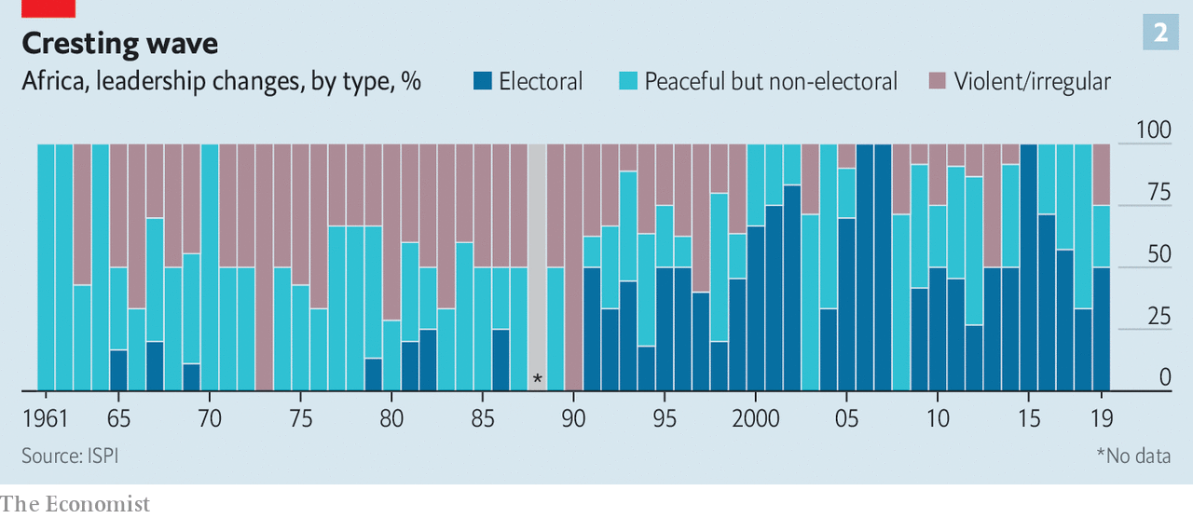

The forces for and against democracy will shape African countries in different ways. Nic Cheeseman of the University of Birmingham expects there to be a “growing democratic divide” on the continent, as politics in countries such as Botswana, Ghana, Namibia and South Africa become more competitive, while authoritarian states become more repressive.

The future of more fragile democracies, like Benin, is less certain. But Mr Sossoukpe is determined to ensure that the repression unleashed by Mr Talon is temporary. Citing the role of his father who helped topple Kérékou, the dictator, he adds: “I see it as a duty to my children to keep fighting.” ■

This article was downloaded by calibre from <https://www.economist.com/middle-east-and-africa/2020/03/07/young-africans-want-more-democracy>

|  |  |  |  |
| --- | --- | --- | --- |
| Previous | Articles | Sections | Next |

|  |  |  |
| --- | --- | --- |
| Middle East and ... | Sections | Britain |

Europe

Refugees: You shall not pass

.

The euro area: A series of unfortunate events

.

Ireland: Shape-shifters

.

Slovakia’s election: A different kind of populism

.

France: Aux powerpoints, citoyens!

.

Charlemagne: Minority Report: Brussels edition

.

|  |  |  |
| --- | --- | --- |
| Middle East and ... | Sections | Britain |

|  |  |  |  |
| --- | --- | --- | --- |
|  | Articles | Sections | Next |

#### No refuge

# Turkey threatens to let asylum-seekers flood into Europe

But Greece and the EU are refusing to let them in

Mar 7th 2020 | ATHENS AND EDIRNE

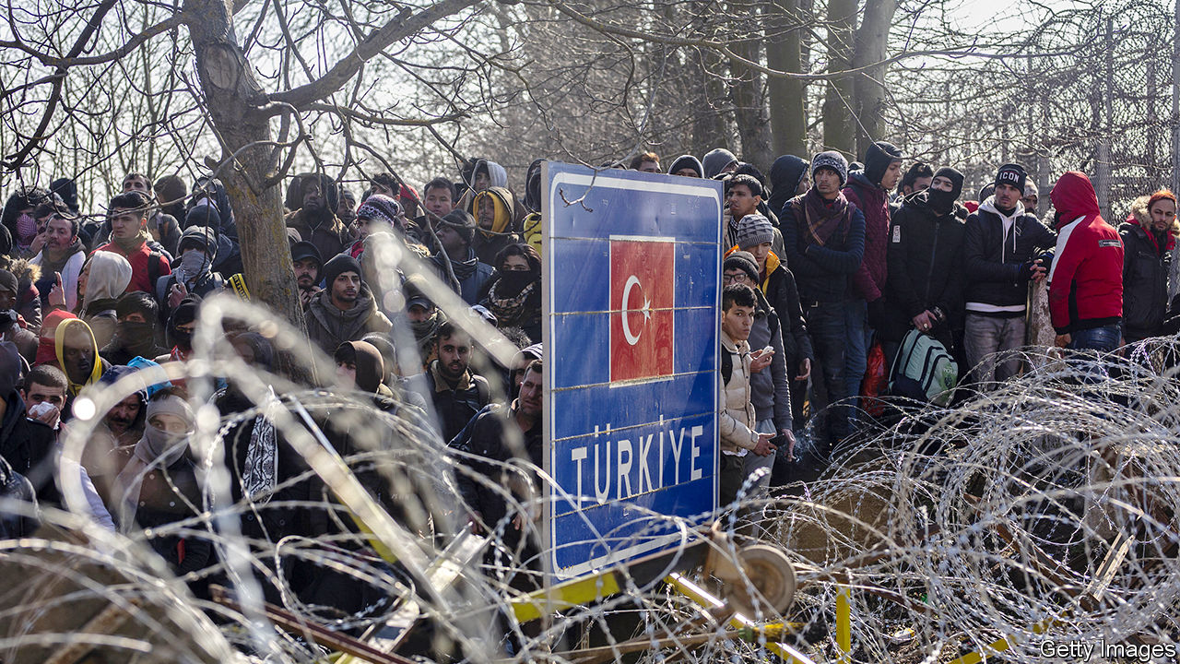

WHEN President Recep Tayyip Erdogan announced on February 28th that his government would no longer stop refugees from crossing into Greece, Nabila’s parents packed her and her five siblings onto a bus, left their house in the Turkish town of Tokat and headed west. The 12-year-old Afghan refugee had no chance to say goodbye to her Turkish classmates. No one bothered to tell Nabila and her family that the Greek side of the border would be closed. So they and dozens of other migrants have spent the past five days in a field on the banks of the Maritsa River, which separates the two countries, with armed Greek guards on the far side. “We have to keep waiting for the border to open,” says Nabila, translating for her father (she learned fluent Turkish at school). “We have no money to go back.”

Nabila and the tens of thousands of other migrants who took up Mr Erdogan’s empty promise of free passage to Europe are now trapped in an international standoff. Turkey is home to 3.6m refugees from the war in Syria, and polls show most Turks want them to leave. Turkey says it opened the border to Greece in the face of an imminent influx of another 1m refugees from bloody fighting in Idlib (see article). More likely, it wants to divert attention from its military problems there.

In response, Greece began forcibly turning back migrants. It sent riot police, armoured vehicles and 1,000 soldiers to the border, and suspended the right to apply for asylum for a month. The European Union rushed to Greece’s aid. After a visit to the border on March 3rd, Ursula von der Leyen, the president of the European Commission, promised €700m ($780m) in emergency assistance, along with seven vessels, two helicopters, a plane and extra guards from Frontex, the EU border agency. European foreign ministers will meet on March 6 to discuss further measures.

Turkey and the EU are stuck in an uneasy bargain over refugees. After more than 1m migrants entered Europe from Turkey in 2015-16, the two sides came to a deal. The EU offered Turkey €6bn in aid for refugees. Turkey promised to do whatever it could to prevent them from leaving, and to take back any migrants who reached Greece but had their applications for refugee status rejected. But the aid ran out at the end of last year. Mr Erdogan says he turned down an offer of another €1bn as insufficient; the EU denies making the offer.

Since the deal was first signed, Mr Erdogan has often threatened to let migrants stream into Europe again. On February 29th, as more than 10,000 people stepped off buses and passed through a Turkish checkpoint near the town of Edirne, “it looked as if our nightmare scenario ... was coming true,” said a Greek diplomat. Greek border guards blocked the migrants, who became trapped between the checkpoints. On March 2nd police fired tear-gas on the crowd, and the Greek military staged an exercise nearby using live artillery. Intimidated, some migrants have begun returning to Turkey.

The other main route into Greece has been via inflatable dinghy to Lesbos, an island just five miles (8km) off the Turkish coast. The number of migrants rose there too, with some 1,200 arriving on March 1st and 2nd alone. But the island is already overcrowded with migrants, including 19,000 in a camp built for 3,000, and locals have grown weary of the burden. Some migrants say their boats have been attacked by unidentified men who push them back towards Turkey. A small boy drowned on March 2nd when a dinghy capsized; the Greek coastguard rescued the others.

Greece’s tough response has forestalled another crisis like that of 2015 (the numbers remain tiny, see chart), and it has the support of the EU. But its suspension of the right to apply for asylum violates international and European law. The International Convention on Refugees bars countries from turning away people seeking asylum, a practice known as “refoulement”. “The minimum that a state has to do is to check whether those who come to its border have a right to refugee status, and you can’t do that if you’re keeping them at a distance with tear-gas,” says Hanne Beirens of the Migration Policy Institute Europe, a think-tank in Brussels.

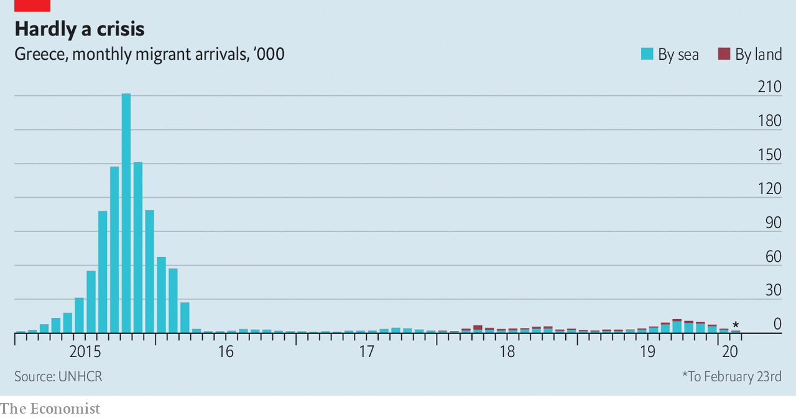

Greece has invoked anarticle of the EU Treaty that allows emergency measures when a state is overwhelmed by migrants. But that does not include suspending asylum, according to UNHCR, the UN’s refugee agency. Gerald Knaus, an expert who helped design the EU-Turkey migration pact, says the suspension threatens the very existence of the right to asylum, and accuses the EU of implementing “Trump-style policies”. Harsh words for Greece’s newish prime minister, Kyriakos Mitsotakis, to hear.

A durable solution will require more people, presumably to be paid for by Europe as a whole, to process asylum applications in Greece, so that the EU is less vulnerable to extortion. It will also require a new deal with Turkey. Some EU foreign ministers support a no-fly zone in Idlib as part of an effort to prevent the refugee flood Turkey fears. There has been less talk of more generous aid to Turkey. That is unpopular with European voters, who tend to dislike the autocratic Mr Erdogan.

In the meantime, Greece and Europe are relying on deterrence. Turkey claims that 130,000 refugees have already headed for Greece, a wildly inflated figure aimed at satisfying domestic anti-refugee pressure. Most of them are not Syrians, but Afghans and others. No one knows the real numbers, nor how many have made it across. Those who have, and were caught, return with harrowing stories.

Ali Khoja, an Afghan teenager, says he crossed the river four times, once by swimming and three times by boat. He says the Greek police took his phone, identity papers and clothes, and sent him back in his underwear. Others say they were beaten or tasered. On March 4th migrants and Turkish authorities reported that Greek police had fired on a group crossing near the town of Pazarkule, killing one and wounding five; the Greek government denied it. Greece may be avoiding another migrant crisis, but it risks plunging Europe into a crisis of conscience. ■

This article was downloaded by calibre from <https://www.economist.com/europe/2020/03/07/turkey-threatens-to-let-asylum-seekers-flood-into-europe>

|  |  |  |  |
| --- | --- | --- | --- |
|  | Articles | Sections | Next |

|  |  |  |  |
| --- | --- | --- | --- |
| Previous | Articles | Sections | Next |

#### A series of unfortunate events

# Covid-19 risks tipping Germany and Italy into recession

Both economies have already borne a number of blows

Mar 7th 2020 |

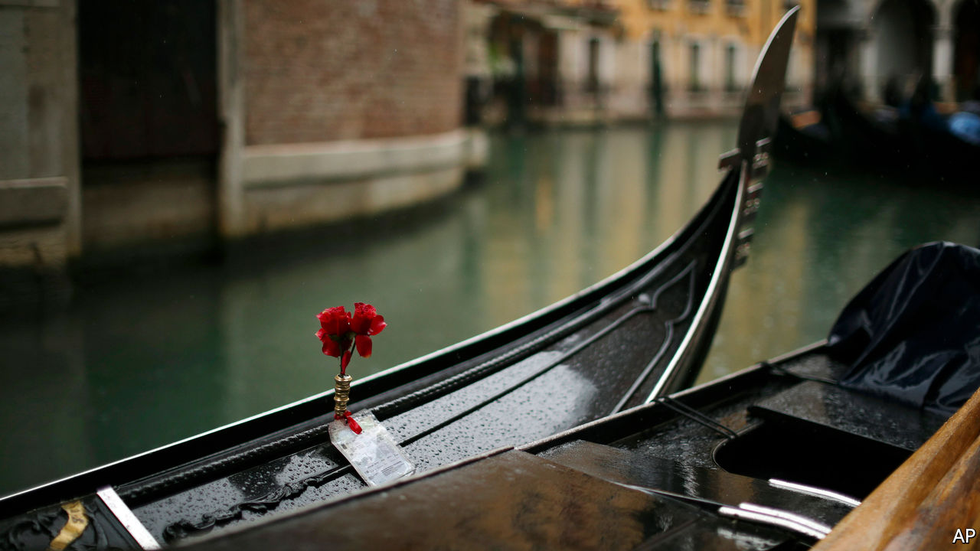

BAD WEATHER, trade war, changes to car-emissions testing, and low water levels in the Rhine: since 2017 Europe’s economy has been struck by a number of shocks, none of which hapless finance ministers or central bankers could control. Last year euro-area GDP rose by only 1.2%. Germany and Italy, which as big manufacturers were most exposed to America’s trade war with China, sank to the bottom of the zone’s growth rankings.

Now covid-19 is spreading across the continent. Over 3,000 cases have been confirmed in Italy, and more than 200 each in France and Germany. Responding to the outbreak falls to health authorities. But the virus also deals the economy a big blow.

The economic trouble began even before the virus reached Europe. China is usually a keen buyer of European cars and other manufactured goods, gobbling up 7% of German exports. Figures for February are not yet available, but it seems certain that sales will have fallen as the epidemic took hold in China.

Disruption will also have rippled along manufacturers’ supply chains, many of which rely on parts from China, and hurt countries such as Germany. According to a survey of euro-area purchasing managers, released on March 2nd, lead times for the delivery of manufacturing parts had lengthened “appreciably” in February, with respondents attributing the delay to coronavirus-related shutdowns in China.

Added to all of this is the economic impact of the outbreak of the virus in northern Italy. The country’s most productive regions, Lombardy and Veneto, have been the most seriously affected. Together they account for nearly a third of output. On March 4th the government ordered the closure of schools and universities nationwide until March 15th. Such containment measures could force more people to stay at home, leading to a further drop in economic activity.

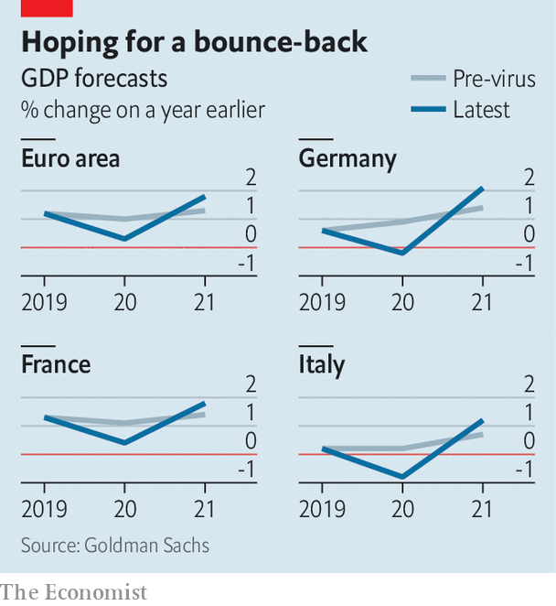

All told, another bad year for Italy and Germany seems likely (see chart). Analysts at Goldman Sachs are expecting both to fall into recession in the first half; the euro area as a whole is expected narrowly to skirt one. Forecasters are pencilling in a sharp rebound in the second half of the year. But precisely when it comes will depend on the extent to which the virus spreads and on the measures taken to contain it. Authorities in France, for instance, have banned large-scale indoor events. Some tourist attractions, such as the Louvre, have closed. That will slow the spread of the virus. But it will also drag down output: according to the OECD, tourism accounts for 7% of France’s GDP, and around 12% in Portugal and Spain.

Expectations are rising that policymakers will help companies that face the most disruption. On March 2nd Christine Lagarde, the head of the European Central Bank (ECB), promised to take “appropriate and targeted” measures to deal with the economic effects of the virus. Investors expect the ECB to cut interest rates in coming months, following the lead of America’s Federal Reserve, which on March 3rd unexpectedly cut rates. But with the ECB’s rates already at -0.5%, it has little room to prune further. Some economists expect it to tweak its cheap-lending scheme for banks at its meeting on March 12th instead, perhaps to encourage lenders to keep credit flowing to companies that have been most affected by the spread of the virus.

So far governments have shown varying degrees of enthusiasm for loosening the purse strings. Italy has promised to spend €3.6bn ($4bn) on health care and tax cuts to help companies facing the most disruption. Given the unusual circumstances, it has a dispensation from the European Commission to spend more than the EU’s fiscal rules would allow in normal times. France’s finance minister, Bruno Le Maire, is urging more spending to cushion the blow to the economy. By contrast, Germany’s government, traditionally tight-fisted, has so far done little.

This could rapidly change if the virus spreads further. Analysts from Deutsche Bank predict that euro-area GDP growth could fall at an annualised rate of 4% in the second quarter if there is a more severe outbreak, and by even more in Germany. The prospect of job losses and bankruptcies might soon jolt governments into doing a lot more. ■

This article was downloaded by calibre from <https://www.economist.com/europe/2020/03/07/covid-19-risks-tipping-germany-and-italy-into-recession>

|  |  |  |  |
| --- | --- | --- | --- |
| Previous | Articles | Sections | Next |

|  |  |  |  |
| --- | --- | --- | --- |
| Previous | Articles | Sections | Next |

#### From balaclavas to ballots

# Is Sinn Fein now a normal political party?

It is fuzzy how much the Irish Republican Army still influences it

Mar 7th 2020 | DUBLIN

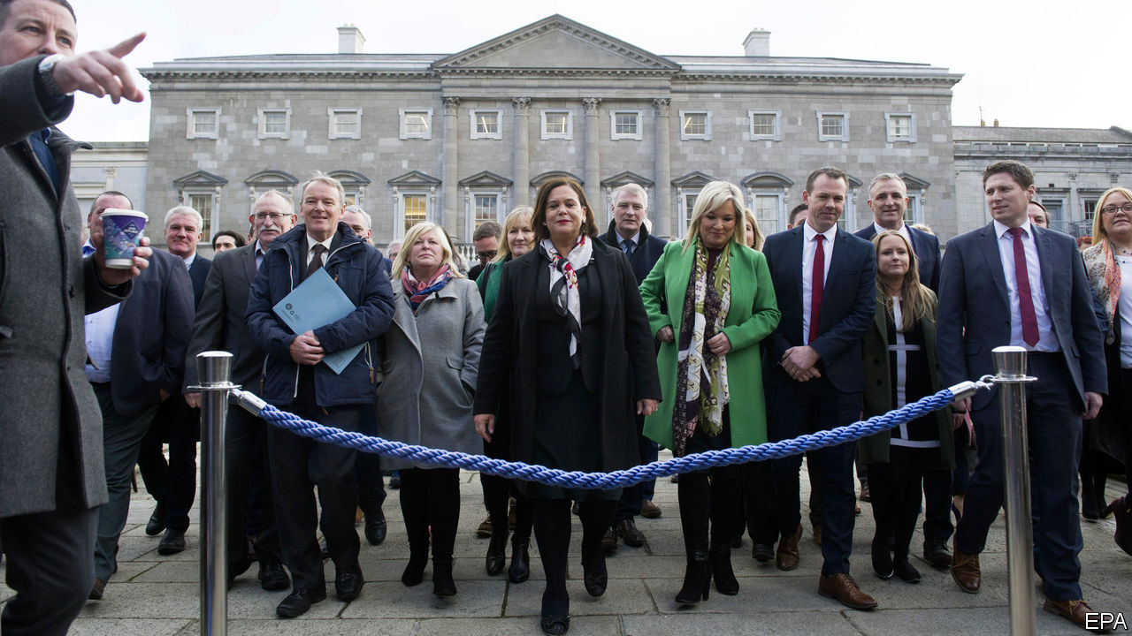

NO ONE WAS more surprised than Sinn Fein when it came first in Ireland’s general election last month. Having slumped to 9.5% of the vote in local elections last year, close to the presumed floor of support for what many still see as the political wing of the Irish Republican Army, it rebounded to 24.5% on February 8th, making it, for the first time, Ireland’s most popular party. Since the election its popularity has risen even more, with a recent poll putting it at an astonishing 35%. That may not do it much good though: Ireland’s other two big parties, the centre-right rivals Fianna Fail and Fine Gael, are still both trying to put together a government that would continue to exclude Sinn Fein from power. Despite protestations that it has moved on from the violence of Northern Ireland’s “Troubles” to become a normal party of the centre-left, it is still widely viewed with deep suspicion.

This is not the first time Sinn Fein has been transformed by events. Founded in 1905 with the moderate aim of securing a dual Irish-British monarchy in the manner of Austria-Hungary’s, the tiny movement was radicalised by the Easter Rising of 1916, which the British authorities incorrectly blamed on Sinn Fein rather than the secretive Irish Republican Brotherhood. As sympathy rallied to it after 14 leaders of the “Sinn Fein rebellion” were executed, the party won 73 of Ireland’s 105 seats in the Westminster parliament in the election of 1918. It then used that mandate to declare an independent Irish republic.

So is Sinn Fein, Ireland’s great shape-shifter, now a normal party? It has taken part in power-sharing executives in Northern Ireland since 1999. Its manifesto promises a huge surge in social spending and public housing, if it can negotiate a place in a new ruling coalition. The party’s leader, Mary Lou McDonald, is a middle-class Dubliner with no history of militant service, unlike her predecessor Gerry Adams, a central figure during Northern Ireland’s bloody troubles and widely thought to have been an IRA leader, which he denies.

But Ms McDonald also has a history of endorsing the IRA’s bloody past. Sceptics note that supporters of Dessie Ellis, a former IRA prisoner who won a seat, sang “Come Out Ye Black and Tans”, a pro-IRA ballad, to celebrate his poll victory. Another Sinn Fein candidate ended his victory speech with the IRA slogans “Up the ‘RA” and “Tiocfaidh ar la” (“our day will come”). Little wonder that many fret that the IRA, though officially disbanded, may still be pulling the strings.

Ireland’s police commissioner, Drew Harris, says he still agrees with an assessment in 2015 by the Police Service of Northern Ireland which said the Army Council of the IRA oversees Sinn Fein “with an overarching strategy”, but that its focus is now political. Ms McDonald responded that “the war is over and the IRA is off the stage. The only threat now is so-called dissident elements that actually threaten Sinn Fein because we support the police service.”

Declan Power, an analyst who served in Irish military intelligence, says that a lightly armed IRA still maintains a loose organisation to protect itself from dissident republicans who refuse to recognise the peace process, and to deter recruitment into them. One such group, the “New IRA”, is blamed for killing Lyra McKee, a journalist, in Londonderry last year. “In a way, there’s a degree of responsible thinking in place. You can’t just wind up an entire private army and put it to bed,” he says.

Aidan Regan of University College Dublin says the IRA-Sinn Fein relationship is more nuanced. “Does Mary Lou take her orders from shadowy people in West Belfast [an IRA stronghold]? I don’t think so. But someone who was heavily involved in the Army Council in the IRA, who is still a member of Sinn Fein, of course they are going to have a voice in the party.” ■

This article was downloaded by calibre from <https://www.economist.com/europe/2020/03/07/is-sinn-fein-now-a-normal-political-party>

|  |  |  |  |
| --- | --- | --- | --- |
| Previous | Articles | Sections | Next |

|  |  |  |  |
| --- | --- | --- | --- |
| Previous | Articles | Sections | Next |

#### A different kind of populism

# An anti-corruption campaigner triumphs in Slovakia

What else Igor Matovic stands for is unclear

Mar 7th 2020 |

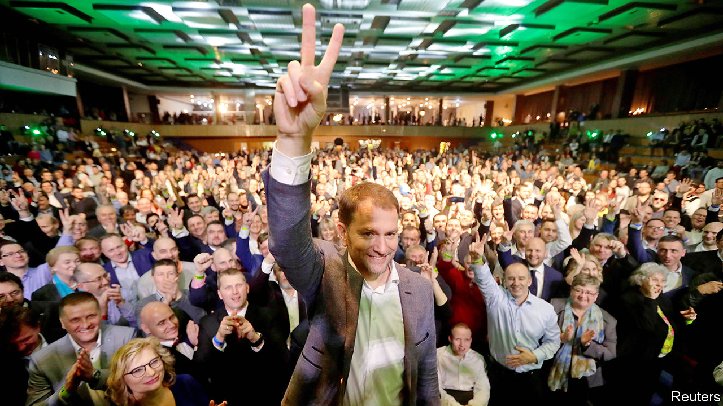

LAST MONTH Svina (“Swine”), a thinly veiled cinematic portrait of Slovakia’s venal political class, opened to record-breaking crowds. At an election on February 29th Slovakia’s voters proved similarly motivated, turning out in large numbers to kick out Smer, a left-wing party whose 12 almost unbroken years in office had become a byword for corruption and complacency. The winner, with 25% of the vote, was Ordinary People and Independent Personalities (OLaNO), a vaguely centre-right outfit that vows to clean up politics.

OLaNO was established a decade ago as a vehicle for the political career of Igor Matovic, a media baron turned anti-corruption firebrand with a penchant for publicity stunts. A skilled campaigner, Mr Matovic focused on expanding his base across Slovakia under the slogan “Let’s beat the mafia together,” while sidestepping potentially divisive issues like abortion and immigration. “A lot of people wanted to show off their anger, and Matovic was able to portray himself as a respectable figurehead for this feeling,” says Aneta Vilagi, a political scientist at Comenius University in Bratislava.

Mr Matovic’s success had much to do with the murder, in February 2018, of Jan Kuciak, a young journalist probing links between politicians, oligarchs and organised crime. The killing triggered huge protests that led to the resignation of Robert Fico, the Smer prime minister, and the election as president of Zuzana Caputova, a former environmental activist. The trial of an oligarch accused of ordering Kuciak’s murder, which began in January and continues, has exposed an alleged grubby network of co-operation between crooked politicians, judges and law-enforcement officials. All this created fertile ground for OLaNO. One-third of voters said corruption was the most important issue.

Mr Matovic’s 53 MPs, some of whom he is rumoured not to know, are a heterogenous bunch, including social conservatives brought in to appeal to Slovakia’s rural Catholic heartlands. His proposed four-party coalition, which includes right-wing nationalists, also looks unwieldy. All are united in opposing graft; less so on tax or social policy. Yet Eduard Heger, an OLaNO MP tipped to become finance minister, says his party will aim to bring “dramatic change” to public services. “This”, he adds, “will be the best government Slovakia ever had.”

This article was downloaded by calibre from <https://www.economist.com/europe/2020/03/07/an-anti-corruption-campaigner-triumphs-in-slovakia>

|  |  |  |  |
| --- | --- | --- | --- |
| Previous | Articles | Sections | Next |

|  |  |  |  |
| --- | --- | --- | --- |
| Previous | Articles | Sections | Next |

#### Aux powerpoints, citoyens!

# France asks its citizens how to meet its climate-change targets

An experiment in consultative democracy

Mar 7th 2020 | PARIS

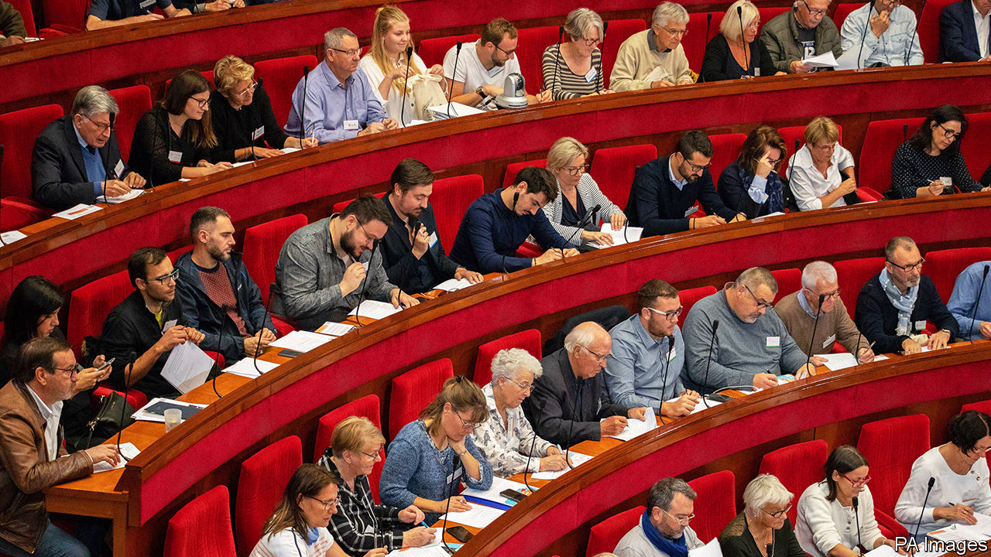

A NURSE, a roofer, an electrician, a former fireman, a lycée pupil, a photographer, a teacher, a marketing manager, an entrepreneur and a civil servant. Sitting on red velvet benches in a domed art-deco amphitheatre in Paris, they and 140 colleagues are part of an unusual democratic experiment in a famously centralised country. Their mission: to draw up measures to reduce French greenhouse-gas emissions by at least 40% by 2030, in line with an EU target that is otherwise in danger of being missed (and which the European Commission now wants to tighten). Six months ago, none of them had met. Now, they have just one month left to show that they can reinvent the French democratic process—and help save the planet. “It’s our moment,” Sylvain, one of the delegates, tells his colleagues from the podium. “We have the chance to propose something historic.”

On March 6th the “citizens’ climate convention” was due to begin its penultimate three-day sitting, the sixth since it began work last October. The convention is made up of a representative sample of the French population, selected by randomly generated telephone numbers. President Emmanuel Macron devised it in an attempt to calm the country after the gilets jaunes (yellow jackets) crisis of 2018. In response to the demand for less top-down decision-making, he first launched what he grandly called a “great national debate”, which took place a year ago. He also pledged the creation of a citizens’ assembly. It is designed to focus on precisely the conundrum that provoked the original protests against a rise in the carbon tax on motor fuel: how to make green policy palatable, efficient and fair.

“It was a real shock at first,” says Guy, a retired computer technician from Limousin, in central France, “because I realised that all the common-sense things we are doing are far from enough to stop climate change.” When delegates began travelling to Paris for their monthly sessions, they took evidence from experts, listened to presentations, and studied. “I didn’t know what to expect. I thought it would be mostly a discussion,” says Agny, who works for a medical firm. When the prime minister, Edouard Philippe, turned up on the first day, however, “we realised that the stakes were really high.”

Divided into five working groups—to discuss such topics as transport, housing or food—they then began working on proposals that could actually be put into practice. Scientists, farmers, businessmen, urban planners and over 100 other witnesses were summoned. In January they invited Mr Macron, who spent over two hours answering questions and urged them to be “precise” and “bold”. In an over-lit basement meeting room on a recent Friday evening, small groups could be found poring over documents, discussing the feedback given by legal experts on their initial ideas. Five lawyers are on hand to help shape proposals into legally enforceable text.

Forging a consensus, even after five months of exhaustive discussion, will not be easy. The older members tend to be more complacent about climate change, note some of the delegates, while the younger are more ambitious. A few grumble that the exercise is a gimmick; others argue that Mr Macron is politically committed to making it work. The regional mix has exposed divergent views, but has also precluded metropolitan bias. Grégoire, a 31-year-old from Normandy who works with the unemployed, says that he had to remind Parisians that it is not practical for those in rural areas “just to say ban cars”. Despite such differences, over 90% of the original delegates are still taking part, notes Thierry Pech, a think-tanker who presides over the assembly. He argues that the gravity of the subject, along with Mr Macron’s backing, have been crucial in persuading delegates to invest long hours and weekends away from home in the exercise.

It is a gamble nonetheless. Next month, the assembly will send its final list of measures to Mr Macron. He has promised delegates that he would put the bulk of them either to parliament, or to a referendum. Still unpopular in the polls, the president badly needs to show that he has listened to the many critics of his elitist governing style. In this respect, it did not help that his government chose to force its unpopular pension-reform proposals through parliament this week by using a special constitutional provision, known as 49-3.

If the proposals that emerge from the citizens’ assembly are indeed bold, and Mr Macron is prepared to risk putting them to a vote, this could prove a way for him both to renew popular legitimacy and to deflect blame for potentially unpopular green policies onto the assembly. If he rejects too many, however, the exercise will be denounced as a sham, designed to disguise what in most other respects remains a highly centralised presidency. ■

This article was downloaded by calibre from <https://www.economist.com/europe/2020/03/07/france-asks-its-citizens-how-to-meet-its-climate-change-targets>

|  |  |  |  |
| --- | --- | --- | --- |
| Previous | Articles | Sections | Next |

|  |  |  |  |
| --- | --- | --- | --- |
| Previous | Articles | Sections | Next |

#### Charlemagne

# Minority Report: Brussels edition

Who will kill the European Green Deal?

Mar 5th 2020 |

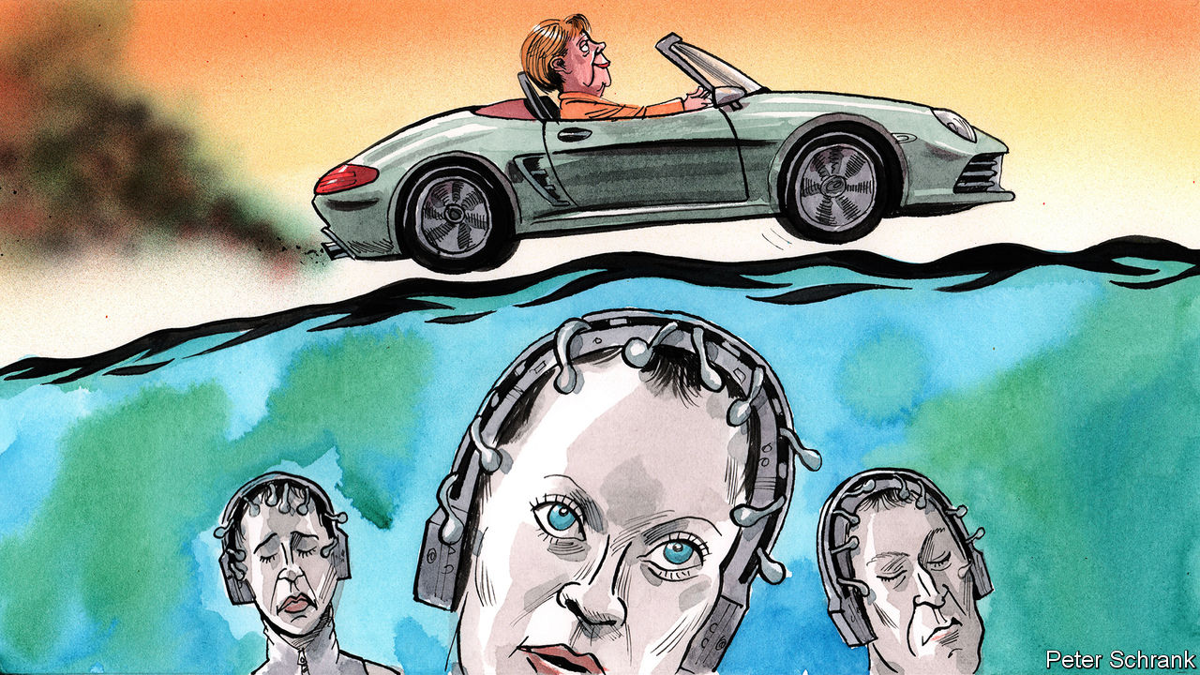

IN “MINORITY REPORT”, a short story by Philip K. Dick, a certain type of mutant is able to foresee crimes before they are committed. Future culprits are named, arrested and found guilty of “precrime” on the word of a team of soothsayers, controlled by a special police unit. Such a system would be welcome in Brussels, where EU wallahs are pondering the fate of its flagship European Green Deal. For now the project seems in rude health. A new climate law, which will oblige EU members to stop carbon emissions on a net basis by 2050, was formally unveiled on March 4th. Fantastical sums of funding have been pledged. A gamut of other legislation is planned. Yet diplomats and officials are starting to fear the worst. Who will kill the European Green Deal?

The first potential culprit is Poland, which has declared itself not to be bound by the 2050 goal. Globally, climate policy proves so rancorous in part because countries that benefited most from turning carbon into cash are now asking others not to take the same easy path. Poor countries can, often justifiably, argue that they are paying a bill run up by rich countries. Such a debate also exists in a version shrunken to European proportions. While western Europe cooks up ways to cut car use, parts of eastern Europe complain that they still need to build motorways in the first place. Cynical diplomats suggest that Polish resolve may weaken if cash is provided to soften the blow. Polish diplomats are doing little to disabuse them. Warsaw’s resistance may not last long.

If a Minority Report-style gang of crime-predicting mutants did exist, then its natural home would be in the European Commission. In Dick’s telling, John Anderton, the officer overseeing precrime, is accused of a yet-to-be-committed murder. Some left-wingers are similarly keen to blame the commission for smothering the Green Deal at birth, by not being ambitious enough in its proposals. On the face of it, the charge is absurd. No other big bloc has orchestrated a pledge to be net neutral in its carbon emissions by 2050. In total, €1trn ($1.1trn) of investment has been earmarked for green projects in the coming decade.

Yet Brussels bean-counters have form for conjuring up suspiciously large, suspiciously round numbers. Reaching the €1trn involves heroic assumptions about the EU’s ability to bring in private investment and the rapid relabelling of money that would have been spent anyway. In terms of hard cash, the EU has only €7.5bn of genuinely new money to play with. This is not much when spread over seven years and between 27 countries.

Though the commission is looking at ways of weakening its strict state-aid rules to encourage governments to dish out more green cash, it has balked at more potent measures. The prospects of loosening fiscal rules, so that member-states can invest heavily in green matters without being slapped over the wrist by the bureaucrats, look dim. Such a policy is anathema to frugal northern countries, such as Germany, which fear governments will simply shovel cash at pet projects by sticking a green label on them. Blaming the commission for being kept on a short leash is unfair.

The most likely offender to be spat out by the mutants in the basement of the commission’s headquarters is Germany. Angela Merkel may have cajoled her sceptical centre-right party into backing the 2050 target. But signing up to distant targets is easy for a leader who knows she will be long gone, points out one diplomat. When it comes to more short-term measures, the complaints have already begun. A German minister has sent a letter to Brussels demanding that the EU go easy on car manufacturers over plans to reduce emissions from next year. German MEPs bleat about plans to reduce emissions to between 50% and 55% of 1990 levels by 2030.

Objections from eastern Europe can be solved. Shifting to a greener economy costs money, since leaders are unwilling to leave a generation of workers on the scrapheap. It is politically hard to spend taxpayers’ money on paying off miners in a politician’s own country, never mind sending the cash next door. Yet it is doable. By contrast, the German handbrake may prove harder to release. Germany has a history of sinking green ambitions. Ms Merkel’s panicked decision to phase out nuclear power after the Fukushima disaster forced the country to burn vast amounts of filthy coal instead. Even the “dieselgate” scandal, when German carmakers engaged in nefarious activities stretching from nobbling emissions results to gassing monkeys in a laboratory while they watched cartoons, did not stop the German government lobbying against tougher enforcement of anti-pollution rules.

## Too big to bully, too big to bribe

Germany does not always get its own way, but it is usually powerful enough to stop others from having theirs. As a rule, what Germany does not want, Europe does not get. Decades of pleading failed to persuade big countries such as France and Italy to enact structural reforms of their economies; they were large enough to shrug off such demands. Germany may prove just as obstinate when it comes to “greening” its successful but carbon-intensive economy. The ironies of this situation stack up quickly. The home of Europe’s biggest green party stands in the way of a comprehensive package of environmental legislation. Reforms being pushed through by Germany’s first commission president in five decades faces the stiffest opposition from her home country.

In “Minority Report” John Anderton wrestles with the question of free will after being told he will murder someone. In the end, he chooses to carry out the murder, but only to ensure the programme remains accurate. Free will in politics is simpler than in science fiction. A Green chancellor, once the realm of fantasy, is now imaginable, with the Green Party second in the polls. As the environment shoots up the agenda, even centre-right parties must grapple with how to balance support for business with strident greenery. Such a change may help save the Green Deal. But if pre-crime existed in Brussels, Germany would already be in jail. ■

This article was downloaded by calibre from <https://www.economist.com/europe/2020/03/05/minority-report-brussels-edition>

|  |  |  |  |
| --- | --- | --- | --- |
| Previous | Articles | Sections | Next |

|  |  |  |
| --- | --- | --- |
| Europe | Sections | International |

Britain

The budget and the bond markets: Neither shaken nor stirred

.

Coronavirus preppers: Apocalypse soon

.

Brexit negotiations: Seconds away, round two

.

Politicians and civil servants: Priti difficult

.

Hydrology: Putting the wiggles back in rivers

.

Retail: The high street’s escape route

.

Bagehot: A man of the world

.

|  |  |  |
| --- | --- | --- |
| Europe | Sections | International |

|  |  |  |  |
| --- | --- | --- | --- |
|  | Articles | Sections | Next |

#### Fiscal policy

# Britain’s budget and the bond markets

If the government wants to increase borrowing in next week’s budget, that’s fine by the bond markets

Mar 7th 2020 |



THERE WAS a time when so-called “bond-market vigilantes” could intimidate governments. “Over the course of my career we’ve gone from being rottweilers to poodles”, laments a 35-year market veteran. “You’d go and meet with the Treasury and say the market won’t wear this. Now you’re just thankful to buy something that has a positive yield rather than negative one.”

Since the financial crisis of 2007-2009 Britain has lost its AAA credit rating, seen its debt-to-GDP ratio rise from 40% to more than 80% and voted for Brexit. And yet over the same period the yield on gilts, the benchmark ten-year government bond, has fallen from around 4.5% to under 0.5%. In this, Britain is not alone; interest rates have fallen across the advanced economies. This week the yield on gilts hit a historic low below 0.4%, and the equivalent yields on American and German government debt fell below 1% and -0.6% respectively. The vigilantes do not appear to be very vigilant.

That record-low borrowing cost was hit ahead of a budget, due on March 11th, which most investors expect to be marked by an increase in borrowing. The new chancellor of the exchequer, Rishi Sunak, is widely expected to revise the fiscal rules he inherited from his predecessor, either in this budget or later in the year. Britain now looks set to get its sixth fiscal framework in a decade. Bond-market types have reacted with a shrug rather than a gasp.

Fiscal rules are supposed to guard against politicians’ propensity to run up debt by setting rules on how much borrowing is appropriate. Such rules are, in theory, aimed at reassuring investors in British government debt that they are lending to a credible counterparty. But investors pay less heed to them than politicians might imagine. According to Chris Jeffery of Legal & General Investment Management, an asset manager, “fiscal rules are a political figleaf: they help preserve the government’s modesty, tend to irritate the most delicate areas of the government and don’t last very long before needing replacement.”

The delicate area being irritated in this case is departmental spending. The current rules allow plenty of space for new capital projects but they pledge to balance the current budget within three years. Promises to increase spending on the National Health Service, hire 20,000 new police officers and protect schools funding while also cutting payroll taxes means a squeeze on other departments and local government. The need for a policy response to covid-19 puts further pressure on the existing fiscal framework. After falling from around 10% of GDP in 2009 to less than 2% today, the government’s deficit will probably start climbing again. That is less of a problem than many assume.

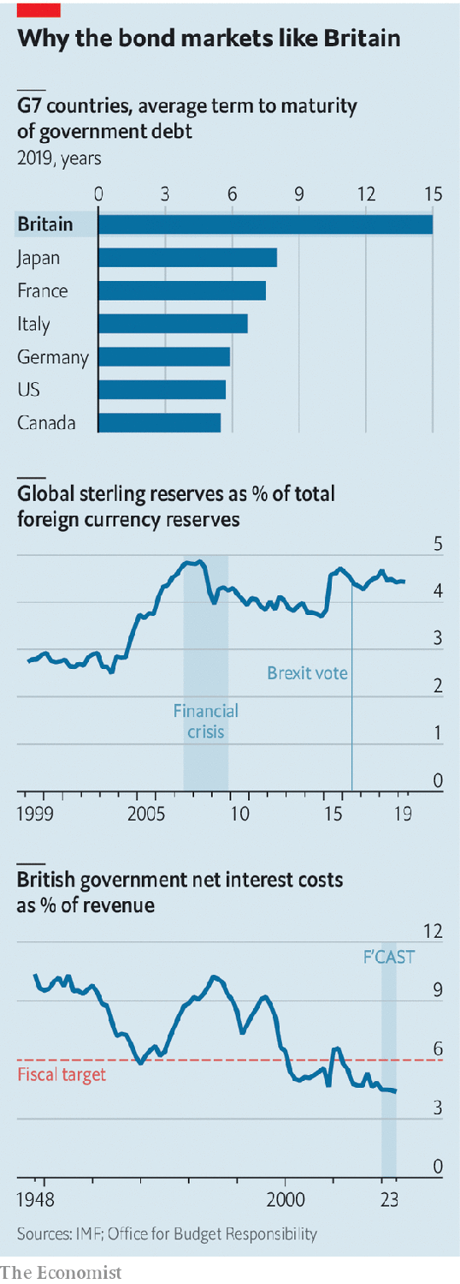

Britain’s existing stock of government debt may be high but the cost of servicing it is extremely low. In 2018-19 the net interest bill amounted to just 1.7% of GDP, the joint lowest of any year since the second world war. Borrowing costs amount to only 4.5% of tax revenues—well below the government’s rule of holding them below 6% (see chart). Demand for gilts has been high for two decades, which has pushed down yields.

The role of the Bank of England, which bought more than £400bn ($512bn) of government debt as part of its quantitative-easing programme between 2009 and 2016 and now owns around a quarter of the outstanding debt, has got a lot of attention. But over the longer term, demand from foreign reserve managers and domestic pension funds has been more important.

Gilts were a beneficiary of a large increase in global foreign-exchange reserves in the 2000s. As East Asian and Middle Eastern governments increased their reserves, gilts appeared attractively priced relative to other safe forms of debt. Sterling’s share of global reserves has risen from under 3% in 1999 to around 4.5% now. That money has proved to be sticky, and an increase in British borrowing is unlikely to make managers panic. “The obvious stress test was 2008,” when government borrowing leapt during the banking crisis, argues Moyeen Islam, a gilt strategist at Barclays. If foreign holders did not get rid of their gilts then or after the Brexit referendum, they are unlikely to do so in the face of a modest loosening of the purse strings now. “Where else are they going to go? Italy?”, asks a global fund manager. Choosing bonds is sometimes like picking the least dirty shirt out of the laundry basket and, compared with some peers, Britain does not look too crumpled.

Domestic pension funds and insurance companies hold around a third of the stock. Defined-benefit pension funds, in particular, have been keen to seek long-dated, safe sources of fixed income to match their liabilities. Although most such schemes are closed to new members, they still control over £1.5trn of assets. Their demand for gilts over the past 15 years has been “almost insatiable”, says a broker. Bonds made up 28% of their assets in 2006 but 63% by 2019.

In a low-interest-rate environment with gilt demand still high, Mr Sunak will have no problem funding his additional borrowing. Indeed, some bond managers argue the government has been ignoring market pressure to borrow more. Just as high rates in the past were taken as sign that fiscal policy was too loose and should be tightened, low rates today might point to fiscal policy being too tight. “If anything, markets have been calling for easier policy for years in Britain,” says Toby Nangle of Columbia Threadneedle Investments, an asset manager.

Things could, of course, change. The higher its debt, the more vulnerable a country is to shifts in market sentiment. But the average maturity of British government debt, at 15 years, is the longest of any advanced economy. Strong demand from pension funds for long-term paper has allowed Britain’s debt managers to gradually lengthen their borrowing. That maturity profile means not much of it needs to be refinanced each year and provides insulation against any sudden move in global interest rates. If Mr Sunak wants to splash the cash at the budget the bond market will be happy to oblige. ■

This article was downloaded by calibre from <https://www.economist.com/britain/2020/03/07/britains-budget-and-the-bond-markets>

|  |  |  |  |
| --- | --- | --- | --- |
|  | Articles | Sections | Next |

|  |  |  |  |
| --- | --- | --- | --- |
| Previous | Articles | Sections | Next |

#### Preppers

# For some Britons, coronavirus means apocalypse soon

Christmas has come for disaster hobbyists

Mar 7th 2020 |



“I’M NOT GOING to be selling boiled heads on a market stall,” says the anonymous leader of the South East England Preppers, a survivalist group that has meticulously planned for the coming apocalypse. Historical analysis, he says, is crucial to this preparation. After discovering that peasants turned to cannibalism during the Russian famine in the 1920s, he was spurred on to avoid a similar situation. Since then he has brought fellow-travellers together through online groups and awaydays to share bushcraft techniques.

Until now emergency preparation has been the preserve of a small band of eccentrics. But since coronavirus began spreading throughout Britain, their social media groups have seen an influx of applicants. To these hobbyists of disaster, all catastrophes are streamlined into the simple acronym “SHTF”, and thorough preparation means that when “Shit Hits the Fan” they will be the übermenschen.

Britain’s spate of coronavirus infections has so far remained rather mild, with the number of cases rising to 87 on March 4th, and 12 people who tested positive have recovered. But the government’s latest plans make for alarming reading. Police will ignore all but the most serious crimes, concentrating on public order. Health workers currently enjoying retirement will be called back to nurse the infected. Large-scale gatherings could be reduced and schools closed. Lockdown would prove popular, according to Ipsos MORI, a polling firm, which found that three-quarters of Britons support quarantining cities and towns. At present, the government is content with reminding citizens to wash their hands. The British public are complying. Hand sanitiser sales are up by 255%.

Those disinclined to stay calm are stripping supermarket shelves of bottled water, tinned food, pasta and cleaning products. Some are joining the survivalist clubs. One Facebook group “Coronavirus UK Preppers S.H.T.F raw survival” has gained 787 new members in the last 30 days, bringing their total to 5,872. They also offer a specialist offshoot account, selling items that they judge will be handy in the event of social collapse: crossbows fitted with telescopic sights and 12-hour ration packs. These are the hardcore survivalists, who see Armageddon round every geopolitical corner. Last year, their name was “Preppers UK S.H.T.F brexit raw survival”.

Their advice ranges from stockpiling tips to instructions on fitting ultraviolet lights above your doormat that kill germs arriving on your mail. Mostly, though, the survivalists’ advice is about discouraging people from going rogue and “bugging out” (running away). “A lot of people think they are going to live in the woods, and live off rabbits and fish,” says the South East England Preppers commander, a Gillingham travel agent by day. “If they do go and live off that diet for three weeks, they are going to be very ill indeed.” He is giving lessons on what happened after the Romans left Britain. To help his followers survive the modern Dark Ages now looming, he has been instructing amateurs in the making of pottage, a vegetable stew.

Others have turned to more professional outfits. James Blake, who runs Europe’s largest crisis food supplier, says orders are up 100-fold. Demand, Mr Blake suggests, may have been suppressed in recent years. “We’ve had a long extended period of austerity, so emergency planning has always taken a back seat.” It’s a reasonably priced way to get ready for the apocalypse: £425 ($550) buys three months’ supply of food that will last 25 years. For even more parsimonious preppers, there’s the budget option: pottage.■

This article was downloaded by calibre from <https://www.economist.com/britain/2020/03/07/for-some-britons-coronavirus-means-apocalypse-soon>

|  |  |  |  |
| --- | --- | --- | --- |
| Previous | Articles | Sections | Next |

|  |  |  |  |
| --- | --- | --- | --- |
| Previous | Articles | Sections | Next |

#### Brexit negotiations

# The gaps between the EU and Britain are wide—and time is short

Seconds away, round two

Mar 7th 2020 |

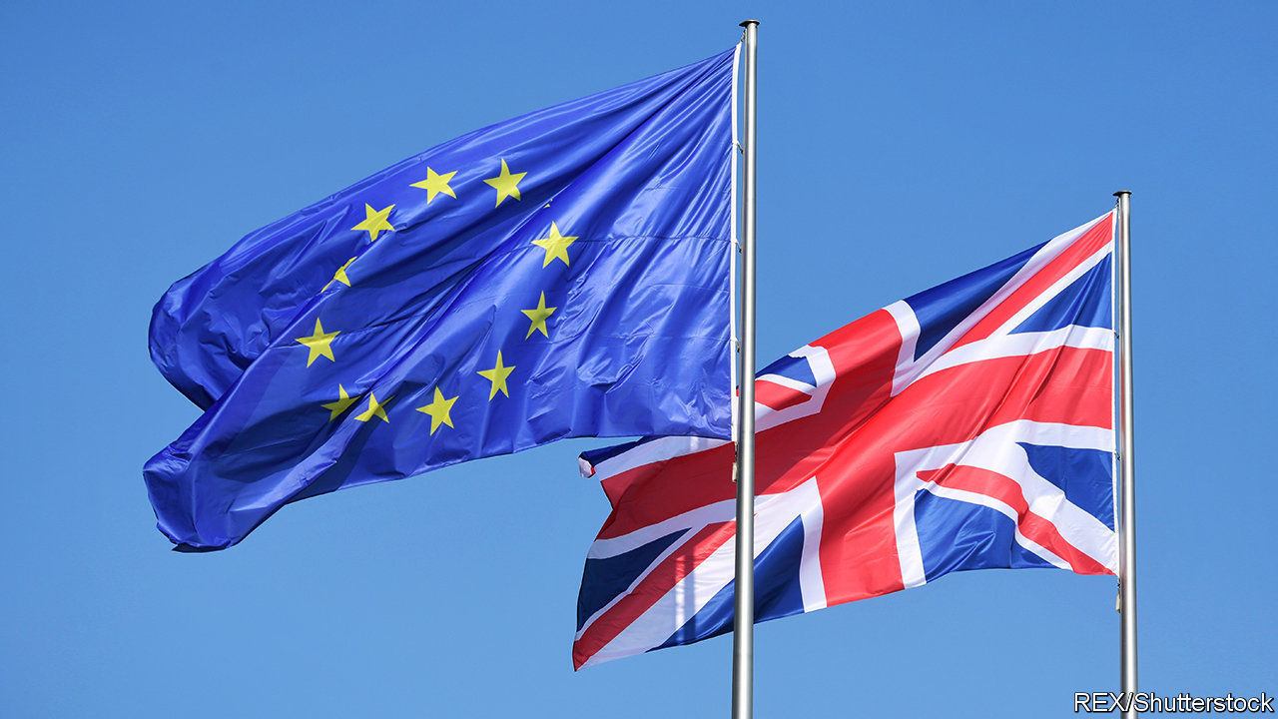

TALKS ABOUT future EU-UK relations formally opened in Brussels this week. Although the two sides share the goal of a zero-tariff, zero-quota free-trade deal similar to Canada’s, there are big differences over how to reach it. The most contentious, which will be thrashed over in negotiating rounds alternating between Brussels and London, are demands for a level playing-field on regulation, access to British fisheries, financial-services regulation, data protection and dispute settlement.

The EU says it cannot give Britain a deal like Canada’s without regulatory alignment. Its negotiating mandate cites EU labour, environmental and other standards merely as “reference points”. But it wants British commitments to be legally binding; and, for state subsidies to industry, it demands full adherence to its rules. Britain is ready to promise not to undercut the EU unfairly, but it rejects sticking to the bloc’s laws on the grounds that regulatory divergence is a key purpose of Brexit.

The political declaration attached to October’s withdrawal treaty suggested agreeing on fisheries, financial services and data protection by the end of June. This deadline is unlikely to be met. The EU wants to keep today’s access to British waters, but Britain suggests annual haggles instead. The British want their financial-services regulation and data protection deemed to be equivalent to the EU’s, but Brussels says these are non-negotiable, unilateral decisions it can withdraw at any time.

Dispute settlement is problematic. The EU wants an overarching agreement allowing it to choose unspecified punishment for any breaches. Britain prefers individual deals that avoid the risk that a dispute in one place leads to retaliation in an unrelated area. It also rejects any role for the European Court of Justice, whereas Brussels insists that the court must always be the sole interpreter of EU law.

Both sides believe a hard line bolsters their bargaining position. As the smaller side, the British are adding two other tricks. One is to threaten to walk out if not enough progress is made by June. The idea is to signal that London is not worried about having no trade deal when the current transition period ends in December. This is unlikely to work, as the EU thinks Britain has a lot more to lose.

The second is to tout trade talks with America as an alternative. Liz Truss, the trade secretary, published her negotiating terms this week. She says Washington is eager, though her insistence on retaining high food standards and excluding National Health Service procurement may dampen its enthusiasm, since opening these areas up is among America’s priorities. True to the new tactic in Brussels, Ms Truss already threatens to walk out if the Americans do not offer the right deal.

What was most notable about her plan was its economic analysis. She talked airily of boosting bilateral trade by some £15bn ($19bn). But her own modelling puts the boost to GDP from a US-UK trade deal after 15 years at only between 0.07% and 0.16%, depending how far trade barriers were reduced. Gains from free-trade deals with other countries would be smaller.

Such numbers are tiny compared with the likely losses from new barriers to trade with the EU. Treasury analysis in November 2018 found that, over ten years, a Canada-style deal would reduce GDP by some 4.9% compared with staying in the EU. Leaving with no trade deal would cut it by as much as 7.7%.

The government refuses to update this analysis. David Frost, its Brexit negotiator, has said the impact of tariffs and customs barriers is exaggerated, but offered no economic argument to support this claim. In its trade mandate, the government promises only to “invite contributions about the economic implications of the future relationship”. As for the November 2018 study, Downing Street says primly it was done by “another government”. What accounts for this coyness? Maybe the fact that most economic models show losses from leaving the EU being vastly bigger than gains from trade deals with other countries.■

This article was downloaded by calibre from <https://www.economist.com/britain/2020/03/07/the-gaps-between-the-eu-and-britain-are-wide-and-time-is-short>

|  |  |  |  |
| --- | --- | --- | --- |
| Previous | Articles | Sections | Next |

|  |  |  |  |
| --- | --- | --- | --- |
| Previous | Articles | Sections | Next |

#### Politicians and civil servants

# Priti Patel’s bust-up at the Home Office

A bullying row reveals a lot about Boris Johnson’s government

Mar 7th 2020 |

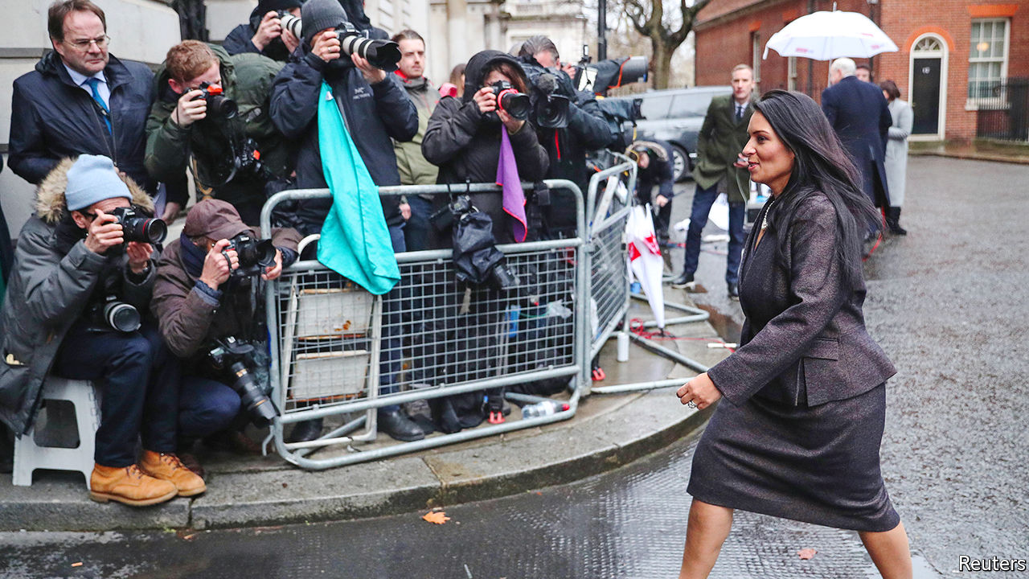

“THE HOME SECRETARY is doing an outstanding job,” according to Boris Johnson, defending Priti Patel during prime minister’s questions in the House of Commons on March 4th, as she sat beside him. Sir Philip Rutnam, who on February 29th resigned as permanent secretary to the Home Office after a 33-year career, begs to differ. He claims Ms Patel bullies her staff and was involved in a vicious briefing campaign against him. He is suing the department for constructive dismissal. Mr Johnson has asked the Cabinet Office to conduct an investigation, which may become a running sore for the government.

Several combustible factors have come together to create this bust-up. The first is Ms Patel’s personality. A hardliner on Europe and crime, she has a chequered history in government. Theresa May sacked her from a job as a foreign office minister because she had unauthorised meetings with Israeli government officials that she had failed to reveal.

The Home Office is not the only department in which colleagues have had problems with her. Complaints of rough treatment were made at her former ministries of welfare and international development. “Anybody who has gone into a department as a minister where Priti has been is greeted with open arms, because she is a such a high-tempered person,” says an ex-colleague. An acquaintance from her days as a lobbyist says she refused to take no for an answer and often left underlings in tears. “She would appear to enjoy that.”

Ms Patel denies any wrongdoing. Her allies say “dark forces” are at work, and that she’s an iron lady, guilty of nothing more than delivering the people’s will.

That points to the second factor—ideology. New cabinet ministers and their permanent secretaries often start out on a frosty footing, but the current level of mistrust is unusual. Many of Mr Johnson’s ministers regard the civil service as idle, know-it-all and hostile to Brexit. Dominic Cummings, the prime minister’s top aide, thinks bureaucrats use legal advice to bamboozle ministers, and argues that the likes of Sir Philip should be replaced by political appointees. Top officials at the Foreign Office and Treasury are on a Downing Street “shit list” and face being culled, according to reports.

The third factor at work is the peculiarity of the Home Office, where danger lurks around every corner for ministers. Unlike those in areas such as health and education, where operational decisions are devolved to arms-length bodies, Home Office ministers find themselves on the hook for individual immigration cases or terrorist probes. Ministers get ambushed by things that have gone on in the machinery way out of their line of sight. The heavy pressure to drive down immigration in recent years has increased the likelihood of foul-ups. “The Home Office exists in an atmosphere of permanent, heightened tension,” says a former minister. Survival, says Will Tanner, an aide to Theresa May when she was home secretary, “requires absolute attention to detail, cast-iron self-belief and a team of people to watch your shadow.”

Ms Patel is said to have been particularly incensed by a judge’s decision on February 10th to halt the deportation of criminals to Jamaica, on the grounds that their legal rights had been denied. Laws that bind ministers’ hands on security and immigration make the department particularly unsuited to an assault on the liberal “blob”. “It’s a conflict between a saloon bar fantasist in the form of Priti Patel, versus a hard-core realist” in the form of Sir Philip, according to Charles Clarke, a Labour former home secretary.

Brexit adds to the pressure. Mr Johnson has ordered the Home Office to recruit an additional 20,000 police officers to reverse a trend of rising crime. The department is trying to get several complex new computer systems up and running. Coronavirus may stretch the cops further.

In addition, a new immigration system needs to be ready at the end of the year, when Britain’s departure from the EU is complete. The department must also complete the registration of 3.6m EU citizens already living in Britain, and work out how to mitigate the loss of EU information-sharing systems used by police and border guards. All these elements are crucial to a smooth Brexit; getting them working in the tight timetable that the government has set would tax the patience of even the easiest of ministers. ■

This article was downloaded by calibre from <https://www.economist.com/britain/2020/03/07/priti-patels-bust-up-at-the-home-office>

|  |  |  |  |
| --- | --- | --- | --- |
| Previous | Articles | Sections | Next |

|  |  |  |  |
| --- | --- | --- | --- |
| Previous | Articles | Sections | Next |

#### Hydrology

# Re-engineering Britain’s rivers

Why the wiggles are being put back into watercourses

Mar 7th 2020 | PENRITH



BENEATH THE junction where Hobgrumble Gill meets Swindale Beck in the Lake District of Cumbria is a suspended valley that has been farmed, against all the odds, for centuries. Today just one active farm remains. Crumbling buildings and 47km of stone walls that climb right up to the highest hill passes bear witness to a time when ten or more families would have eked a living from this inhospitable land.

The wet valley floor is mown in the summer to provide hay for sheep in the winter months, when steep and rocky flanks of the valley are too cold and snowy for grazing. At some point, 200 years ago or perhaps more, the river was straightened in an effort to speed up the movement of water through the valley and to dry out the hay meadows.

This kind of battle to control water was repeated across Britain, as farming expanded and landowners consistently sought to keep rivers on the straight and narrow, inside their riverbeds where they belonged, and thus maximise the land area available for cultivation. But rivers, particularly ones that travel through flat valleys like this one, do not want to run straight. Their natural inclination is to wander back and forth in oxbow bends that shift across the land over time.

Meandering waterways have many virtues. They are slower; they have a greater diversity of wildlife habitats from ponds to gravel beds and rapids which draw more oxygen into the water; they boost water quality, by creating elbows and pools where sediment flowing down the river gets trapped rather than washing off the land; they are prettier. And—a matter of increasing salience—their water spends more time upstream, reducing the risk of floods downstream.

Now that farming has receded, and squeezing the last unit of production out of this land is no longer an imperative, these other considerations are gaining weight among those who manage rivers. As a result, a new trend is taking hold, in Swindale and elsewhere: Britain is putting the kinks and wiggles back into its rivers. Across the country, thousands of waterways are being encouraged to take a wander.

The simplest but least predictable approach to re-wiggling a river is to block the upper end of its straightened bed and let the water find its own way. This was done at Ennerdale, also in Cumbria, with great success. In Swindale, there was farmland to consider so geomorphologists estimated the river’s most likely natural path, which diggers then scraped out helping the water find its way to the valley’s lowest point—conveniently off to the side of the haymeadows. The project is a collaboration between the Royal Society for the Protection of Birds, which runs the Swindale farm as an experiment to demonstrate how farming can be done hand-in-hand with ecological conservation, United Utilities, which owns the land, Natural England, a government body, and the UK Environment Agency.

The result of all this is a longer and healthier riverbed, ecologically speaking. Within months of the diggers moving out of Swindale, new gravel beds had formed organically and salmon were using them to spawn. A vast tree-planting programme on the banks of the beck and up the sides of the valley should also stabilise the land, further hold back sediment and increase the amount of carbon stored, which both enriches the soil and sucks some of the carbon dioxide out of the atmosphere, helping combat climate change.

It is not all plain sailing. The Lake District is a World Heritage site, which puts an onus on preserving the cultural identity of the landscape as a farmed one. Farmers who follow ancient farming practices do not always appreciate being told that the rivers their forefathers created are the wrong shape and don’t do the jobs they need to do.

Nonetheless, projects like the one under way in Swindale may help inspire farmers to think differently about their land. This is a time of change for them. After Brexit, the EU’s comfortable Common Agricultural Policy looks like being replaced with a new, less generous subsidy regime, in which payments will be tied to, among other practices, the provision of environmental services. “Most farmers in these areas will admit that it’s hard to make money in these marginal upland areas,” says Jim Bliss, who helps farm the 3,500-acre Lowther estate some 10km north of Swindale. “Diversification is the way forward. But this is a live debate: are we farming for goods or nature?”

Lowther estate is in the process of shifting to the nature side. Like many others, it is transected by a straight river channel. But for some months now, Mr Bliss and his team have been nudging the water this way and that, encouraging it to go back to its natural winding course, whose trace can still be seen on the landscape. The goal is to have a much smaller, pedigree herd of 120 longhorn cattle that cost less to maintain and benefit from a richer, healthier “wildland farm”. And a wiggly river running through it all.■

This article was downloaded by calibre from <https://www.economist.com/britain/2020/03/07/re-engineering-britains-rivers>

|  |  |  |  |
| --- | --- | --- | --- |
| Previous | Articles | Sections | Next |

|  |  |  |  |
| --- | --- | --- | --- |
| Previous | Articles | Sections | Next |

#### Retail

# A new role for Britain’s high streets

Selling experiences instead of stuff

Mar 7th 2020 |



“BEAUTIFUL! CUTE! Now kill each other,” orders the instructor as a couple face off, axes aloft, for the post-date photoshoot after a night on the town throwing hatchets. The choice of unusual options for a London date is vast these days—battling a zombie apocalypse in Greenwich, escaping a haunted Pirate Ship on the Holloway Road and tossing tomahawks with friends in Vauxhall.

Competitive socialising, as this trend is known, sounds like a social-media peer-pressure nightmare, but loosely translates as doing an activity with your friends. It ranges from the traditional (go-karting, crazy golf and ping-pong) to the futuristic (virtual-reality Everest climbing and AI-led murder mysteries). It is being cautiously embraced as a lifeline by high-street landlords ravaged by e-commerce.

Both new-school and old-school pursuits are thriving. Between 2013 and 2019, the number of escape rooms in Britain leapt from 13 to more than 1,400 according to Mintel, a market-research firm. Over the same period revenues from ten-pin bowling, which along with cinema has anchored retail developments for decades, have grown by a third.

Several factors have caused this. First, there has been a demographic shift to what consultancies call “the experience economy”. Younger people increasingly prefer experiences to goods, inspired by social media and “fear of missing out”, and from a sense that, in the West at least, people have reached “peak stuff”. A recent survey of British adults showed that two-thirds would rather spend their money on experiences than possessions, rising to three-quarters for millennials.

The second factor is the rise of online shopping, whose growth has taken its toll on bricks and mortar. In the first half of 2019 shop closures across Britain’s top 500 high streets reached the highest rate for five years. Department stores in shopping centres have been hit particularly hard, shedding nearly a quarter of units since 2013, and rents are projected to continue falling for the next five years.

As high-street chains collapse into administration or close stores en masse and shoppers move online, retail space is increasingly being used for socialising. This doesn’t just prop rents up: it also benefits an area by encouraging shoppers to linger. For games operators, the glut of floor space and cheap rents in areas of high footfall is perfect. “Everything has changed from five years ago,” says Ben Hodges, co-founder of the Crystal Maze live experience. “It feels like the stars are aligning.”

The sector’s rapid growth has not gone unnoticed. Merlin and Centre Parcs, two of the country’s largest leisure operators, have added escape rooms to their offerings, while private-equity firms are snapping up stakes in the industry’s hottest prospects. Puttshack, a tech-infused golf outfit with four venues, attracted £30m from investors and talks of opening another 64 venues by 2024. Flight Club, which offers “darts for the 21st century” (much the same as the old-fashioned variety, but with electronic boards that do the maths for you), received a £15m investment in 2018 and has expanded to eight locations in Britain and America. High-street landlords should embrace the axe-throwers, or prepare for the chopping block.

This article was downloaded by calibre from <https://www.economist.com/britain/2020/03/07/a-new-role-for-britains-high-streets>

|  |  |  |  |
| --- | --- | --- | --- |
| Previous | Articles | Sections | Next |

|  |  |  |  |
| --- | --- | --- | --- |
| Previous | Articles | Sections | Next |

#### Bagehot

# Rishi Sunak, man of the world

The chancellor of the exchequer is a champion of globalisation who has been brought to power by a wave of nationalism

Mar 7th 2020 |

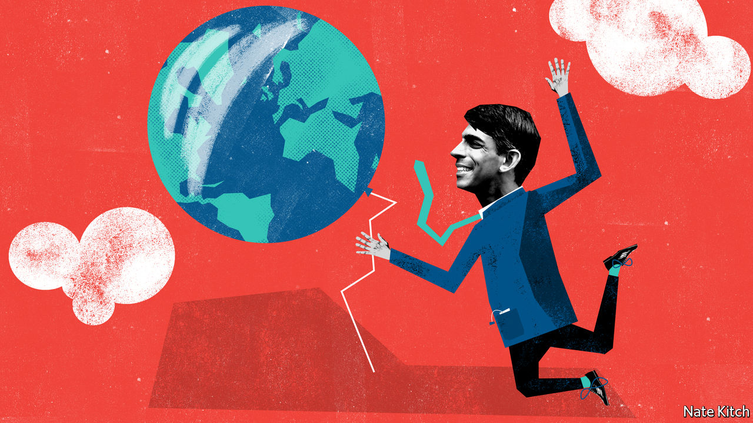

THE NEW chancellor of the exchequer, who will present the budget on March 11th, is arguably the most globalised member of the House of Commons. His grandparents arrived in Britain from Punjab by way of East Africa. He met his Indian-born wife at Stanford Business School in California. His father-in-law is a co-founder of Infosys, a giant Indian outsourcing firm. He swore his oath as an MP on a copy of the Bhagavad Gita, a Hindu sacred text.

And yet Mr Sunak is a senior member of a government that was brought to power, in good part, by a backlash against globalisation. The party won the election in December not just by promising to get Brexit done but also by promising to tackle the causes of Brexit: left-behind communities that had seen their mines and steam mills destroyed by cheap competition; hostility not just to the Brussels bureaucracy but also to London elites; and, seldom mentioned out loud but often in the back of people’s minds, a feeling that, as a result of out-of-control immigration, people could no longer recognise their own country.

How does this glittering member of the global elite find himself in the forefront of such a movement? Theresa May liked to argue that “Brexit means Brexit”. But in fact Brexit means completely different things to conservative tribes. Pro-globalisers think that Brexit is a natural extension of globalisation. For them the European Union is a transnational protectionist bloc that discriminates against non-Europeans in its immigration policy and protects its farmers from the global market. Anti-globalisers see the EU as an engine of globalisation that prevents countries from controlling their borders, particularly when it comes to immigration, and hands power to unelected bureaucrats and global freeloaders.

The anti-globalisers drove Brexit. Nigel Farage put it on the agenda by co-founding UKIP and then saved it from betrayal by founding the Brexit Party. He has never shied away from playing the race card (during the referendum he signed off on a poster showing thousands of Syrian refugees crossing the border between Croatia and Slovenia) or praising Donald Trump’s economic nationalism. But the pro-globalists nevertheless succeeded in gaining control of the Brexit movement and retaining control of the Conservative Party. Dominic Cummings, the prime minister’s chief strategist, whose eccentric views are probably best described as libertarian Maoist, ran Vote Leave, which waged war against Mr Farage’s various leave-supporting organisations. Boris Johnson came out in favour of leaving the EU on the ground that Britain needed to look outward to the rest of the world. The globalisers’ triumph was sealed by the adoption of the slogan “global Britain”.

At the same time the squabble between the globalisers and the nationalists also created a chance for ambitious young Tories with the right politics and a back-story to leapfrog to power. Brexit cost the Conservative Party a generation of leaders who campaigned against Brexit: not just David Cameron and George Osborne but also younger Cameroons who retired from politics (such as Amber Rudd, a former home secretary) or failed to get a seat (such as Rupert Harrison, a former chief of staff to Mr Osborne). It put a premium on giving cabinet jobs to ethnic minorities, whose presence could refute the charge that Brexit is all about racism.

The Conservative Party has a genius for absorbing contradictions rather than being torn apart by them. Mr Johnson likes to smother problems with his damn-the-details optimism. Mr Sunak believes passionately in globalisation’s ability to solve the problems for which it is blamed: he once specialised in investing in British start-ups and, in 2014, he wrote a pamphlet on ethnic diversity for Policy Exchange, a think-tank, arguing that members of ethnic minorities felt more “British” than the white majority.

Mr Sunak’s first budget is likely to be fairly uncontroversial, providing the economy with a boost and avoiding the ruffling of too many feathers. But there will be tensions in the coming months. The government will have to make difficult choices as it negotiates with both the EU and the United States. People who voted to take back control will be confronted with serial disappointments: global companies and markets are going to continue to operate according to global rules that are outside local control and, as the architecture of a new trade agreement is sketched out, disputes will be settled by unelected bureaucrats, albeit ones in the World Trade Organisation in Geneva rather than in Brussels.

Three problems will force the party to confront this particular contradiction. Agriculture will expose the tension between its pro-globalisation wing and the protectionist sentiments of some of its loyalist supporters. Most farmers want to replace EU subsidies with a home-grown regime of subsidies. But pro-globalisers have rather different ideas. A leaked email written by Tim Leunig, a Treasury adviser, argues that the “food sector” is not critically important to the economy and that Britain might follow the example of Singapore, “which is rich without having its own agricultural sector”. The problem of regulatory alignment will expose the tensions between businesspeople and nationalists: global manufacturers support regulatory alignment with the EU precisely because it makes global supply chains easier to operate, whereas nationalists regard alignment as a threat to sovereignty. Any trade deal with America will have to face protests from both consumers and farmers over chlorinated chicken and GM foods.

Mr Sunak represents one of the least globalised corners of Britain. Richmond, in North Yorkshire, is almost entirely white. Locals claim that the last time immigrants came in any numbers was with the Norman Conquest. Farming looms larger in the local consciousness than finance: a local gave Mr Sunak an enthusiastic welcome on the assumption that his involvement in a hedge fund indicated an interest in topiary. So far the chancellor has managed the contrast between his global CV and the concerns of his northern constituents elegantly. That will become harder as the contradiction at the heart of government becomes clearer. ■

This article was downloaded by calibre from <https://www.economist.com/britain/2020/03/07/rishi-sunak-man-of-the-world>

|  |  |  |  |
| --- | --- | --- | --- |
| Previous | Articles | Sections | Next |

|  |  |  |
| --- | --- | --- |
| Britain | Sections | Business |

International

Abortion: From backstreet to mail-order

.

|  |  |  |
| --- | --- | --- |
| Britain | Sections | Business |

|  |  |  |  |
| --- | --- | --- | --- |
|  | Articles | Sections | Next |

#### Pills by post

# Abortions are becoming safer and easier to obtain—even where they are illegal

Pills are making it easier for women to end unwanted pregnancies

Mar 7th 2020 | AUSTIN AND MCALLEN, TEXAS, AND REYNOSA, MEXICO



IN AMERICA ABORTION is a battleground. Pro-lifers urge the Supreme Court to overturn Roe v Wade, its convoluted ruling in 1973 that made abortion legal in all states. Pro-choice campaigners fret that, one day, they will succeed. Presidential elections hinge, in part, on the kind of judges each candidate vows to appoint. And test cases crop up regularly. This week the Supreme Court heard arguments for a law making it harder to run abortion clinics in Louisiana, which could lead to the closure of two of the three in that state.

Yet behind the headlines, abortion is becoming more widely available in most of the world. Between 2000 and 2017 some 27 countries made it easier for women to get abortions. Only Nicaragua made it harder. In the past two years Cyprus, the Republic of Ireland, Northern Ireland and North Macedonia have all loosened restrictions. Since last April, South Korea and Thailand’s constitutional courts have ruled that banning abortion is unconstitutional. Argentina will probably legalise it soon, though Colombia’s top court refused to do so on March 3rd. And in countries where ending a pregnancy is still illegal or tightly restricted, do-it-yourself abortions, which once involved back-alley butchery or wire coat-hangers, are becoming safer.

Reynosa, a city on Mexico’s border with America, is controlled by drug cartels and patrolled by heavily armed state police, their bulletproof vests bristling with spare magazines. The streets are lined with pharmacies which are visited regularly by Americans. Maria (not her real name), a pharmacist, says she sells the “abortion pill” to at least one “gringo” every day.

Misoprostol, the drug in question, is a stomach-ulcer drug which can also be used to cause abortions. It is tightly regulated in America. In Mexico, where abortion is mostly illegal, pharmacies stock it next to cough drops and painkillers. The generic version costs 990 pesos ($50). Some 15 miles away in McAllen in Texas, a state that is dogged in its efforts to stop women getting abortions, the region’s sole surviving abortion clinic charges $700 for treatment that includes the same drug. Some who cannot afford that take their chances with Reynosa’s guns and gangs. Others who dare not cross the Rio Grande buy misoprostol on the black market in America, where they risk getting fakes. Even if the medication is genuine, it is less effective without a second drug, mifepristone, which is much harder to get.

Now there is a third option. Last year Isis, an unemployed 20-year-old from Fort Worth in Texas, got an abortion. She consulted online a doctor in Austria who works for Aid Access, a non-profit that helps women who cannot otherwise get abortions. She paid the group $90. A pharmacy in India sent her seven pills. Isis never had to leave her home. Such abortions are increasingly available—even in countries where ending a pregnancy is illegal.

Bans and restrictions seem to do little to cut the number of abortions. In countries where it is mostly illegal, 37 in 1,000 women have an abortion each year compared with 34 in countries where it is widely available, estimates the Guttmacher Institute, a pro-choice research group. Abortion rates in America have declined steadily since the late 1980s, with no significant difference between states that have introduced new limits and those that have not.

Better access to contraception, by contrast, does make abortions rarer. Every year nearly half of pregnancies worldwide are unintended. That share has been falling for years, mostly thanks to the increased availability of effective contraceptives. In 1969 only 4% of women in the least-developed countries who wanted modern contraception got it; by 2019 that figure was 59%. In much of the rich world it is nearly 90%. Abortion was a prime form of birth control in the Soviet Union. Since communism’s collapse, contraceptive use in eastern Europe has risen sharply. Abortion rates there have halved since 1990. In Mozambique the share of women using contraception doubled between 2011 and 2018. The government is in the middle of making pills and condoms available in all secondary schools. Teenage pregnancies are down.

Delaware is a model of how to improve access to contraception quickly and effectively. From 2014 to 2019 it trained primary health-care workers regularly to ask each woman of childbearing age whether she was happy with her method of birth control or was thinking about having a baby. It also enabled women to get whichever kind of contraception they wanted that same day, explains Mark Edwards of Upstream, the non-profit which ran the programme. Births following unintended pregnancies fell by 25% between 2014 and 2017. The abortion rate dropped more sharply than in any other state in America.

## Necessary but not sufficient

Yet effective birth control is not enough. Half of American women seeking an abortion said they used contraception in the month they got pregnant, reports the Guttmacher Institute. Just ask Gaby Ramirez, a 27-year-old cashier and single mother, whose contraception failed. The morning-after pill also let her down (few realise that it does not work after ovulation). “This”, she says as she nods to the faded-pink waiting area of the Whole Women’s Health clinic in McAllen, its walls enlivened by quotes from women such as Michelle Obama and Isabel Allende, “was a very difficult decision. But I just can’t have another baby.” After three hours of medical tests, state-mandated counselling and form-filling, she was sent home with an appointment to return the next day (Texas law requires two separate visits for abortions). Ms Ramirez opted for a medical abortion (using pills) because she can take them in private.

Brazilian women first discovered misoprostol could be used to terminate pregnancies in the 1980s. Women across Latin America told each other about “the pill that makes your period come back”, first in person and later through hotlines and online.

Since then the shift from surgical abortions to medical ones has been dramatic; in the Nordic countries over 90% of abortions are now drug-induced, in India 80% and in America a third. When taken with mifepristone, misoprostol ends 97% of pregnancies in the first ten weeks without complications. More women are seeking abortions earlier in their pregnancies. That is largely because of cheap at-home pregnancy tests, says Jasbir Ahluwalia, a doctor at the McAllen clinic: “The 98 cents test at Walmart has given women such power.” In most rich countries over two-thirds of terminations are carried out before nine weeks and 90% before 13 weeks.

Statistics on how many women take abortion pills without medical care are understandably patchy. Still less is known about how they fared. But a study in 2016 by Abigail Aiken of the University of Texas at Austin of 1,000 women in Ireland who managed their own abortions with the help of Women on Web, a non-profit which provides online advice and prescribes pills by post, found that 95% ended their pregnancies without any surgical intervention. Just 3% received medical help such as a blood transfusion or antibiotics. The organisation gets around 150,000 requests for help each year, many coming from Brazil, Poland, Thailand and (until abortion was legalised) Northern Ireland. Requests shoot up whenever the website is translated into a new language, says Rebecca Gomperts, the group’s founder.

Interest in self-induced abortion is keen, particularly in conservative places. In one month in 2017, there were 210,000 Google searches in America about it. In 2018 Dr Gomperts set up a separate organisation for Americans after a rise in requests by women in states where it is relatively hard to get abortions. In its first ten months Aid Access held over 11,000 consultations and prescribed abortion pills 2,600 times.

Other websites provide women with information on how to get the medication to induce abortions and how to take it safely. One such site, Plan C, regularly tests pills ordered from online pharmacies and rates providers on the quality of the tablets, price, shipping time and advice. It also answers questions about how to avoid getting in trouble with the law.

The Royal College of Obstetricians and Gynaecologists recently called on the British government to relax rules that require women to take the first pill in a doctor’s office. Were they to do so, abortions could be organised entirely by smartphone and post. Clinics in some parts of the world are already trying this.

The impact on women who live in countries where abortion is illegal is most dramatic. Backstreet abortions used to result in perforated uteruses and life-threatening infections and haemorrhages. Some still do. But globally such complications have become rarer. Since 1990 the number of women dying as a result of botched abortions—most of them illegal—has dropped by 42%, from 108 per 100,000 abortions (1990-94) to 63 (2010-14).

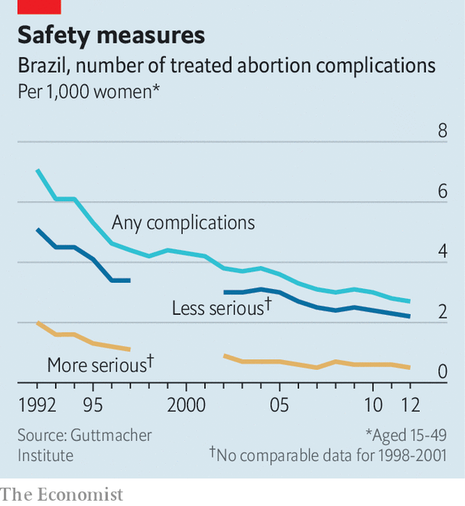

Even on its own, misoprostol is effective in around 85% of cases, and it is far less dangerous than other DIY methods. Countries where misoprostol has become most widely available saw the biggest decline in deaths as a result of unsafe abortions. The fall in unsafe terminations in Brazil, where abortion is illegal, has been dramatic (see chart). In Reynosa, Maria says she regularly sells pills to local women who send their husbands with “lousy excuses about stomach problems”. In Mozambique hospitals have seen many more incomplete abortions in recent years, but a dramatic drop in women coming in with perforated uteruses, says Diana Restrepo of the UN Population Fund. She believes this is due to informal use of misoprostol, which is increasingly easy to buy in pharmacies.

For 90m women in 26 countries abortion is still banned under all circumstances. In El Salvador women have been jailed after having miscarriages. Donald Trump’s administration is trying to extend its global “gag rule”, which bans government aid to foreign non-governmental organisations that “actively promote” abortion, by demanding that all UN aid meets the same criteria. Some American states, along with the Food and Drug Administration, are going after the providers and users of abortion pills.

“Ultimately, what are they going to do? Stop every package? Shut down the internet?” wonders Dr Aiken in a soft Irish-Texan accent. The practice has become too widespread to stop, she says. A recent survey found that nearly a third of patients at three Texan clinics already knew about self-managed abortion with pills. As she learned in Ireland, when governments introduce unreasonable laws and barriers, “you merely drive people to find ever more creative solutions.” Those solutions are, at least, becoming safer.■

This article was downloaded by calibre from <https://www.economist.com/international/2020/03/07/abortions-are-becoming-safer-and-easier-to-obtain-even-where-they-are-illegal>

|  |  |  |  |
| --- | --- | --- | --- |
|  | Articles | Sections | Next |

|  |  |  |
| --- | --- | --- |
| International | Sections | Finance and ... |

Business

Jack Welch: Captain of industry

.

Technology mergers: Xeroxing HP

.

Bartleby: A woman’s work

.

Private equity: Locusts of attention

.

Go north, young woman: The glass-ceiling index

.

Telemedicine in China: The smartphone will see you now

.

Schumpeter: Plan V

.

|  |  |  |
| --- | --- | --- |
| International | Sections | Finance and ... |

|  |  |  |  |
| --- | --- | --- | --- |
|  | Articles | Sections | Next |

#### Captain of industry

# Jack Welch transformed American capitalism as boss of GE

In good ways and bad

Mar 7th 2020 | NEW YORK

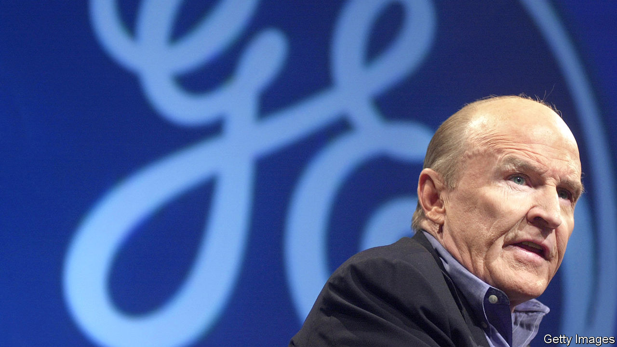

IN HIS AUTOBIOGRAPHY, published soon after retiring from GE in 2001, Jack Welch explained the challenge he had faced when taking over as chairman and chief executive of the iconic American company 20 years earlier. The firm had grown top-heavy and sclerotic. Some divisions had not posted profits in over a decade. In his farewell speech, Reginald Jones, his patrician predecessor, likened the industrial conglomerate poetically to the Queen Mary, a majestic ocean liner, caught in a storm.

In his inaugural address Mr Welch maintained the nautical metaphor—with less decorum and a greater sense of urgency. He told his charges that he wanted GE to be like a speedboat in the harbour “trying to move like hell”. The threat from sophisticated competitors from Japan was growing. He did not want GE to go the way of Detroit’s carmakers or IBM, which failed to adapt. As corporate America mourns his death on March 1st, aged 84, the company he reinvented is itself struggling to keep up with the times.

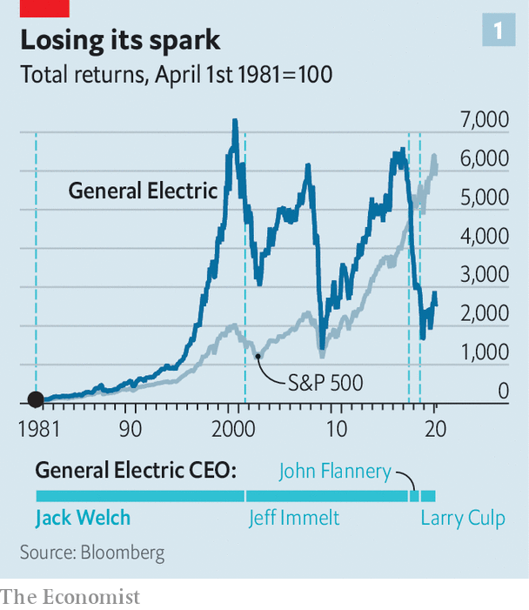

Mr Welch certainly revved up GE’s propellers. Under Jones, who led the firm from 1973 to 1980, it doubled revenues to $25bn and saw its share price sink by about a fifth. Under Mr Welch revenues quintupled from $27bn in 1981 to $130bn in 2000. Total shareholder returns, including dividends, rose 70-fold, more than three times as fast as those for the S&P 500 index of big corporations (see chart 1).

This made him the talk of corporate America. In 1999 Fortune magazine anointed him “manager of the century” (never mind Henry Ford, who pioneered mass production, and Alfred Sloan, who more or less invented modern management at General Motors). The plain-spoken Mr Welch had admirers outside business circles, too. Beth Comstock, a former GE vice-chairwoman, recalls attending overflowing shareholder meetings with him where “little old ladies were shaking like they were meeting a rock star.”

The Welch revolution rested on four pillars: people, process, purpose and profit. Start with people. Ex-lieutenants praise him for nurturing talent. He encouraged employees to take risks and speak their minds, remembers Jeff Sonnenfeld of the Yale School of Management, who taught at the company university in Crotonville.

He also promoted an obsessive, ruthless meritocracy. To tame GE’s bloated bureaucracy, he introduced the policy of “rank and yank”, sacking the bottom 10% of managers, measured by financial and other metrics, each year. “Public hangings are…worth a thousand CEO speeches,” Mr Welch once quipped. He lavished praise when managers excelled, but upbraided them publicly if they did not. “You were either a pig or a prince,” recalls a senior aide.

Mr Welch was also obsessed with processes. Some were radical in his day but have since become commonplace. To prevent turf wars from killing new ideas, for instance, he insisted that town-hall meetings (dubbed “work-outs”) be held so that all relevant parties could raise objections. He championed Six Sigma, a series of techniques that aimed to keep manufacturing defects below 3.4 per million parts.

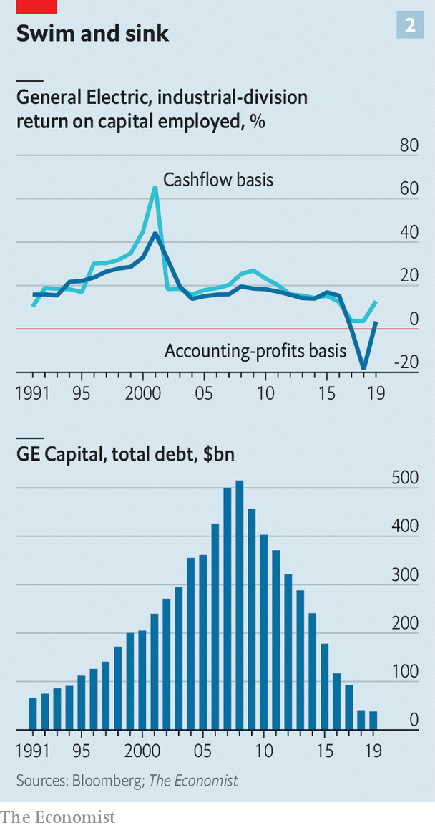

GE’s purpose also changed on his watch. Since its founding by Thomas Edison in 1892 it had focused on engineering, from refrigerators to turbines. Mr Welch extended it to product-related services, like selling airlines flight time rather than merely jet engines. More controversially, he also grew GE’s financial-services arm.

Everything, always, in the service of profits. To boost them further, Mr Welch slashed costs and sold flagging units, insisting that every GE division be first or second in its industry. Net income duly soared from $1.7bn in 1981 to $12.7bn in 2000.

## Unfinished business

Mr Welch always had critics. His insistence on downsizing while GE was still profitable—headcount fell from above 400,000 in 1980 to below 300,000 five years later—earned him the epithet “Neutron Jack”, in reference to the neutron bomb, which kills people but leaves buildings intact. Tom Peters, co-author of “In Search of Excellence”, a hallowed management tome, accepts that GE needed discipline as its woes were “obvious to a fourth grader”. But he likens Mr Welch’s methods to “dumping loads of bodies off the side of the cruise ship”.

More important, GE began to unravel almost as soon as he left. His hand-picked successor, Jeffrey Immelt, was finally ousted in 2017 after failing to reverse a sharp decline. John Flannery, who replaced him, lasted barely a year. GE’s market capitalisation fell from a peak of $600bn in 2000 to $95bn today.

Was Mr Welch to blame? Some strategies that fuelled heady returns during his tenure no doubt played a role. “The dark side of worshipping at the altar of Six Sigma is that breakthrough innovations get cut,” says Vijay Govindarajan of the Tuck School of Business. The checklist culture and underinvestment in research left GE’s innovation engine sputtering.

Mr Welch also missed the digital revolution. He admitted in his autobiography that he was “slow to understand the impact of the internet”. Mr Govindarajan points to his aggressive outsourcing of information technology to Indian firms, a move that saved money in the short run at the expense of surrendering the future. “If Jack had been visionary, we could have done what Google or AWS [Amazon’s cloud-computing arm] did,” grumbles a former senior GE man. Instead, Mr Welch bought trophy assets like NBC, a television network and Kidder Peabody, an investment bank.

Mr Welch’s most consequential mistake was to grow the financial arm, GE Capital, into a monster. The division’s easy profits during the long economic expansion of the 1990s masked plenty of sins, including mounting troubles at GE’s core industrial units. As Mr Peters puts it, mincing no words, Mr Welch handed his successor “a real pile of shit” in the form of GE Capital.

The division grew quickly from the early 1990s, bolstering profits, free cashflow and returns on capital. Its loaded up on debt and relied on fickle short-term funding. By 2000 it generated 51% of GE’s revenues; GE’s industrial and power divisions eked out barely a tenth each.

Industrial performance peaked as Mr Welch left, and collapsed between 2001 to 2003, with Mr Immelt in charge. Part of this was down to a recession in 2001. However, after 2003 GE’s industrial businesses continued to deteriorate; their returns on capital collapsed and cashflow dried up. Mr Immelt pursued pricey acquisitions (most notably of France’s Alstom, which makes power equipment, and Baker Hughes, an energy firm) and ill-timed asset sales. For years he continued to expand GE Capital. Though less dependent on short-term funding, it remained highly leveraged. It was pushed to the brink by the global financial crisis of 2007-09, saved only by a federal bail-out. Only then was Mr Immelt forced to shrink the division, a move his successors have since intensified.

There is no denying that Mr Welch was a towering figure who helped jolt America Inc out of the complacent 1970s. At times, he may have shaken too hard. On March 4th the current boss, Larry Culp, observed that Mr Welch had “changed the business landscape as we know it”. He did not say whether it was for better or worse. ■

This article was downloaded by calibre from <https://www.economist.com/business/2020/03/07/jack-welch-transformed-american-capitalism-as-boss-of-ge>

|  |  |  |  |
| --- | --- | --- | --- |
|  | Articles | Sections | Next |

|  |  |  |  |
| --- | --- | --- | --- |
| Previous | Articles | Sections | Next |

#### Tech takeovers

# Xerox launches a takeover bid for HP

It is an attempt to burnish tech royalty whose glory has faded

Mar 7th 2020 |

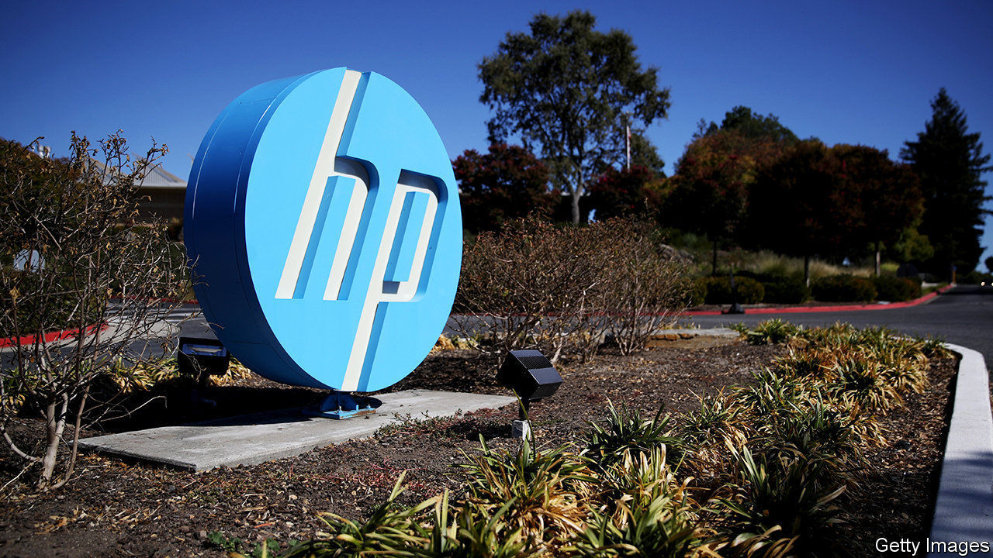

IF THE BOARD won’t agree, try the shareholders directly. After nearly a year of advances, on March 2nd Xerox made a formal tender offer for HP, a much bigger rival computer-and-printer-maker. It is willing to pay HP’s shareholders $24 a share, valuing the company at $35bn. That is a third higher than its market capitalisation before Xerox made its intentions clear in November—and five times that of Xerox itself.

Both firms are Silicon Valley royalty, left behind by the pace of a technological revolution they did much to shape. Xerox—particularly its fabled Palo Alto Research Centre—helped invent photocopying, laser printing, desktop computers and the “graphical user interfaces” that everyone now takes for granted. A plaque commemorates the garage where Bill Hewlett and David Packard founded HP, with $538 of capital, as “the birthplace of Silicon Valley”.

These days Xerox’s printing business looks to be in long-term decline. The paperless office may be a pipe dream, but IDC, a research firm, forecasts that the number of pages the world prints each year will drop from around 3trn in 2017 to 2.6trn or so in 2023. Xerox’s revenues have fallen every quarter since 2016 bar one, year on year.

HP, too, has struggled in the smartphone age. Besides its own range of printers, it is the world’s second-largest seller of personal computers (PCs). That market is also now shrinking. An uptick of 0.6% in worldwide PC shipments in 2019, to 261m units, was the first increase in seven years. In the age of mobile devices no one expects a PC revival.

Xerox argues that joining forces would help both firms compete. It promises $2bn of annual cost savings after two years. However, Katy Huberty of Morgan Stanley, a bank, points out that the two companies’ printing-product lines are mostly complementary, with HP specialising in smaller machines than Xerox.

The tech industry has a history of ill-judged mergers (HP’s own acquisition of Compaq, a rival computer-maker, in 2002 being a prime example). Xerox’s plan to swallow a firm five times its size looks ambitious, to put it mildly. Bad blood could complicate things further. HP’s board rejected an earlier offer of $22 a share, made in November, saying it “significantly undervalues” the firm. In February HP said it would return $16bn to its shareholders, in an attempt to block the deal.

Xerox has one thing going for it. Among its big shareholders is Carl Icahn, an activist investor with a string of hostile takeovers to his name (and a stake of around 4% in HP). The markets seem optimistic. Despite the coronavirus-inspired slump, both firms’ share prices remain higher than before Xerox came a-wooing.■

This article was downloaded by calibre from <https://www.economist.com/business/2020/03/07/xerox-launches-a-takeover-bid-for-hp>

|  |  |  |  |
| --- | --- | --- | --- |
| Previous | Articles | Sections | Next |

|  |  |  |  |
| --- | --- | --- | --- |
| Previous | Articles | Sections | Next |

#### Bartleby

# Women still face barriers in the workplace

Many arguments about female progress are a convenient fiction for men

Mar 7th 2020 |

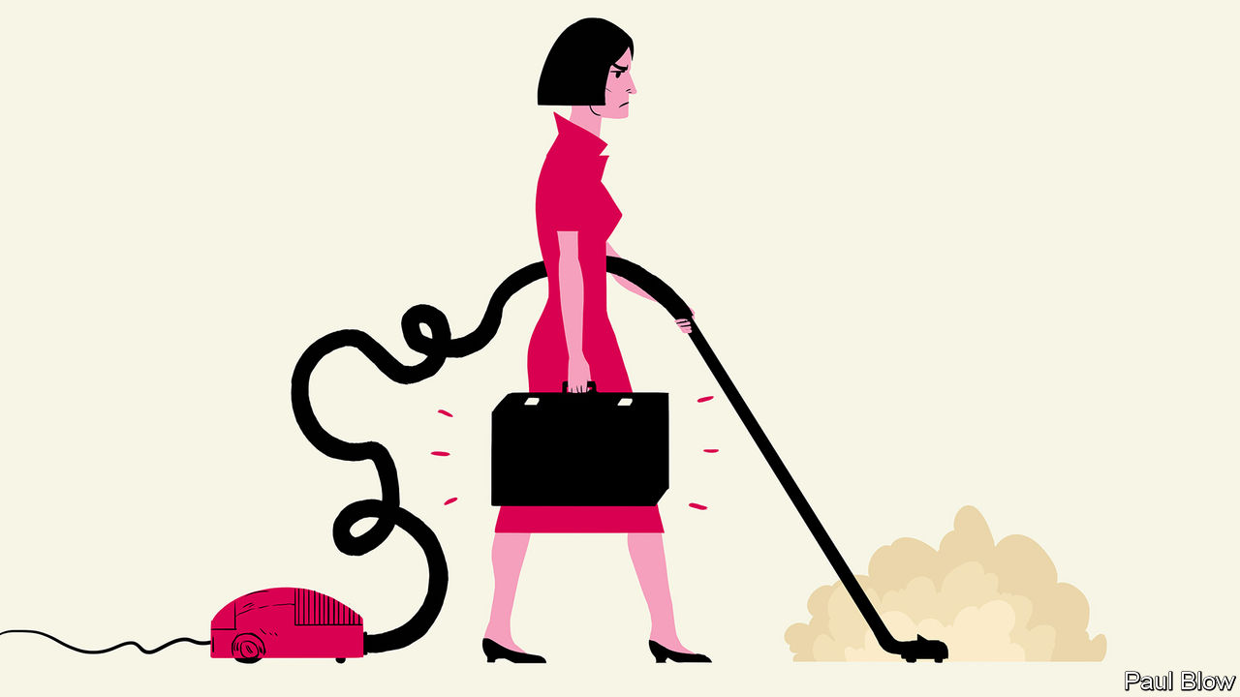

WOMEN HAVE made great strides in the employment market over the past 50 years. But many still feel that their progress is being obstructed and, to coincide with International Women’s Day on March 8th, two new books by feminist writers tackle the issues.

In “The Fix” Michelle King, director of inclusion at Netflix, a video-streaming giant, observes that women are constantly told they need to change themselves—be more assertive, work longer hours and so on. Instead, she argues, working practices should change to accommodate the needs of half the adult population. In “The Home Stretch” Sally Howard, a journalist, suggests that a big reason why women are held back is that even those who work full-time are still expected to do the bulk of the housework. To cite the book’s lengthy but apposite subtitle, she makes a strong case “why it’s time to come clean about who does the dishes”.

Male managers may find these books an uncomfortable read, peppered with talk of the patriarchy and gender privilege. Sometimes, the authors go too far. Ms Howard links the patriarchy with capitalism so often that one wonders whether she has ever seen a picture of the Soviet Union’s all-male politburo or considered the harm done to women and baby girls by the Chinese Communist Party’s one-child policy.

But men do not need to forsake the capitalist system to appreciate the plight of female workers. They just need empathy. Are women in the workplace judged by the same standards as their male colleagues? Are they described with adjectives (strident or emotional, for example) that would not be applied to men with the same characteristics?

Despite recent progress, women still face a glass ceiling (see article). A couple of stories in Ms King’s book illustrate the point. Sarah was an executive at a multinational who worked late, underwent management training and enthusiastically received and acted on feedback. After many years of rejection, it seemed she was due for promotion to the next tier, which was 100% male. But at the key meeting a male executive said: “I don’t know; she just doesn’t fit. She has those glasses and she wears that clip in her hair.” Not exactly “scientific management”.

In the other tale Ms King, on her first day in a new job, walked into a kitchen full of men. Her boss said “Hey, Michelle, there are dishes in the sink and you are a woman, so, you know, wash them.” His colleagues laughed. When she protested, she was told to learn to take a joke.

Bullying disguised as humour is still bullying. And women are expected to put up with it. They must also tolerate different dress standards. Boris Johnson, Britain’s prime minister, often messes up his hair before public appearances to maintain his “lovable buffoon” image. Dominic Cummings, his adviser, dresses scruffily, which suits his persona as the “eccentric genius”. It is hard to imagine any woman reaching a position of political power while adopting a similar style.

Sometimes the excuse for the lack of female progress in certain professions is that women and men naturally choose to pursue different career paths. Yet those outcomes may simply be the result of formal or informal barriers against female success. At the end of the 19th century, when only 4-5% of American doctors were women, some men no doubt put this down to a lack of aptitude. Many medical schools, perhaps sharing that preconception, did not admit female candidates; Harvard’s began accepting women only after the second world war. In Britain women were not allowed to become practising lawyers until they were admitted to the Law Society in 1922.

In both professions the playing field was eventually levelled. The result? In 2017 more women were admitted to American medical schools than men for the first time. By 2018 half of British solicitors were female.

Another common argument is that it makes sense for married people to specialise, with the man taking on higher-paid employment and the woman doing more of the chores. It is equally dubious. One study, for instance, found that husbands who earn less than their wives do even less housework than those who earn more.

Many of the arguments that women’s lack of progress is down to aptitude or choice look like a convenient fiction for men, who do rather well out of the bargain. Women, who end up doing most of the chores as well as working long hours, get a raw deal. It is not them who need to change—it is the attitudes of men.

This article was downloaded by calibre from <https://www.economist.com/business/2020/03/07/women-still-face-barriers-in-the-workplace>

|  |  |  |  |
| --- | --- | --- | --- |
| Previous | Articles | Sections | Next |

|  |  |  |  |
| --- | --- | --- | --- |
| Previous | Articles | Sections | Next |

#### Locusts of attention

# Two buy-out firms pay €17bn for Thyssenkrupp’s lifts business

It is the latest example of Germany’s buzzing private-equity scene

Mar 7th 2020 | BERLIN

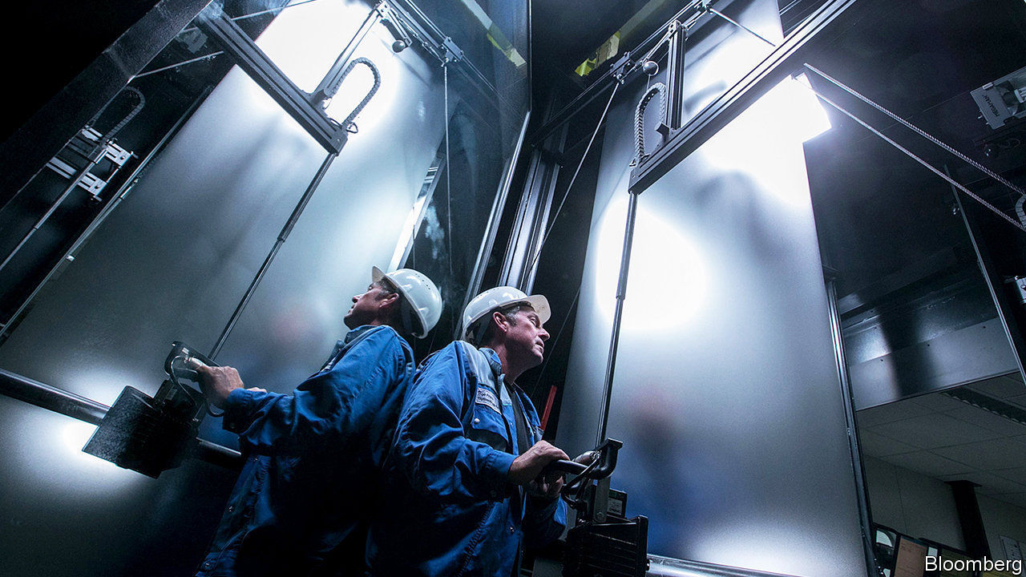

THE BID was months in the making. On February 27th the supervisory board of Thyssenkrupp announced that a consortium led by two Anglo-Saxon private-equity firms, Advent International and Cinven, had beaten one led by two others, Blackstone and Carlyle, in the bidding war for Thyssenkrupp Elevator (TKE), a division of the troubled conglomerate. They paid €17.2bn ($19bn), a rich price for the world’s fourth-largest liftmaker. It is the biggest private-equity deal ever in Germany, and one of largest anywhere in Europe.

It is not the only recent one. Germany has become the most popular European market for private-equity investors, according to consultants at PwC. Last year the value of disclosed deals reached an all-time high of €32bn (see chart). Many of them involved foreign buy-out firms, whose advances seem increasingly welcome in Germany. Martina Merz, chief executive of the cash-strapped Thyssenkrupp, preferred the bids of the two consortiums to a higher one from Kone, a rival Finnish liftmaker. She worried that antitrust concerns would cause long delays in completing the deal (even though Kone planned to let CVC, another private-equity firm, run TKE’s European business). And union leaders opposed the Kone bid, assuming it would result in larger job losses than a takeover by private-equity groups, as the combined rivals reaped economies of scale.

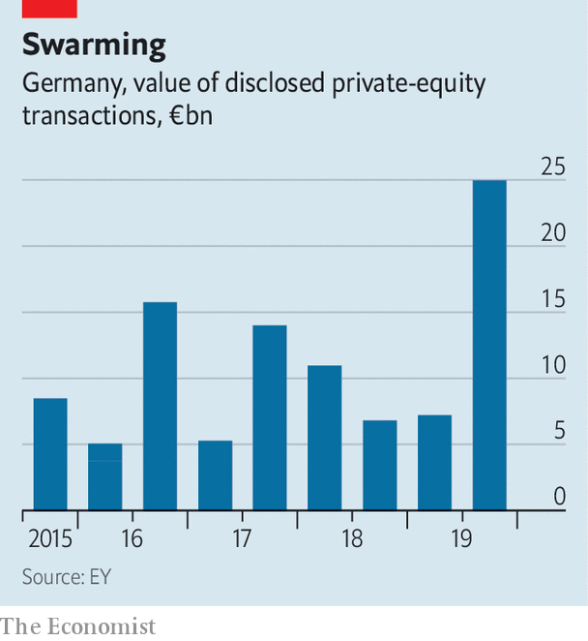

Such bonhomie between buy-out firms, their targets and labour and political leaders would have been unthinkable a few years ago. When in 2004 Texas Pacific Group bought Grohe, a maker of bathroom equipment, Franz Müntefering, then boss of the Social Democratic Party, in whose constituency Grohe was based, branded the firms asset-stripping “locusts”.

## A friendly infestation

Better relations are the consequence of private-equity barons’ evolving sensitivity to German quirks. They have grown wilier, developing Fingerspitzengefühl—“fingertip feeling” for tone and timing necessary to navigate the local landscape, characterised by complex rules on mergers and acquisitions and an idiosyncratic system of “co-determination”, which gives workers more power on corporate boards than anywhere else in the developed world.

Advent and Cinven are a case in point. Both have offices in Germany, staffed with locals who understand the peculiarities of German corporate governance and local politics. They buttered up IG Metall, the metalworkers’ union, as well as the mayor of Essen, the city where Thyssenkrupp is based, and Armin Laschet, the premier of its home state of North Rhine Westphalia. “You can only do such a deal with feet on the ground,” says Steve Roberts, head of PwC’s German private-equity practice.

As a result, only big firms with resources are likely to succeed. Fundraising has shifted to “winner takes all”, argues Alexander Schmitz, a partner at Bain & Company, another consultancy. He expects more mega-deals like TKE that only a few big British or American private-equity powerhouses can arrange.

For all their recent progress, however, buy-out firms continue to face structural impediments to growth in Germany. Lukas Schäfer, head of private equity in Germany for McKinsey, yet another consultancy, notes that the number of takeover targets is limited because the Mittelstand, Germany’s famed medium-sized family companies, remain wary of private equity. Moreover, says Mr Schäfer, many traditional German firms, including retailers and car-parts manufacturers, are seen as being threatened by the rise of e-commerce and electric vehicles. Even Mr Schmitz, who is more bullish, concedes that rules such as the domination agreement, which stipulates that an owner must secure 75% of votes at an extraordinary general meeting to control a target company’s cashflow, deter potential buyers.

Having won over Thyssenkrupp’s long-suffering shareholders with their hefty offer, Advent and Cinven say they are planning to spend billions on expanding TKE’s business. That ought to placate labour unions and politicians. Whether the pricey deal ends up rewarding the two funds’ investors is another matter entirely. ■

This article was downloaded by calibre from <https://www.economist.com/business/2020/03/07/two-buy-out-firms-pay-eu17bn-for-thyssenkrupps-lifts-business>

|  |  |  |  |
| --- | --- | --- | --- |
| Previous | Articles | Sections | Next |

|  |  |  |  |
| --- | --- | --- | --- |
| Previous | Articles | Sections | Next |

#### The glass-ceiling index

# Go north, young woman

Women continue to face barriers to equality in the workplace

Mar 7th 2020 |



TO MARK International Women’s Day on March 8th we have updated our glass-ceiling index, which ranks 29 countries on ten indicators of equality for women in the workplace: educational attainment, labour-force participation, pay, child-care costs, maternity and paternity rights, business-school applications, and representation in senior positions in management, on company boards and in parliament. East Asian women face a ceiling that appears to be made of bulletproof glass. In South Korea they earn on average 35% less than men and occupy only one in seven managerial jobs and one in 30 board seats. In Iceland, which topped the league table this year, women claim nearly half of all executive and board positions. As usual, Nordic countries perform best overall. America, which granted women the right to vote a century ago this year, continues to frustrate the ambitions of female workers. It comes a dismal 22nd on The Economist’s list, a little ahead of Britain and below the average for the oecd club of industrialised countries. Full results can be found at [economist.com/glassceiling2020](https://www.economist.com/glassceiling2020)■

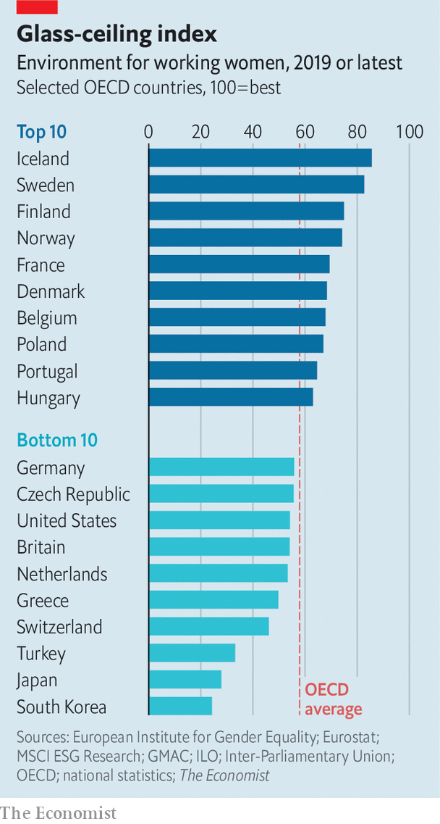

This article was downloaded by calibre from <https://www.economist.com/business/2020/03/07/go-north-young-woman>

|  |  |  |  |
| --- | --- | --- | --- |
| Previous | Articles | Sections | Next |

|  |  |  |  |
| --- | --- | --- | --- |
| Previous | Articles | Sections | Next |

#### The smartphone will see you now

# Millions of Chinese, cooped up and anxious, turn to online doctors

Even after the covid-19 epidemic, many will continue to favour internet hospitals

Mar 5th 2020 | SHANGHAI

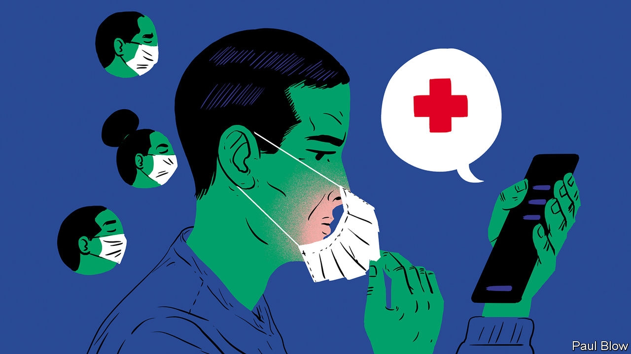

WHEN SARS, a coronavirus, hit China in 2003 citizens hunkered down at home. This proved a blessing for some businesses. Chinese social media took off. So did e-commerce. Richard Liu, who ran a chain of consumer-electronics shops, shut all his brick-and-mortar stores and set up JD.com. The firm is now valued at $64bn.

A novel coronavirus that has brought China to a halt this year is boosting another fledgling industry: telemedicine. As hospitals turn away patients with other ailments and many Chinese are confined to their homes or steer clear of clinics for fear of infection, millions are seeking treatment and advice on the internet. The government is egging them on.

Xin Lijun, boss of JD Health, says that his platform’s monthly consultations have grown tenfold since the outbreak, to 2m. Some 1.6m tuned in to a talk by a top cardiologist that the JD.com subsidiary live-streamed. Without the outbreak, the shift in consumer behaviour would have taken perhaps five years, reckons Mr Xin. Chen Qiaoshan of Analysys, a consultancy in Beijing, thinks that China’s online health-care market may near 200bn yuan ($29bn) this year, up from her pre-outbreak estimate of 158bn yuan.

China’s telemedicine market—including consultations and drug sales—had been predicted to grow vigorously even before the latest epidemic. Ping An Good Doctor, a medical-services app run by a big insurer, claimed in September that over 300m had registered on it, equivalent to one in three internet users in China. Tianyancha, a data firm, counts over 1,000 home-grown telemedicine companies.

Until now, however, most of these firms have stuck to delivering drugs or, in Ping An’s case, booking appointments with specialists, whom Chinese patients favour over general practitioners, even if it means queuing for hours at a hospital. Prestigious “AAA” hospitals account for one in ten public institutions but receive half of all outpatients. And the many Chinese who believe in traditional medicine, with its injunction that a reliable diagnosis cannot be made without feeling the pulse, would not dream of accepting health advice by video link.

Authorities, too, have been cautious. In many countries, including America, the world’s biggest telemedicine market, most insurers do not reimburse patients’ online expenses. Nor, in all but a few regions, does China’s national health-insurance scheme. Most Chinese online doctors are permitted only to handle repeat prescriptions and follow-up consultations, not make an initial diagnosis. A draft government policy from 2017 took “a negative tone” on internet hospitals and recommended they be shut down, recalls Li Tiantian, founder of Dingxiang Doctor, which runs a medical myth-busting-and-advice forum.

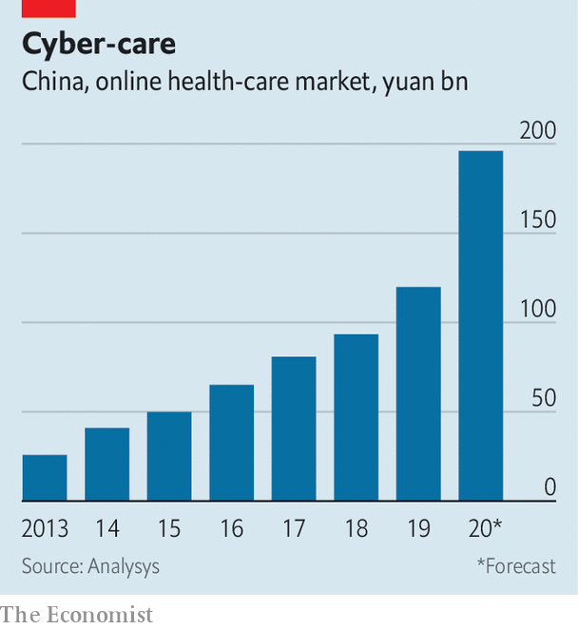

Last year the government began to lift some restrictions, such as a ban on the sale of prescription drugs. But covid-19, as the new disease is known, has accelerated the shift. At the peak of the epidemic in early February a health-ministry directive mandated that internet-based medical services be given “full play” to diagnose and treat patients. Another encouraged hospitals to give online consultations. Jiangsu province, China’s industrial powerhouse, authorised reimbursements for online medical care. So have cities including Shanghai and Wuhan, capital of Hubei province, where covid-19 first emerged.

Telemedicine firms are trying to win over the government and consumers by behaving like good corporate citizens. Many, including JD Health, are offering patients consultations free of charge while the epidemic lasts. Ali Health, an arm of Alibaba, China’s e-commerce titan, launched a free “online clinic” for residents of Hubei, which has been under lockdown; in five days 100,000 patients got a remote consultation. WeDoctor, an app backed by Tencent, a tech giant, mobilised 20,000 physicians to work online for no pay. Ping An set up an “antivirus command centre” to dispatch free face masks around the country. Dingxiang Doctor got epilepsy medication to 300 children in Hubei amid an acute shortage of suppliers and delivery firms. Its real-time heat map tracking covid-19 infections has been viewed 2.5bn times.

All this is costing the companies money. But, says Mr Xin of JD Health, it makes “little sense” to focus on profit at the moment. What matters, he adds, is how covid-19 has made people think twice about rushing to hospital and helped foster trust in general practitioners, who provide the bulk of online advice. It has also broadened the appeal of firms like his, beyond middle-aged patients with chronic conditions to web-savvy youngsters seeking advice for parents and grandparents and healthy types simply seeking reassurance. Of the 10m people who have turned to the internet for health services in the past month, perhaps half were first-time online patients, says Ms Chen. At least a third are likely to keep using such apps, she estimates.

## Remote possibilities

It is not just patients and politicians who are embracing telemedicine. JD Health has lured more pharmacies to its platform (in part by waiving the fee it earns on drug orders in Hubei). China’s underpaid, overworked doctors are also keen. Xiao Xingxing left a AAA hospital in Beijing to consult full-time for JD Health; many old colleagues and classmates are doing the same, she reports. And against the backdrop of a global, virus-induced stockmarket rout, Chinese online health firms offer a tonic to ailing investors. This year the share prices in Ping An Healthcare and Ali Health are up by 33% and 74%, respectively. ■

This article was downloaded by calibre from <https://www.economist.com/business/2020/03/05/millions-of-chinese-cooped-up-and-anxious-turn-to-online-doctors>

|  |  |  |  |
| --- | --- | --- | --- |
| Previous | Articles | Sections | Next |

|  |  |  |  |
| --- | --- | --- | --- |
| Previous | Articles | Sections | Next |

#### Schumpeter

# Covid-19 is foisting changes on business that could be beneficial

CEOs should be aware of the potential opportunities

Mar 7th 2020 |

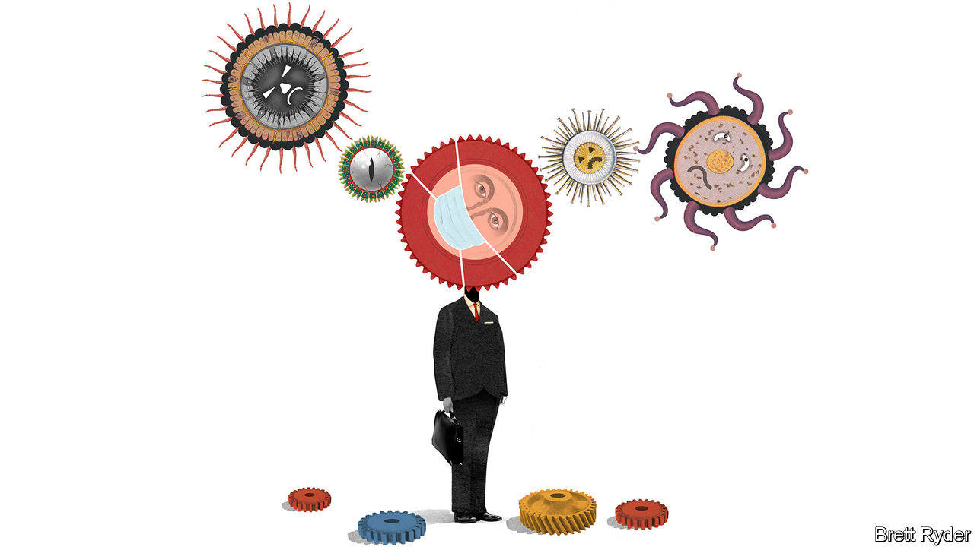

IN FEBRUARY 2014 a strike on the London Underground offered management theorists a lesson in resilience and adaptation. Because the shutdown closed some but not all Tube lines, frustrated Londoners were forced to rethink their commutes to and from work. Researchers at Oxford and Cambridge universities subsequently found that around 5% of passengers stuck to their new itineraries even after normal service resumed. The long-term economic gains of one in 20 travellers adopting new and improved ways to get to work turned out to be greater than the short-term costs of the disruption.

The global covid-19 outbreak presents a far greater challenge to the corporate world than striking transport workers. Profit warnings are spreading nearly as fast as the disease. Analysts at Goldman Sachs, a bank, estimate that earnings growth for firms in the S&P 500 index could grind to a halt. Gauges of business activity, such as purchasing managers’ indices, have cratered in Asia and are expected to weaken elsewhere as the coronavirus crosses more borders. Consumers are spending money on little except sanitary wipes, face masks and tins of Campbell’s Soup. Fears of a pandemic have wiped $7trn off the market value of listed firms worldwide in the past fortnight (see article).

Some companies will, like most of London’s commuters, revert to autopilot once the threat recedes. But for others the interruption will have a lasting effect, accelerating trends in business organisation that were already under way. Two are particularly important. The next few months are set to be a giant experiment in whether new technologies can allow successful mass remote working for employees, speeding up the reinvention of the office. And for firms already worried about rickety supply chains amid a trade war, the virus gives another reason to reconfigure them.

Take employees first. Companies have had to ask themselves whether to let employees travel, attend conferences or even come into the office. In all three cases the answer is increasingly “no”. Many big firms, including Amazon and JPMorgan Chase, have banned all non-essential excursions. Airlines and hotels are reporting steep falls in bookings. Corporate Travel Management, a listed Australian firm that organises business jaunts, has warned the impact could last up to six months. It has slashed its earnings forecast for the year by up to 16.5%. A survey by the Global Business Travel Association, an industry body, found that business travel, which costs companies over $1trn a year (and emits roughly as much carbon as Ukraine in flights alone), could fall by over a third while the epidemic rages.

Large corporate events are being called off. The oil industry’s biggest annual jamboree in Houston and the Geneva motor show will not take place this month. Google and Facebook have given the term “teleconferencing” a whole new meaning by moving a few of their big shindigs partly or wholly online. With Milan and Paris fashion weeks curtailed, Armani streamed its autumn/winter show from behind closed doors. This is bad news for events firms such as Informa, whose share price is down by a fifth since the start of February, especially at a time when many high-profile industry powwows are already losing their lustre.

At the same time more companies are learning to love telecommuting. On March 3rd JPMorgan Chase told thousands of its bankers in America to work from home as it tests its contingency plans. Twitter has asked its 5,000 employees to do likewise. Sony went so far as to shut some of its European offices altogether, just in case. The affected workers are nonetheless expected to toil remotely.

As well as highlighting how bloated some travel budgets are, virus contingency plans may also reveal how inefficiently office space is used. Big British and American firms pay on average $5,000 per employee in annual rental costs. Just 40-50% of desks are actually used during working hours—often not very well. Last year two in five respondents to a survey of 600,000 desk-jockeys by Leesman, a data provider, said their office prevented them from working productively. If their managers now find that productivity does indeed rise—or at least doesn’t dip—as staff self-isolate at home, the case for teleworking may look irresistible. Investors are betting it will. In the past month the share prices of Slack, a corporate-messaging platform, and Zoom, which makes videoconferencing software, have shot up by 18% and 35%, respectively.

The second way in which companies are rethinking their business has to do with supply chains. Since the 1980s these have become more complex and global, with large firms now dependent on thousands of suppliers. The embrace of lean manufacturing and just-in-time delivery of components, pioneered by Toyota in the 1970s, has made production more efficient but more vulnerable to disruption, as companies stockpile fewer and fewer necessary materials. The median firm in the S&P 500 carries only 66 days of inventory, and some have far smaller buffers than even that—Apple has just nine days, according to data from Bloomberg.

When natural disasters strike big companies usually get by, shifting production temporarily from afflicted areas to those that are not. But unlike a flood, an earthquake or even the Sino-American trade war, all of which companies have some experience in planning for, covid-19 could affect all of a firm’s actual and potential subcontractors simultaneously. In such a scenario carrying bigger inventories and having suppliers at home may no longer look wasteful. It may come to be seen as necessary.

## Immune response

The coronavirus will not make business travel or lean global supply chains disappear. Chinese factories are cranking up again and high-flyers will, in all likelihood, be back in airport lounges soon enough. But the crisis offers a chance to experiment with new ways of doing things—and to question the wisdom of old habits. Chief executives should not be immune to the opportunity.■

This article was downloaded by calibre from <https://www.economist.com/business/2020/03/07/covid-19-is-foisting-changes-on-business-that-could-be-beneficial>

|  |  |  |  |
| --- | --- | --- | --- |
| Previous | Articles | Sections | Next |

|  |  |  |
| --- | --- | --- |
| Business | Sections | Science and ... |

Finance and economics

The world economy: Sneezy money

.

Asset prices: Motion sickness

.

Buttonwood: Penthouse to pavement

.

Liquidity in bond markets: Match point

.

American banks: When the bucks stop

.

Catastrophe finance: A pussyfooting cat bond

.

Free exchange: Material losses

.

|  |  |  |
| --- | --- | --- |
| Business | Sections | Science and ... |

|  |  |  |  |
| --- | --- | --- | --- |
|  | Articles | Sections | Next |

#### How to revive the world economy

# A recession is unlikely but not impossible

Covid-19 infects the world economy

Mar 7th 2020 | SAN FRANCISCO AND SHANGHAI

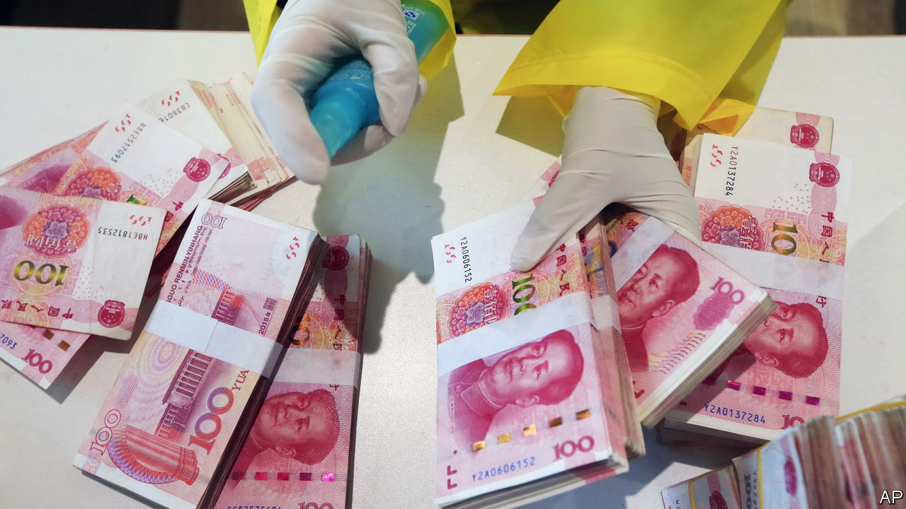

IF THE FINAL week of February saw financial markets jolted awake to the dangers of a covid-19 pandemic, the first week of March has seen policymakers leaping into action. The realisation that global GDP will probably shrink for part of this year, and the looming risk of a financial panic and credit-crunch, has led central banks to slash interest rates at a pace last seen in the financial crisis of 2007-09.

On March 3rd the Federal Reserve lowered its policy rate by 0.5 percentage points, two weeks before its scheduled monetary-policy meeting. Central banks in Australia, Canada and Indonesia have also cut rates. The European Central Bank and the Bank of England are expected to follow. If the money-markets are right, more Fed cuts are in store. A composite measure of the global monetary-policy rate, compiled by Morgan Stanley, a bank, is expected to fall to 0.73% by June, from 1% at the start of the year and 2% at the start of 2019.

Yet there is an uneasy feeling that a flurry of rate cuts may not be the solution to this downturn. In part that reflects the fact that they are already so low. A golden rule of crisis-fighting is that in order to be credible you should always have more ammunition available. In 2008-10 the global composite policy rate fell by three percentage points. Today, outside America, rich-world interest rates are close to, at, or below zero. Even the Fed has limited scope to cut much further—one reason, perhaps, why share prices failed to revive in the hours after its latest move.

The tension also stems from the peculiarity of the shock that the economy faces—one that involves demand, supply and confidence effects. The duration of the disruption mainly depends on the severity of the outbreak and the public-health measures undertaken to contain it. Given those uncertainties, policymakers know that while interest-rate cuts are an option, they also need fiscal and financial measures to help business and individuals withstand a temporary but excruciating cash crunch.

One way the virus hurts the economy is by disrupting the supply of labour, goods and services. People fall ill. Schools close, forcing parents to stay at home. Quarantines might force workplaces to shut entirely. This is accompanied by sizeable demand effects. Some are unavoidable: sick people go out less and buy fewer goods. Public-health measures, too, restrict economic activity. Putting more money into consumers’ hands will do little to offset this drag, unlike your garden-variety downturn. Activity will resume only once the outbreak runs its course.

Then there are nasty spillovers. Both companies and households will face a cash crunch. Consider a sample of 2,000-odd listed American firms. Imagine that their revenues dried up for three months but that they had to continue to pay their fixed costs, because they expected a sharp recovery. A quarter would not have enough spare cash to tide them over, and would have to try to borrow or retrench. Some might go bust. Researchers at the Bank for International Settlements, a club of central banks, find that over 12% of firms in the rich world generate too little income to cover their interest payments.

Many workers do not have big safety buffers either. They risk losing their incomes and their jobs while still having to make mortgage repayments and buy essential goods. More than one in ten American adults would be unable to meet a $400 unexpected expense, equivalent to about two days’ work at average earnings, according to a survey by the Federal Reserve. Fearing a hit to their pockets, people could start to hoard cash rather than spend, further worsening firms’ positions.

Modelling the resulting hit to economic activity is no easy task. In China, which is a month ahead of the rest of the world in terms of the outbreak, a survey of purchasing managers shows that manufacturing output in February sank to its lowest levels since factory bosses were first surveyed in 2004. It seems likely that GDP will contract in the first quarter for the first time since the death of Mao Zedong in 1976.

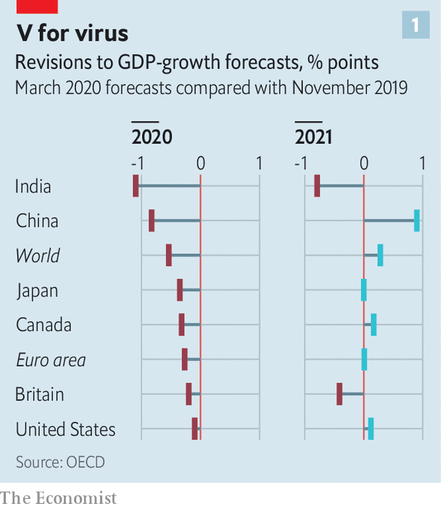

Forecasters are pencilling in sharp falls in output elsewhere (see chart 1). Goldman Sachs, a bank, reckons global GDP will shrink at an annualised rate of 2.5% in the first quarter. With luck the slump will end once the virus stops spreading. But even if that happens the speed and size of the economic bounce-back also depends on the extent to which those costly spillovers are avoided.

That is why central bankers and finance ministries are turning to more targeted interventions (see chart 2). These fall into three broad categories: policies to ensure that credit flows smoothly through banks and money markets; measures to help companies bear fixed costs, such as rent and tax bills; and measures to protect workers by subsidising wage costs.

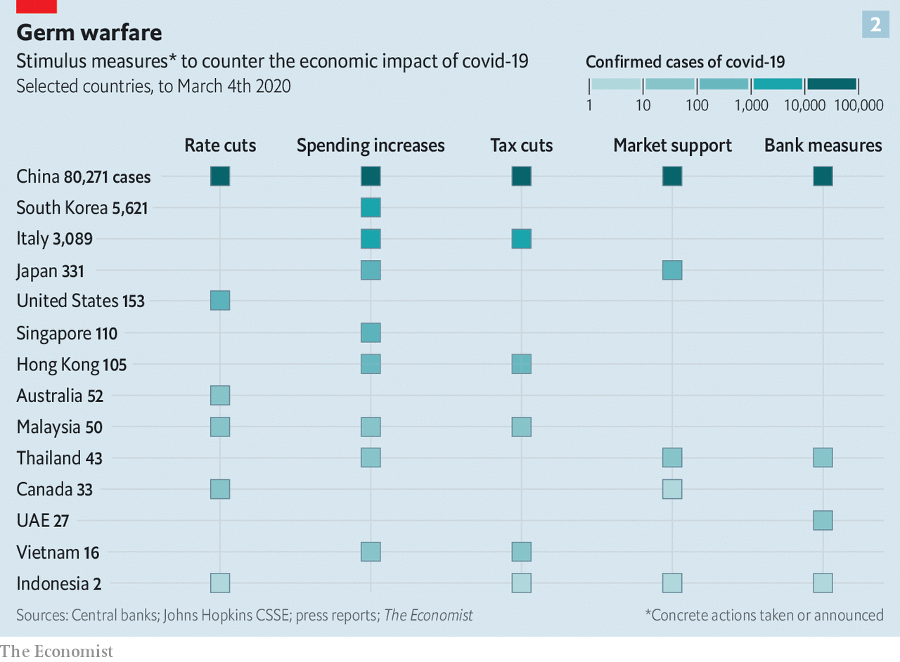

Start with credit flows. Central banks and financial regulators have tried to ensure that markets do not seize up, but instead continue to provide funds to those who need them. On March 2nd the Bank of Japan conducted ¥500bn ($4.6bn) of repo operations to ensure enough liquidity in the system. The People’s Bank of China has offered 800bn yuan ($115bn, or 0.8% of GDP) in credit to banks so long as they use it to make loans to companies badly hit by the virus. Banks have been asked to go easy on firms whose loans are coming due.

Governments are also helping firms with their costs, the second kind of intervention. Singapore plans corporate-tax breaks, and rental and tax rebates for commercial property. Korea will give cash to small firms struggling to pay wages. Italy will offer tax credits to firms that experience a 25% drop in turnover. In China the government has told state landlords to cut rents and given private-sector landlords subsidies to follow suit.

The final set of measures is meant to protect workers by preventing lay-offs and keeping incomes stable. China’s government has enacted a temporary cut to social-security contributions. Japan will subsidise wages of people who are forced to take time off to care for children or for sick relatives. Singapore has announced cash grants for employers of affected workers.

Today these policies are being sporadically announced, and their implementation is uncertain. As the virus spreads, expect more interest-rate cuts—but also the systematic deployment of a more complex cocktail of economic remedies. ■

This article was downloaded by calibre from <https://www.economist.com/finance-and-economics/2020/03/07/a-recession-is-unlikely-but-not-impossible>

|  |  |  |  |
| --- | --- | --- | --- |
|  | Articles | Sections | Next |

|  |  |  |  |
| --- | --- | --- | --- |
| Previous | Articles | Sections | Next |

#### Parsing the financial turmoil

# What the markets imply about the economic impact of the coronavirus

Investors should get used to the rollercoaster

Mar 5th 2020 | NEW YORK

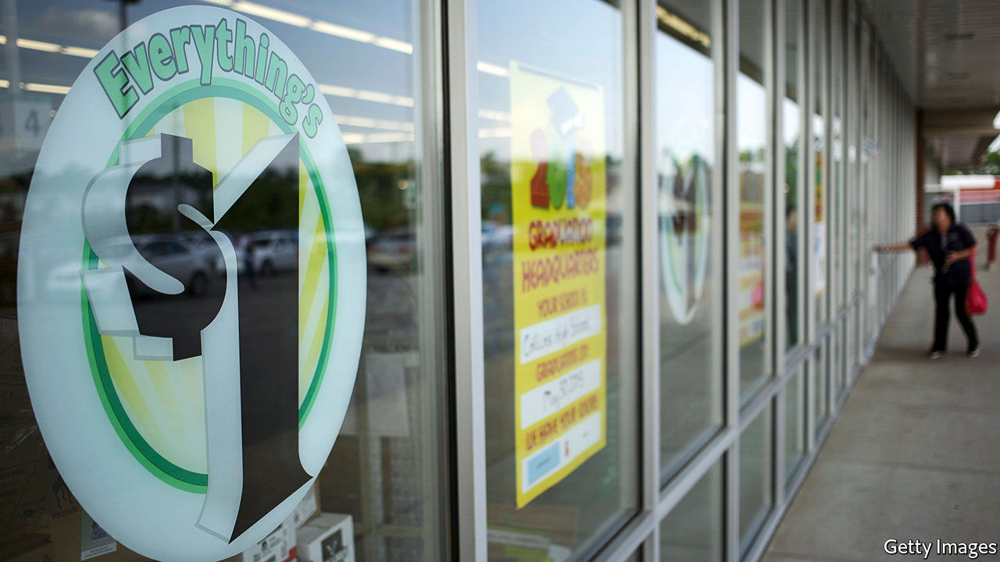

THE START of the year has been a rollercoaster for stockmarket investors. Out of the gates in January they experienced a gradual ratchet higher, climbing to an all-time peak in America, before a brutal and swift 11.5% plunge in the S&P 500 during the last week of February. So far in March investors have loop-the-looped. After the Federal Reserve convened an emergency meeting on March 3rd to cut interest rates by 0.5 percentage points, stocks spun and gyrated and the yield on the ten-year Treasury bond fell below 1% for the first time ever (see chart).

Uncertainty and fear about the spread of the covid-19 disease are to blame for the havoc (credit for some of the gains on March 4th may belong to Joe Biden, a moderate Democrat, who won the most delegates in primary voting on “Super Tuesday”). The market is wrestling with three fears. First, that the virus will (and may already have) spread widely across America and the rest of the world. Second, that fear of covid-19 and measures to stem its spread, like advising workers to stay home, will have severe consequences for economic activity. And third, that policymakers may be unable to keep short-term disruption from becoming long-term damage.

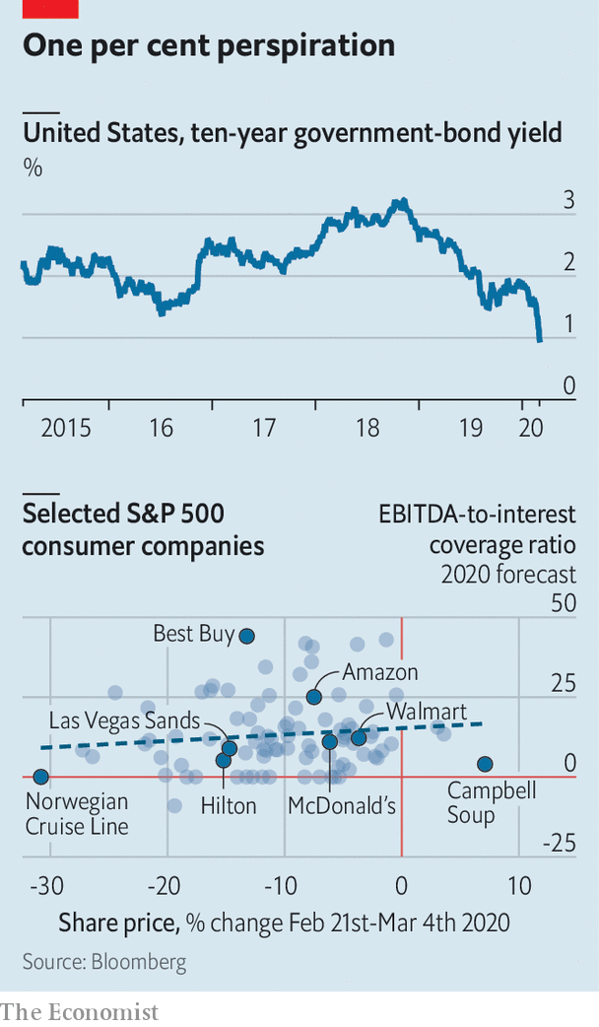

These fears have culminated in a sharp “risk-off” move in markets. As stocks have tumbled, safe-haven assets like gold, government bonds and certain currencies—such as the yen and the Swiss franc—have rallied sharply. Copper and oil prices, both bellwethers of economic health, have swooned. The VIX, an index of the implied volatility embedded in options prices, has jumped. The price of high-risk corporate bonds fell sharply.

There are two reasons why rapid moves in markets are worth examining. They are important sources of information. By parsing changes in asset prices it is possible to glean insight into how the virus might affect the American economy. And while some markets merely predict doom, others can hasten its arrival—the healthy functioning of credit markets is especially vital.

So what does the market imply about economic expectations? One way of capturing this is to consider what will happen to firms’ finances if people can no longer gather or move around freely. Revenues would take a hit across the board. The damage would be most acute for firms that rely on large groups of people coming to them, such as casino and theme-park owners. It would, however, also hurt those that rely on travel, like hotels and airlines. Corporate events and conferences have been cancelled in many countries—Starbucks, for example, plans to hold its annual shareholder meeting virtually.

Such consumer-facing firms have seen bigger share-price falls than most. But revenues will also suffer at companies with complex supply chains. If factories close in China, firms like Apple are unable to produce their wares. While sales may plummet, costs will not. Firms will still need to pay their staff, landlords and banks, among many other expenses. The markets are suggesting that the hit to profits will be significant. In aggregate the stockmarket gyrations since the middle of February imply that investors, who once thought this year would see robust profit growth of 14.3%, now expect perhaps half that amount.

But the risks may be even greater for some companies, and possibly existential for those with large debts to service. Consumer companies in general have lost 7.1% of their market value since February 24th. But as our chart shows, the prices of listed firms with high interest expenses relative to profits have fallen more than their peers—those with lots of debt have fared worse (except for those purveying essentials, like Campbell Soup). This suggests investors think the risk of a cashflow crunch at some firms is very real. Smaller firms may be more exposed. According to the IMF, small and medium-sized firms with annual interest costs larger than their profits account for more than half of all corporate borrowing in America.

That feeds jitters about bad debts in credit markets. The interest-rate spread over Treasuries demanded by investors to hold high-yield corporate debt had widened to 4.9 percentage points on March 4th, from 3.3 percentage points at the start of the year. Public credit markets even briefly ground to a halt. There was hardly any corporate issuance at all between February 24th and March 2nd in America and Europe. Fear about tight credit markets was one of the reasons the Fed stepped in to cut rates. There is evidence it is helping. After the emergency rate cut on March 3rd a handful of issuers seized the opportunity to issue small quantities of bonds.

Two questions now hang over the markets. First, is their reaction to the epidemic exacerbated by technology? Algorithmic trading has come to dominate stockmarket transactions. Just one in ten equity trades is carried out by a human. Plenty of sensible people worry that these “algos” exacerbate short-term moves. But the evidence in this case suggests that they are not to blame. Algos tend to trade heavily at the open and the close. Market moves since the middle of February have been characterised by extremely high volumes throughout the day.

Second, will the turmoil continue? The VIX gauge offers the closest thing to an answer. Because stocks tend to sedately tick up, but lurch downwards, volatility usually only rises when stocks are falling. But recent news has caused stocks to lurch in both directions. Unusually, volatility therefore remains elevated despite a recovery in share prices. A high VIX also suggests that violent swings will continue. Investors should get used to the rollercoaster ride, because the end is not in sight. ■

This article was downloaded by calibre from <https://www.economist.com/finance-and-economics/2020/03/05/what-the-markets-imply-about-the-economic-impact-of-the-coronavirus>

|  |  |  |  |
| --- | --- | --- | --- |
| Previous | Articles | Sections | Next |

|  |  |  |  |
| --- | --- | --- | --- |
| Previous | Articles | Sections | Next |

#### Buttonwood

# Share prices fall hard in recessions. It is tricky to take advantage

Seeing through a falling stockmarket

Mar 7th 2020 |

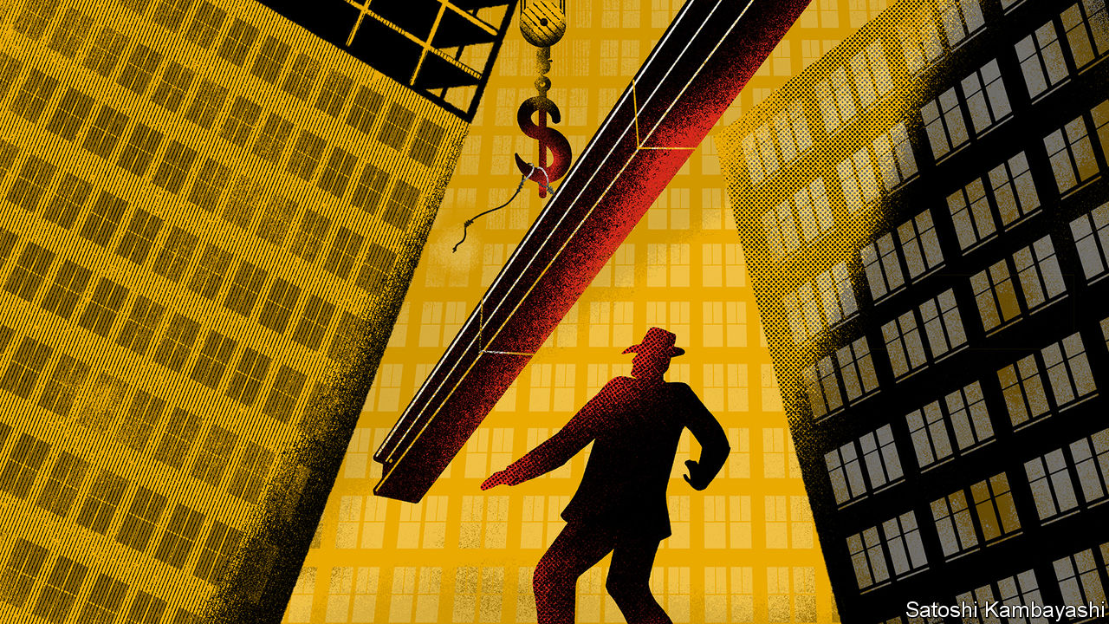

SAM SPADE, the detective in “The Maltese Falcon”, a crime novel by Dashiell Hammett, recounts a story of a missing-person case. Flitcraft, an everyman, is nearly killed by a falling beam. Confronted with the randomness of life, he decides—randomly—to vanish. After drifting for years, he settles into a new life much like his old one: marriage, kids, and golf at four. “He adjusted himself to beams falling,” says Spade. “And when no more of them fell, he adjusted himself to them not falling.”

The covid-19 virus has dropped from the sky, much like the girder that narrowly missed Flitcraft. Investors are shaken. Many are still adjusting to a world of falling beams. It will be a while before they adjust to them not falling. Meanwhile, the news on the economy gets worse. And bad economic news is generally bad for share prices.

If you are about to retire or derive your income from shares, this will hurt you. But there is a class of investor for which falls in asset values, or drawdowns, are an opportunity. Were prices to fall exactly in line with the value of lost profits, shares would be no cheaper. But in recessions, stocks tend to fall by a lot more than that. A clear-headed investor can pick up some bargains.

Economic downturns are—or should be—a fact of life for investors. A good working definition for them is a change to global GDP that causes a meaningful hit to the near-term corporate cashflows that shareholders lay claim to. A blow of this kind seems certain this year. But downturns eventually give way to recoveries. Only a fraction of firms will go bust. And equities are perpetual securities. The profits lost to recession can be thought of as an annual dividend cheque that got lost in the post and is not replaced. It hurts your wealth. But you are still entitled to payments stretching into the indefinite future. These account for most of a share’s value.

In principle, then, investors need not demand a big discount to hold stocks in recessions. But in practice they do. During the steep downturn of 2008-09, for instance, the S&P 500 index fell by almost 50% in the space of a few months. Although that was an especially brutal recession, it was not a drawdown for the ages. The peak-to-trough falls in earlier crashes were nearly as big. Clearly a lot of shareholders cannot look past the downturn. Call this panic, if you like, but it is all-too-human. When the beam hit the pavement beside him, Flitcraft “felt like somebody had taken the lid off life and let him look at the works”. Big drawdowns affect people in a similar way. Suddenly, risks seem to be everywhere—to your job, to your business, to your pension and your way of life. It seems imprudent to hold on to stocks.

The simplest, rules-based way to take advantage of lower stock prices is portfolio rebalancing. An investor who holds a portfolio split 50-50 or 60-40 between shares and bonds sells the bonds that have gone up in price, as interest rates fall, to buy shares that have fallen in price, and are now cheaper. She does this once a month or once a quarter to keep the weights constant. A bolder group of investors keeps cash in reserve so they can take advantage of bargain prices when the markets have turned away from risky shares. “There is a point when I say ‘this is getting interesting’,” says one investor. The threshold for “interesting” is a fall of at least 20%. For deep-value investors, it might be 40%.

A good stockpicker will have a watch list: a roster of company shares she would like to own should they become cheaper during the current sell-off. Market sages, tapping their nose, boast that they plan to load up on “quality stocks” at good prices when the stockmarket really tanks. If only life were that simple. Quality stocks (companies with a business model that is hard for rivals to emulate) started off dear and are only a little less so now. Meanwhile unloved value stocks, which sell for a low multiple of their profits, have become even cheaper. Such firms are in industries whose long-term prospects look bleak—banks, carmakers, oil firms and so on. Owning them has been an unrewarding experience. Their profits will be crushed by travel bans, supply-chain snarl-ups and the like. But their cheapness will push bolder investors to take a look.

Flitcraft was shocked to discover how random life can be. The hardboiled Sam Spade already understands this. Investors of the Spade kind know that beams fall, and they adjust to it. They also know that beams eventually stop falling. It is this that allows them to buy stocks when prices hit the pavement.

This article was downloaded by calibre from <https://www.economist.com/finance-and-economics/2020/03/07/share-prices-fall-hard-in-recessions-it-is-tricky-to-take-advantage>

|  |  |  |  |
| --- | --- | --- | --- |
| Previous | Articles | Sections | Next |

|  |  |  |  |
| --- | --- | --- | --- |
| Previous | Articles | Sections | Next |

#### Corporate-bond trading

# Electronic platforms are challenging bond broker-dealers

Their success is key to providing liquidity in stressed markets

Mar 7th 2020 |

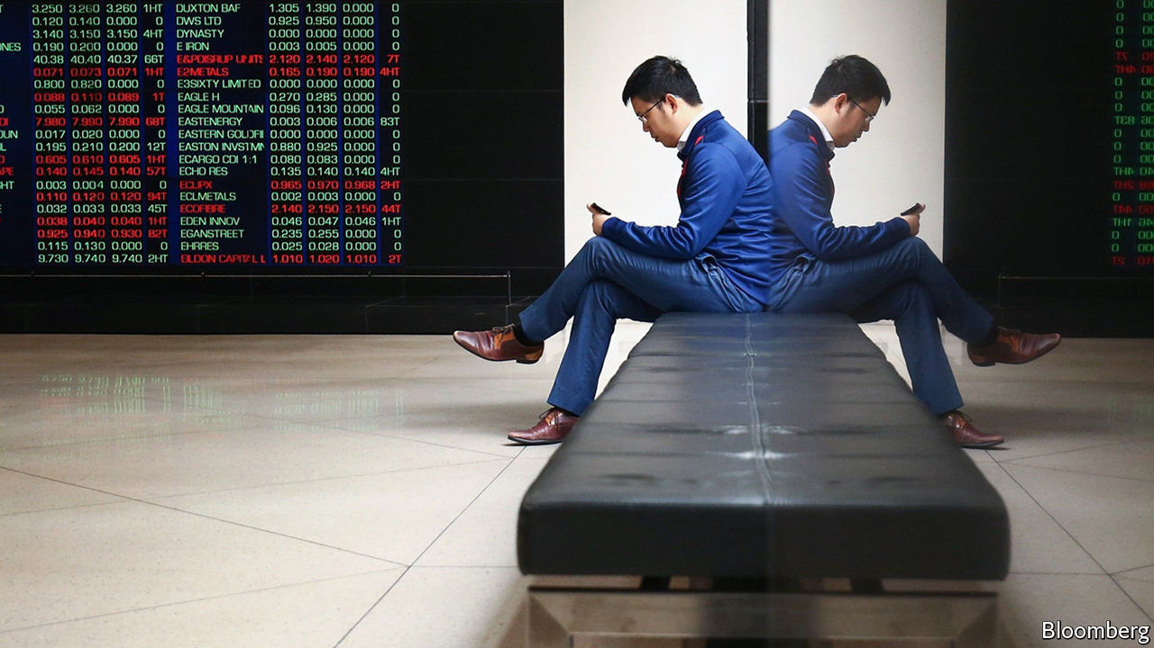

ONE OF THE minor miracles of financial markets is that, in volatile periods such as these, sellers of securities can be readily matched with buyers. Though the direction of prices is uncertain, trading volumes are solid. Yet worrywarts say that while liquidity is plentiful at first when volatility rises, it cannot be relied on if markets stay jumpy for a while.

Corporate bonds cause the biggest headaches. A cheap and convenient way to hold them is via exchange-traded funds, or ETFs, low-cost vehicles that hold baskets of bonds and trade on stock exchanges. Part of the appeal of bond ETFs is the ease with which they can be bought or sold. But the corporate bonds held in such funds are typically less liquid than shares. Bonds are not as standardised; a company may issue them at varying maturities. Investors may still think they can sell them at a moment’s notice. There have long been concerns about a shortage of willing traders should the markets become stressed.

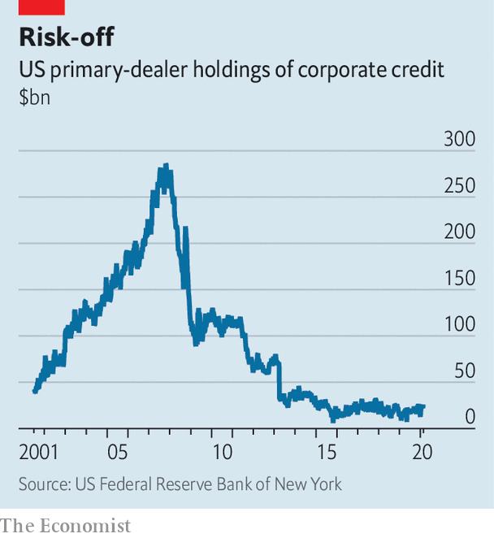

The broker-dealers who have traditionally stood between buyers and sellers of corporate bonds have scaled back their role as risk-takers (see chart). New forms of market-making are emerging. Slowly at first, and lately more quickly, the corporate-bond market is embracing trading on electronic platforms. Bloomberg is one of the main players. Another is Tradeweb, a venue favoured for the trading of government bonds. A third platform, MarketAxess, is the one best known for corporate-bond trades. A big question is, can such platforms make up for the diminution of old-school sources of liquidity?

Until 2008, the ease with which investors could trade corporate bonds relied on the willingness of big investment banks to hoard securities. These telephone-based dealers would buy bonds during periods of heavy selling and warehouse them for when investors were willing to bid for them again. But new rules since the financial crisis have made it expensive for banks to use capital for trading activities of any kind. The stockpile of corporate bonds they held dropped like a stone.

Enter the trading platforms. MarketAxess started 20 years ago as a way for pension funds and insurers to trade with the big dealer-brokers in an efficient way. After the financial crisis, it became clear that its clients needed something more. The firm started a programme to bring smaller, regional dealers and other liquidity providers into the fold. Individually none could match the muscle of the big Wall Street banks. But put them together and they provide meaningful liquidity for MarketAxess’s big clients. The firm has over 1,700 users, including mega-funds such as BlackRock and Legal & General. Volumes have risen for 11 years in a row. It handles a fifth of trading in investment-grade bonds in America. By far the fastest volume growth in the year to the end of February was in less-liquid securities, such as high-yield and emerging-market bonds.

The wonder is that it has taken so long for electronic trading to take hold in bond-land. It seems rather quaint that some deals are still brokered by traders with a phone glued to each ear. Screen-based trading is more transparent and far more efficient. But old habits die hard. A challenge for any platform—whether it is a dating website or an online-trading venue—is to persuade customers that there will be plenty of other customers to transact with. The barriers to “open trading” were high; traders were at first chary of advertising their bids and offers to all and sundry for fear that prices would move against them. But that has changed, says Rich Schiffman, head of Open Trading at MarketAxess. “They have come to realise that the benefits far outweigh the risks.” The more people who see your order, the better chance someone will fulfil it. Renewed market volatility might even attract more arbitrageurs to the platform.

Big tests lie ahead. Half of all investment-grade bonds have a credit rating of BBB. In a deep recession some of those bonds will be downgraded to junk. A lot of mutual funds can hold only investment-grade bonds. If big blocks of bonds have to change hands quickly, it might overwhelm the market’s liquidity. A lot rests on the further success of the electronic platforms.■

This article was downloaded by calibre from <https://www.economist.com/finance-and-economics/2020/03/07/electronic-platforms-are-challenging-bond-broker-dealers>

|  |  |  |  |
| --- | --- | --- | --- |
| Previous | Articles | Sections | Next |

|  |  |  |  |
| --- | --- | --- | --- |
| Previous | Articles | Sections | Next |

#### Where the bucks stop

# Can America’s banking system keep cash flowing if activity dries up?

Banks are on the front lines of the economic fallout

Mar 5th 2020 | NEW YORK

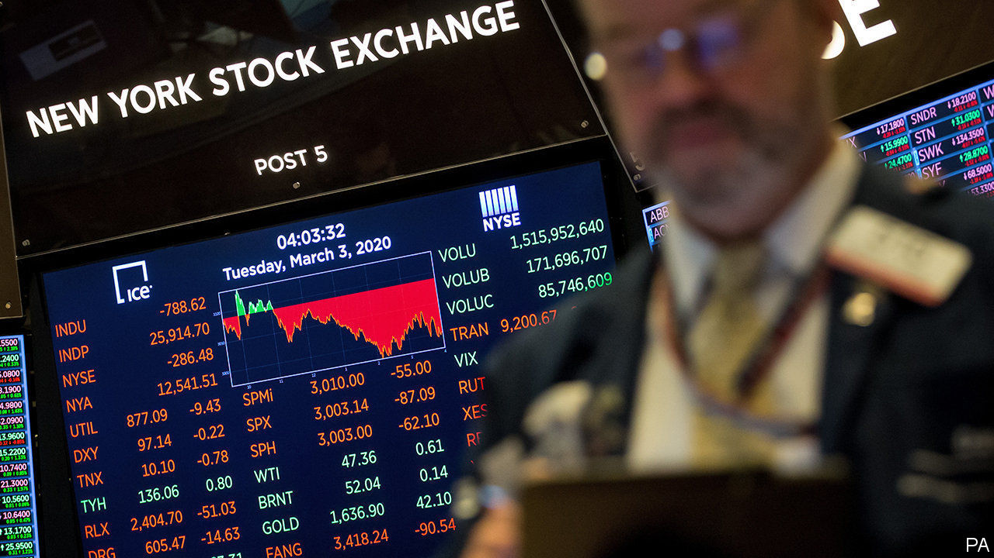

DURING THE financial crisis of 2007-09, American banks were part of the problem. As the covid-19 disease spreads, and efforts to halt it threaten to cause a cash crunch, they could be part of the solution. Company revenues may tumble but firms will still need to cover wages, leases and loans. Workers—especially temporary or gig ones—may not be paid, but mortgage or rent payments and credit-card bills will pile up. The banks (maybe backed by the government) will need to plug the gap.

Ordinarily, such stresses would indicate insolvency and banks would attempt to collect. But this crisis is different. There is a reasonable expectation that the cash crunch will be temporary. When activity resumes payments can once again start flowing.

America has recently endured a small-scale version of such a cashflow crisis. From December 22nd 2018 the government was shut down for 35 days, resulting in delays to the wage payments of 800,000 federal employees. According to Prudential, an insurance company, half of the federal employees it surveyed missed bill payments, like utilities or phone bills, and a quarter missed making a mortgage payment.

Many banks at the time acted to minimise financial hardship, by agreeing to delays in mortgage payments, waiving credit-card interest and overdraft fees, allowing early access to fixed-term deposits and offering low- or no-interest short-term financing to some customers. There were some long-term effects, like lower credit scores, but few major ones.

If such measures are required for a longer period, the pressures on banks to lend or offer forbearance might clash with post-crisis regulatory restrictions. Big banks already report seeing “flight to quality” deposits pouring in. But leverage ratios constrain bank balance-sheets. More deposits might induce banks to cut back on other activities.

No one is served by defaults on the part of borrowers who would have been solvent but for the epidemic. The question for banks, their customers and their regulators is how these can be avoided.

This article was downloaded by calibre from <https://www.economist.com/finance-and-economics/2020/03/05/can-americas-banking-system-keep-cash-flowing-if-activity-dries-up>

|  |  |  |  |
| --- | --- | --- | --- |
| Previous | Articles | Sections | Next |

|  |  |  |  |
| --- | --- | --- | --- |
| Previous | Articles | Sections | Next |

#### A pussyfooting cat bond

# A novel pandemic security is no match for a novel virus

Catastrophe finance is a work in progress

Mar 7th 2020 |

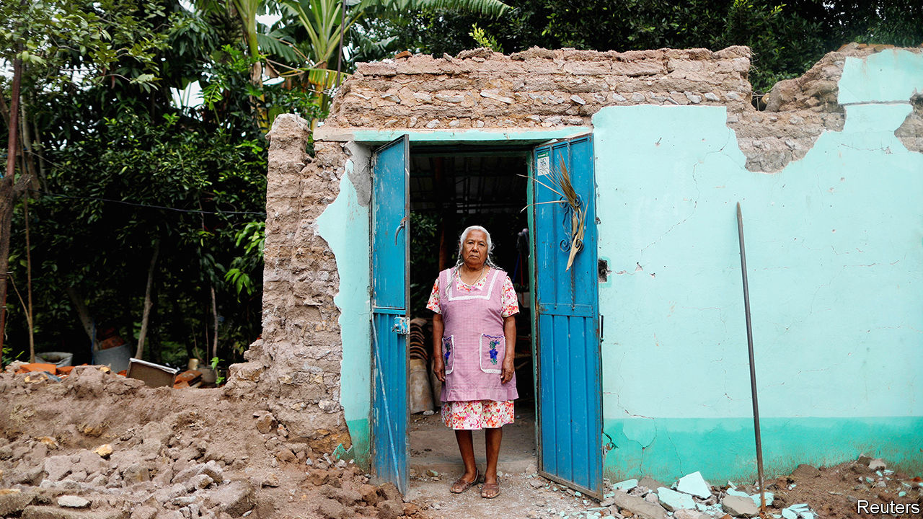

IN SEPTEMBER 2017 Mexico’s strongest earthquake in a century killed scores of people, flattened hundreds of buildings and left millions without power. The quake was also bad news for the holders of $150m-worth of “catastrophe bonds”, issued only a month before by the World Bank. Buyers were offered an attractive yield in return for the risk of not getting their money back if disaster struck. Once the quake was judged sufficiently disastrous, the money was instead paid to Mexico’s government to help it rebuild.

If such bonds can help countries cope with earthquakes, why not also disease? A few months before Mexico’s disaster, the World Bank sold $320m-worth of pandemic bonds (and some swaps) on behalf of the poorest 77 developing countries that it serves. The advocates of such bonds point out that they provide an upfront commitment of cash, triggered automatically according to preset rules, which is more reliable than trusting to the kindness of strangers. They also reward investors with higher yields for bearing risks that are little correlated with the rest of their portfolios.

The initial buyers of the bank’s riskier bonds (worth $95m) were told that they faced a 28% chance of losing money to a virus of some kind and a 5.9% chance of losing money to a novel coronavirus in particular. Those odds have now jumped. But the bonds have yet to release money to governments scrambling to prevent a pandemic. Why not?

According to the terms of the bond, a payout cannot be triggered until 12 weeks after an outbreak has been reported to the World Health Organisation (which would be March 23rd). The virus must have killed at least 250 people in total and 20 people in more than one country (a condition the covid-19 virus met on February 27th, when Iran reported over 20 deaths). The outbreak must still be growing when these other criteria are met. And the amount of money a country can get depends on the number of cases it has confirmed (relative to other countries claiming the money).

Critics argue that the conditions are overly stringent, inflexible and dilatory, taking far too long to fulfil. Of course, if the criteria were less strict, investors would have demanded an even higher interest rate on the bond, and if the trigger allowed more scope for discretion, buyers would also have shied away. The charge of tardiness is, however, harder to answer. How can such bonds prevent a pandemic happening if governments must first wait for verification that it has happened?

If countries respond quickly to the danger, lowering the number of cases, they may qualify for less money (or none) as a result. In normal insurance markets, people who take sensible precautions pay lower premiums. But in the case of these bonds, the “premiums” are covered by wealthy donors Japan and Germany.

A case can still be made for such instruments. They encourage better monitoring and reporting of infections. And although the existing bonds are too slow, the same is true of more traditional sources of finance, such as the generosity of donor countries. One novelty of the covid-19 disease is how quickly it has captured everyone’s attention. The World Bank, for example, said this week it would provide up to $12bn to help its clients respond to the outbreak, providing the money as quickly as possible. It may take the bank’s pandemic bonds until March 23rd to acknowledge the disaster taking place. But at least the bank itself does not have to wait that long. ■

This article was downloaded by calibre from <https://www.economist.com/finance-and-economics/2020/03/07/a-novel-pandemic-security-is-no-match-for-a-novel-virus>

|  |  |  |  |
| --- | --- | --- | --- |
| Previous | Articles | Sections | Next |

|  |  |  |  |
| --- | --- | --- | --- |
| Previous | Articles | Sections | Next |

#### Free exchange

# Commodity economies face their own reckoning due to covid-19

As prices fall, pressure for more health-care spending will rise

Mar 7th 2020 |

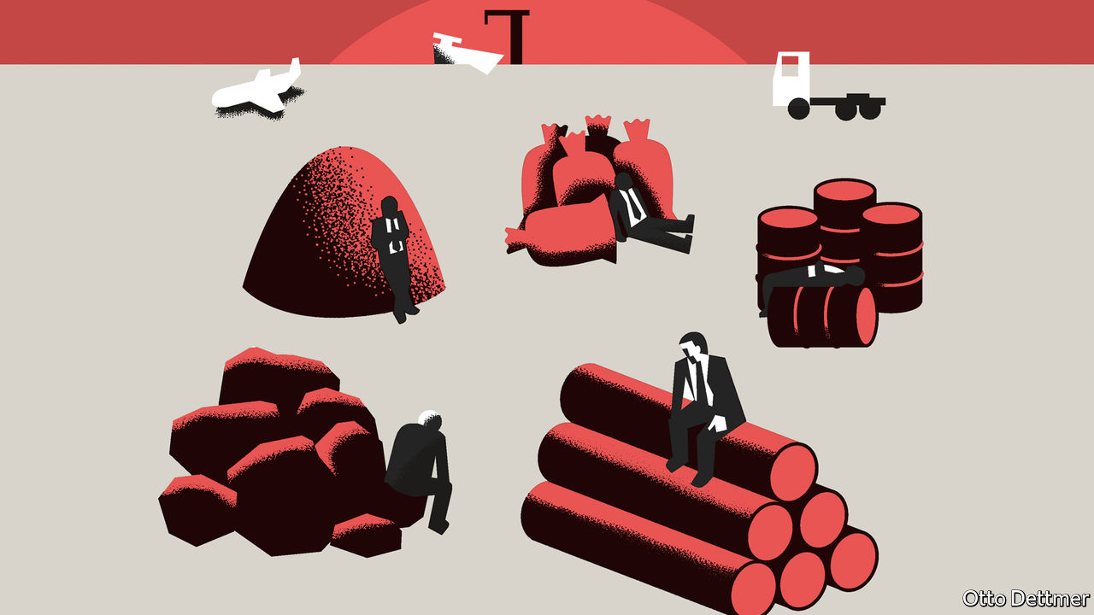

THE REWARD for providing the world economy with the raw materials it needs to grow is perpetual vulnerability. The hyperglobalisation of recent decades, and the associated Chinese growth miracle, yielded large benefits to commodity producers of all sorts. Now, as the shock of the covid-19 pandemic works its way through the world’s new, tangled economic plumbing, commodity-dependent economies find themselves exposed. The dangers faced by this group—UNCTAD, a United Nations trade-and-investment body, classifies 102 economies as commodity-dependent—differ from those of countries wired tightly into manufacturing supply chains. For them, falling commodity prices instantly put a strain on public finances, just as the burden of coping with a public-health crisis is likely to increase.

Managing a commodity-based economy is never easy. When prices rise, governments must worry about excessive spending and financial risk-taking. When they fall, budgets bust and foreign investors take flight, even as the need for domestic spending and easy credit grows. Commodity exporters have faced more bad times than good of late. They have been battered by a slowdown in China’s materials-hungry economy, a shale revolution in America which upended global oil markets in the middle of the 2010s, and growth-sapping trade wars. The tide looked like it was turning late last year, as a trade detente between America and China lent support to an unsteady revival in global manufacturing. Scarcely had producers begun to hope for better times when covid-19 threw a sopping wet blanket on their fortunes.

Markets have fallen dramatically as the pandemic has gained strength. Soyabean prices are off by nearly 6% from January highs, copper by more than 10%, and oil by around 30%. Brent crude fetched $74 per barrel in April of last year and $69 as recently as January, but is now trading at around $52. Prices could fall further if the outlook for the economy deteriorates further, and travel and trade dwindle. Better news out of China, where the number of new cases of covid-19 continues to fall, is encouraging. The Chinese economy accounts for roughly half of global demand for industrial metals and more than 10% of global demand for oil. But a return to economic normality in China could be delayed by the boomerang effect of a spread of the disease elsewhere.

Tumbling prices hit government revenues at a time when higher government spending means public finances are already under strain in countries like Saudi Arabia. The IMF estimates the fiscal breakeven price of oil for many large oil-exporting economies—the price which balances the government’s budget—to be well above current levels: more than $100 a barrel in Algeria and Iran, for example, and over $80 per barrel in Saudi Arabia. Even Russia, with a breakeven price of about $42, may soon feel a squeeze. A recent IMF analysis of the economies of the Persian Gulf notes that while most built up savings as oil prices rose between 1997 and 2007, spending grew faster than revenue over the subsequent seven years. Fiscal reforms implemented between 2014 and 2018, when oil prices entered a prolonged slump, have helped, but most Gulf economies continued to draw down their sovereign-wealth funds and accumulate debt. As The Economist went to press, OPEC producers and allies such as Russia were meeting in Vienna to discuss ways to lift oil prices. Capital Economics, a consultancy, expected them to agree to an emergency output cut of 1m barrels per day for at least three months. Under stress, co-operation could prove short-lived.

Cutbacks in production because of sagging demand for raw materials also affect the strength of the domestic economy: there is less work, and less money to be spent on local goods and services. Growth forecasts are already being revised down for mineral-rich countries like Russia and South Africa. Analysts at Goldman Sachs, a bank, reckon that a 10% drop in commodity prices might shave more than a percentage point from GDP growth in Peru and Chile: both are exporters of industrial commodities such as copper that rely heavily on demand from China.

The rising fiscal pressure on commodity economies could hardly come at a worse time. Managing the viral threat will be expensive. The burden in some countries such as Iran, where almost 3,000 cases of the virus have already been confirmed, could be crushing. In other commodity-producing regions, such as Latin America and sub-Saharan Africa, far fewer cases have been confirmed as yet, and hot and dry climates could limit the virus’ transmissibility. But it is too soon to assume they will be unaffected.

## Raw deals

A severe but temporary economic shock seems a perfectly reasonable excuse for a government to borrow more than planned. Commodity-based economies with a history of capable macroeconomic management can run larger deficits without fear of a market backlash; indeed, the yields on bonds issued by Australia have fallen sharply over the past month, reducing the cost of borrowing for a government grappling with a dual public-health and economic threat. Other big commodities producers will need to be more careful. In those with a history of recent financial stress, like Argentina and Venezuela, the covid-19 pandemic could pile misery upon misery. Brazil only recently escaped a cycle of fiscal incontinence, market scepticism and accelerating inflation.

Least predictable of all are the political effects of a potential pandemic. In good times, commodity wealth can blunt the complaints of political malcontents, while straitened circumstances expose all manner of ills. The slump of the past few years has already bred public disaffection across commodity economies, from Russia to Bolivia. The shock from covid-19 will test political systems around the world. Among commodity producers, especially those with little fiscal room for manoeuvre, fractures will be exposed more quickly and, occasionally, more destructively. ■

This article was downloaded by calibre from <https://www.economist.com/finance-and-economics/2020/03/07/commodity-economies-face-their-own-reckoning-due-to-covid-19>

|  |  |  |  |
| --- | --- | --- | --- |
| Previous | Articles | Sections | Next |

|  |  |  |
| --- | --- | --- |
| Finance and ... | Sections | Books and arts |

Science and technology

Military technology: The rise of the ray gun

.

Wildfires: Animal heat

.

Satellite communications: A call from the heavens

.

Evolution: Which is really the weaker sex?

.

|  |  |  |
| --- | --- | --- |
| Finance and ... | Sections | Books and arts |

|  |  |  |  |
| --- | --- | --- | --- |
|  | Articles | Sections | Next |

#### Military technology

# Laser weapons are almost ready for the battlefield

Ray guns, in other words, are now real

Mar 7th 2020 |



WHEN MARTIANS descend on England in H.G. Wells’s novel “The War of the Worlds”, published in 1898, they incinerate troublesome humans and lay waste to suburban towns with heat-rays that turn all before them into a “a smoky dance of lurid flames”. Such ray guns have been a recurrent feature of science-fiction ever since.

Despite the efforts of military types, though, reality has lagged far behind sci-fi. In 1934, to no avail, Britain’s Air Ministry offered £1,000 to anyone who could use rays of some sort to kill a sheep at a distance of 180 metres. A decade later a Japanese device that generated microwaves managed to snuff out a rabbit that was 30 metres away. But it took ten minutes to do so. Even the invention of lasers, in 1960, failed to usher in the age of the directed-energy weapon, as ray guns are known in the jargon. Ronald Reagan’s effort to weaponise lasers in the “Star Wars” programme of the 1980s was spectacularly unsuccessful.

This time, however, it’s different, according to Kelly Hammett, who joined America’s Air Force Research Laboratory 27 years ago, and now runs its Directed Energy Directorate. “For my entire career,” he says, “we have been working on directed energy. We’re finally at the point at which we’re going to see systems that will make a more substantive difference on the battlefield.”

## Zap!

If true, that will change the cost of war. At the moment, shooting an object out of the sky generally means firing something expensive at it. If the object is an enemy plane or sophisticated ballistic missile, that is probably worthwhile. But Israel, for example, routinely expends $50,000 interceptors on home-made rockets that cost about $1,000. Disparities like this make it easy and affordable to attempt to overwhelm defences with missile salvos or drone swarms. Lasers, by contrast, are cheap to fire and never run out of ammunition.

Lasers come in many varieties, but two, in particular, have been the subject of weaponisation. These are solid-state lasers and chemical lasers. A solid-state laser works by stimulating the emergence of a laser beam from a crystal or a piece of glass by pumping energy into that solid. (The first laser used a ruby as the crystal and a flashlamp as the pump.) The power to do this is provided by an electric current. A chemical laser, meanwhile, draws its energy from reactions between two or more substances and uses that energy to pump yet another substance to emit the beam.

In the first decade of the current century America came close to developing a chemical-laser weapon. This was a hangover from Star Wars, a megawatt device intended to destroy intercontinental ballistic missiles just after they took off. Tests conducted in 2009 were successful. But the system weighed 17 tonnes, and was so large that it required a Boeing 747 to carry it. Also, the pumping reaction involved chlorine, hydrogen peroxide and potassium hydroxide, all of which are corrosive—as was the substance being pumped, iodine. This is not an ideal mixture to have on board a plane. Having burned through $5bn over 16 years, the programme was therefore cancelled in 2011.

Today’s laser weapons have, by contrast, gone down the solid-state route. As Thomas Karr, who heads the Pentagon’s work on directed energy, explains, they use a laser to pump a laser. The main laser’s core—the equivalent of the ruby—is doped with an element such as niobium, to give it suitable properties. Instead of a flashlamp, this laser is stimulated by a laser-emitting diode.

By picking the right combination of ingredients for the main laser, its output can be tuned to an optimum wavelength—about one micron—that results in a narrow, far-reaching beam resistant to absorption by water vapour in the atmosphere. Today’s solid-state lasers are also much more efficient than their predecessors. A third of the electricity driving them is converted into laser light, compared with just a few percent in earlier generations. Dispensing with gases, moreover, means less plumbing and a more compact design.

The breakthrough for solid-state lasers came in 2014, with the testing by America’s navy of one that had a power of 30 kilowatts (kW)—the output of an average home boiler. When fitted to a small vessel called USS Ponce it proved able to fry the components and motors of nearby drones and boats. Ponce’s captain was then given permission to use it for real, if he needed to.

In light of this success a 60kW system, similarly intended for use, will be fitted on USS Preble, a destroyer, later this year. And an even more potent 150kW weapon is undergoing tests on larger ships. Nor are such devices exclusively naval. In February the American army said it planned to field its first “combat relevant” laser, a 50kW weapon that would sit atop Stryker armoured vehicles and defend them against aerial threats, by 2022.

## Mirrors, but no smoke

Military lasers have also benefited from progress in materials science. The heat-rays employed by Wells’s Martians relied on “a polished parabolic mirror of unknown composition”. Their real-world successors similarly use mirrors to combine and bounce light within the weapon, before sending it out through a window on its way to its target. Since lasers concentrate huge amounts of power into small areas, these mirrors have to be coated with reflective materials that absorb as little energy as possible. Similarly, the coatings of the windows require high-transmission materials that permit as much energy as possible to pass. Both types of coating have come along greatly in the past 20 years, because of their use in optical gyroscopes, which are fitted widely in aeroplanes and ships, says Mr Karr.

Another advance has been adaptive optics—a set of techniques that use special sensors and deformable mirrors to compensate, in real-time, for distortions caused by Earth’s atmosphere (think of the twinkling of stars). This technology, which enables military lasers to be aimed accurately, was pioneered in secret laboratories in the 1980s and then declassified in the 1990s, to the considerable delight of astronomers, who use it to adjust their telescopes. Last year the American air force’s Starfire Optical Range in New Mexico approached industry to develop a new and powerful sodium laser (one that energises the sodium atoms in a layer of the atmosphere called the mesosphere, to create artificial “guide stars”). This would refine adaptive optics for both astronomical and military purposes.

The next challenge is to soup lasers up still further, so they can take aim at large missiles, as well as the small ones that the Preble and Stryker weapons will be aimed at. The goal, according to Mr Karr, is to achieve 300kW by 2022 and 500kW by 2024. These will be demonstration devices, rather than battlefield-ready. But, a century and a quarter after Wells’s vision, it looks as though the ray gun is at last a reality.■

This article was downloaded by calibre from <https://www.economist.com/science-and-technology/2020/03/07/laser-weapons-are-almost-ready-for-the-battlefield>

|  |  |  |  |
| --- | --- | --- | --- |
|  | Articles | Sections | Next |

|  |  |  |  |
| --- | --- | --- | --- |
| Previous | Articles | Sections | Next |

#### Wildfires

# Fauna, as much as flora, govern susceptibility to wildfires

Animals can create or destroy fuel, and also make accidental fire breaks

Mar 7th 2020 |



THE WORLD is warming. All else being equal, that warming will promote wildfires. One job which human beings face in the future is therefore to ensure that all else is not equal. And that means understanding how those fires are regulated naturally.

Part of such understanding, Claire Foster of the Australian National University, in Canberra, argues, is a better perception of the role in fires of animals. In a paper in Trends in Ecology and Evolution she examines ways that animals’ activities can suppress or promote the spread of fire.

Some are obvious. That browsing and grazing animals like deer and wallabies keep under control the grasses and brushy plants through which fires spread is well known. The activities of invertebrates in the leaf litter are, by contrast, easily neglected. But two recent studies Dr Foster cites, conducted in Australian eucalyptus forests, have shown that excluding such litter-devouring critters almost halves the rate at which leaf litter decomposes, leaving more fuel on the ground for fires.

The role of large browsers, too, is more subtle than might at first appear. Their activities often destroy the lowest branches of a tree and thus create a gap between those branches that remain out of reach and the kindling of undergrowth and leaf litter scattered on the forest floor. These gaps act as fire breaks by stopping small fires climbing trees and turning into big ones that can jump from the crown of one tree to the next.

Animals are also responsible for creating more conventional, horizontal fire breaks. Species like deer frequently stamp trails bare of vegetation as they travel over and over again along the same routes. Though narrow, these trails are surprisingly effective at preventing fires from spreading. Even more surprising is that some of the most striking examples of firebreak trails are created not by mammals but by ant colonies. Vast numbers of tiny feet repeatedly crossing the same ground more than make up, it seems, for the minuscule weight of the creatures doing the treading.

Regrettably, some animal activities fan the flames. A number of herbivores—insects such as lace bugs (pictured) as well as mammals—stimulate plants to increase the amount of lignin in their leaves. This makes those leaves less edible, and thus more likely to end up on the ground. It also makes them slower to degrade if they do end up there, and therefore more likely to build up as fuel.

Other species actually collect leaves and wood for various purposes. For example, plains viscacha, a type of South American rodent, pile them up to attract mates. These accumulations are bonfires in waiting. Tree-killing insects like pine-bark beetles generate fuel in large quantities, too, since the dead trees they leave behind burn more easily than living ones do. And, ironically, the vertical firebreaks created by branch browsers also clear space for fire-friendly conifers to establish themselves.

Dr Foster and her colleagues suggest that an understanding of the activities of animals in an area would thus help those fighting fires there predict how big a fire is likely to get, how quickly it is likely to spread, how patchy it will be and whether or not it has a good chance of spreading to the canopy. There may even be the potential to shape the behaviour of future fires through measures that increase the populations of fire-suppressing species.■

This article was downloaded by calibre from <https://www.economist.com/science-and-technology/2020/03/07/fauna-as-much-as-flora-govern-susceptibility-to-wildfires>

|  |  |  |  |
| --- | --- | --- | --- |
| Previous | Articles | Sections | Next |

|  |  |  |  |
| --- | --- | --- | --- |
| Previous | Articles | Sections | Next |

#### Call from the heavens

# A new firm says it can link satellites to ordinary smartphones

If it works, there will be no escaping a mobile signal

Mar 7th 2020 |



SMARTPHONES GIVE people access to each other and to the internet when they are on the move—but only where there is network coverage. Satellite constellations, like those being built by SpaceX, OneWeb and Amazon, will provide broadband access anywhere on the planet, but will not talk directly to existing telephone handsets (they will instead require small receiving stations on the ground, to act as gateways). By contrast Abel Avellan, the founder of an American firm called AST & Science, claims to have invented a way to provide the best of both worlds: satellite connectivity that works anywhere on the planet and yet is accessible directly, via existing handsets.

AST & Science emerged from “stealth mode” this week. It dubs its service “SpaceMobile”. Mr Avellan, a veteran of the satellite industry, says he has spent years devising a way to get satellites to talk directly to ordinary phones. The result is an unusually large satellite that is capable of picking up a handset’s feeble signal, and also of broadcasting directly back to that handset. The satellite acts as a relay between the handset and existing antennas on the ground that are connected to cellular networks. In short, the satellite is not an orbiting base-station, but a radio repeater.

Mr Avellan says this approach can work with 2G, 3G, 4G and 5G networks, providing access in remote areas of land that currently have no coverage, and also on planes and at sea. SpaceMobile will, he says, launch a network of “a few hundred” satellites to provide global coverage. That compares with the 12,000 planned by SpaceX.

The company tested its technology in an unusual way. Last April, rather than launching a prototype of one of its large satellites, it kept the prototype on the ground and instead launched a tiny satellite to create what was, in effect, an orbiting handset. Even though the positions of relay and handset were thus reversed, their relative motions were the same as they would have been if the satellite had been in space and the handset on the ground.

Mr Avellan says the tests were successful. And on March 3rd his firm announced that Vodafone, a mobile-telecommunications giant, and Rakuten, a Japanese conglomerate, have joined the project as investors. Other backers include Samsung, a big handset manufacturer, and American Tower, which operates wireless-communications infrastructure around the world.

Such companies would not have backed SpaceMobile if they did not think the technology had a good chance of working. But not everyone is convinced. One industry insider, who has previously been involved with the SpaceX and OneWeb satellite projects, says getting handsets to talk directly to satellites means overcoming a huge number of problems relating to power requirements, propagation delay, allocation of frequency bands, interference and cross-border regulation.

Mr Avellan says he has solved all these problems, and has filed around 30 patents in the process of doing so, though he has yet to reveal full details of how his system works. He says the satellites switch on and off depending on which territory they are over, and use mobile operators’ existing frequency bands when active. Access to the service will be sold wholesale to operating partners, who can then offer SpaceMobile to customers as a global roaming option.

As well as working with existing phones, without the need for terrestrial gateways, Mr Avellan says that because his system needs far fewer satellites than its mega-constellation rivals, and thus fewer launches, it will be cheaper to build. As for pricing, he says access will be cheap enough for it to be used as a gap-filling technology in poor countries, where coverage can be patchy in rural areas. Such extraordinary claims require extraordinary evidence. Now he must prove that his scheme will fly.■

This article was downloaded by calibre from <https://www.economist.com/science-and-technology/2020/03/07/a-new-firm-says-it-can-link-satellites-to-ordinary-smartphones>

|  |  |  |  |
| --- | --- | --- | --- |
| Previous | Articles | Sections | Next |

|  |  |  |  |
| --- | --- | --- | --- |
| Previous | Articles | Sections | Next |

#### Evolution

# Which really is the weaker sex?

It depends on the way sex is determined in the first place

Mar 7th 2020 |



WOMEN LIVE longer than men. And, more generally, female mammals live longer than male ones. This might be put down to the fact that males live more dangerous lives than females—competition for the affections of those females being an ingrained part of malehood. Such competition leads either to dangerous fights, or to the growing of showy-offy but physiologically expensive and thus life-limiting accoutrements, or both. All of which would make perfect sense were it not also true that male birds, which cede nothing to their mammalian counterparts in the fighting and showing-off departments, nevertheless manage, on average, to outlive their respective females. Male spruce grouse (pictured), for example, live for 13 years; females for five.

A long-standing hypothesis holds the sex chromosomes to blame. Male mammals are, in the jargon, heterogametic. They have X and Y chromosomes, whereas females have a pair of Xs. In birds, it is the females which are heterogametic. In both groups, the sex-determining chromosome is a stubby thing that is missing many of the genes on its counterpart. It therefore cannot cover for its partner’s genetic deficiencies by providing working copies of genes which are mutated in that partner. (In humans, haemophilia, Duchenne muscular dystrophy and colour-blindness are all caused this way.) As a result, the heterogametic sex is less resilient and dies earlier.

It is a plausible idea. But two sample points (mammals and birds) do not prove it. So Zoe Xirocostas and her colleagues at the University of New South Wales, in Sydney, Australia have looked further. As they describe in Biology Letters, they searched the literature for animals where both the relative longevity of the sexes and the nature of any heterogameticity are known.

Adding reptiles, amphibians, sharks, bony fish, arachnids and insects to the list, they confirmed that the relationship between longevity and heterogameticity does indeed hold up in other groups of animals. But there is a twist. When males are heterogametic the sex difference in lifespan averages 20.9%. Despite extreme examples like the spruce grouse, however, when females are heterogametic the average difference is only 7.1%. These numbers suggest that fighting and showing off are involved in determining longevity differences, too.

This article was downloaded by calibre from <https://www.economist.com/science-and-technology/2020/03/07/which-really-is-the-weaker-sex>

|  |  |  |  |
| --- | --- | --- | --- |
| Previous | Articles | Sections | Next |

|  |  |  |
| --- | --- | --- |
| Science and ... | Sections | Economic and ... |

Books and arts

Inequality, revisited: A modern Marx

.

New American theatre: Notes from the underground

.

Baltic literature: The farmer’s tale

.

Irish fiction: A life in parts

.

|  |  |  |
| --- | --- | --- |
| Science and ... | Sections | Economic and ... |

|  |  |  |  |
| --- | --- | --- | --- |
|  | Articles | Sections | Next |

#### A modern Marx

# A bestselling economist sets out the case for socialism

Thomas Piketty’s new book may prove as famous—and controversial—as its predecessor

Mar 5th 2020 |

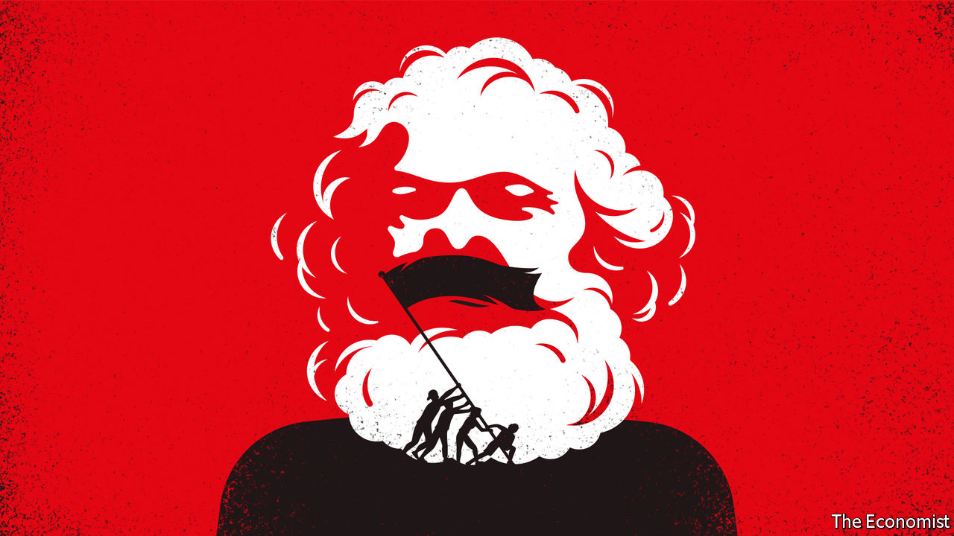

Capital and Ideology. By Thomas Piketty. Translated by Arthur Goldhammer. Belknap Press; 1,104 pages; $39.95 and £31.95.

THOMAS PIKETTY’S “Capital in the Twenty-First Century”, first published in 2013, made the French economist a household name. Combining heavy economic theory with data wizardry and commentary on the novels of Jane Austen and Honoré de Balzac, Mr Piketty argued that capitalism almost inevitably generates high and rising inequality. Many of his claims—that the stock of wealth in an economy grows faster than income, for instance, or that inequality in the West is approaching levels last seen during the Belle Époque—are now both familiar and fiercely debated.

Mr Piketty’s new book is over 1,000 pages long and looks far beyond the West. Austen and Balzac turn up again—joined by “Black Panther”, a recent blockbuster film, and Chimamanda Ngozi Adichie’s novel “Americanah”. Mr Piketty says the tome is “in large part a sequel” to its predecessor, yet in an important way it is a clear change of direction. In “Capital” Mr Piketty shared Karl Marx’s goal in the work of the same name that he published in 1867: to reveal the economic logic of the capitalist mode of production. “Capital and Ideology”, by contrast, is closer to the sociological writings of Marx and his followers, especially “The German Ideology” (1845-46), which sought to explain the social and political means by which capitalists maintained power over the working classes.

The scope of Mr Piketty’s analysis is wider than Marx’s, however. “Every human society must justify its inequalities,” he begins. The book surveys not only capitalist societies but colonial, slave-owning and feudal ones, too. In almost all, income and wealth have been distributed highly unequally. To retain their dominant position, Mr Piketty says, elites have used “ideologies”, which he describes as “a set of a priori plausible ideas and discourses describing how society should be structured”. “Plausible” they may be, but for Mr Piketty all such ideologies are in a crucial sense illegitimate or unjust. His deconstruction of these rackets leads him to advocate a transition to a hardline version of socialism.

## Some of the people, all of the time

Mr Piketty spends much of the book explaining how ideological techniques have varied. In the Middle Ages church authorities said the natural order required small numbers of clergy and nobility and a mass of labourers; the lower ranks were meant to meekly accept their lot. In India the “Manusmriti”, a compendium of laws compiled in the second century BC, proposed “a social structure and rules intended to…restore order to the Hindu social and political system”. In the 18th century Western elites declared that slavery was justified because the enslaved needed moral guidance; similar arguments were thereafter used in favour of colonialism. And so on.

None of this analysis of elite skulduggery is very novel. For example, Theodor Adorno and other members of the Frankfurt School argued that the media turned people into capitalist drones. Michel Foucault examined how prisons, hospitals and schools shaped good capitalist subjects.

And Mr Piketty’s account of ideology is less well developed than some such predecessors’. In part this is because he flits between case studies (with strange digressions, such as an explanation of the role of vegetarianism in Hinduism). It is not clear who exactly is promulgating the ideologies he sketches, or how. Moreover, in his overly pessimistic view of history, elites are only ever self-serving. Take the repeal of the Corn Laws in Britain in the mid-1840s, an episode which Mr Piketty barely mentions. Some bigwigs wanted to preserve the privileges of the landed gentry by maintaining high tariffs on imported grain, but others genuinely wanted to reduce the cost of food for the working classes.

Nevertheless, his book has virtues that many post-Marxist critiques lack. For one thing, it is more readable. The prose is pithy and light on theory. Mr Piketty draws on an impressive range of historical statistics. In the early 1980s, he relates, income inequality in Soviet Russia was only marginally lower than it was in Europe. His numbers show how the definition of “elite” has changed over time. Just before the revolution of 1789 the French church owned almost a quarter of the country’s property; today all non-profit organisations in France own just 1%. Above all, Mr Piketty’s sweeping scholarship enhances, rather than obscures, his central argument.

It is a familiar one. In 1867 Marx said the “essential difference between…a society based on slave-labour, and one based on wage-labour, lies only in the mode in which this surplus-labour is in each case extracted”. Capitalism, in other words, was just as exploitative and immoral as slavery or feudalism—it just did a better job of covering it up. As Mr Piketty casts his eye over a millennium of global history, he reaches a strikingly similar conclusion.

## The tyranny of property

From today’s perspective, many past societies appear obviously unjust. It now seems self-evident that colonialism was immoral, for instance, and that feudalism deprived people of agency. Many of the arguments once deployed against liberal reforms now seem blatantly self-interested. Thomas Jefferson’s views on the emancipation of slaves are a stark example: “We have the wolf by the ear, and we can neither hold him, nor safely let him go. Justice is in one scale, and self-preservation in the other.”

Mr Piketty believes that “the justifications [for inequality] given in the past turn out, if studied carefully, to be no more incoherent than those of the present.” He calls the current inequality regime “neo-proprietarian”, an ideology characterised by absolute respect for property rights and the distribution of income and wealth that results. It is a thin creed, in his view. The notion that people have “an inviolable natural right [to] strictly private property” cannot withstand analysis, since the “accumulation of wealth is always the fruit of a social process, which depends, among other things, on public infrastructures…the social division of labour, and the knowledge accumulated by humanity over centuries.” At the same time, access to fundamental goods, such as education, is so unequal that the resulting distribution of income and wealth must be illegitimate.

This is too gloomy—as some of Mr Piketty’s own data show. Inequality has risen in most countries in recent decades, but it remains much lower than it was a century ago. The world is healthier and wealthier than ever; the author accepts the rise in life expectancy, though he begrudgingly points to “the limitations of available demographic sources”. The development of capitalism from the 18th century onwards greatly lifted average living standards. Meanwhile, considerable (if incomplete) progress has been made on racial and gender equality. But for Mr Piketty, history lurches from one inequitable regime to the next, each scarcely better than the last.

The last part of his book focuses on his alternative to “neo-proprietarianism”. He is no fan of Soviet communism, in part because he accepts that society “sometimes requires small businesses funded with private capital and employing a handful of workers”. And though he is encouraged by the willingness of politicians in the mid-20th century to confront elites, for instance by steeply raising income and inheritance taxes, he cannot bring himself to endorse 20th-century social democracy. It fell short, he thinks, not least because “progressive taxation…power-sharing in firms…democratic budgeting and public ownership were never explored as fully or systematically as they might have been.” Instead he proposes a new form of socialism.

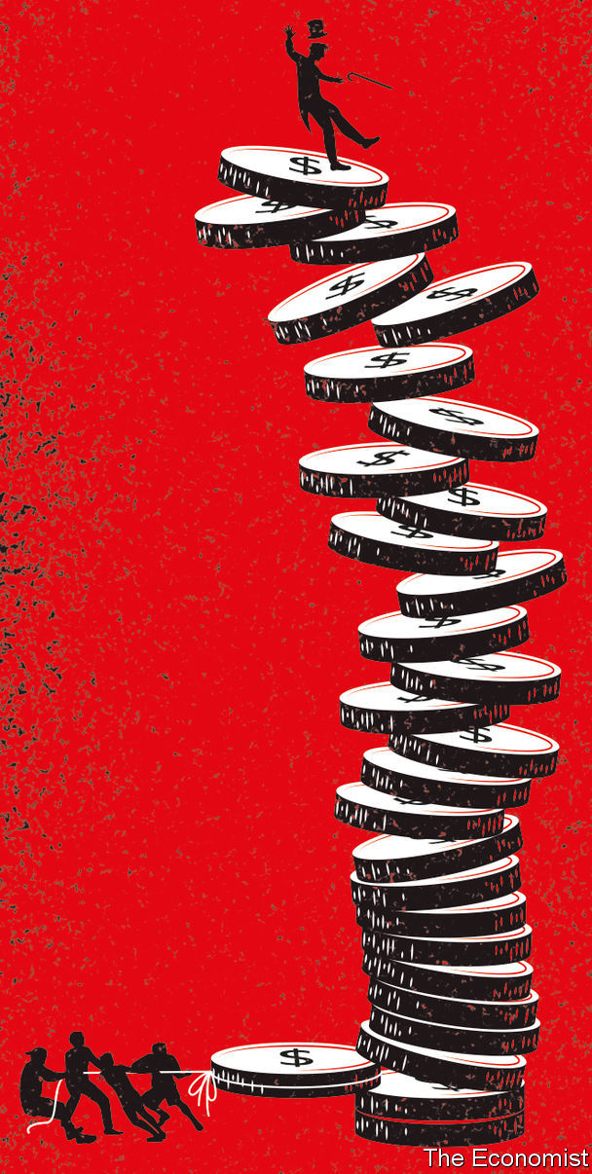

This system bears many of the hallmarks of a movement The Economist has called “millennial socialism”, which is on the rise on both sides of the Atlantic. The core idea is to “democratise” the economy, transferring control from capitalist and government elites to ordinary folk. Employees would have a decisive say in the management of their firm: think of Bernie Sanders’s plan to put workers on boards. Public services, especially education, would be vastly enhanced. Every youngster would get a cash lump sum. Mr Piketty envisages radically higher taxes on the rich, not just to raise revenue but to drastically reduce their clout. He imagines a wealth tax of up to 90% on the largest fortunes.

## Keeping the red flag flying

Such measures would unquestionably reduce income and wealth inequality, perhaps to all-time lows. But would they create better societies? After all, socialism carries its own risks and distortions. Reductions in material inequality might be offset by increases in other sorts—in access to public services, say, or in free expression and political power. Businesses run by “the workers” might be captured by trade unions. A more powerful state might become more self-serving. Would such societies be truly just and their inhabitants truly free? In the end, Marx came to worry about this complication. Not Mr Piketty.

Then there is the economy itself. Many thinkers on both left and right agree with him that inequality is too high, and that, even in mature democracies, income and wealth are often accumulated unfairly. Unlike him, most resist the idea of a socialist overhaul, in part because they fear it would leave everyone, including the poorest, worse off. You don’t have to be a plutocrat to fret that sky-high wealth taxes would play havoc with incentives, reducing investment and entrepreneurship.

Mr Piketty waves away such concerns in a few paragraphs, an oddly brief discussion given the book’s length, not to mention his profession. He provides some graphs which purport to show that high tax rates are actually good for economic growth. “Bill, Jeff and Mark”, he reckons, “would no doubt have lived their lives in exactly the same way” in the face of confiscatory taxes (never mind that they would lose control of Microsoft, Amazon and Facebook). He evinces a breezy disregard for orthodox economics, asserting, for example, that “there is no obvious reason why wealth redistribution should be limited to property in land”. That ignores the widespread opinion that, since its supply is fixed, land may be treated differently to other assets.

This book may well become as famous as “Capital”. But it is hard not to conclude that, deep down, Mr Piketty believes the worth of a society is measured by its Gini coefficient alone. For all his flair and learning, that is a mistaken ideology. ■

Listen to our interview with Thomas Piketty on “The Economist Asks” at [economist.com/thomaspiketty](https://www.economist.com/thomaspiketty)

This article was downloaded by calibre from <https://www.economist.com/books-and-arts/2020/03/05/a-bestselling-economist-sets-out-the-case-for-socialism>

|  |  |  |  |
| --- | --- | --- | --- |
|  | Articles | Sections | Next |

|  |  |  |  |
| --- | --- | --- | --- |
| Previous | Articles | Sections | Next |

#### Notes from the underground

# A West Virginian tragedy in Manhattan

“Coal Country” tells the story of a fatal mining accident in 2010

Mar 7th 2020 | NEW YORK



THE BLAST that killed 29 men at the Upper Big Branch mine in West Virginia in 2010 was the deadliest coalmining explosion in America in decades. Afterwards investigators found dangerous levels of methane, poor ventilation, faulty machines, broken water-sprinklers and thick, sight-obscuring clouds of coal dust. The mine’s owner, Massey Energy Company, was subsequently bought by a rival; its boss at the time, Don Blankenship, was convicted of a misdemeanour in 2015 and served a year in prison. He claims he is innocent and is now running for president as a third-party candidate. Yet the miners who lost their lives, and the families who mourn them, were largely forgotten.

Now their stories can be heard at the Public Theatre in Manhattan, where “Coal Country”, a “documentary play” by Jessica Blank and Erik Jensen, opened on March 3rd. The accounts, delivered by actors but collected from survivors—and accompanied by Steve Earle’s Appalachian banjo and guitar—are riveting. They tell a tale of corporate greed and silenced dissent. These are men who followed their fathers and grandfathers into the pits, firm in the belief that the work was honest and safe. When Gary Quarles (played by Thomas Kopache), whose son died in the disaster, began mining in 1976, the union saw to it that shifts lasted eight hours, lunches could be eaten sitting down and “you didn’t worry ’bout gettin’ fired by speakin’ up.”

When Massey bought the lucrative mine in 1994, the union was sidelined. “Safety started goin’ out the window,” recalls Stanley Stewart (Michael Gaston), a miner better known as Goose. Months before the explosion, he sensed the facility was a “ticking time-bomb”. He left a record of the firm’s hazardous practices for his wife, so she could sue if anything happened to him. He suspected his days were numbered, but options were scarce in rural West Virginia, and this was the only job he ever knew.

Verbatim theatre—in which the drama is adapted from real-life documents and transcripts—has been used to explore topical issues and historic events in Britain and Russia. Ms Blank and Mr Jensen, who are married and regular collaborators, are among its most accomplished exponents in America. “The Exonerated”, their play based on interviews with more than 40 exonerated death-row inmates, has been produced around the world. In 2003 (three years after it opened) it reportedly influenced the decision by George Ryan, then governor of Illinois, to commute all the state’s death sentences. “Aftermath” (2009) relied on interviews with refugees in Jordan to convey the chaos left in the wake of America’s invasion of Iraq. Enlisting first-hand accounts in this way helps overcome the audience’s politics and prejudices.

The mining tragedy “gets at the heart of what we need to be grappling with as a country,” reckons Ms Blank. Since the playwrights began work on the project in 2014, its themes have become only more pressing: anxiety over corporate power; declining unions; the erosion of opportunities for poorly educated American men; an over-reliance on fossil fuels. Still, persuading the miners and their families to talk was difficult, not least because “this is a community that has long been exploited by outsiders,” says Ms Blank. Once they gained their subjects’ trust, however, they discovered that West Virginians were natural raconteurs. “Every person we spoke to was a beautiful storyteller,” says Mr Jensen.

The duo hope “Coal Country” will soften metropolitan views of rural America. “A bias against the rural working class is one of the last socially acceptable prejudices to hold publicly among coastal progressives,” observes Ms Blank. She confesses to being surprised by the nuances of politics in Appalachia, where families display their guns proudly but hold left-wing convictions about workers’ rights. By letting these Americans speak for themselves, the playwrights hope audiences will empathise with their stories—and grasp the pain behind their nostalgia for a simpler time. ■

This article was downloaded by calibre from <https://www.economist.com/books-and-arts/2020/03/07/a-west-virginian-tragedy-in-manhattan>

|  |  |  |  |
| --- | --- | --- | --- |
| Previous | Articles | Sections | Next |

|  |  |  |  |
| --- | --- | --- | --- |
| Previous | Articles | Sections | Next |

#### The farmer’s tale

# A landmark Estonian novel is adapted into a film

“Truth and Justice” tells the national story—but its meaning has changed with the times

Mar 7th 2020 | TALLINN

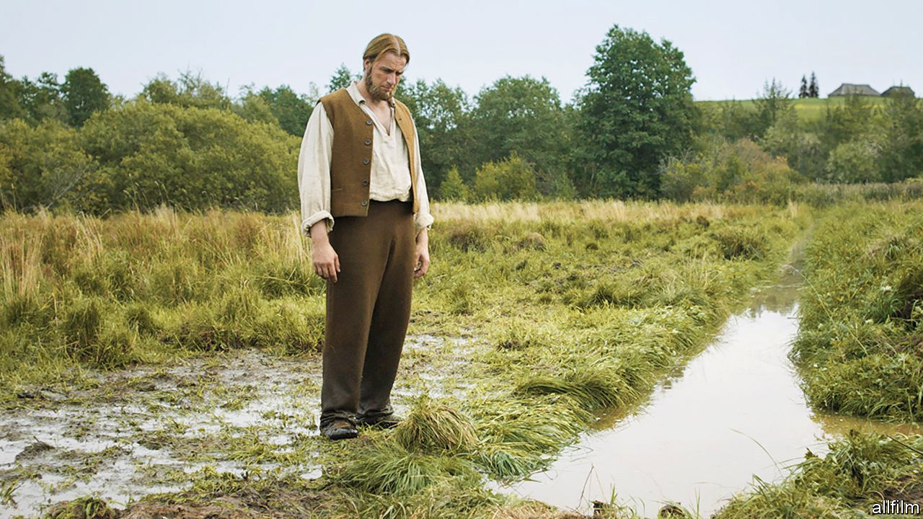

BY 1927 PEOPLE began to descend on North-Tammsaare, a farm deep in the Estonian countryside. They asked the farmer, August Hansen, to show them the spot where Juss hanged himself, or where Kroot had given birth. Hansen was surprised, and sometimes annoyed: Juss and Kroot did not exist. They were characters from the fictional farm of Vargamae who appeared in the first volume of a five-part novel, “Truth and Justice”, published the previous year by Hansen’s younger brother, Anton. (The author adopted the name of the real farm as his pseudonym, becoming A.H. Tammsaare.)

At first, locals pointed out that the people and places sought by the visitors were invented. As more kept coming, though, they began recounting the stories as if they were true. “The reality got mixed up so perfectly with the fiction that we are not able to say any more what was made up and what was actually there,” says Maarja Vaino, who runs a museum devoted to the author in Tallinn. “It [became] kind of a sacred cultural place for Estonians.” The farm has remained so ever since—even if its meaning has changed with the times. Now a blockbuster film is spreading the legend to an even wider audience.

Together, the story’s five volumes chart Estonia’s progress from province of the Russian empire to statehood. The first volume is by far the best known; most Estonians are familiar with the characters, even if they have never read the book. Some secondary-school pupils take other classes to avoid studying it—and it is easy to see why. The series is a daunting read, full of metaphysical asides and tangential subplots, centring on the grinding life of peasants.

It opens in the 1870s during the “national awakening”, when a unique Estonian national identity began to emerge. An idealistic young man named Andres buys a poor farm—the best he can afford—determined to improve it for his children. He repeatedly scraps with his idle, drunken neighbour, Pearu. As their antagonism grows, so does Andres’s obsession with making his plot prosperous. He fights trivial legal battles with Pearu, all the while slaving over the farm along with his put-upon family.

Early Estonian readers saw themselves and their ancestors in Andres’s struggles. Serfdom was abolished in the Baltic region in 1816-19, more than 40 years before most of Russia’s empire. Much of the land still belonged to Baltic-German aristocracy, but people could now lease or buy their own patch. Conditions were harsh, but literacy spread rapidly, enabling peasants to fight for their rights in court, against both squires and each other. (The literal translation of the novel’s Estonian title, “Tode ja oigus”, is “Truth and Jurisprudence”.) Reading the Bible helped them form their own religious views; Tammsaare’s characters frequently question divine authority.

Later volumes deal with the events—including revolution and the first world war—that led to Estonia becoming an independent republic in 1918. In his compatriots’ imagination, Tammsaare and his creations were bound up with the historical tumult. Even in his lifetime he was a literary hero. His death in 1940, just before the Soviet invasion, was seen as a harbinger of the republic’s demise.

## Never-ending story

In the Soviet era, interpretations of “Truth and Justice” were updated. Tammsaare’s criticism of revolution originally landed his work on a list of suspicious books, but by 1950 Soviet authorities had come up with a way to exploit the story. New forewords praised its depiction of unceasing labour in pursuit of a better future—“work hard, and love will come later” remains one of the most famous lines—while blaming the misery of Andres’s family on his urge to accumulate wealth and property. For most Estonians, meanwhile, the book was a reminder of a past and an identity that their occupiers wanted to erase.

The new film—the first ever cinema adaptation—is yet another twist in the cultural odyssey of “Truth and Justice”. Within a month of its premiere last year, it was the most watched movie in the country since it emerged from the Soviet Union in 1991. Though paltry by Hollywood’s standards, the budget of €2.5m ($2.8m), mostly state-funded, was among the biggest ever for an Estonian film. It won recognition abroad, just missing a nomination for Best International Feature Film at the Academy Awards.

The adaptation was a saga in itself. Tanel Toom, the director, was among those who avoided reading “Truth and Justice” as a child. He jokes that, after graduating, he lugged the book around for a decade before opening it. The film took seven years to make, in part spent honing the sprawling story into a coherent script. In this selective rendering, stoicism and striving are more destructive than virtuous. Desperate for a son, Andres repeatedly impregnates his first wife until she dies in childbirth; he beats his second rather than acknowledge his guilt over marrying her. He reads his Bible obsessively, shuns society and cannot see why his children want to leave the land he moulded for them. These lives play out in a sweeping, inhospitable landscape, against which they seem insignificant.

“I understood that I’m a bit like [Andres],” Mr Toom says of the project. To him, it is a reminder to “see the rest of the world, to not forget about your loved ones”. Evidently his interpretation struck a chord: he was named “person of the year” for 2019 by Postimees, Estonia’s biggest newspaper. Almost a century after they first appeared, the denizens of Vargamae farm live on. ■

This article was downloaded by calibre from <https://www.economist.com/books-and-arts/2020/03/07/a-landmark-estonian-novel-is-adapted-into-a-film>

|  |  |  |  |
| --- | --- | --- | --- |
| Previous | Articles | Sections | Next |

|  |  |  |  |
| --- | --- | --- | --- |
| Previous | Articles | Sections | Next |

#### A life in parts

# In “Actress”, a daughter strives to understand her mother

Anne Enright’s new novel is a meditation on families and fame

Mar 7th 2020 |



Actress. By Anne Enright. W.W. Norton; 272 pages; $26.95. Jonathan Cape; £16.99.

VERY LITTLE about Katherine O’Dell was genuine. Born in south London in 1928, she would come to be celebrated as “the most Irish actress in the world” (her “standard south Dublin” lilt was charming but affected). Her hair’s flaming auburn hue came out of a bottle. Her first and only marriage was a sham: a union between a gay man and his young co-star, conceived by the Hollywood studio that had matched them on-screen. Even the name O’Dell was a kind of deception—her mother’s maiden name, but “Irished”.

Katherine is the strange and captivating figure at the centre of “Actress”, Anne Enright’s seventh novel. Many years after the character’s death, Norah, her daughter, begins a search for the woman beneath the famous roles, stage make-up and costumes. She is a slippery subject, who concealed and exaggerated much more than she revealed. Norah can never quite grasp Katherine’s nature. How many lovers did she take? Was she involved in the IRA, or did the paramilitaries just use her for publicity?

Norah hopes to better understand their relationship, as well as to answer more difficult questions: who her father was, why Katherine always refused to name him and why she eventually lost her grip on reality. Katherine’s mental decline culminated in a seemingly random attack on a film producer, followed by a spell in an asylum. (She dressed in an expensive suit for the assault, ready “for the six o’clock news”.)

“Actress” is a poignant tale of the vicissitudes of fame and its effects on the loved ones of the famous. In good times Katherine revelled in adoration, raucous parties and shopping trips to Fifth Avenue; when they were bad, she suffered bouts of depression. Money ebbed and flowed. As she aged she became unable to find decent roles. She thrived on public attention but Norah was her most constant companion. “No one liked her for herself, she said, which was a little bit paranoid and a little bit true.”

Ms Enright’s story of the abuses reserved for young female stars is timely; her observations on the strains of mother-daughter relationships are shrewd. But it is in rendering the less glamorous sides of show business that her writing is at its most memorable. Norah recalls watching her mother perform from the wings, aged only four or five. What seems magical is, up close, cheap and horrid. “The sparkles on her gown were, in fact, plastic bits stuck on flesh-coloured net that creased, as she bent over me, like a second, loose skin.”

This article was downloaded by calibre from <https://www.economist.com/books-and-arts/2020/03/07/in-actress-a-daughter-strives-to-understand-her-mother>

|  |  |  |  |
| --- | --- | --- | --- |
| Previous | Articles | Sections | Next |

|  |  |  |
| --- | --- | --- |
| Books and arts | Sections | Graphic detail |

Economic and financial indicators

Economic data, commodities and markets

.

|  |  |  |
| --- | --- | --- |
| Books and arts | Sections | Graphic detail |

|  |  |  |  |
| --- | --- | --- | --- |
|  | Articles | Sections | Next |

# Economic data, commodities and markets

Mar 7th 2020 |

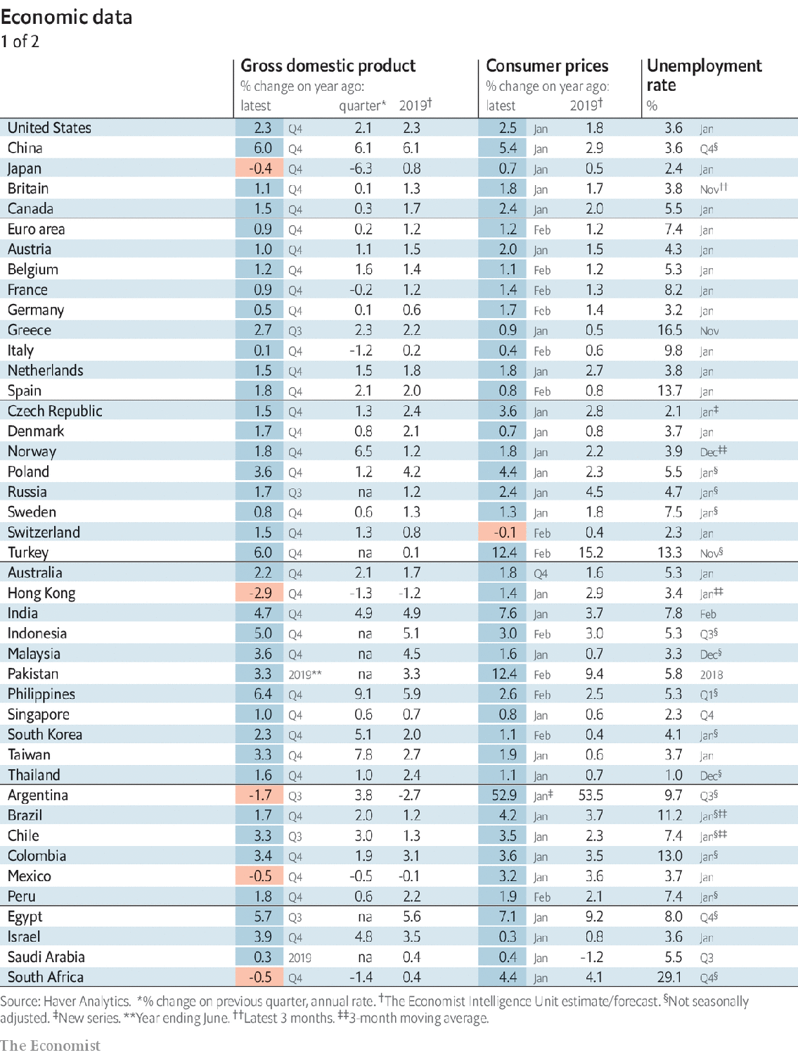

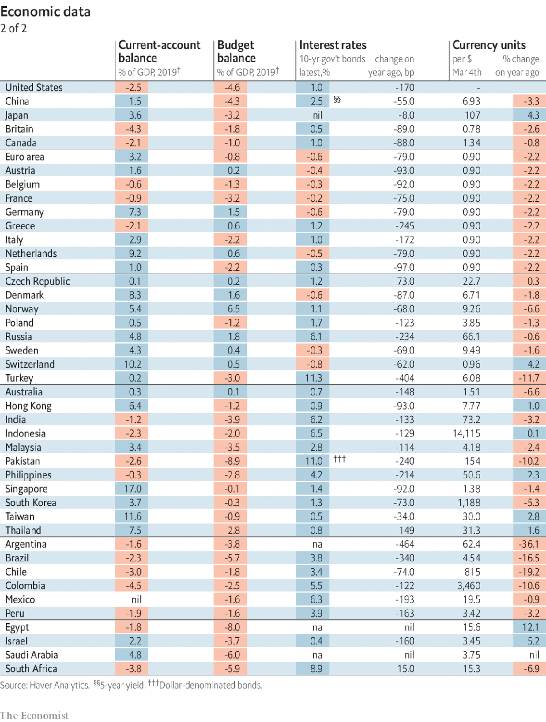

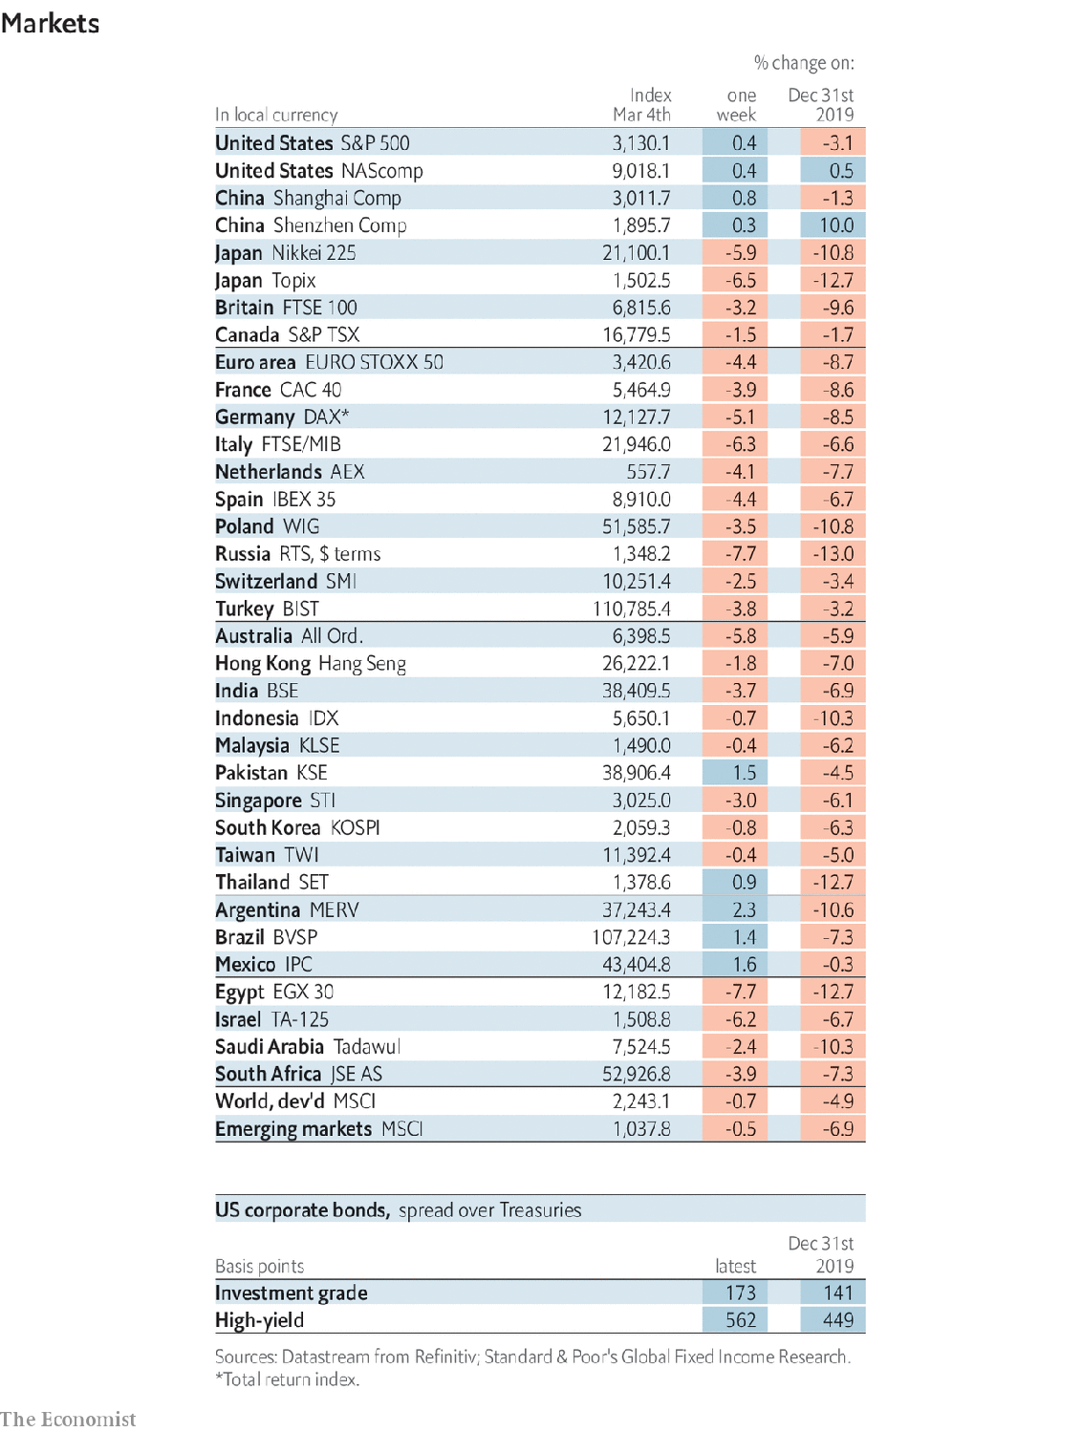

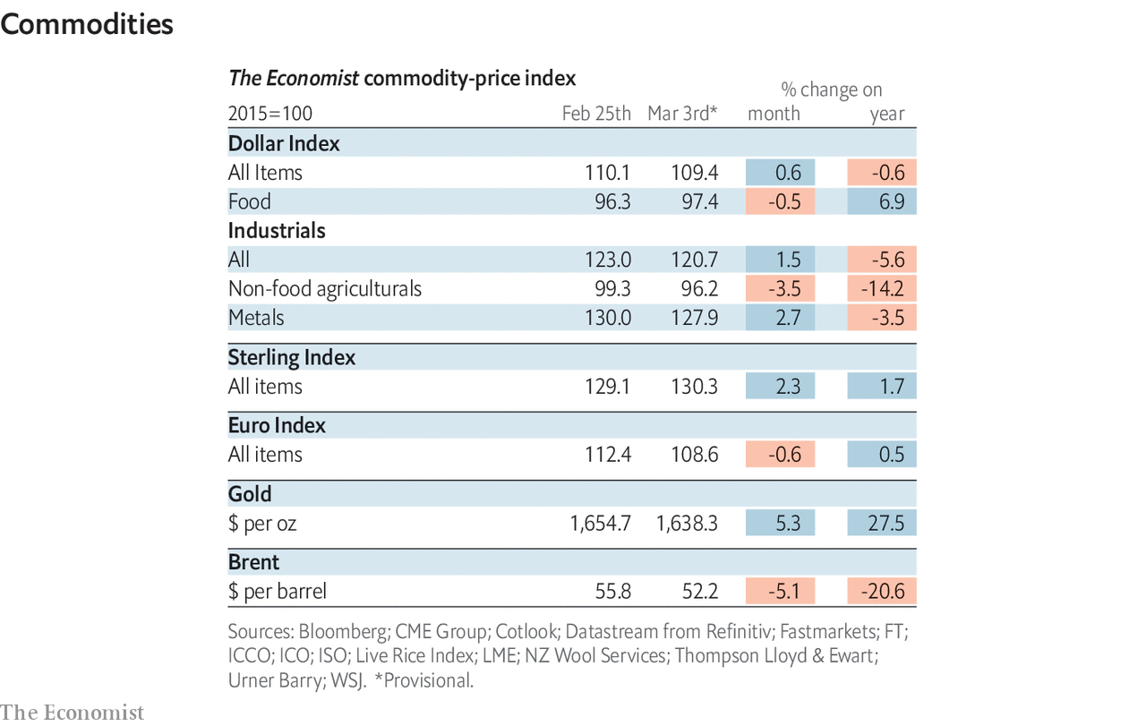

This article was downloaded by calibre from <https://www.economist.com/economic-and-financial-indicators/2020/03/07/economic-data-commodities-and-markets>

|  |  |  |  |
| --- | --- | --- | --- |
|  | Articles | Sections | Next |

|  |  |  |
| --- | --- | --- |
| Economic and ... | Sections | Obituary |

Graphic detail

Coronavirus statistics: Tracking the stealthy killer

.

|  |  |  |
| --- | --- | --- |
| Economic and ... | Sections | Obituary |

|  |  |  |  |
| --- | --- | --- | --- |
|  | Articles | Sections | Next |

#### Tracking the stealthy killer

# Tourism flows and death rates suggest covid-19 is being under-reported

Indonesia, Myanmar, Russia and the Philippines have confirmed just eight cases

Mar 7th 2020 |

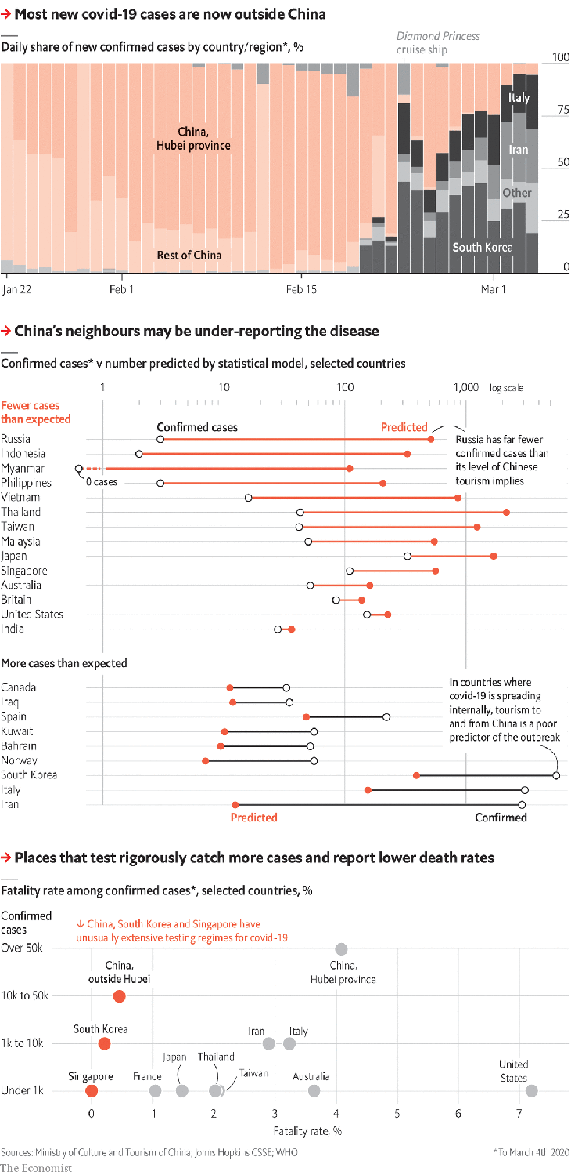

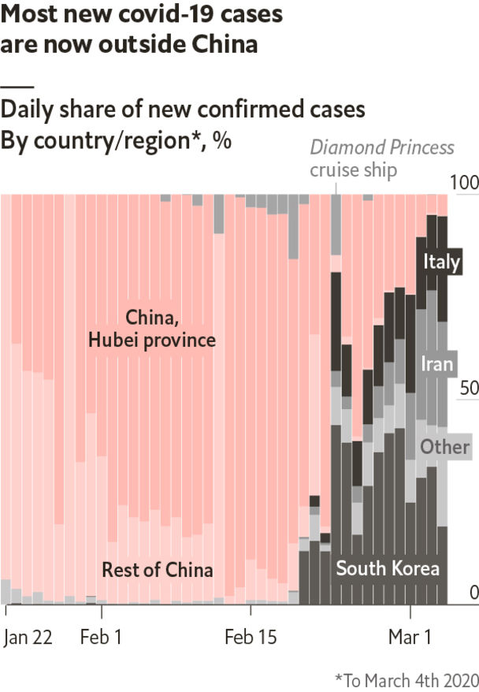

IN RECENT WEEKS covid-19, a deadly new disease, has slowed in China but spread widely elsewhere. China’s strict quarantine has led to a 90% decline in new infections, whereas outbreaks in Italy and Iran have grown rapidly. In the last week of February 70% of new diagnoses were outside of China. As covid-19 reaches countries unwilling or unable to monitor it, officials must use educated guesswork to track its evolution.

The number of cases each country reports depends both on the number of infections and on how many people get tested. By March 1st South Korea had tested over 100,000 people; America just 472.

To estimate the number of undetected cases, scholars can make use of patterns in more complete data. One model, built by a team at Harvard, used the number of people flying from Hubei province in China, where the outbreak began, to various countries to predict imported cases. Such data are less relevant now, because Hubei has been locked down for a month.

To derive fresh estimates, The Economist built a similar model. We tested the link within the OECD—a club of mostly rich countries, which should have strong detection capacity—between Chinese tourism in 2019 and confirmed covid-19 cases. As expected, OECD states that swapped lots of tourists with China, such as Switzerland, tend to report higher infection rates than do ones with small flows, like Belgium.

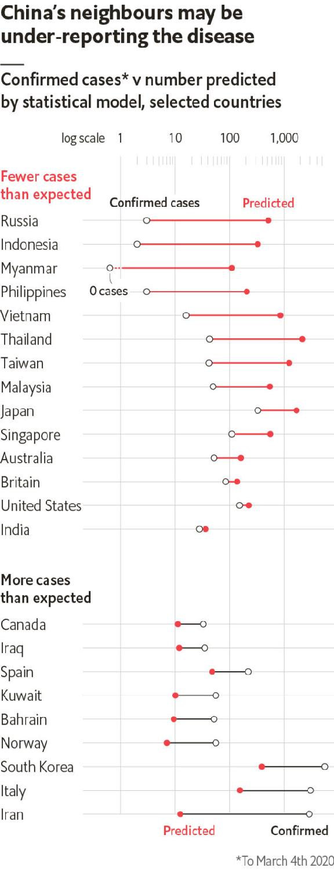

Applied worldwide, our model finds big outliers. The outbreaks in Iran, Italy and South Korea, where the virus is spreading internally, are bigger than tourist flows suggest. At the other extreme, countries like Singapore may have fewer diagnoses than expected because of strong containment efforts. But the Philippines, Russia, Myanmar and Indonesia have lots of people and tourism to and from China, and just eight confirmed cases in total. Thousands more have probably gone undetected.

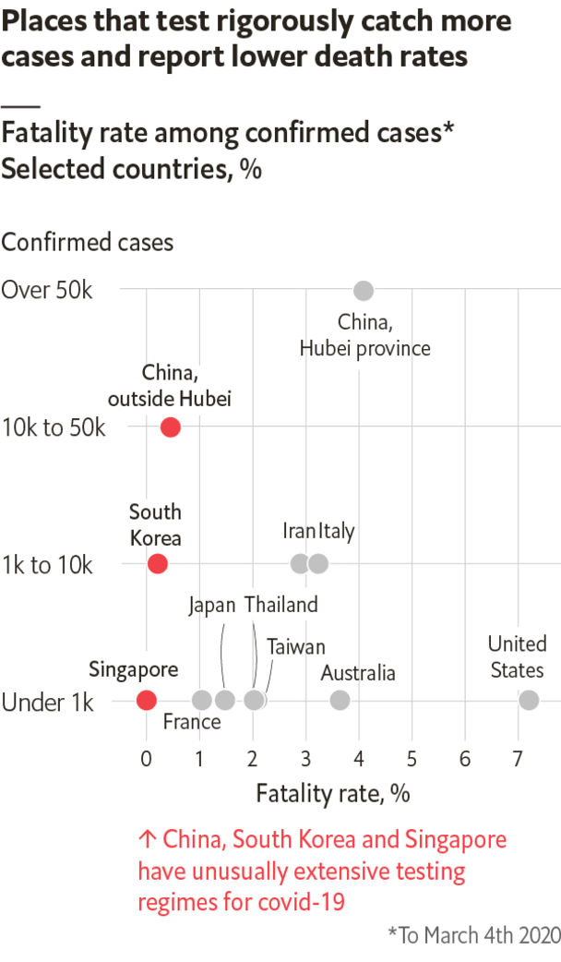

Another pattern bolsters this finding. South Korea and China test regularly. In both places—excluding Hubei, where the virus began claiming lives before authorities formulated a response—0.5-1% of people who have tested positive have died. In other countries with at least one death, this rate is five times higher. Deaths are easier to count than infections are. The most likely explanation for this gap is that for every person diagnosed in these countries, four more do not know they are infected. ■

Sources: Ministry of Culture and Tourism of China; Johns Hopkins CSSE; WHO

This article was downloaded by calibre from <https://www.economist.com/graphic-detail/2020/03/07/tourism-flows-and-death-rates-suggest-covid-19-is-being-under-reported>

|  |  |  |  |
| --- | --- | --- | --- |
|  | Articles | Sections | Next |

|  |  |  |
| --- | --- | --- |
| Graphic detail | Sections |  |

Obituary

Ernesto Cardenal: Building Utopia

.

|  |  |  |
| --- | --- | --- |
| Graphic detail | Sections |  |

|  |  |  |  |
| --- | --- | --- | --- |
|  | Articles | Sections | Next |

#### Building Utopia

# Ernesto Cardenal died on March 1st

Nicaragua’s revolutionary priest-poet was 95

Mar 7th 2020 |

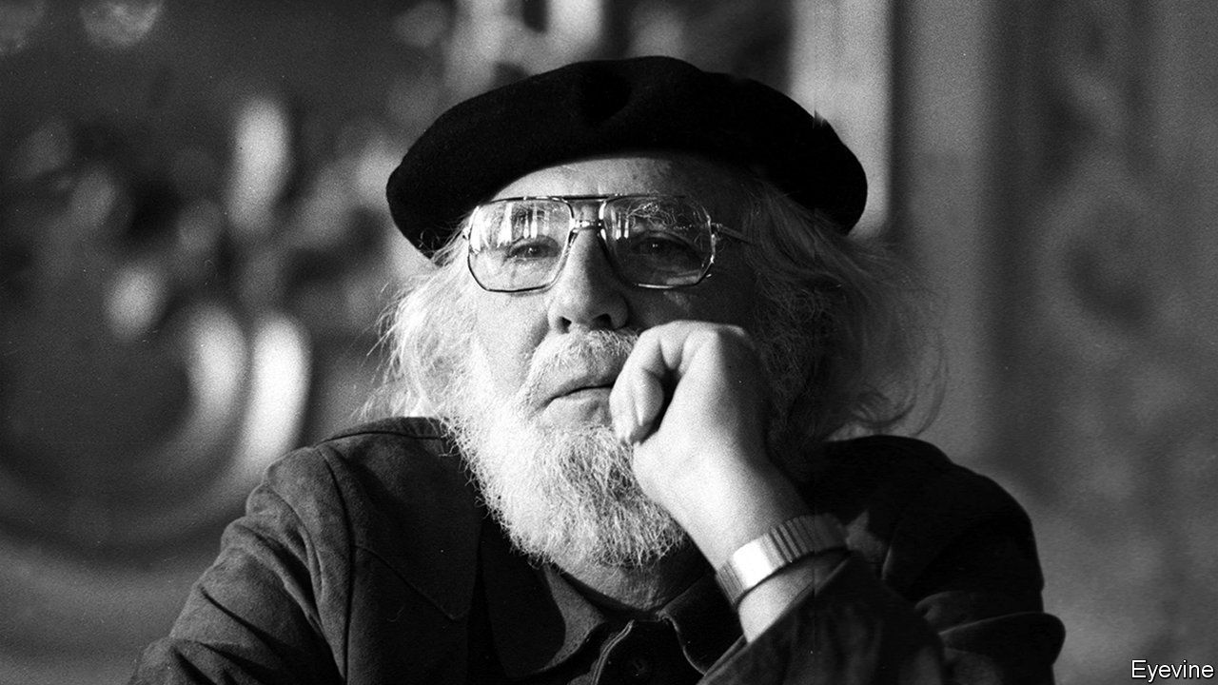

IN MARCH 1983 Ernesto Cardenal, then Nicaragua’s minister of culture, found himself on the broiling tarmac at Managua airport, waiting for the pope. John Paul II had no love for the left-wing Sandinista regime, but the minister—a priest as well as a revolutionary, for all his collarless shirt and black beret—was eager to see him. As the pope approached, he knelt and pulled off his beret for a blessing. What he got was a finger-wagging lecture. “You must sort out your affairs with the church,” the pope told him. Twice.

The photograph of the incident showed him smiling, as if he agreed. But he did not. He felt the pope did not know what true Marxism was. In his experience, Christ had led him to Marx, and the Gospels, with their message of social justice, had led him to communism. The link was obvious, direct. As the crowd that day was yelling out regularly, in case the pope should miss it, “Entre crístianismo y revolución, no hay contradicción.”

Many years before in Solentiname, in a remote southern corner of Lake Nicaragua, he had worked to prove that slogan true. He arrived there in 1967, after Trappist training under Thomas Merton at Gethsemani, to start a contemplative community. Almost at once it became something else. He had grown up as a rich boy, in a mansion at the other end of the vast lake. Here, though, he was among poor fishermen and farmers who had never before been sent a priest. His union with God in meditation would mean nothing unless he involved them as equals. He therefore set about it.

Gradually, a Christian-Marxist Utopia grew up by the edge of the lake. The campesinos were taught to share and live communally. He then encouraged them to paint and they produced, untaught, bright, primitive pictures of the lake, its birds and flowers, that looked like paradise. This, he would tell them, was the perfect world they were aiming for. Creation was evolution; the universe was incomplete, but they would assist its progress. At Solentiname he set up workshops for all to be creators: painters, sculptors, dancers, poets. A library was built, full of Marxist books. Visitors from abroad came to buy pictures and to see his principles in action.

Liberation theology, the “option for the poor”, was then current all over Latin America, but his was sharper-focused. At Solentiname Sunday mass became a free-form discussion, everybody sitting in a circle for Gospel readings which the campesinos would comment on, and he would explain. Why was the good news of Jesus’s birth given first to shepherds? Because the poor and oppressed needed it most. What about the parable of the mustard seed? That was the seed of change they all carried in them. What was the Kingdom of God? That was a place where everything was turned upside down, as when you flipped a tortilla. The Kingdom of God was revolution. It was the overthrow of the right-wing Somoza regime that had ruled Nicaragua for decades—those tyrants who barged through his poems, swanning round in their chocolate-biscuit palace, guarded by goons with machineguns, who would kill a man as casually as they smoked a cigarette.

He had written that way for a long time. Hate alternated with love, especially, in his early “Epigrams”, in lyrics addressed to girls his pleading kisses could no longer reach. Later, both God and rebellion took him over. In the 1950s he supported a coup, yelling for liberty in the street, but fled when it failed. His long poem “Hora 0” (Zero Hour) eulogised Augusto César Sandino, the Sandinistas’ model, as a figure like himself, no soldier, no politician, leading with grim serenity a ragged, shoeless army against the yanquioccupation in the 1920s. Feeling at last that he had to foment armed struggle, in 1977 he sent some would-be martyrs from Solentiname to attack a guard post in the town of San Carlos. In revenge, Anastasio Somoza’s troops destroyed his island Utopia.

Yet all was not lost. In two years the Somocistas themselves had been toppled, and Nicaragua had the rulers he had hoped for. Surprisingly—since he was a man devoted to solitude and simplicity, to Neruda, Whitman and Pound’s “Cantos”—he was one of them. His post as minister of culture, Nicaragua’s first, gave him a chance to do nationally what he had achieved in miniature before.

For nine years he tried, establishing cultural centres and poetry workshops all over the country, restoring Solentiname, launching a literacy drive and selling the Nicaraguan revolution abroad. His white hair and black beret made him its symbol, seemingly mild, until he raised his oracular voice in poems. But there was never enough money in the ministry. Besides, many thought his poetry workshops were not so much classes for the common man as propaganda mills, where the only poetry taught had to be like his: simple, direct, and with the raw howls against dictatorship that typified his “Psalms”. (“Their lying radios roar into the night/Their desks are strewn with criminal intentions...”) That charge was hard to counter. He too was wildly ardent, then.

Eventually the fervour cooled. No one seemed able to adopt either Christianity or Marxism fully in practice; the creeds were equal in that, too. The Sandinistas’ beautiful revolution turned dynastic under Daniel Ortega and his wife, who in 1988 eased him out of the ministry. By 1994 he had left the movement; in 2008 he condemned it as a thieving monarchy. And his priestly life, too, had gone. He had been stripped of his sacramental functions in 1984, soon after his airport scolding, because he refused to leave the government. Only a year ago did he get them back.

That loss he dealt with in his own way, through books and the practice of poetry. He was ever Trappist; in his bare room he needed only a bed, a shelf, a crucifix and a desk. He retreated to Solentiname where God, he said, slept with him in his hammock by the lake. But he wrote less about politics now, and more about the wonders of the cosmos: the stardust that made humans universal, the flowering of galaxies, the poignancy of messages sent to uninhabited planets. His favourite reading was scientific journals. There he tracked the discoveries that showed creation ever greater, evolving slowly, despite many a slip, towards a perfect revolution—as Marx taught and as Christ taught, both alike.■

This article was downloaded by calibre from <https://www.economist.com/obituary/2020/03/07/ernesto-cardenal-died-on-march-1st>

|  |  |  |  |
| --- | --- | --- | --- |
|  | Articles | Sections | Next |